電通二乙微處理器實驗 實驗結報

實驗名稱 | Lab11
組別 | 11 | 組員 | 陳奕璁

- 實驗目的
到MCS註冊帳號
建立網頁應用程式（web application）
透過MCS REST API進行溝通
LinkIt 家族開發板、手機、瀏覽器
- 實驗步驟
(1) 修改 MCS_GET code, 加入 MCS Remote
(2) 將 A0 電阻值上傳
- 程式碼
#include <LWiFi.h>
#include "MCS.h"

char _lwifi_ssid[] = "LoveCat";
char _lwifi_pass[] = "vbqz3nzmr6x5z";
MCSDevice mcs("D8RYcHgE", "LupRBQ0n08dVNX1p");

MCSControllerOnOff led("A123456");
MCSDisplayOnOff remote("B123456");

void setup()
{
Serial.begin(9600);

Serial.println("Connect to Wifi");
while (WiFi.begin(_lwifi_ssid, _lwifi_pass) != WL_CONNECTED)
{
Serial.println("Wifi Reconnecting..");
delay(1000);
}

Serial.println("Connect to MCS...");
while (!mcs.connected())
{
Serial.println("MCS Reconnecting..");
mcs.connect();
}
Serial.println("MCS Connected!");
mcs.addChannel(led);
mcs.addChannel(remote);

pinMode(7, OUTPUT);

}

void loop()
{
while (!mcs.connected()) {
Serial.println("MCS.connect()...");
mcs.connect();
if (mcs.connected()) {
Serial.println("MCS Reconnect");
}
}
mcs.process(1000);
while(!led.valid())
{
Serial.println("read LED value from MCS...");
led.value();
}
Serial.print("done, LED value = ");
Serial.println(led.value());
digitalWrite(7,led.value() ? HIGH : LOW);
if(!remote.set(led.value()))
{
Serial.print("Failed to update remote");
Serial.println(remote.value());
}
if (led.value() == 1) {
digitalWrite(7, HIGH);
} else {
digitalWrite(7, LOW);
}
delay(200);
}
- 實驗結果及分析
上禮拜是用藍芽連手機來連線操控 今天是用wifi連網路到網站去操控
- 心得討論
感覺挺方便的
- 修正電路圖

(1)
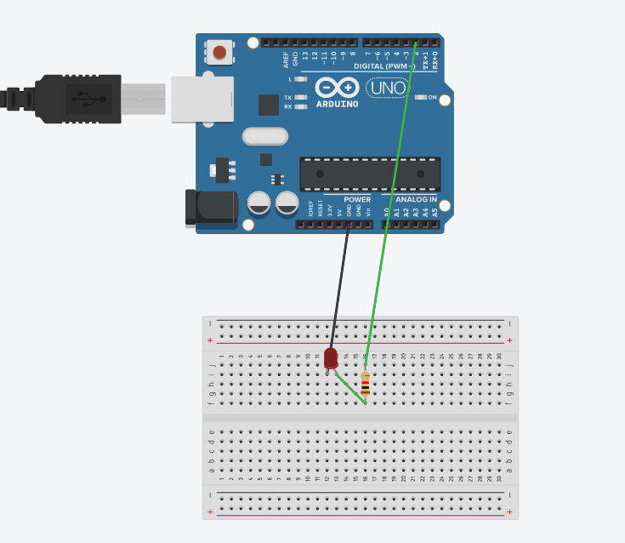
(2)
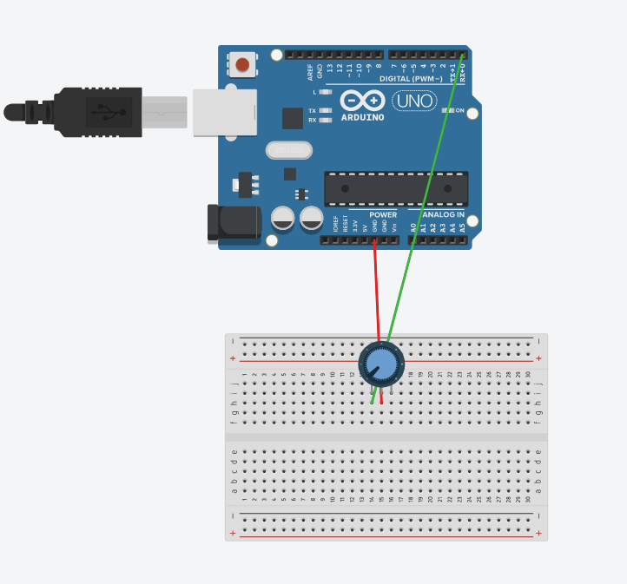
- 修正程式碼

(1)
#include <LWiFi.h>
#include "MCS.h"

char _lwifi_ssid[] = "LoveCat";
char _lwifi_pass[] = "vbqz3nzmr6x5z";
MCSDevice mcs("D8RYcHgE", "LupRBQ0n08dVNX1p");

MCSControllerOnOff led("A123456");
MCSDisplayOnOff remote("B123456");

void setup()
{
Serial.begin(9600);

Serial.println("Connect to Wifi");
while (WiFi.begin(_lwifi_ssid, _lwifi_pass) != WL_CONNECTED)
{
Serial.println("Wifi Reconnecting..");
delay(1000);
}

Serial.println("Connect to MCS...");
while (!mcs.connected())
{
Serial.println("MCS Reconnecting..");
mcs.connect();
}
Serial.println("MCS Connected!");
mcs.addChannel(led);
mcs.addChannel(remote);

pinMode(7, OUTPUT);

}

void loop()
{
while (!mcs.connected()) {
Serial.println("MCS.connect()...");
mcs.connect();
if (mcs.connected()) {
Serial.println("MCS Reconnect");
}
}
mcs.process(1000);
while(!led.valid())
{
Serial.println("read LED value from MCS...");
led.value();
}
Serial.print("done, LED value = ");
Serial.println(led.value());
digitalWrite(7,led.value() ? HIGH : LOW);
if(!remote.set(led.value()))
{
Serial.print("Failed to update remote");
Serial.println(remote.value());
}
if (led.value() == 1) {
digitalWrite(7, HIGH);
} else {
digitalWrite(7, LOW);
}
delay(200);
}
(2)
#include <LWiFi.h>
#include "MCS.h"

char _lwifi_ssid[] = "LoveCat";
char _lwifi_pass[] = "vbqz3nzmr6x5z";
MCSDevice mcs("D8RYcHgE", "LupRBQ0n08dVNX1p");

MCSDisplayInteger Temp("Temp");

void setup()
{
Serial.begin(9600);

Serial.println("Connect to Wifi");
while (WiFi.begin(_lwifi_ssid, _lwifi_pass) != WL_CONNECTED) {
Serial.println("Wifi Reconnecting..");
delay(1000);
}

Serial.println("Connect to MCS...");
while (!mcs.connected()) {
Serial.println("MCS Reconnecting..");
mcs.connect();
}
Serial.println("MCS Connected!");

mcs.addChannel(Temp);

}

void loop()
{
while (!mcs.connected()) {
mcs.connect();
if (mcs.connected()) {
Serial.println("MCS Reconnect");
}
}
mcs.process(1000);

int sensor = analogRead(A0);

Temp.set(sensor);
Serial.println("Add sensor value.");
delay(200);
}

