EECE 5860/COEN 4860 PROJECT #2 Spring 2014
Due: Monday, April 22, 2014

Goals:
1. Learn how to implement the supervised ANN using Matlab Neural Network Toolbox
2. Gain experience of using ANNs to solve real world problems.
3. Practice how to organize your ideas in good writing.

Do the following:
1: Develop supervised ANN (with 2-2-1) architecture to solve the well-known XOR problem
(1) Develop an ANN with the sigmoid output PE
(2) Develop an ANN with the all linear PEs
(3) Compare the results (you may use any training algorithms in the NN toolbox)

2. One of the most common applications of the backpropagation ANN is the approximation of nonlinear function mappings. Design an ANN with one hidden layer, and train it using backpropagation algorithms.
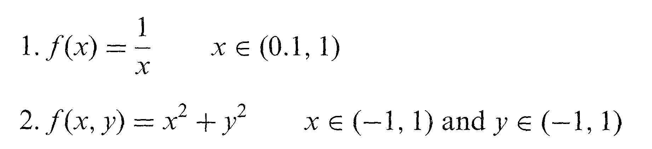

Foe each of the above function approximation problems, do the following:
(a) Generate three independent sets of input patterns:
training set: 20 patterns
testing set: 10 patterns
validation set: 10 patterns
For each of the sets, generate the target values, using the analytical expression for the function to be approximated.
(b) In the process of ANN training, use the “training set” to modify the weights. Use the “testing set” at the end of each training epoch to monitor the ability of the network to generalize and prevent overfitting. Finally, use the “validation set” to verify the overall performance of the ANN after it has been trained.
(c) Experience the results with different number of neurons in the hidden layer as well as the number of hidden layers. Discuss it in the report.
(d) Compare the speed of convergence of BP and LM methods.

3. Develop an ANN that predicts the S&P500 data. You may use any training algorithms in the NN toolboxes. The S&P500 datafile is on the class website (sp500.csv).
Note:
1. The report must be TYPED and should be no-more-than-10-pages in total. A useful hint: a picture (or a table) is worth a thousand words.
2. Turn in all programs and the report using Digital Drop box.

