LABORATORY ASSIGNMENT REPORT
Department of Computer Engineering
Subject Name: | WT
Assignment No.: | 02
Name of the Student: | Mulla Saber Layak
Division: | H
Batch: | B3
Roll No: | 26
PRN Number: | 12412542

AIM:
Build an advanced real-time clock dashboard application using React that combines Analog Clock, Digital Clock, Time zone Management, Alarm Features, and Dynamic UI Controls into a single responsive system. The application should simulate a professional world-clock dashboard capable of displaying live time updates across multiple regions while maintaining smooth animations and optimized performance.
OBJECTIVES:
- To design and implement a synchronized dual-clock system featuring high-precision vector SVG analog clock faces and a digital clock interface with continuous sweep and discrete quartz movement options.
- To develop a multi-region global timezone management network with synchronized mini-clocks, daylight/night tracking, business hour classification, and an interactive 24-hour timeline meeting planner.
- To implement an offline Web Audio API synthesized alarm sound engine with multi-tone frequency modulation, repeat schedules, customizable snooze capabilities, and browser push notification integration.
- To architect dynamic UI controls and state management using custom React hooks and LocalStorage persistence for high-frequency drift-corrected rendering, theme customization, and responsive layout scaling.
SOFTWARE REQUIREMENTS:
Operating System | Windows 10 / 11, Linux, or macOS
Runtime Environment | Node.js (v18.0.0 or higher), npm (v9.0.0 or higher)
Frontend Library / Framework | React 18.3.1, React DOM 18.3.1
Build Tool / Bundler | Vite 6.0.5, @vitejs/plugin-react
Styling & UI Tools | Tailwind CSS 3.4.17, PostCSS, Autoprefixer, Lucide React, Canvas Confetti
Web APIs Leveraged | Web Audio API (Synthesizer), requestAnimationFrame, Fullscreen API, Web Notifications API, LocalStorage API, Intl.DateTimeFormat
Code Editor & Browser | Visual Studio Code, Google Chrome / Microsoft Edge (Latest)

CODE:
Project Architecture & Modular File Structure:
LAB 02/
├── index.html # Application HTML entry shell & typography fonts
├── package.json # Dependencies, build scripts & metadata
├── vite.config.js # Vite compilation & React plugin configuration
├── tailwind.config.js # Tailwind design tokens, fonts & keyframe animations
├── postcss.config.js # PostCSS autoprefixer pipeline
├── README.md # Complete system documentation & usage guide
└── src/
├── main.jsx # Application bootstrap & DOM root renderer
├── index.css # Global Tailwind directives & dark/light theme definitions
├── App.jsx # Central state manager, tab navigator & layout orchestrator
├── constants/
│ └── timezones.js # Worldwide timezone database (20+ cities) & offset helpers
├── utils/
│ └── soundEffects.js # Web Audio API procedural synthesizer (alarms & clock ticks)
├── hooks/
│ ├── useRealTime.js # Drift-compensated timer with requestAnimationFrame (60 FPS)
│ ├── useAlarms.js # Alarm scheduler, notification handler & snooze engine
│ └── useLocalStorage.js # Persistent browser storage hook for settings & alarms
└── components/
├── Header.jsx # Top bar with live status, theme switcher & fullscreen toggle
├── AnalogClock.jsx # Vector SVG clock with 4 face styles & continuous sweep
├── DigitalClock.jsx # Large digital readout with calendar, Day of Year & UTC pill
├── HeroClockSection.jsx # Synchronized dual analog & digital centerpiece view
├── WorldClockCard.jsx # Pinned city card with mini analog face & business hour tags
├── WorldClockSection.jsx # Multi-region world clock network with searchable city adder
├── TimeConverter.jsx # Interactive 24-hour time scrubber & global meeting planner
├── AlarmSection.jsx # Alarm manager with sound tone previews & repeat selectors
├── AlarmModal.jsx # Fullscreen alarm ringing alert with confetti & audio loop
├── StopwatchTimerSection.jsx # Millisecond lap stopwatch & Pomodoro countdown timer
└── SettingsModal.jsx # Dynamic UI controls & theme customization modal

Module Descriptions & Key Responsibilities:
AnalogClock.jsx | Renders SVG vector dials with 4 face styles (Modern, Roman, Chrono, Minimal) with smooth 60 FPS sweep hand.
DigitalClock.jsx | Displays formatted 12H/24H time, milliseconds, weekday, date, Day of Year, Week of Year, and UTC offset.
WorldClockSection.jsx | Synchronized world clock grid across 20+ cities with live mini clocks, relative time differences, and business hours.
TimeConverter.jsx | Interactive 24-hour timeline scrubber slider calculating converted times across all pinned world cities simultaneously.
soundEffects.js | Pure Web Audio API procedural sound synthesizer for 5 distinct alarm melodies and subtle mechanical clock ticks.
useAlarms.js & AlarmSection.jsx | Alarm scheduling engine supporting repeat rules, snooze logic, desktop push notifications, and ringing overlays.
StopwatchTimerSection.jsx | Precision stopwatch with lap recording (fastest/slowest lap highlighting) and countdown timer with Pomodoro presets.
SettingsModal.jsx & Header.jsx | Dynamic UI controls for 4 color themes (Obsidian, Neon, Gold, Light), tick audio toggle, and fullscreen mode.
OUTPUT:
Application is deployed and running live at: http://localhost:5173/
Below are the primary dashboard output views and screenshot placeholders:
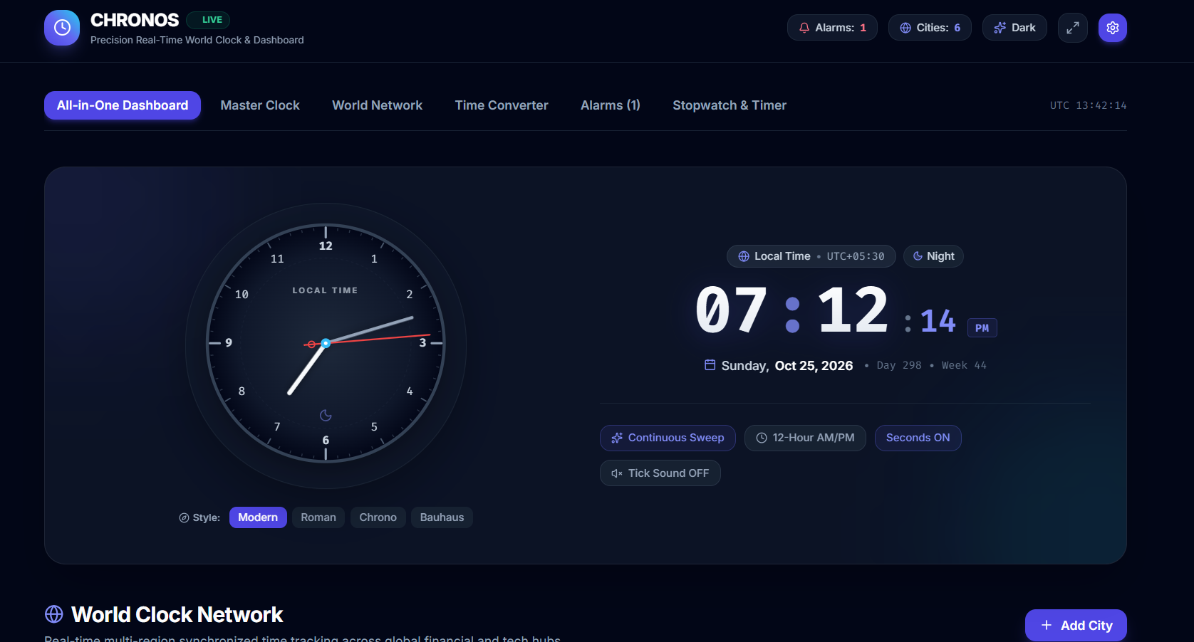
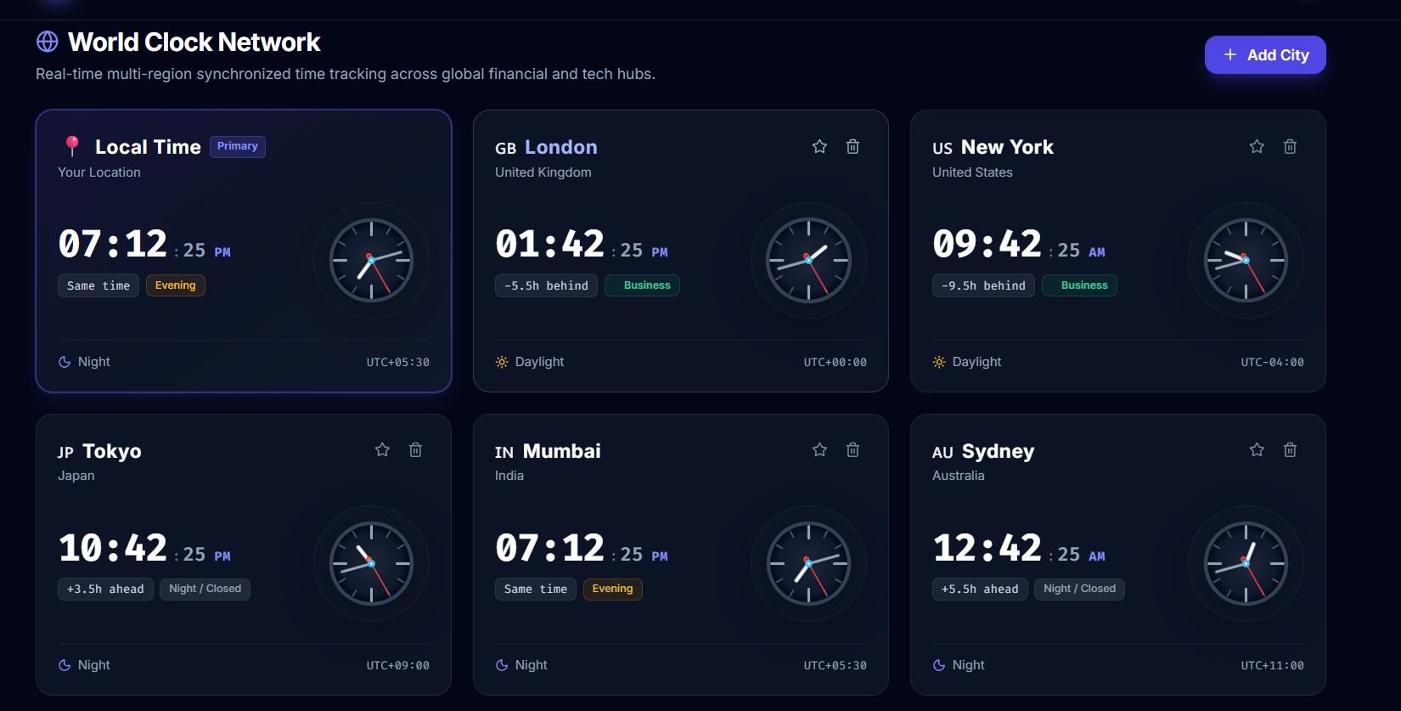

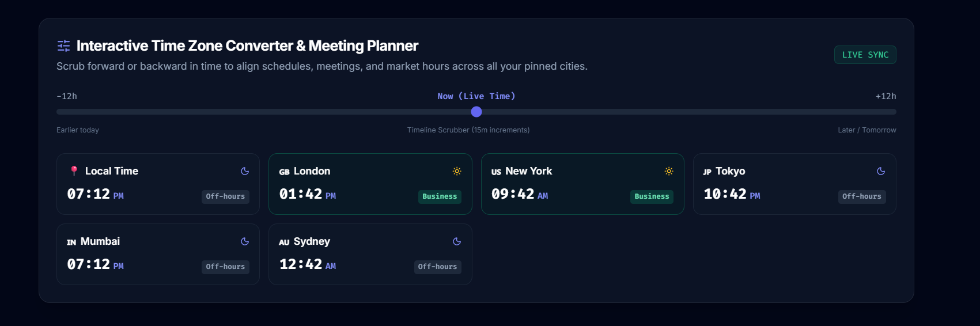

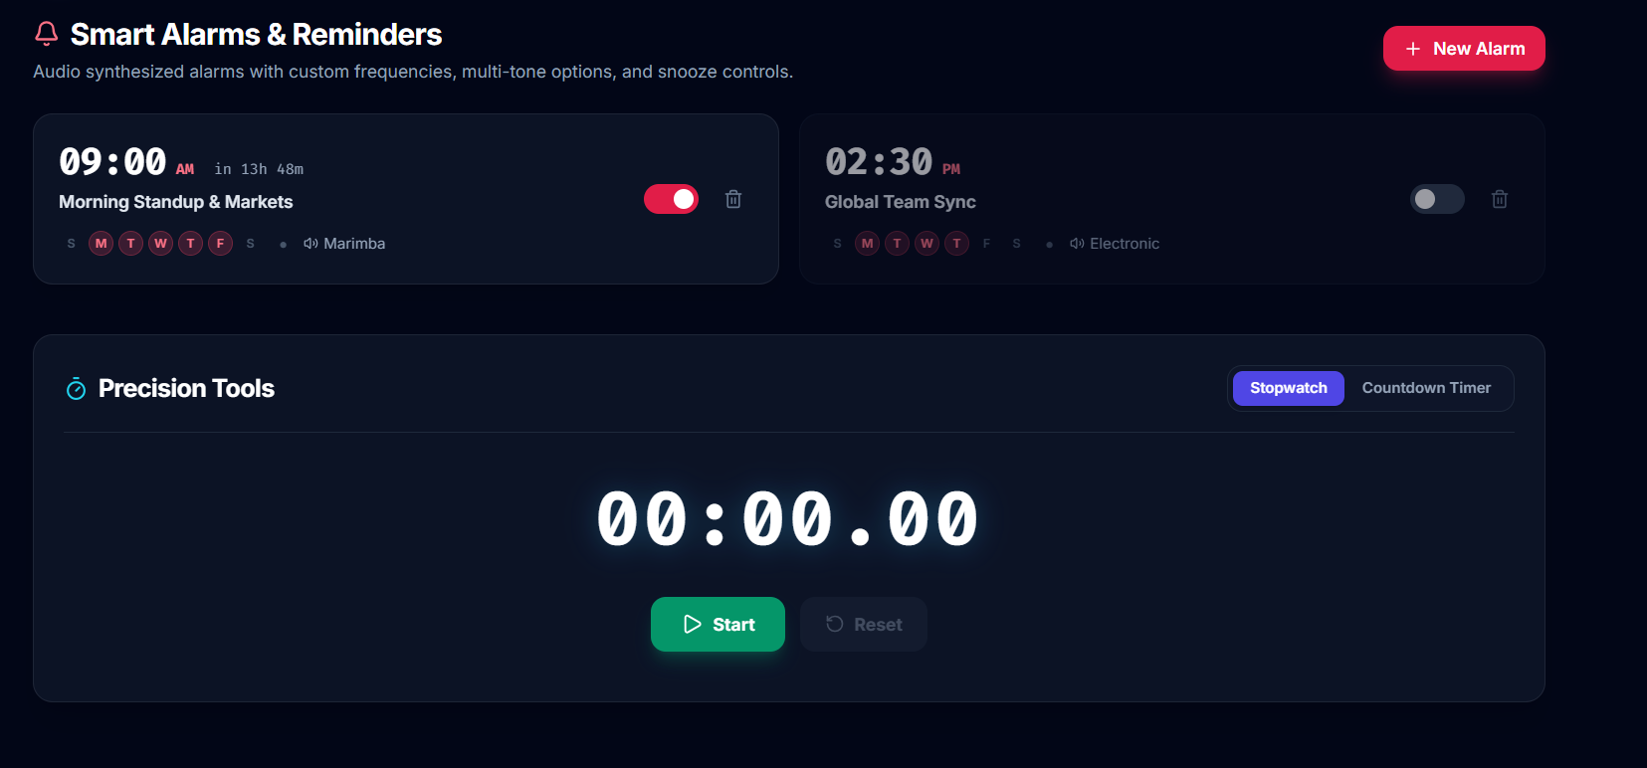

Github URL:

