Does Hybridisation Pay? A Systematic Review of Metaheuristic Optimisation and Machine Learning Hybrids in Pavement Engineering (2005–2026)
Seyed Saber Naseralavi
Ali Reza Ghanizadeh
2026-08-08
Abstract
PLACEHOLDER — structured abstract, ~280 words, written last so that every number in it traces to the audit. Do not draft this before Section 9 is final.
Draft status. This file renders to PDF, Word and HTML from one source. Sections marked PLACEHOLDER are not yet written. Every citation resolves against references.bib, which is generated from data/seed_bibliography.csv; a citation key that is not in the verified database fails the render rather than passing silently.

1. Introduction
PLACEHOLDER — see docs/01_SCOPE_AND_TAXONOMY.md §1 for the argument this section must carry: hybridisation is the field’s dominant claim of novelty, and the marginal benefit of hybridisation over a properly tuned base learner is almost never tested.
The review literature this study builds on is summarised in Figure 1. Prior surveys catalogue where neural and hybrid methods have been applied (Cao et al., 2020; Gopalakrishnan, 2018; Yang et al., 2021); two recent contributions name the underlying problem without converting it into per-study evidence (M’harzi Alaoui et al., 2026; Tamagusko and Ferreira, 2023).
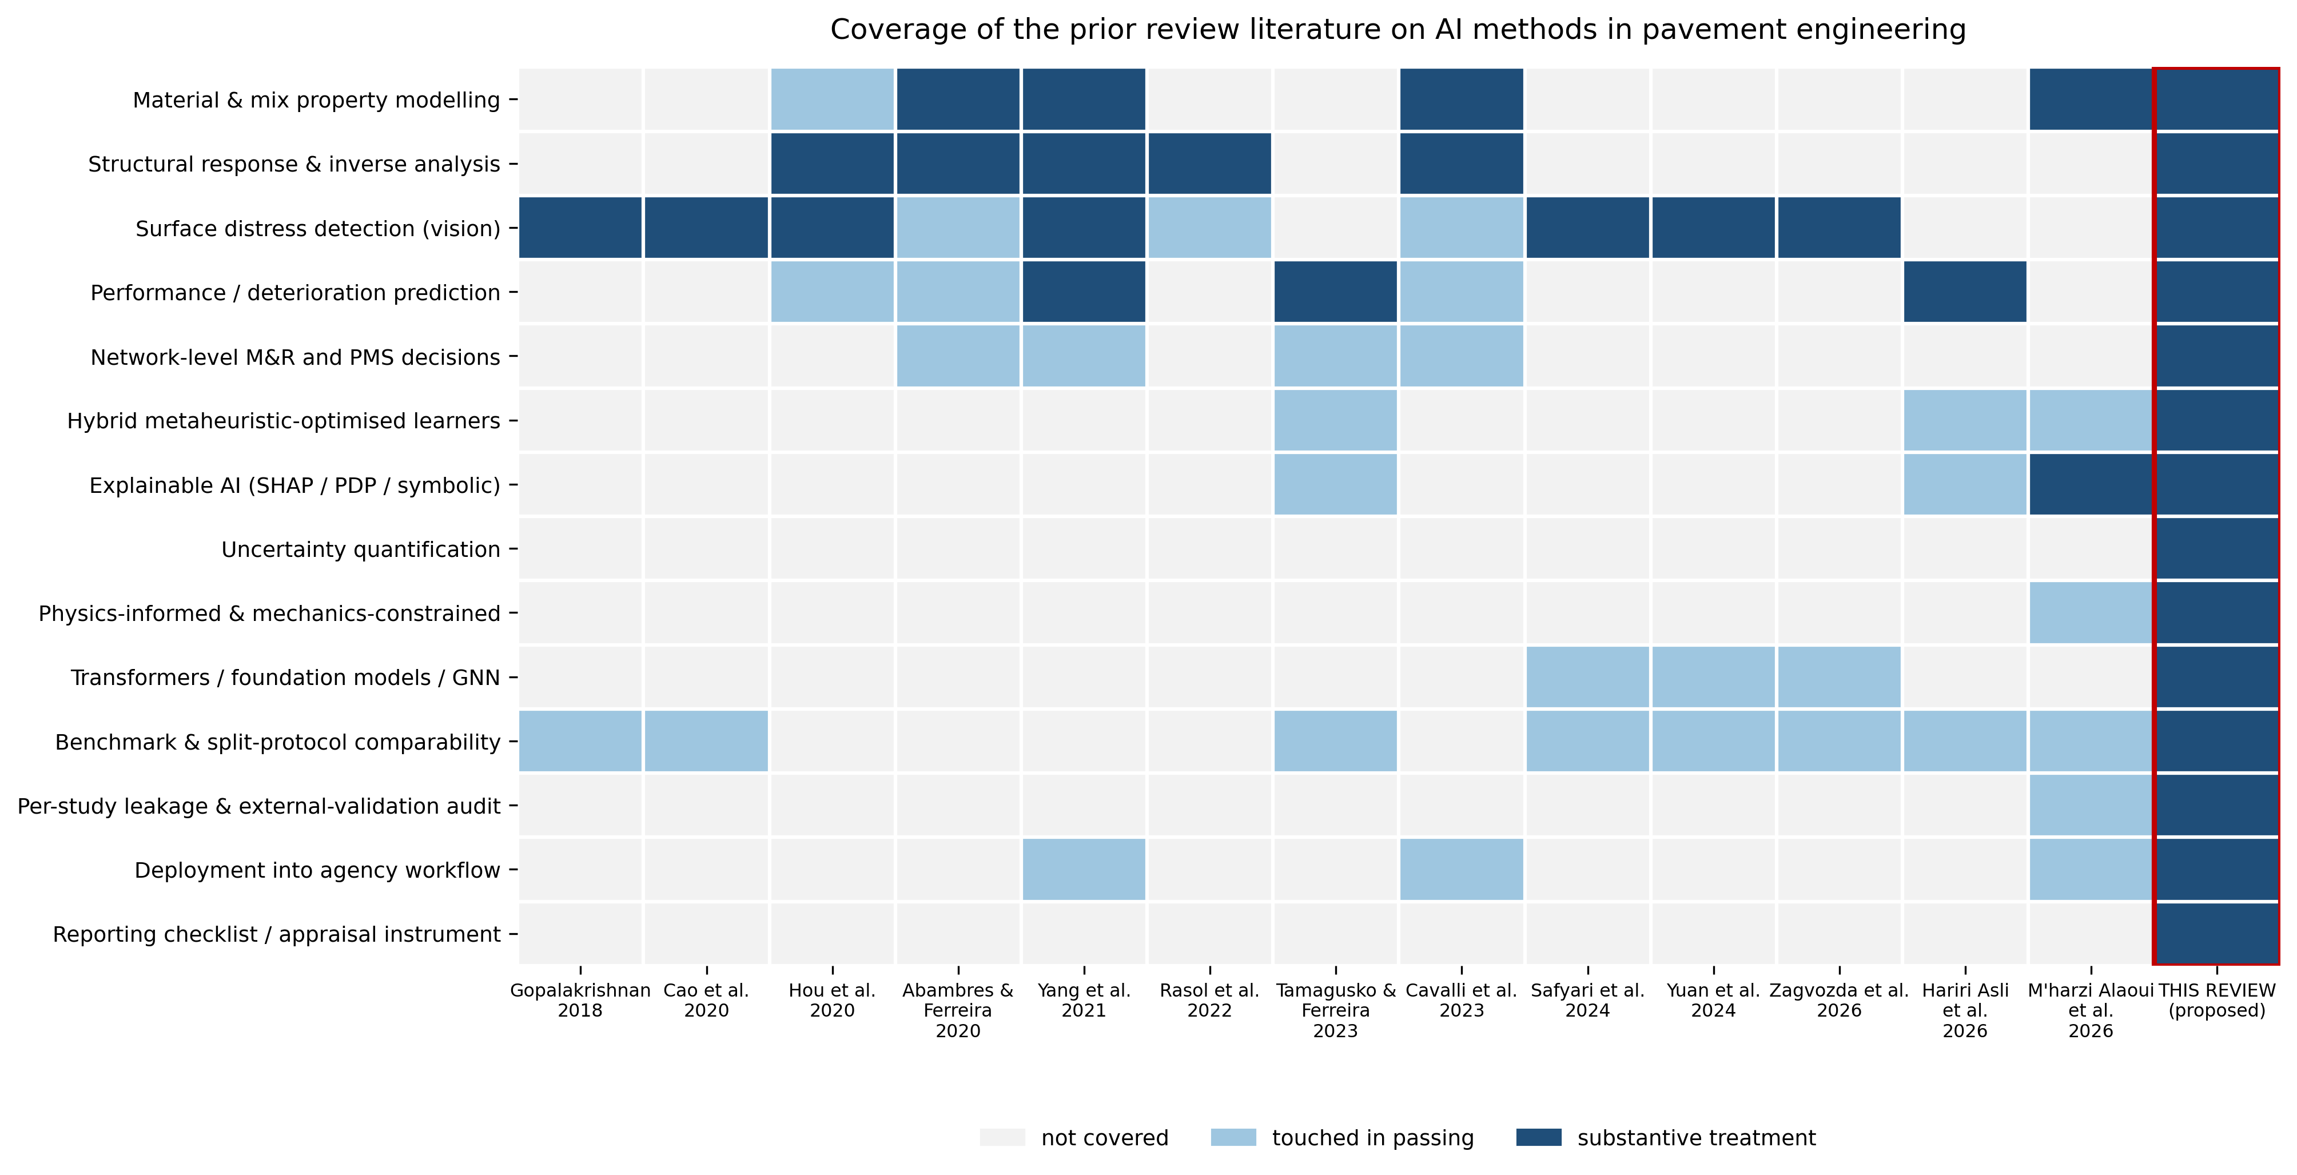
Figure 1: Coverage of the prior review literature on artificial-intelligence methods in pavement engineering. Scoring: 2 = substantive dedicated treatment, 1 = touched in passing, 0 = absent.

2. Review methodology
Full draft in docs/02_MANUSCRIPT_S2_methodology.md; transferred here section by section as each is finalised.

2.1 Scope and framing question
PLACEHOLDER — transfer from the draft.

2.2 Information sources and search
Records were identified from OpenAlex, Scopus, Web of Science Core Collection and Semantic Scholar, with backward and forward snowballing from the 13 prior reviews listed in Table 1. The window runs from 1 January 2005 to 30 June 2026.
Table 1: Prior reviews of artificial-intelligence methods in pavement engineering, with the territory each occupies.
Review | Year | Venue | Territory
Gopalakrishnan | 2018 | Data | distress-detection
Cao et al. | 2020 | IEEE Access | distress-detection
Hou et al. | 2020 | Engineering | structural-evaluation/distress-detection
Abambres et al. | 2020 | TechRxiv (preprint) | all
Yang et al. | 2021 | J. Traffic Transp. Eng. (Engl. Ed.) | all
Rasol et al. | 2022 | Constr. Build. Mater. | structural-evaluation
Cavalli et al. | 2023 | J. Road Eng. | all
Tamagusko et al. | 2023 | Infrastructures | performance-prediction
Yuan et al. | 2024 | Remote Sensing | distress-detection
Safyari et al. | 2024 | Sensors | distress-detection
M’harzi Alaoui et al. | 2026 | J. Umm Al-Qura Univ. Eng. Archit. | materials
Zagvozda et al. | 2026 | Adv. Civ. Archit. Eng. | distress-detection
Hariri Asli et al. | 2026 | J. Infrastruct. Preserv. Resil. | performance-prediction

2.3 Eligibility
PLACEHOLDER — transfer from the draft, including the structural (not lexical) definition of hybridity in docs/01_SCOPE_AND_TAXONOMY.md §2.

3. Bibliometric landscape
PLACEHOLDER — written after the harvest completes.

4. Taxonomy of hybridisation
PLACEHOLDER — the H1–H7 taxonomy with theoretical justification and characteristic failure mode, from docs/01_SCOPE_AND_TAXONOMY.md §3.

5. Hybrid models in material and mix modelling
PLACEHOLDER.

6. Hybrid models in structural evaluation and inverse analysis
PLACEHOLDER — anchored on back-calculation (Elbagalati et al., 2017; Ghanizadeh et al., 2020; Ghanizadeh2025implementing?).

7. Hybrid models in performance prediction
PLACEHOLDER.

8. Physics-informed, fusion, stacking, decomposition and symbolic hybrids
PLACEHOLDER — Pasupunuri et al. (2024) for the physics-informed case; Ghanizadeh et al. (2024) for the symbolic–numeric case.

9. The hybridisation premium
PLACEHOLDER — the paper’s central analysis. Definition and the evidence already in hand are in docs/01_SCOPE_AND_TAXONOMY.md §4 (Azam et al., 2022; Duan, 2024; Zeiada et al., 2025).

10. Interpretability and uncertainty in hybrid pipelines
PLACEHOLDER.

11. From premium to decision
PLACEHOLDER — built on the cost-of-prediction-error curve in Hosseini and Smadi (2021).

12. PAVE-ML: a reporting and appraisal checklist
PLACEHOLDER — instrument in docs/03_PAVE-ML_instrument.md.

13. Research agenda
PLACEHOLDER.

14. Conclusions
PLACEHOLDER.

Declaration of competing interest
The authors declare no competing financial interests or personal relationships that could have influenced the work reported in this paper.

Declaration of generative AI in the writing process
PLACEHOLDER — to be completed per the target journal’s wording before submission. Elsevier requires a statement naming the tool, the purpose of use, and confirmation that the authors reviewed and take full responsibility for the content. Disclosed use is permitted; undisclosed use is not.

Data availability
The screening database, coding rubric, harvesting scripts and the full analysis pipeline that produced every figure and table in this paper are available at [REPOSITORY URL].

References
Azam, A., Bardhan, A., Kaloop, M.R., others, 2022. Modeling resilient modulus of subgrade soils using LSSVM optimized with swarm intelligence algorithms. Scientific Reports. https://doi.org/10.1038/s41598-022-17429-z
Cao, W., Liu, Q., He, Z., 2020. Review of pavement defect detection methods. IEEE Access. https://doi.org/10.1109/access.2020.2966881
Duan, X., 2024. Assessment of resilient modulus of soil using hybrid extreme gradient boosting models. Scientific Reports. https://doi.org/10.1038/s41598-024-81311-3
Elbagalati, O., Elseifi, M.A., Gaspard, K., others, 2017. Development of an artificial neural network model to predict subgrade resilient modulus from continuous deflection testing. Can. J. Civ. Eng. https://doi.org/10.1139/cjce-2017-0132
Ghanizadeh, A.R., Heidarabadizadeh, N., Jalali, F., 2020. Artificial neural network back-calculation of flexible pavements with sensitivity analysis using garson’s and connection weights algorithms. Innov. Infrastruct. Solut. https://doi.org/10.1007/s41062-020-00312-z
Ghanizadeh, A.R., Tavana Amlashi, A., Bahrami, A., others, 2024. A formulation for asphalt concrete air void during service life by adopting a hybrid evolutionary polynomial regression and multi-gene genetic programming. Scientific Reports. https://doi.org/10.1038/s41598-024-61313-x
Gopalakrishnan, K., 2018. Deep learning in data-driven pavement image analysis and automated distress detection: A review. Data. https://doi.org/10.3390/data3030028
Hosseini, S.A., Smadi, O., 2021. How prediction accuracy can affect the decision-making process in pavement management system. Infrastructures. https://doi.org/10.3390/infrastructures6020028
M’harzi Alaoui, F.e., Taki, Y., Aalil, I., others, 2026. From lab to algorithm: A review of AI-driven predictive modeling in soil stabilization for road construction. J. Umm Al-Qura Univ. Eng. Archit. https://doi.org/10.1007/s43995-026-00294-6
Pasupunuri, S.K., Thom, N., Li, L., 2024. Roughness prediction of jointed plain concrete pavement using physics informed neural networks. Transportation Research Record. https://doi.org/10.1177/03611981241245991
Tamagusko, T., Ferreira, A., 2023. Machine learning for prediction of the international roughness index on flexible pavements: A review, challenges, and future directions. Infrastructures. https://doi.org/10.3390/infrastructures8120170
Yang, X., Guan, J., Ding, L., others, 2021. Research and applications of artificial neural network in pavement engineering: A state-of-the-art review. J. Traffic Transp. Eng. (Engl. Ed.). https://doi.org/10.1016/j.jtte.2021.03.005
Zeiada, W., Obaid, L., El-Badawy, S.M., others, 2025. Benchmarking classical and deep machine learning models for predicting hot mix asphalt dynamic modulus. Civil Engineering Journal. https://doi.org/10.28991/cej-2025-011-01-06

