A reproducibility ladder with design-aware re-estimation for survey-based travel research: a case study of twenty-two studies of the US National Household Travel Survey
Seyed Saber Naseralavi

Abstract
Transport planners use regression coefficients and prediction scores from national travel surveys to judge how much ride-hailing, public transport or electric vehicles change travel. These numbers depend on choices that papers rarely state in full: which records were kept, whether the survey weights were used, how the uncertainty was computed, and how a prediction model was tested. We propose a reproducibility ladder with four rungs (rebuild the sample, rebuild the descriptive tables, refit the published model, refit it under the survey’s own sampling design) and apply it to 22 published studies of the United States National Household Travel Survey (NHTS); the public files allowed the models of 13 studies to be refitted. The samples of 9 studies were rebuilt well, and 81 per cent of 1,454 printed descriptive values were matched. Studies that had used the survey weights were reproduced only with weights: in one study weighted odds ratios matched 57 per cent of the printed values and unweighted ones 8 per cent. When the replicate weights shipped with the survey were used, standard errors were a median of 2.2 times larger than the unweighted ones; 32 per cent of the coefficients that were significant at the five per cent level lost their significance, and 8 per cent changed sign between the unweighted and the weighted fit. Clustering of persons within households, not the replicate formula, explained most of the difference. For classification models, oversampling the rarer class before splitting the data raised the area under the receiver operating characteristic (ROC) curve, a score of chance level at fifty per cent and perfection at one hundred per cent, of a random forest from 64 per cent to 99 per cent, and a published regression score, the share of variance explained, of 71 per cent was reproduced at 20 per cent on held-out households. The machinery is released as two modules of the open-source Python package pynhts.
Keywords: National Household Travel Survey; reproducibility; survey weights; replicate-weight variance; data leakage; negative binomial regression

Introduction
The US National Household Travel Survey (NHTS) is the main public source on how Americans travel. Its waves of 2001, 2009, 2017 and 2022 hold between about seventy thousand and one hundred and fifty thousand households each, with every member’s trips on one assigned day, the vehicles, and a long list of household and person attributes. Researchers use the files to estimate who rides, who pays and who emits, and the resulting regression coefficients, odds ratios and prediction scores are read by planners as evidence on ride-hailing, bike-sharing, transit, electric vehicles and vehicle miles travelled (Alberini et al., 2021; Conway et al., 2018; Wu and MacKenzie, 2021). A coefficient such as “one more ride-hailing trip per month is associated with more trips per day” is a short sentence that rests on a long chain of decisions: which respondents entered the analysis, whether the survey weights were applied, how the standard error was formed, and, for a prediction model, how it was tested on data it had not seen.
Those decisions matter because the NHTS is not a simple random sample. Households are drawn in strata, persons are clustered within households, response differs by group, and the files therefore carry person and household weights and, for the 2001, 2009 and 2017 waves, between ninety-eight and one hundred replicate weights per record, so that analysts can obtain variance estimates that respect the design (Rust and Rao, 1996; Wolter, 2007). Whether to weight a regression is a long-standing question in survey statistics: weights can remove bias when selection depends on the outcome, but they cost efficiency when they do not (Bollen et al., 2016; Gelman, 2007; Solon et al., 2015; Winship and Radbill, 1994). Whether to use the design when computing standard errors is less debatable: ignoring clustering and stratification understates uncertainty (Lumley, 2004). Demonstrations from health surveys show that an association that is significant in an unweighted analysis can cease to be so once weights and design are respected (Birrell et al., 2019; Gard et al., 2023). How often this happens in transport research, where regression on NHTS data is routine, has not been measured.
A second doubt concerns reproducibility more broadly. Computational results are often hard to regenerate from the published description (Hardwicke et al., 2021; Peng, 2011; Stodden et al., 2018), and when independent analysts receive the same data and question, defensible but different choices can lead to different conclusions, sometimes in opposite directions (Schweinsberg et al., 2021; Silberzahn et al., 2018; Simonsohn et al., 2020; Steegen et al., 2016). Prediction models add a further layer. Machine learning has entered travel-behaviour research with claims that flexible models beat classical ones (Hagenauer and Helbich, 2017; Martín-Baos et al., 2023; Wang et al., 2024), while the wider literature documents how leakage between training and test data produces over-optimistic scores in many fields (Kapoor et al., 2024; Kapoor and Narayanan, 2023; Rosenblatt et al., 2024). Two leaks are especially relevant here. Creating synthetic examples of a rare class before the data are split puts copies of test rows into training, which inflates scores sharply (Blagus and Lusa, 2013; Chawla et al., 2002; Demircioğlu, 2024). Splitting rows at random when rows share a household, a place or a person puts near-duplicates on both sides of the split, and validation designs that respect such structure give lower and more honest scores (Ploton et al., 2020; Roberts et al., 2017; Vabalas et al., 2019). NHTS rows are exactly of this kind: persons of one household share almost everything that matters.
Work on the NHTS itself has mostly examined the quality of its data, for example selection bias among respondents who agree to follow-up surveys (Wang et al., 2022), or used it to answer substantive questions (Conway et al., 2018). Open pipelines exist for synthetic travel demand from other national surveys (Hörl and Balac, 2021). We found no study that takes a body of published NHTS analyses, rebuilds their samples and tables, refits their models, and asks whether their conclusions survive the survey’s own design and a leakage-free validation. This is a gap in a double sense: the size of the effect of ignoring the design in transport regressions is unknown, and the extent to which published prediction scores depend on the validation pipeline is unknown.
This paper fills the gap with a method and a case study. The method is a reproducibility ladder with four rungs, each of which can be graded against printed numbers, together with a design-aware re-estimation that compares three ways of fitting the same model and a re-scoring of classifiers under four pipelines. The case study applies it to 22 published studies of the NHTS, collected as a convenience set, of which 13 could be refitted from the public files. We ask four questions: how much of each study can be rebuilt; whether the printed estimates are reproduced by the estimator the paper declares; how much the conclusions change under the survey design; and how much a prediction score depends on the pipeline. The same machinery is released as two modules of the open-source package pynhts, so that the check takes a few lines of code instead of a few weeks.

Materials and methods

The case-study set and the data
The set consists of 22 studies published between 2011 and 2025 that analyse the NHTS and print enough numbers to compare with (Table 1). They are listed in the table (Alberini et al., 2021; Barua et al., 2021; Deka and Fei, 2019; Fu et al., 2020; Jia et al., 2020; Jia, 2019; Jiao et al., 2020; Krizek and McGuckin, 2019; Lidbe et al., 2021; Naseralavi et al., 2025; Quinn et al., 2016; Sabouri et al., 2020; Sadeghvaziri and Tawfik, 2020; Shirgaokar and Nobler, 2021; Su et al., 2021; Wu and MacKenzie, 2021; Xue et al., 2021; Yang et al., 2011; Zhang and Zhang, 2018a, 2018b, 2018c; Zhou and Wang, 2014) and were collected by the authors while building the pynhts package, so they are a convenience set and not a systematic sample of the literature; we draw no conclusion about the share of all NHTS papers that behave like them. One study is by the first author and the package developer; it is included in the register but was not re-estimated here, and its models are reserved for a separate paper. Public-use NHTS files of 2001, 2009 and 2017 were obtained from the survey’s website through pynhts, which verifies each file against its codebook. All 22 studies use the 2001, 2009 or 2017 wave.
Table 1: The 22 case studies and the rung each reached. L1 gives the number of printed descriptive values graded and, in brackets, the share graded EXACT or CLOSE.
ID | Study | Wave | Model | Sample (L0) | Printed values matched (L1) | Model (L2)
P01 | Yang 2011 | 2001 | logit | rebuilt | 154 (95%) | refitted
P02 | Zhou 2014 | 2009 | SEM | partly | 23 (48%) | refitted
P03 | Quinn 2016 | 2009 | logit | partly | 21 (48%) | refitted
P05 | Deka 2019 | 2017 | ZINB | partly | 86 (70%) | not run
P06 | Jia 2019 | 2017 | ML classifiers | rebuilt | 42 (86%) | refitted
P07 | Krizek 2019 | 2017 | descriptive | partly | 18 (22%) | not run
P09 | Fu 2020 | 2017 | simulation | not rebuilt | 13 (8%) | not run
P10 | Lidbe 2021 | 2001/2017 | descriptive | rebuilt | 336 (90%) | not run
P11 | Alberini 2021 | 2017 | OLS | rebuilt | 50 (94%) | refitted
P12 | Xue 2021 | 2017 | SEM | not rebuilt | 20 (35%) | not run
P13 | Zhang 2018a | 2017 | ZINB | partly | 80 (69%) | refitted
P14 | Zhang 2018b | 2017 | ZINB | rebuilt | 97 (97%) | refitted
P15 | Zhang 2018c | 2017 | ZINB | rebuilt | 85 (96%) | refitted
P16 | Sabouri 2020 | 2017 | multilevel Poisson | partly | 30 (70%) | not run
P17 | Jia 2020 | 2017 | ML classifiers | rebuilt | 40 (85%) | refitted
P18 | Jiao 2020 | 2017 | NB | rebuilt | 55 (87%) | refitted
P19 | Sadeghvaziri 2020 | 2009/2017 | descriptive | partly | 11 (82%) | not run
P20 | Shirgaokar 2021 | 2017 | NB | partly | 63 (41%) | refitted
P21 | Barua 2021 | 2009/2017 | GBM | partly | 40 (48%) | refitted
P22 | Wu 2021 | 2017 | PSM | rebuilt | 71 (97%) | refitted
P23 | Su 2021 | 2017 | motif clustering | partly | 65 (65%) | not run
P24 | Naseralavi 2025 | 2017 | ML per state | partly | 54 (91%) | not run

The reproducibility ladder
The ladder has four rungs (Figure 1). L0: rebuild the analysis sample from the public files by applying the paper’s rules in the order given, and compare the sample size with the printed one. L1: rebuild the descriptive tables and grade every printed value as EXACT (equal at the printed precision), CLOSE (within two per cent), ACCEPTABLE (within five per cent) or GAP. L2: fit the published model with the same variables and the estimator the paper declares (weighted or unweighted), and grade each printed coefficient or score in the same way, with a tolerance of at least the last printed digit. L3: refit the model under the survey design. No rule was altered to reach a printed number: a difference is recorded as a gap, and the most natural reading of an unwritten rule is documented with the evidence that supported it. Rungs L0 and L1 were completed before this paper’s models were run, and their grading is reproduced from the audit files of the package repository.
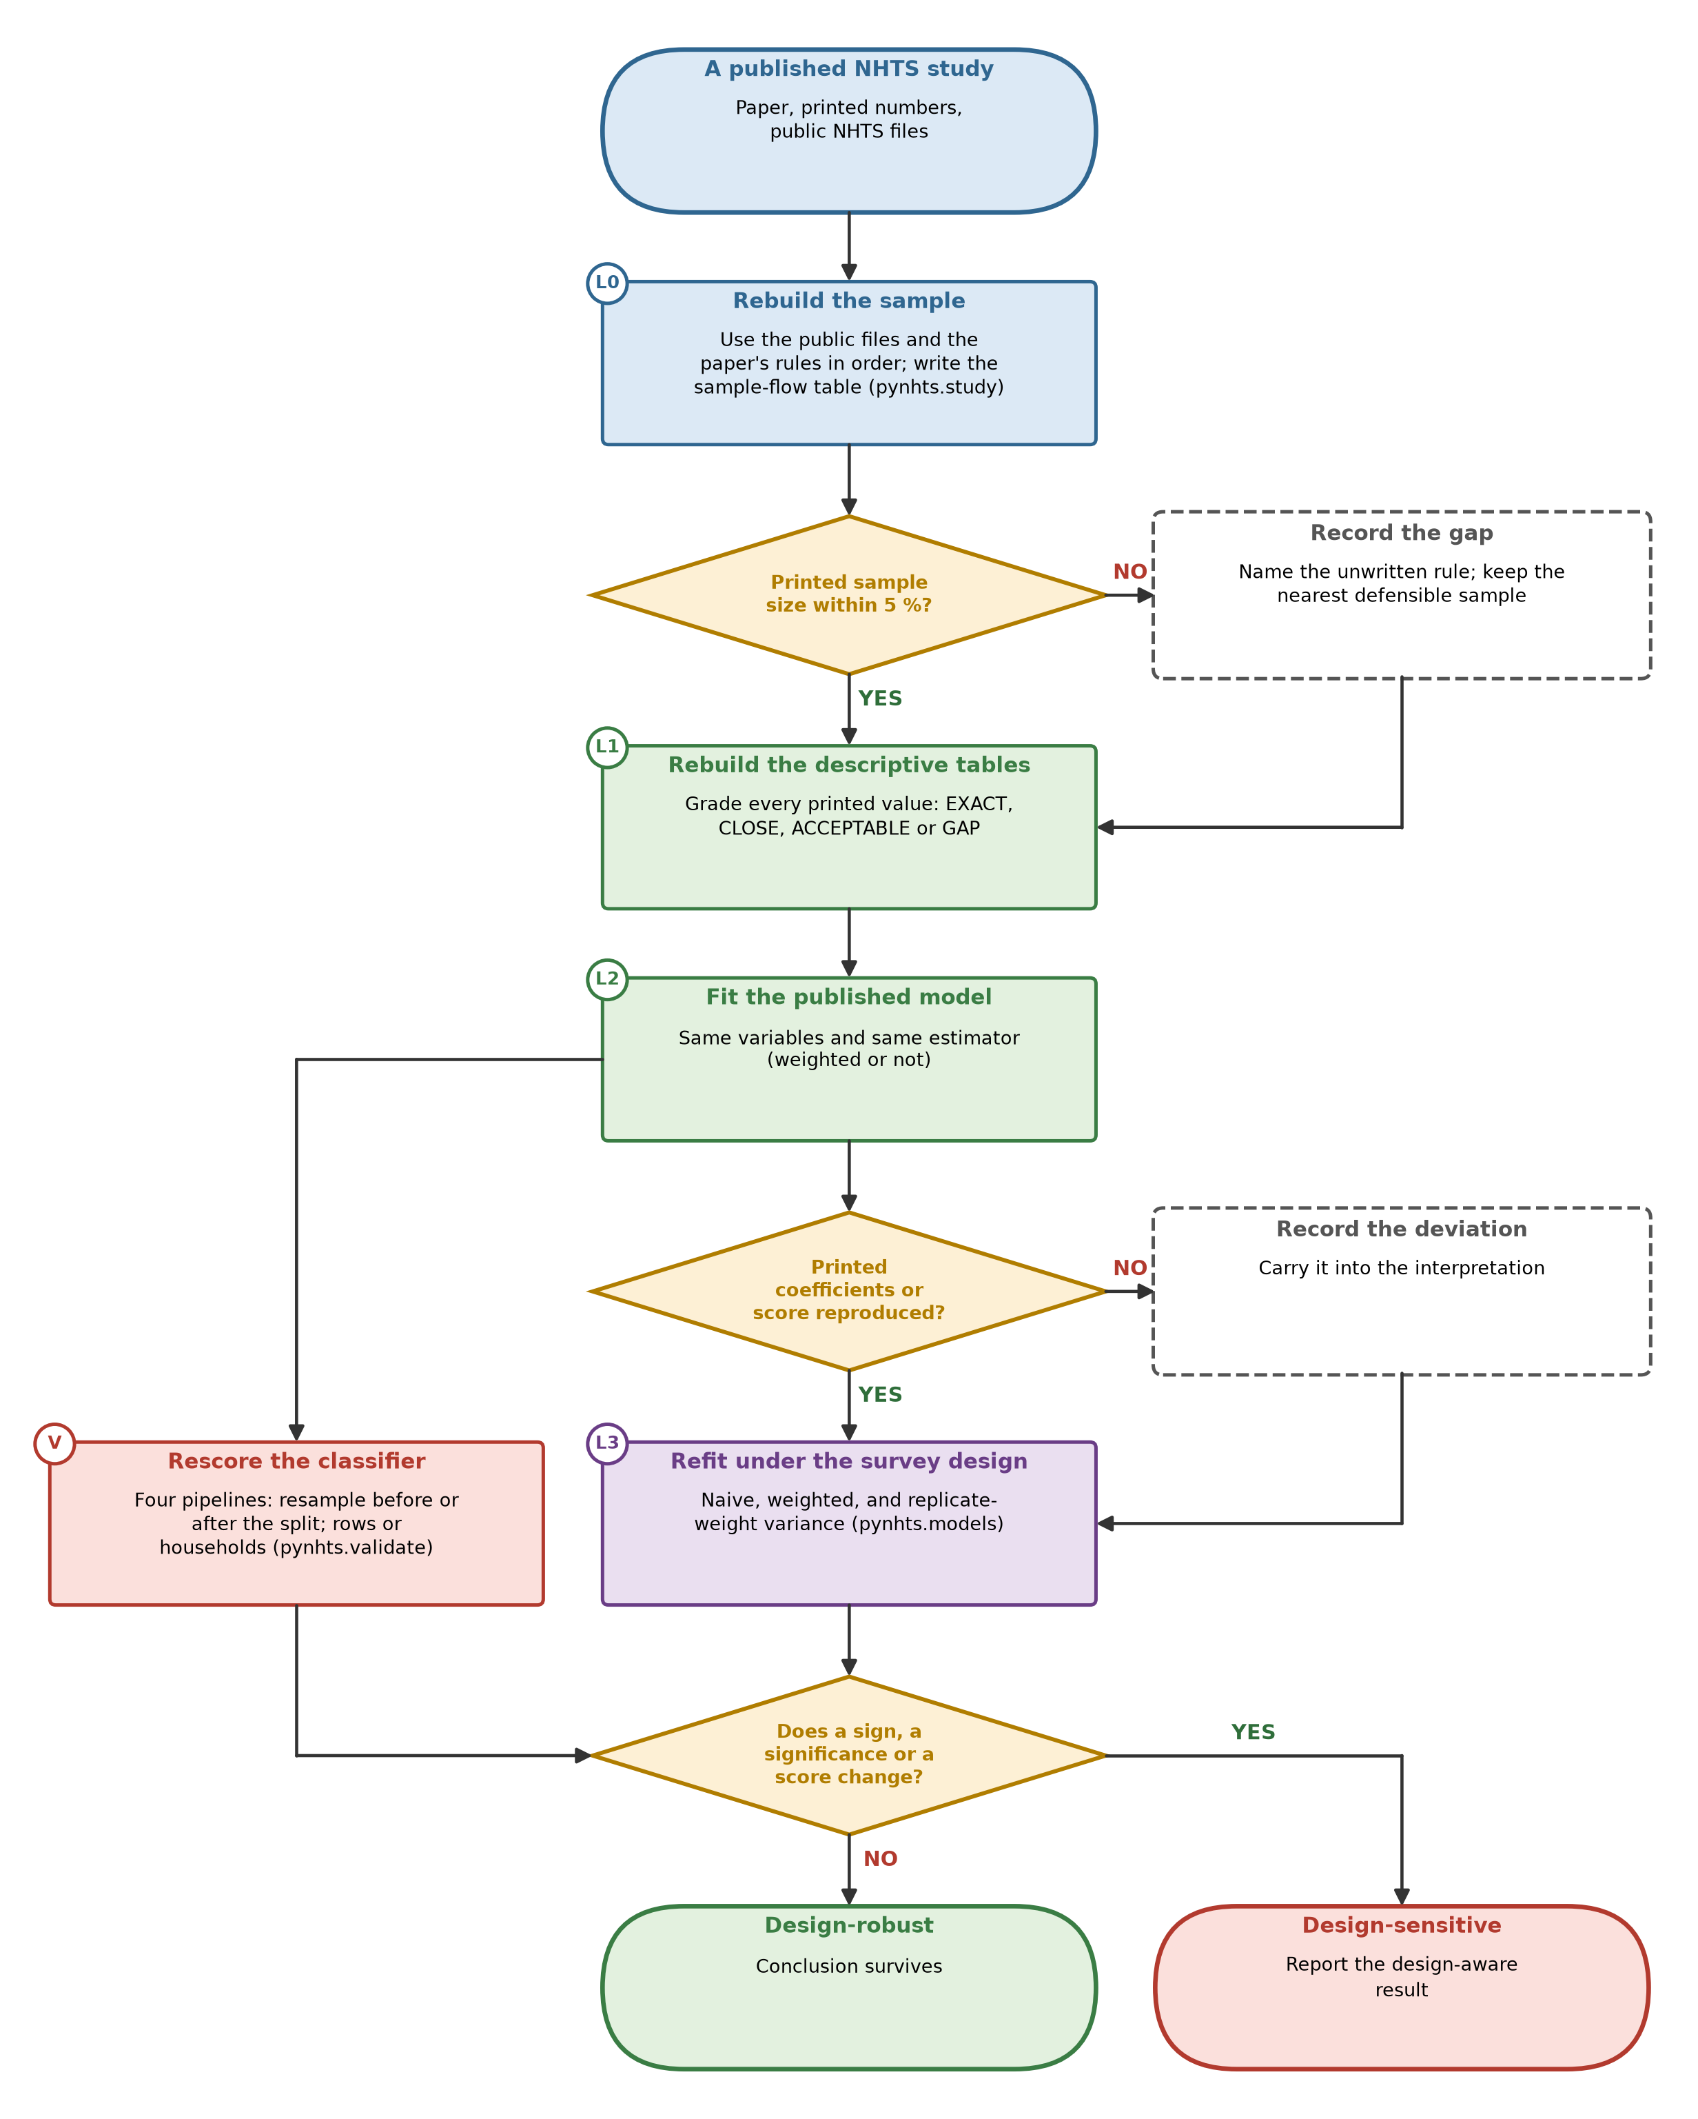
Figure 1: Method of the paper. Rungs L0 to L3 are applied to each published study; the box V rescoring a classifier applies to machine-learning studies. Diamonds are decisions; dashed boxes record what is carried forward.

Three ways to fit the same model
Each regression was fitted three ways. The unweighted fit uses maximum likelihood with model-based standard errors, which is what most of the studies report. The weighted fit uses the person, household or person-day weight of the observation (scaled to the sample size for estimation) with a sandwich variance in which observations of the same household form one cluster. The design-aware fit uses the same weighted estimate with the variance design of the wave. For the waves with replicate weights this is the jackknife: the model is refitted with each of the $R$ replicate weights $w_{r}$, and the variance of a coefficient $\hat{β}$ is
$$\hat{V}(\hat{β})=f\sum_{r=1}^{R}{{\left({\hat{β}}_{r}−\hat{β}\right)}^{2}},$$
with $R=$ 98 and $f=6/7$ for 2017, $R=$ 100 and $f=99/100$ for 2009, and $R=$ 99 and $f=98/99$ for 2001, as in the User’s Guides. Logistic, linear and Poisson regressions are refitted exactly from warm starts. Negative binomial and zero-inflated negative binomial regressions, whose refitting takes minutes, use Newton steps from the full-sample optimum, a step that we checked against exact refits. The count-model likelihoods and their gradients are our own, checked against finite differences and against the statsmodels library (Lambert, 1992; Zeileis et al., 2008). As an independent check, the logistic, Poisson and linear fits on adults of the 2017 person file were compared with the survey package in R (a replicate-weight design with the same factor): coefficients agreed to one part in one hundred thousand and standard errors to 0.2 per cent. The regime in which a study’s printed numbers were reproduced is reported as its declared estimator.

Models of the case studies
Eight published regression studies were refitted: logistic regression of walking and cycling (two studies); ordinary least squares with fixed effects for vehicle make, state and density (one); negative binomial regression of daily trips (two); and zero-inflated negative binomial regression of monthly shared-mobility use (three). A structural equation model with two latent propensities, a propensity-score matching of ride-hailing user groups, a gradient-boosting regression of household online shopping and five classifiers of alternative-fuel and electric vehicle adoption complete the set. Where a printed coefficient table exists, each printed coefficient is a target of L2; where only a headline is printed (the public-transit effect in two ZINB studies, the elasticity in the OLS study), that headline is the target, and where it was derived from a percentage in the abstract this is stated in the supplement.

Machine-learning models, validation designs and tuning
Five classifiers were re-run on the sample of 30,511 new-vehicle owners in 27,413 households, with the outcome alternative-fuel vehicle (AFV, 1,236 owners) or electric vehicle (EV, 389 owners). The sample rule (newest vehicle of each main driver, at most two model years old, complete key variables) was recovered from the printed sample size and is slightly smaller than the printed one. The models are explained in Table 2. Logistic regression turns a weighted sum of the inputs into a probability; the naive Bayes classifier assumes each input to be bell-shaped within a class and independent of the others; a decision tree asks a sequence of yes/no questions on the inputs; a random forest averages the votes of many trees grown on random parts of the data; and a support vector machine with a radial kernel separates the classes with a smooth boundary built from the training points nearest to it. A sixth family, gradient boosting, which adds small trees one after another so that each corrects the errors of the sum of the earlier ones, was used for the household-level online-shopping regression together with linear regression, a support vector regression and a random forest. These four regression models were not tuned: they were run with fixed, documented settings, those printed in the study where it printed them (cost ten and kernel width one hundredth for the support vector regression, a minimum leaf of twenty-five rows for the forest), because the question was whether the printed scores can be approached with the printed settings.
Table 2: The five classifiers and the search space of their settings (the same ten-trial random search for every model).
Model | Idea in plain words | Searched hyper-parameters (ten random trials each)
LR | Logistic regression: a weighted sum of the inputs turned into a probability | penalty strength C (0.001-100, log scale); penalty type (L1 or L2)
NB | Gaussian naive Bayes: each input is assumed bell-shaped within each class and independent of the others | variance floor (1e-11 to 1e-3, log scale)
DT | Decision tree: a sequence of yes/no questions on the inputs that ends in a leaf with a class | maximum depth (3, 5, 8, 12, 20); minimum leaf size (1, 5, 20, 50); split criterion (Gini or entropy)
RF | Random forest: many trees grown on random parts of the data whose votes are averaged | number of trees (50, 100, 200); maximum depth (5, 10, 20, 40); minimum leaf size (1, 2, 5, 20); share of inputs tried per split (0.3, 0.5, 1)
SVM | Support vector machine with a radial kernel: separates the classes with a smooth boundary built from the training points nearest to it | cost C (0.1-100, log scale); kernel width gamma (0.001-1, log scale); trained on at most 12,000 rows

Every model was tuned alike. The search space of every model is given in Table 2. The search method is random search with the same budget (ten trials) for every model; each trial is scored by three-fold validation inside the training rows, grouped by household in the pipelines that split by household and by row in those that split by row, with oversampling inside the inner training folds only when the pipeline oversamples after the split; the criterion is the area under the receiver operating characteristic curve. The selected configuration is refitted on all training rows and scored once on the held-out rows (nested validation). The experiment was run with two master seeds. The four pipelines differ only in where the oversampling happens and in what is split. In oversample, then split rows the rarer class is oversampled on the whole file by interpolating between near neighbours (Chawla et al., 2002), and the rows are then split at random; in split rows, then oversample the split comes first and only the training rows are oversampled; in split households, then oversample every household lies wholly on one side; and in split households, no oversampling the training rows are used as they are and the held-out score is weighted by the survey weight. About 9,189 rows, from about 27,413 households, are held out in every split of the household designs (Table 3), and the frequency histogram of the rare class in all, training and held-out rows is in Figure 8 of the supplementary material. Because the held-out households are a random subset of all households, the designs test generalisation to new households within the same sample; no held-out group lies outside the range of the training groups, so none is an extrapolation in the sense of a convex hull. For the regression study, a second design holds out whole states, which is a harder test of transfer.
Table 3: Rows removed and kept in the household split and the share of each vehicle class in them (the frequency of the rare class before and after removal).
Group | Rows | Share AFV | Share EV
All new-vehicle owners | 30,511 | 4.1% | 1.3%
Training households (mean of three splits) | 21,322 | 4.1% | 1.3%
Held-out households (mean of three splits) | 9,189 | 3.9% | 1.3%

Software and reproducibility
All numbers, tables and figures are generated by code from the result files; the text contains no typed result. The analysis code, the engine of the regression regimes and the validation pipelines are in the repository, run by one command, and the regression and validation machinery is part of pynhts (modules pynhts.models and pynhts.validate), with unit tests, a real-data test against R and documentation. The analysis plan, with the hypotheses and thresholds, was written before the models of the second half of the studies were run and is dated.

Results

What could be rebuilt
The ladder is shown in Figure 2. Of the 22 studies, the audit judged the public files sufficient to rebuild the data of 9, partly sufficient for 11, and insufficient for 2, for which the population or sampling rule is not stated. Over all studies, 879 of 1,454 printed descriptive values were reproduced exactly at the printed precision, and 81 per cent exactly or within two per cent. The gaps came mostly from the papers: unstated rules for dropping records, arithmetic that does not add up inside a table, and variables that are not in the public file. 13 studies could be taken to the model rung; for the others the reasons are listed in Table 1.
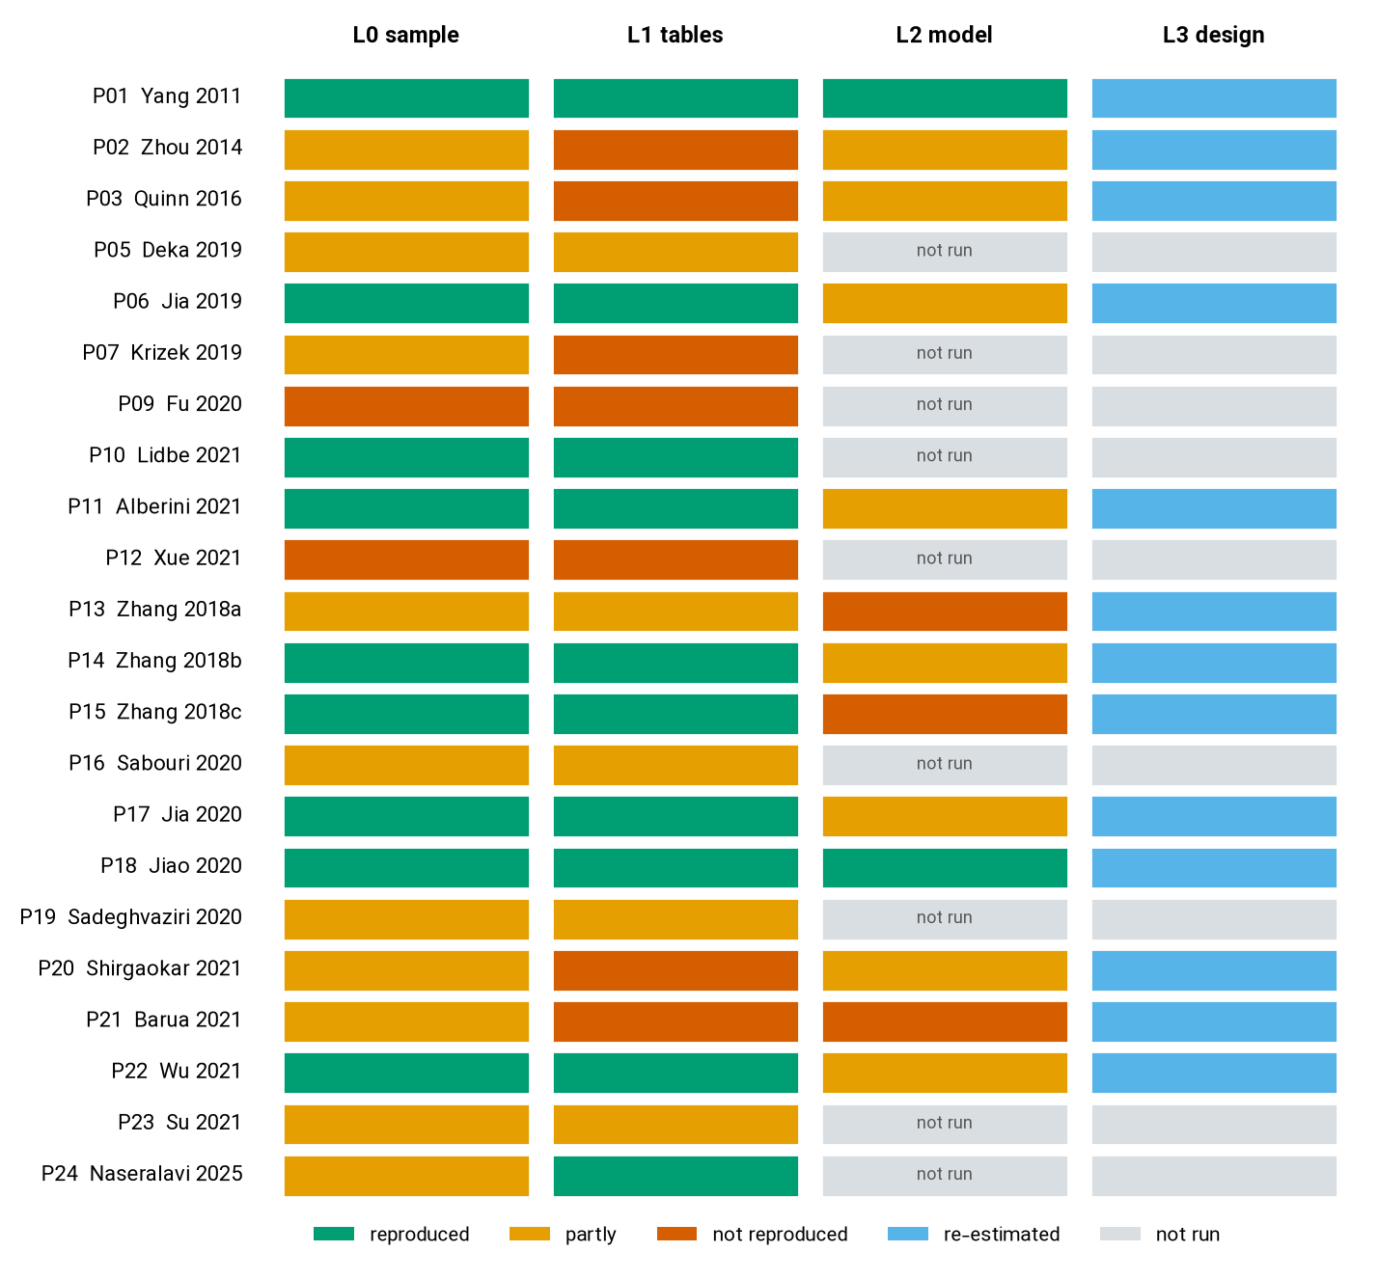
Figure 2: The ladder for the 22 studies. Each row is a study, each column a rung; colours give the grade. The L3 column shows which models were re-estimated, not a grade.

The declared estimator reproduces the printed numbers
Studies that declared weights were reproduced with weights, and those that did not, without. In the study of walking and cycling by Quinn and colleagues, which states that population weights and the jackknife were used, the weighted odds ratios matched 34 of 60 printed values and the unweighted ones 5; for the two commuting models, 29 of 30 matched to the printed precision or within two per cent. In the study of physical activity by season, the weighted odds ratios matched 21 of 21 printed values and the unweighted ones 6. In the other direction, the negative binomial study of shared mobility and trips, which reports an unweighted fit in R, was reproduced by the unweighted fit: 21 of 32 coefficients matched at the printed precision. The zero-inflated negative binomial study of vehicle ownership and ridesharing was reproduced by the unweighted fit within two per cent for 17 of 32 coefficients and within five per cent for 26. The elasticity of annual miles with respect to fuel cost per mile in the study of vehicle miles was −0.515 against the printed −0.510. These results support the first hypothesis: the printed numbers are recoverable from the public files when the declared estimator is used, and not otherwise.
The estimator matters for the substance, not only for the match. The most striking case is the education effect on cycling to work. The printed odds ratio for a graduate degree compared with the lowest education group is 0.41, the weighted fit gives 0.41, and the unweighted fit gives 1.71: the sign of the association with education reverses (Figure 3, reference letter H). The same is true for the Midwest effect on active travel in 2001, with printed 0.67, weighted 0.67 and unweighted 0.83. Weights are informative about the outcome in these data, because response and selection vary with age, education and region, and an unweighted fit estimates the association in the sample, not in the population.
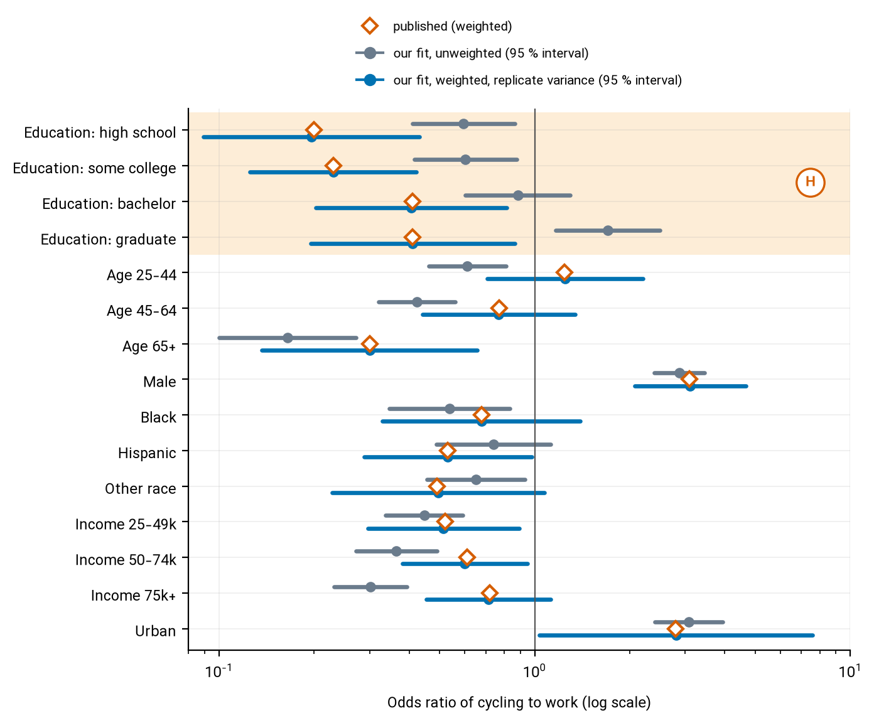
Figure 3: Odds ratios of cycling to work in the study of Quinn and colleagues: printed, our unweighted fit and our weighted fit with replicate-weight variance. The shaded rows (reference letter H) are the education effects discussed in the text.

Standard errors and significance
Across the 310 re-estimated coefficients of eight regression studies, the design-aware standard error was larger than the unweighted one by a median factor of 2.19 (interquartile range 1.86 to 2.66); for 95 per cent of the coefficients the factor exceeded one and a half (Figure 4, panel A). Of the 244 coefficients that were significant at the five per cent level in the unweighted fit, 78 (32 per cent) were not under the design-aware fit, while 11 coefficients became significant; 26 coefficients (8.4 per cent) changed sign between the two fits. The shares differ by study (Figure 4, panel B; Table 4). These results support the second and third hypotheses: the median ratio exceeds one and a half, and more than one tenth of the significant coefficients were not significant under the design.
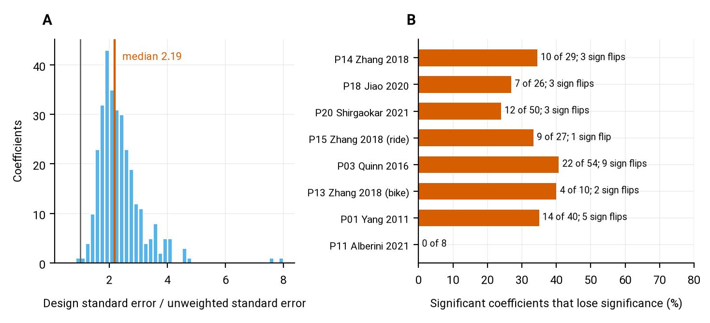
Figure 4: Effect of the survey design on standard errors and significance. Panel A: ratio of the design-aware to the unweighted standard error over all re-estimated coefficients. Panel B: share of coefficients, significant in the unweighted fit, that lose significance under the design-aware fit, by study.

Table 4: Re-estimation of eight regression studies. SE ratio: design standard error over unweighted standard error. Significance lost: coefficients significant at 5 % in the unweighted fit that are not under the design-aware fit. Sign flip: unweighted and design-aware estimates differ in sign.
Study | Coefficients | Printed values reproduced: unweighted / weighted / printed | Median SE ratio | Significance lost | Sign flips
P01 Yang 2011 | 50 | 6 / 21 / 21 | 1.86 | 14 / 40 | 5
P03 Quinn 2016 | 72 | 5 / 34 / 60 | 2.33 | 22 / 54 | 9
P11 Alberini 2021 | 8 | 1 / 0 / 4 | 1.84 | 0 / 8 | 0
P13 Zhang 2018 (bike) | 30 | 0 / 0 / 2 | 1.96 | 4 / 10 | 2
P14 Zhang 2018 | 32 | 17 / 6 / 32 | 2.54 | 10 / 29 | 3
P15 Zhang 2018 (ride) | 30 | 0 / 0 / 2 | 2.42 | 9 / 27 | 1
P18 Jiao 2020 | 32 | 31 / 13 / 32 | 2.45 | 7 / 26 | 3
P20 Shirgaokar 2021 | 56 | 9 / 7 / 14 | 2.43 | 12 / 50 | 3

A concrete example is the negative binomial study of shared mobility and trips. Its conclusion is that ride-hailing use is a significant predictor of daily trips. The coefficient reproduces (0.33 per cent more trips per additional use in the past month on weekdays) and is highly significant in the unweighted fit, with a p-value < 0.001. With the design-aware variance the standard error is 0.0024 instead of 0.0008, and the p-value becomes = 0.17; on weekends it is = 0.11 (Figure 5, reference letter R). The point estimate does not move; the evidence for it does. Bike-sharing, by contrast, is significant on weekdays under both fits. A second example is the number of household vehicles in the ZINB model of ridesharing, which is stable, whereas the effect of being a driver on the count of rides, significant in the unweighted fit (p < 0.001), becomes uncertain under the design-aware fit (p = 0.14).
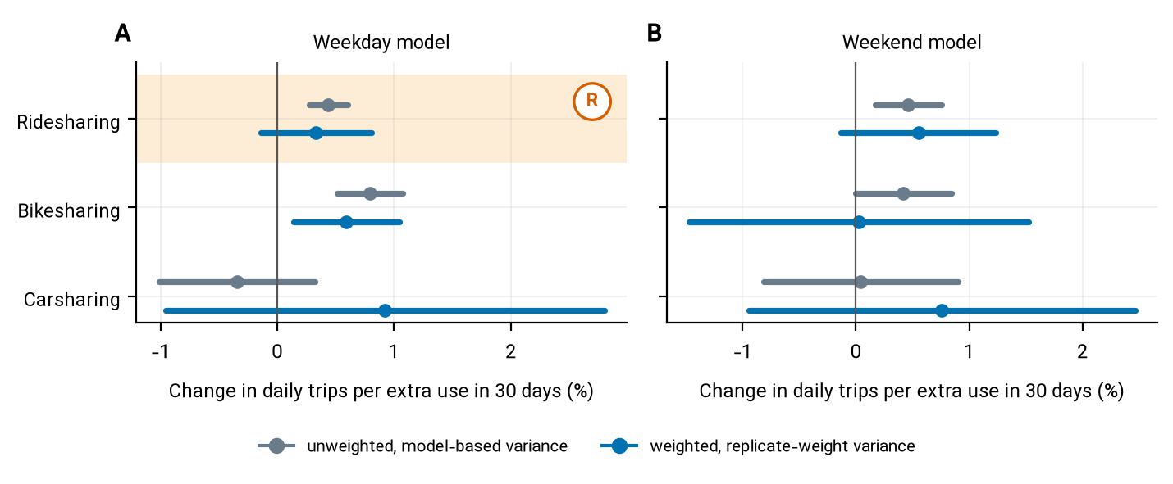
Figure 5: Shared-mobility terms of the weekday (panel A) and weekend (panel B) trip models of Jiao and colleagues, with ninety-five per cent intervals from the unweighted and the design-aware fit. Reference letter R marks the ridesharing row discussed in the text.

Which layer of the design matters
The design-aware fit differs from the unweighted one in three layers: the weights change the estimate; treating persons of a household as a cluster inflates the standard error; and the replicate formula captures the stratification and the remaining structure. Most of the difference in the standard error is due to the second layer. A weighted fit with a household-clustered sandwich variance gave standard errors whose median ratio to the replicate-weight ones was 0.99; of the 182 coefficients significant under that fit, only 16 (9 per cent) lost significance under the replicate variance. In practice, a weighted fit with household-clustered standard errors is a good approximation to the replicate variance in these data, which is useful for the 2022 wave, where no replicate weights exist and the design is expressed through strata and clusters.

Models without a printed coefficient table
The structural equation model of online shopping and shopping trips, which prints standardised coefficients, was fitted with the same variables except two that come from other sources. Its two cross-effects were −0.08 and 0.17 in our weighted fit against 0.12 and 0.21 printed, with design standard errors of about 0.02; signs of exogenous effects agree with the printed ones up to the arbitrary sign of a latent scale, so we grade it as reproduced only qualitatively. For the propensity-score matching study of ride-hailing and vehicle miles, a greedy nearest-neighbour matching in the same strata gave 2,664 matched triples of persons with household vehicle access against about five thousand printed. Matched mean daily miles differed from the printed means (for frequent users 29.8 against 24.8 miles), but the decline in the number of household vehicles when moving from non-users to occasional users was close to the printed one (−0.067 against −0.065). The paired test used in the paper gives a t statistic of 2.45 for this contrast; with the replicate-weight variance it is 0.95. The other two vehicle contrasts have statistics of 0.00 and 1.62 under the design, so none of the three differences in household vehicles is distinguishable from zero in our matched samples under the design.

Machine-learning models
Classifiers of alternative-fuel and electric vehicle adoption showed the largest dependence on the pipeline. When the rarer class was oversampled before the rows were split, the area under the curve of the random forest was 0.99 (alternative-fuel vehicles) and 1.00 (electric vehicles) and of the decision tree 0.98 and 0.99, close to the printed 0.92 and 0.91 (Figure 6, reference letter L). When the split came first, the same models scored 0.64 and 0.73 for the random forest and 0.52 and 0.54 for the tree, and splitting by household did not change this (0.64 and 0.72; weighted by the survey weight, 0.64 and 0.72). The inflation was therefore 0.35 (alternative-fuel) and 0.28 (electric) for the random forest, and 0.45 and 0.46 for the decision tree. The decision tree, which scored 0.98 in the leaky pipeline, is barely better than chance (0.52) when evaluated honestly. This supports the fourth hypothesis: the printed scores can only be approached in a pipeline in which copies of test rows reach the training data. Tuning all models alike did not remove the gap. The tuned random forest scored 0.99 when oversampling came first and 0.66 by household (an inflation of 0.33; for electric vehicles 0.23), and the tuned decision tree rose from 0.52 to 0.63 but stayed far below its leaky score of 0.98. The second master seed gave the same pattern (largest standard deviation of a mean over seeds 0.026).
Table 5: Area under the ROC curve on held-out rows (mean of three seeds for default settings, two for tuned models). Leaky: oversample, then split rows. Rows: split rows, then oversample. Households: split households, then oversample. Weighted: split households, no oversampling, survey-weighted score.
Outcome | Model | Leaky | Rows | Households | Weighted | Tuned, leaky | Tuned, households
Alternative-fuel | LR | 0.69 | 0.67 | 0.67 | 0.68 | 0.69 | 0.67
Alternative-fuel | NB | 0.72 | 0.61 | 0.64 | 0.67 | 0.73 | 0.62
Alternative-fuel | DT | 0.98 | 0.52 | 0.52 | 0.52 | 0.98 | 0.63
Alternative-fuel | RF | 0.99 | 0.64 | 0.64 | 0.64 | 0.99 | 0.66
Alternative-fuel | SVM | 0.91 | 0.60 | 0.62 | 0.57 | 0.97 | 0.65
Electric | LR | 0.78 | 0.75 | 0.77 | 0.77 | 0.78 | 0.77
Electric | NB | 0.81 | 0.73 | 0.74 | 0.76 | 0.81 | 0.74
Electric | DT | 0.99 | 0.54 | 0.53 | 0.54 | 0.99 | 0.69
Electric | RF | 1.00 | 0.73 | 0.72 | 0.72 | 1.00 | 0.77
Electric | SVM | 0.97 | 0.70 | 0.70 | 0.65 | 1.00 | 0.76

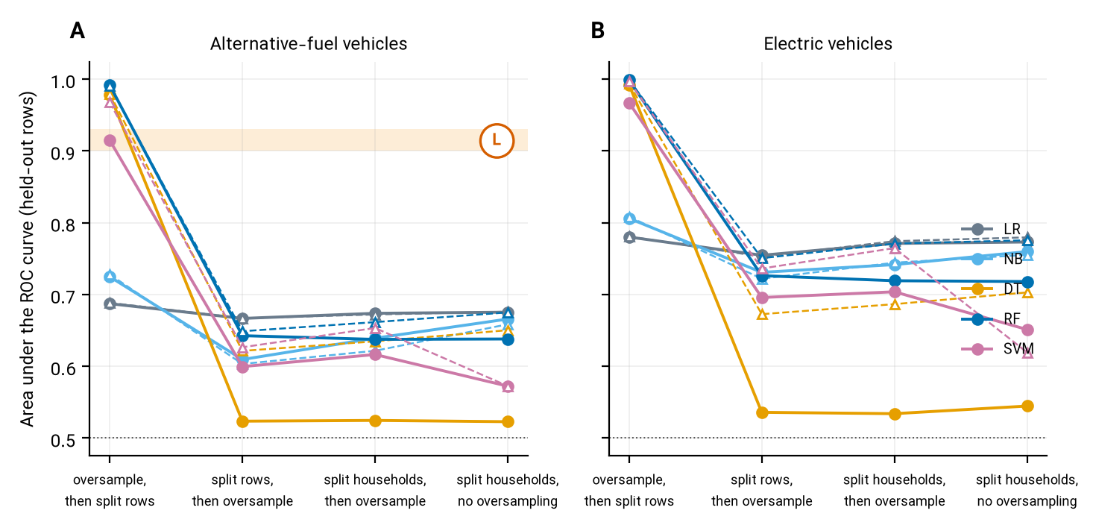
Figure 6: Area under the ROC curve of five classifiers under four pipelines, for alternative-fuel vehicles (panel A) and electric vehicles (panel B). Filled circles: default settings of the first experiment; open triangles: all models tuned alike. Reference letter L marks the printed random-forest score of the study.
The regression study of household online shopping printed held-out R-squared values of 0.71 for gradient boosting in 2017 and 0.72 in 2009. Our boosting model on the public variables that correspond to the printed list reached 0.20 and 0.08 on randomly held-out households and 0.18 when whole states were held out (Figure 7). The gap of about 0.51 is not explained by the validation design; the printed variable table contains percentages above one hundred and a variable listed twice, so we cannot say which variables entered the printed model, and we make no claim about its correctness.
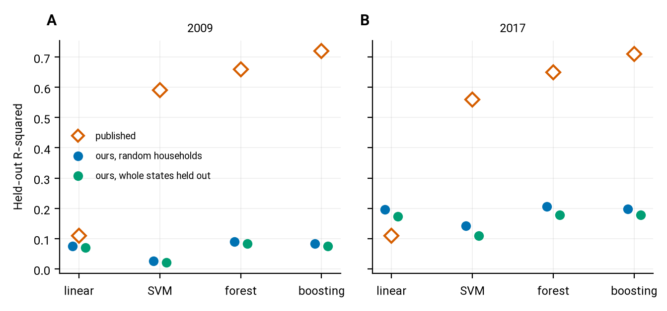
Figure 7: Held-out R-squared of four regression models for household online purchases in 2009 (panel A) and 2017 (panel B): printed values and our values for random and for whole-state hold-out.

Discussion
What the ladder says. For a typical NHTS regression, the printed numbers are recoverable from the public files, provided the reader knows whether the authors weighted, and that is information the paper often has to be read twice to give. The next rung is where the findings move. Median standard errors are about 2.2 times larger under the design, 32 per cent of the significant coefficients lose significance, and 8 per cent change sign. These are not signs of error in the original papers, most of which state what they did; they show that the estimator was a choice with consequences that the article rarely discusses. A reader looking at a significance star in an unweighted NHTS regression is looking at a quantity whose probability statement does not apply to the population the survey describes.
Engineering interpretation. For a planner the question is whether a coefficient can be used to project demand. The ride-hailing example is instructive. A coefficient of about 0.3 per cent more trips per additional use is small, and its sign would not change under any regime, but its significance, on which the paper’s headline rests, does. An unweighted result that holds only in the sample of respondents is a description of respondents; a design-aware result carries the uncertainty that a forecast needs. For the vehicle-miles matching study the conclusion that people change household vehicles as they shift from non-use to frequent use is not supported by our matched samples under the design, which means that the qualitative story about vehicle shedding rests on a sample-level test. Neither conclusion is refuted; both lose the support that an unweighted test gave them.
Why the design effect arises mostly from clustering. Persons of a household share location, income, vehicles and travel opportunities, so the effective sample size for a household-level regressor is smaller than the number of rows. Replicate weights add the stratification and the unequal selection, but with this survey the clustering by household accounts for almost the entire correction. That is encouraging for users of the 2022 wave, who must work with strata and clusters instead of replicate weights, and a practical rule: whenever replicate weights are not an option, cluster at the household level and weight.
The prediction scores. The scores printed for the classifiers of vehicle adoption can only be approached in a pipeline in which synthetic copies of a test row reach the training data, a leak documented in other fields (Demircioğlu, 2024; Kapoor and Narayanan, 2023). We cannot know from the papers which order was used, and our result does not prove that the original pipeline leaked; it shows that the printed numbers are in the leaky range. A reader can check the claim with pynhts.validate.audit_classifier, which takes a few seconds. When the data are split by household and only the training rows are oversampled, a random forest of alternative-fuel adoption, about as accurate as logistic regression (0.64 and 0.67), has an area under the curve that is modest, which is worth knowing before using the model to target adoption policy. The regression-score gap of the online shopping study is of another kind: the validation design cannot explain it, and without the printed variable definitions it remains unexplained.
Implications for the package. The study required three tools that did not exist in the package: a regression that returns weighted estimates with the wave’s variance design, a check of prediction pipelines for leakage, and a way to compare a printed number with a rebuilt one. The first two are released in pynhts as pynhts.models and pynhts.validate, validated against R and with tests, and the rules of the package’s agent guide now say to use them. Three further developments follow from the evidence and are planned: a formula interface and ordinal and multinomial families for the discrete-choice papers that the present set does not include; household-level multilevel models with partial pooling for regional comparisons; and a library of replication recipes, one per published study, so that the registered gaps become regression tests that any user can run.
Limitations. The case-study set is a convenience set of 22 studies, and 13 of them were refitted; the share of fragile conclusions among all NHTS papers is therefore not estimated. For two studies the printed target is a headline derived from a percentage in the abstract, and the grading of those is approximate. Our unweighted fits reproduce some printed values only approximately because the published samples cannot be rebuilt exactly. The matching study was repeated with a greedy matching, not the optimal matching of the original. The ML experiments use five classifiers with ten tuning trials each, a modest search that makes the comparison fair but not exhaustive; the published models may have been tuned further. The survey has no replicate weights in 2022, so the design-aware fit there would use linearisation, which is implemented in the package but not exercised in this paper. Finally, we describe conclusions as design-sensitive; we do not say they are wrong.
Recommendations. For authors: state whether weights were used and why; report the standard error from the survey design or, when only strata and clusters are available, with household-clustered errors; and give the sample-flow table with the number of records removed by each rule. For prediction models: split by household before anything else, oversample only the training rows, report a weighted score, and tune every model alike. For reviewers: a significance star from an unweighted NHTS regression and an area under the curve from a random split of oversampled rows should each trigger a question.

Conclusions
A four-rung reproducibility ladder with design-aware re-estimation turns a general worry about survey-based transport research into numbers. On 22 published NHTS studies, the printed numbers were recoverable when the declared estimator was used; standard errors were about 2.2 times larger under the survey design; 32 per cent of the coefficients that were significant without the design were not; and printed prediction scores of vehicle adoption were reproduced only in a pipeline in which test rows leak into training. The household-clustered sandwich variance recovered most of the replicate-weight correction. The machinery is released as pynhts.models and pynhts.validate, so that other researchers can run the same check on their own analyses.

Declarations
Declaration of generative AI and AI-assisted technologies in the manuscript preparation process. During the preparation of this work the author used Claude (Anthropic) as an assistant for study planning, writing and running analysis code, literature screening, and drafting and editing the text. After using this tool, the author reviewed, verified and edited the material (code, results, references and text) and takes full responsibility for the content of the publication. Numbers in the text are injected by code from the result files, and the references were checked against bibliographic databases.
Competing interests. The author developed the pynhts package whose modules are described here and is the author of one of the case-study papers; that paper was included in the register and not re-estimated. [[AUTHOR-TODO: confirm the standard competing-interests sentence and any co-authors.]]
Funding. This research did not receive any specific grant from funding agencies in the public, commercial, or not-for-profit sectors. [[AUTHOR-TODO: confirm.]]
Data and code availability. The NHTS public-use files are available from the survey’s website. The code, result tables and the package are in the open repository of pynhts (https://github.com/sabernaseralavi-60/pynhts), archived with a persistent identifier on Zenodo.

References
Alberini, A., Teja Burra, L., Cirillo, C., Shen, C., 2021. Counting vehicle miles traveled: What can we learn from the NHTS? Transportation Research Part D: Transport and Environment 98, 102984. https://doi.org/10.1016/j.trd.2021.102984
Barua, L., Zou, B., Zhou, Y., Liu, Y., 2021. Modeling household online shopping demand in the u.s.: A machine learning approach and comparative investigation between 2009 and 2017. Transportation 50, 437–476. https://doi.org/10.1007/s11116-021-10250-z
Birrell, C.L., Steel, D.G., Batterham, M.J., Arya, A., 2019. How to use replicate weights in health survey analysis using the national nutrition and physical activity survey as an example. Public Health Nutrition 22, 3315–3326. https://doi.org/10.1017/s1368980019001927
Blagus, R., Lusa, L., 2013. SMOTE for high-dimensional class-imbalanced data. BMC Bioinformatics 14, 106. https://doi.org/10.1186/1471-2105-14-106
Bollen, K.A., Biemer, P.P., Karr, A.F., Tueller, S., Berzofsky, M.E., 2016. Are survey weights needed? A review of diagnostic tests in regression analysis. Annual Review of Statistics and Its Application 3, 375–392. https://doi.org/10.1146/annurev-statistics-011516-012958
Chawla, N.V., Bowyer, K.W., Hall, L.O., Kegelmeyer, W.P., 2002. SMOTE: Synthetic minority over-sampling technique. Journal of Artificial Intelligence Research 16, 321–357. https://doi.org/10.1613/jair.953
Conway, M.W., Salon, D., King, D.A., 2018. Trends in taxi use and the advent of ridehailing, 1995–2017: Evidence from the US national household travel survey. Urban Science 2, 79. https://doi.org/10.3390/urbansci2030079
Deka, D., Fei, D., 2019. A comparison of the personal and neighborhood characteristics associated with ridesourcing, transit use, and driving with NHTS data. Journal of Transport Geography 76, 24–33. https://doi.org/10.1016/j.jtrangeo.2019.03.001
Demircioğlu, A., 2024. Applying oversampling before cross-validation will lead to high bias in radiomics. Scientific Reports 14, 11563. https://doi.org/10.1038/s41598-024-62585-z
Fu, Z., Liu, W., Zhu, J., Yuan, Y., 2020. Trip chain simulation of electric vehicles based on NHTS data. 2020 12th IEEE PES Asia-Pacific Power and Energy Engineering Conference (APPEEC) 1–6. https://doi.org/10.1109/appeec48164.2020.9220726
Gard, A.M., Hyde, L.W., Heeringa, S.G., West, B.T., Mitchell, C., 2023. Why weight? Analytic approaches for large-scale population neuroscience data. Developmental Cognitive Neuroscience 59, 101196. https://doi.org/10.1016/j.dcn.2023.101196
Gelman, A., 2007. Struggles with survey weighting and regression modeling. Statistical Science 22, 153–164. https://doi.org/10.1214/088342306000000691
Hagenauer, J., Helbich, M., 2017. A comparative study of machine learning classifiers for modeling travel mode choice. Expert Systems with Applications 78, 273–282. https://doi.org/10.1016/j.eswa.2017.01.057
Hardwicke, T.E., Bohn, M., MacDonald, K., Hembacher, E., Nuijten, M.B., Peloquin, B.N., deMayo, B.E., Long, B., Yoon, E.J., Frank, M.C., 2021. Analytic reproducibility in articles receiving open data badges at the journal psychological science : An observational study. Royal Society Open Science 8, 201494. https://doi.org/10.1098/rsos.201494
Hörl, S., Balac, M., 2021. Synthetic population and travel demand for paris and île-de-france based on open and publicly available data. Transportation Research Part C: Emerging Technologies 130, 103291. https://doi.org/10.1016/j.trc.2021.103291
Jia, J., 2019. Analysis of alternative fuel vehicle (AFV) adoption utilizing different machine learning methods: A case study of 2017 NHTS. IEEE Access 7, 112726–112735. https://doi.org/10.1109/ACCESS.2019.2934780
Jia, J., Shi, B., Che, F., Zhang, H., 2020. Predicting the regional adoption of electric vehicle (EV) with comprehensive models. IEEE Access 8, 147275–147285. https://doi.org/10.1109/ACCESS.2020.3014851
Jiao, J., Bischak, C., Hyden, S., 2020. The impact of shared mobility on trip generation behavior in the US: Findings from the 2017 national household travel survey. Travel Behaviour and Society 19, 1–7. https://doi.org/10.1016/j.tbs.2019.11.001
Kapoor, S., Cantrell, E.M., Peng, K., Pham, T.H., Bail, C.A., Gundersen, O.E., Hofman, J.M., Hullman, J., Lones, M.A., Malik, M.M., Nanayakkara, P., Poldrack, R.A., Raji, I.D., Roberts, M., Salganik, M.J., Serra-Garcia, M., Stewart, B.M., Vandewiele, G., Narayanan, A., 2024. REFORMS: Consensus-based recommendations for machine-learning-based science. Science Advances 10, eadk3452. https://doi.org/10.1126/sciadv.adk3452
Kapoor, S., Narayanan, A., 2023. Leakage and the reproducibility crisis in machine-learning-based science. Patterns 4, 100804. https://doi.org/10.1016/j.patter.2023.100804
Krizek, K.J., McGuckin, N., 2019. Shedding NHTS light on the use of “little vehicles” in urban areas. Transport Findings. https://doi.org/10.32866/10777
Lambert, D., 1992. Zero-inflated poisson regression, with an application to defects in manufacturing. Technometrics 34, 1. https://doi.org/10.2307/1269547
Lidbe, A., Adanu, E.K., Penmetsa, P., Jones, S., 2021. Changes in the travel patterns of older americans with medical conditions: A comparison of 2001 and 2017 NHTS data. Transportation Research Interdisciplinary Perspectives 11, 100463. https://doi.org/10.1016/j.trip.2021.100463
Lumley, T., 2004. Analysis of complex survey samples. Journal of Statistical Software 9. https://doi.org/10.18637/jss.v009.i08
Martín-Baos, J.Á., López-Gómez, J.A., Rodriguez-Benitez, L., Hillel, T., García-Ródenas, R., 2023. A prediction and behavioural analysis of machine learning methods for modelling travel mode choice. Transportation Research Part C: Emerging Technologies 156, 104318. https://doi.org/10.1016/j.trc.2023.104318
Naseralavi, S., Soltanirad, M., Ranjbar, E., Lucero, M., Gorzin, F., Hakiminejad, Y., Azimi, S., Baghersad, M., Mazaheri, A., 2025. Machine learning modeling of household trip generation by state using NHTS data. Urban Science 9, 353. https://doi.org/10.3390/urbansci9090353
Peng, R.D., 2011. Reproducible research in computational science. Science 334, 1226–1227. https://doi.org/10.1126/science.1213847
Ploton, P., Mortier, F., Réjou-Méchain, M., Barbier, N., Picard, N., Rossi, V., Dormann, C., Cornu, G., Viennois, G., Bayol, N., Lyapustin, A., Gourlet-Fleury, S., Pélissier, R., 2020. Spatial validation reveals poor predictive performance of large-scale ecological mapping models. Nature Communications 11, 4540. https://doi.org/10.1038/s41467-020-18321-y
Quinn, T.D., Jakicic, J.M., Fertman, C.I., Barone Gibbs, B., 2016. Demographic factors, workplace factors and active transportation use in the USA: A secondary analysis of 2009 NHTS data. Journal of Epidemiology and Community Health 71, 480–486. https://doi.org/10.1136/jech-2016-207820
Roberts, D.R., Bahn, V., Ciuti, S., Boyce, M.S., Elith, J., Guillera‐Arroita, G., Hauenstein, S., Lahoz‐Monfort, J.J., Schröder, B., Thuiller, W., Warton, D.I., Wintle, B.A., Hartig, F., Dormann, C.F., 2017. Cross‐validation strategies for data with temporal, spatial, hierarchical, or phylogenetic structure. Ecography 40, 913–929. https://doi.org/10.1111/ecog.02881
Rosenblatt, M., Tejavibulya, L., Jiang, R., Noble, S., Scheinost, D., 2024. Data leakage inflates prediction performance in connectome-based machine learning models. Nature Communications 15, 1829. https://doi.org/10.1038/s41467-024-46150-w
Rust, K., Rao, J., 1996. Variance estimation for complex surveys using replication techniques. Statistical Methods in Medical Research 5, 283–310. https://doi.org/10.1177/096228029600500305
Sabouri, S., Brewer, S., Ewing, R., 2020. Exploring the relationship between ride-sourcing services and vehicle ownership, using both inferential and machine learning approaches. Landscape and Urban Planning 198, 103797. https://doi.org/10.1016/j.landurbplan.2020.103797
Sadeghvaziri, E., Tawfik, A., 2020. Using the 2017 national household travel survey data to explore the elderly’s travel patterns. International Conference on Transportation and Development 2020 86–94. https://doi.org/10.1061/9780784483169.008
Schweinsberg, M., Feldman, M., Staub, N., Akker, O.R. van den, Aert, R.C.M. van, Assen, M.A.L.M. van, Liu, Y., Althoff, T., Heer, J., Kale, A., Mohamed, Z., Amireh, H., Venkatesh Prasad, V., Bernstein, A., Robinson, E., Snellman, K., Amy Sommer, S., Otner, S.M.G., Robinson, D., Madan, N., Silberzahn, R., Goldstein, P., Tierney, W., Murase, T., Mandl, B., Viganola, D., Strobl, C., Schaumans, C.B.C., Kelchtermans, S., Naseeb, C., Mason Garrison, S., Yarkoni, T., Richard Chan, C.S., Adie, P., Alaburda, P., Albers, C., Alspaugh, S., Alstott, J., Nelson, A.A., Ariño de la Rubia, E., 2021. Same data, different conclusions: Radical dispersion in empirical results when independent analysts operationalize and test the same hypothesis. Organizational Behavior and Human Decision Processes 165, 228–249. https://doi.org/10.1016/j.obhdp.2021.02.003
Shirgaokar, M., Nobler, E., 2021. Differences in daily trips between immigrants and US-born individuals: Implications for social integration. Transport Policy 105, 103–114. https://doi.org/10.1016/j.tranpol.2021.03.008
Silberzahn, R., Uhlmann, E.L., Martin, D.P., Anselmi, P., Aust, F., Awtrey, E., Bahník, Š., Bai, F., Bannard, C., Bonnier, E., Carlsson, R., Cheung, F., Christensen, G., Clay, R., Craig, M.A., Dalla Rosa, A., Dam, L., Evans, M.H., Flores Cervantes, I., Fong, N., Gamez-Djokic, M., Glenz, A., Gordon-McKeon, S., Heaton, T.J., Hederos, K., Heene, M., Hofelich Mohr, A.J., Högden, F., Hui, K., Johannesson, M., Kalodimos, J., Kaszubowski, E., Kennedy, D.M., Lei, R., Lindsay, T.A., Liverani, S., Madan, C.R., Molden, D., Molleman, E., Morey, R.D., 2018. Many analysts, one data set: Making transparent how variations in analytic choices affect results. Advances in Methods and Practices in Psychological Science 1, 337–356. https://doi.org/10.1177/2515245917747646
Simonsohn, U., Simmons, J.P., Nelson, L.D., 2020. Specification curve analysis. Nature Human Behaviour 4, 1208–1214. https://doi.org/10.1038/s41562-020-0912-z
Solon, G., Haider, S.J., Wooldridge, J.M., 2015. What are we weighting for? Journal of Human Resources 50, 301–316. https://doi.org/10.3368/jhr.50.2.301
Steegen, S., Tuerlinckx, F., Gelman, A., Vanpaemel, W., 2016. Increasing transparency through a multiverse analysis. Perspectives on Psychological Science 11, 702–712. https://doi.org/10.1177/1745691616658637
Stodden, V., Seiler, J., Ma, Z., 2018. An empirical analysis of journal policy effectiveness for computational reproducibility. Proceedings of the National Academy of Sciences 115, 2584–2589. https://doi.org/10.1073/pnas.1708290115
Su, R., Xiao, J., McBride, E.C., Goulias, K.G., 2021. Understanding senior’s daily mobility patterns in california using human mobility motifs. Journal of Transport Geography 94, 103117. https://doi.org/10.1016/j.jtrangeo.2021.103117
Vabalas, A., Gowen, E., Poliakoff, E., Casson, A.J., 2019. Machine learning algorithm validation with a limited sample size. PLOS ONE 14, e0224365. https://doi.org/10.1371/journal.pone.0224365
Wang, S., Mo, B., Zheng, Y., Hess, S., Zhao, J., 2024. Comparing hundreds of machine learning and discrete choice models for travel demand modeling: An empirical benchmark. Transportation Research Part B: Methodological 190, 103061. https://doi.org/10.1016/j.trb.2024.103061
Wang, X., Shaw, F.A., Mokhtarian, P.L., Watkins, K.E., 2022. ﻿Response willingness in consecutive travel surveys: An investigation based on the national household travel survey using a sample selection model. Transportation 50, 2339–2373. https://doi.org/10.1007/s11116-022-10312-w
Winship, C., Radbill, L., 1994. Sampling weights and regression analysis. Sociological Methods & Research 23, 230–257. https://doi.org/10.1177/0049124194023002004
Wolter, K.M., 2007. Introduction to variance estimation. Statistics for Social; Behavioral Sciences. https://doi.org/10.1007/978-0-387-35099-8
Wu, X., MacKenzie, D., 2021. Assessing the VMT effect of ridesourcing services in the US. Transportation Research Part D: Transport and Environment 94, 102816. https://doi.org/10.1016/j.trd.2021.102816
Xue, C., Wu, Q., Sun, M., Bai, P., Chen, Y., 2021. The interaction between e‐shopping and shopping trips: An analysis with 2017 NHTS. Complexity 2021, 8247158. https://doi.org/10.1155/2021/8247158
Yang, Y., Diez Roux, A.V., Bingham, C.R., 2011. Variability and seasonality of active transportation in USA: Evidence from the 2001 NHTS. International Journal of Behavioral Nutrition and Physical Activity 8, 96. https://doi.org/10.1186/1479-5868-8-96
Zeileis, A., Kleiber, C., Jackman, S., 2008. Regression models for count data in r. Journal of Statistical Software 27. https://doi.org/10.18637/jss.v027.i08
Zhang, Y., Zhang, Y., 2018a. Associations between public transit usage and bikesharing behaviors in the united states. Sustainability 10, 1868. https://doi.org/10.3390/su10061868
Zhang, Y., Zhang, Y., 2018b. Examining the relationship between household vehicle ownership and ridesharing behaviors in the united states. Sustainability 10, 2720. https://doi.org/10.3390/su10082720
Zhang, Y., Zhang, Y., 2018c. Exploring the relationship between ridesharing and public transit use in the united states. International Journal of Environmental Research and Public Health 15, 1763. https://doi.org/10.3390/ijerph15081763
Zhou, Y., Wang, X.(Cara)., 2014. Explore the relationship between online shopping and shopping trips: An analysis with the 2009 NHTS data. Transportation Research Part A: Policy and Practice 70, 1–9. https://doi.org/10.1016/j.tra.2014.09.014

Supplementary material
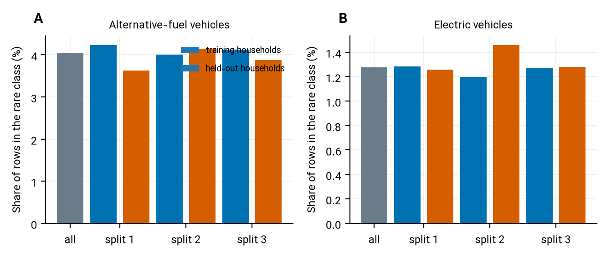
Figure 8: Frequency histogram of the rare class (share of alternative-fuel vehicles, panel A, and of electric vehicles, panel B) in all rows, in the training households and in the held-out households of each of the three splits.

Table 6: Selected hyper-parameters of the tuned models in the household-split pipeline (first master seed). C: cost or penalty strength; vs: variance floor; depth, leaf, crit: tree depth, minimum leaf size, split criterion; n, mf: number of trees and share of inputs per split; gamma: kernel width.
Outcome | Model | Selected values | Inner validation AUC
Alternative-fuel | LR | C = 0.0256, penalty_l1 = False | 0.67
Alternative-fuel | NB | vs = 1.79e-09 | 0.63
Alternative-fuel | DT | depth = 3, leaf = 50, crit = entropy | 0.63
Alternative-fuel | RF | n = 200, depth = 10, leaf = 1, mf = 0.3 | 0.65
Alternative-fuel | SVM | C = 2.59, gamma = 0.00407 | 0.62
Electric | LR | C = 0.0175, penalty_l1 = True | 0.75
Electric | NB | vs = 1.79e-09 | 0.72
Electric | DT | depth = 3, leaf = 50, crit = entropy | 0.68
Electric | RF | n = 200, depth = 10, leaf = 1, mf = 0.3 | 0.74
Electric | SVM | C = 2.59, gamma = 0.00407 | 0.72

