California Housing Price Predictor
End-to-End Machine Learning Project Report
EDA • Feature Engineering • Model Comparison • Deployment
June 2026

1. Problem Statement
Given the characteristics of a California district — its location, demographics, and housing stock — predict the median house value of that district. This is a supervised regression problem: the target is a continuous dollar amount.
Use cases for a model like this include pricing guidance for real-estate platforms, identifying under- or over-valued areas, and understanding which factors drive housing prices.

2. The Dataset
Source: Kaggle — California Housing Prices (camnugent/california-housing-prices), fetched programmatically via the Kaggle API.
It contains 20,640 districts (census “block groups”) from the 1990 US census. Each row describes one district, not one house:
Column | Meaning
longitude, latitude | District location
housing_median_age | Median age of houses in the district
total_rooms, total_bedrooms | Total counts across the whole district
population, households | District population and number of households
median_income | Median household income (in units of $10,000)
ocean_proximity | Category: <1H OCEAN, INLAND, ISLAND, NEAR BAY, NEAR OCEAN
median_house_value | TARGET — median house value in dollars

Two data quirks matter throughout the project:
- total_bedrooms is missing for 207 districts (~1%).
- The target is capped at $500,001 — about 5% of districts sit exactly at that ceiling, so the model can never predict above it accurately.

3. Project Architecture
The project is a pipeline of small, single-purpose scripts rather than one large notebook — easier to read, rerun, and explain:
data_loader.py → eda.py → feature_engineering.py → modeling.py → predict.py → app.py
Path | Contents
data/raw/ | housing.csv (downloaded from Kaggle API)
data/processed/ | train.csv, test.csv (engineered features, stratified split)
src/ | The five pipeline scripts
outputs/figures/ | All EDA and evaluation charts
outputs/models/ | best_model.pkl + preprocessing.json
outputs/reports/ | model_metrics.csv
app.py | Streamlit web application

4. Stage 1 — Data Loading (data_loader.py)
Downloads the dataset through the Kaggle API (authenticated by kaggle.json) into data/raw/housing.csv, then prints shape, dtypes, missing-value counts, and summary statistics. The download happens only once; afterwards the cached CSV is reused. This makes the project fully reproducible — anyone with a Kaggle account can clone the repository and rebuild everything from scratch.

5. Stage 2 — Exploratory Data Analysis (eda.py)
Six figures are generated to understand the data before modeling. The key findings:
- Income is the dominant predictor. Median income has by far the strongest correlation with house value (r ≈ 0.69). Everything else is much weaker individually.
- Location matters, but not linearly. Latitude and longitude alone correlate weakly with price, yet the geographic scatter shows unmistakable expensive clusters around San Francisco Bay and Los Angeles. The signal is joint (where you are), not marginal (how far north) — a hint that tree-based models, which can carve up 2-D space, will beat linear ones.
- Ocean proximity stratifies prices cleanly. INLAND districts are dramatically cheaper than coastal categories — this categorical column carries real signal.
- The target is capped. A visible spike at $500,001 (≈5% of districts) puts a ceiling on achievable accuracy for expensive areas.
- Count features are heavily right-skewed (total_rooms, population, …), suggesting ratios and log transforms will be more informative than raw totals.
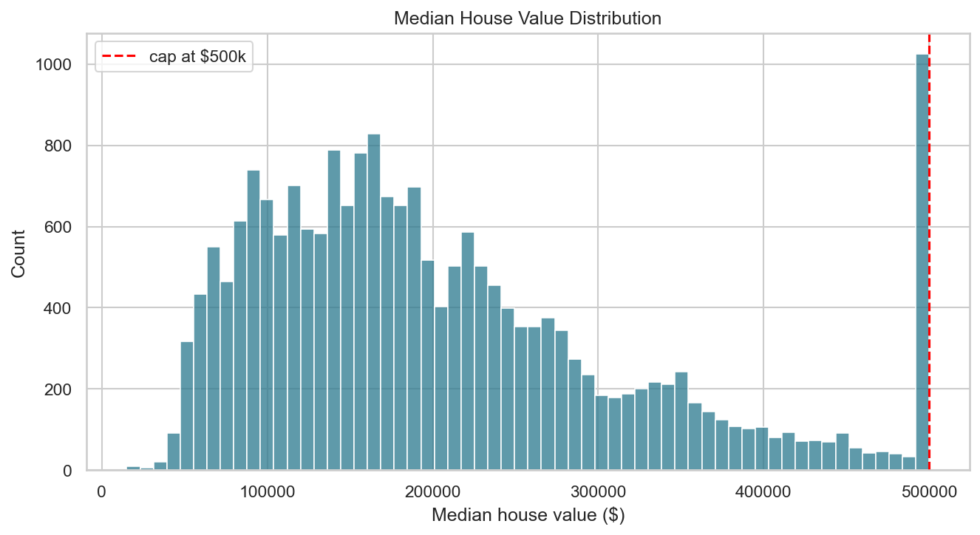
Figure 1 — Target distribution with the $500k cap clearly visible
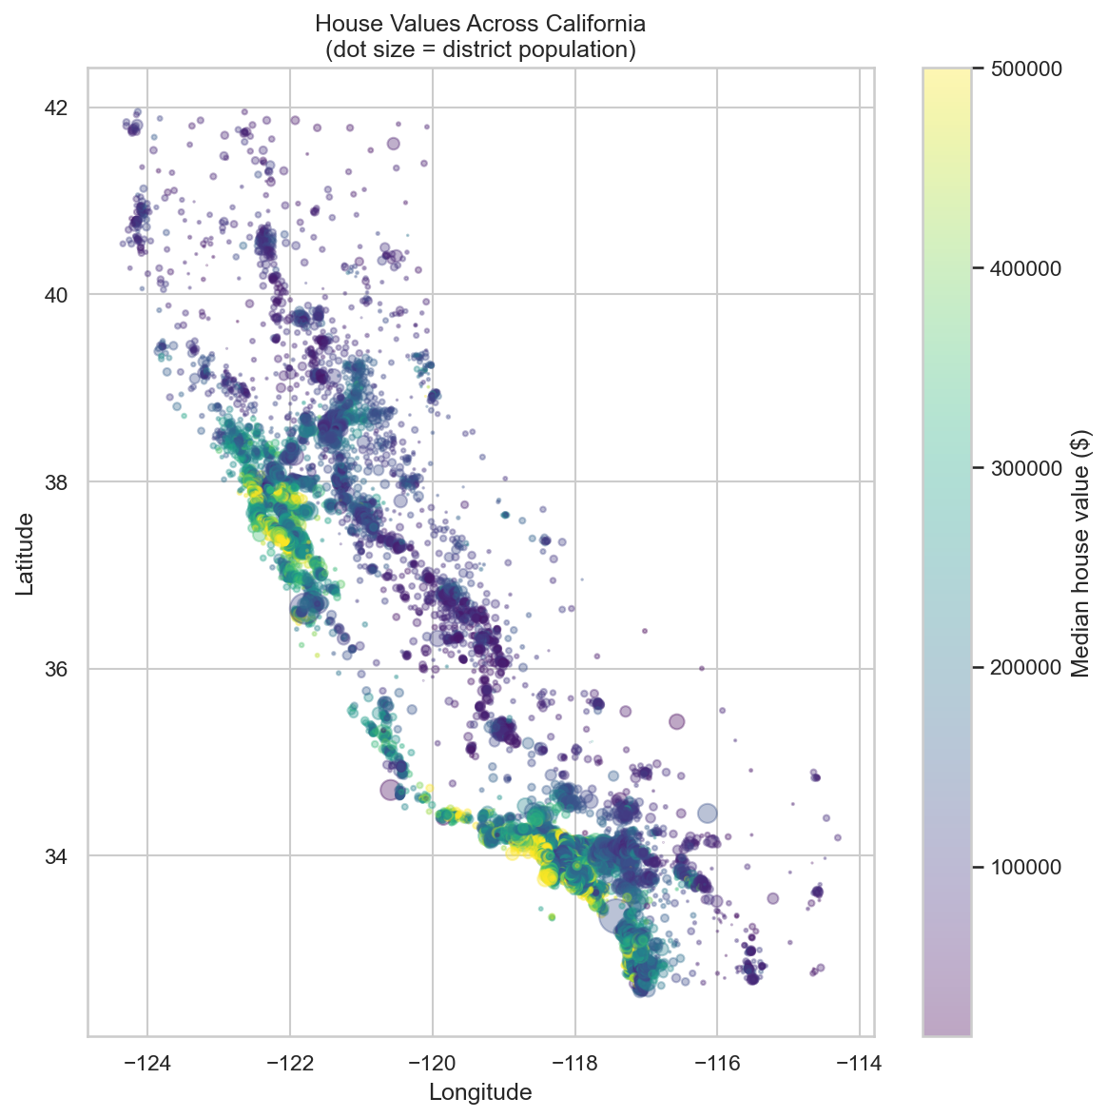
Figure 2 — House values across California; expensive clusters hug the coast around SF and LA
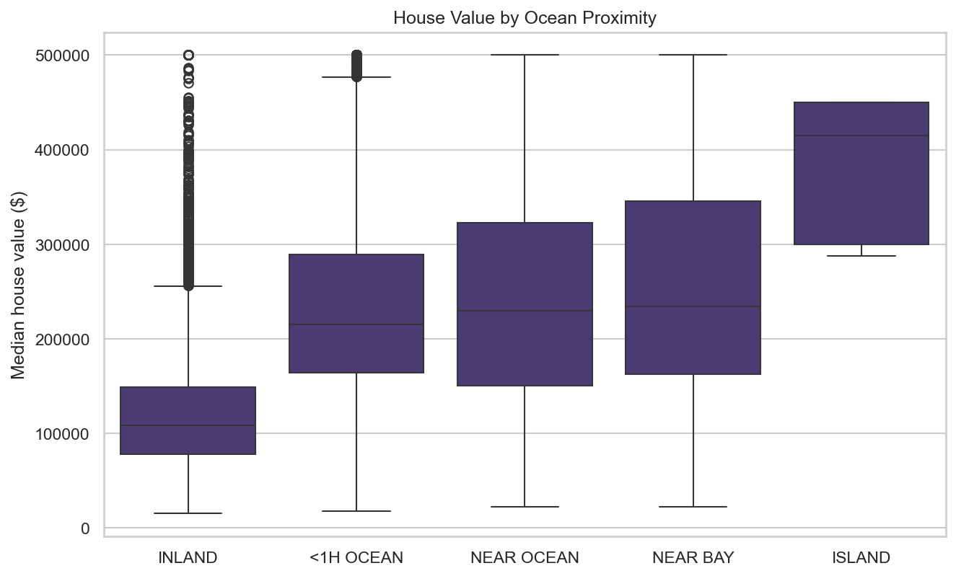
Figure 3 — House value by ocean proximity; inland districts are far cheaper
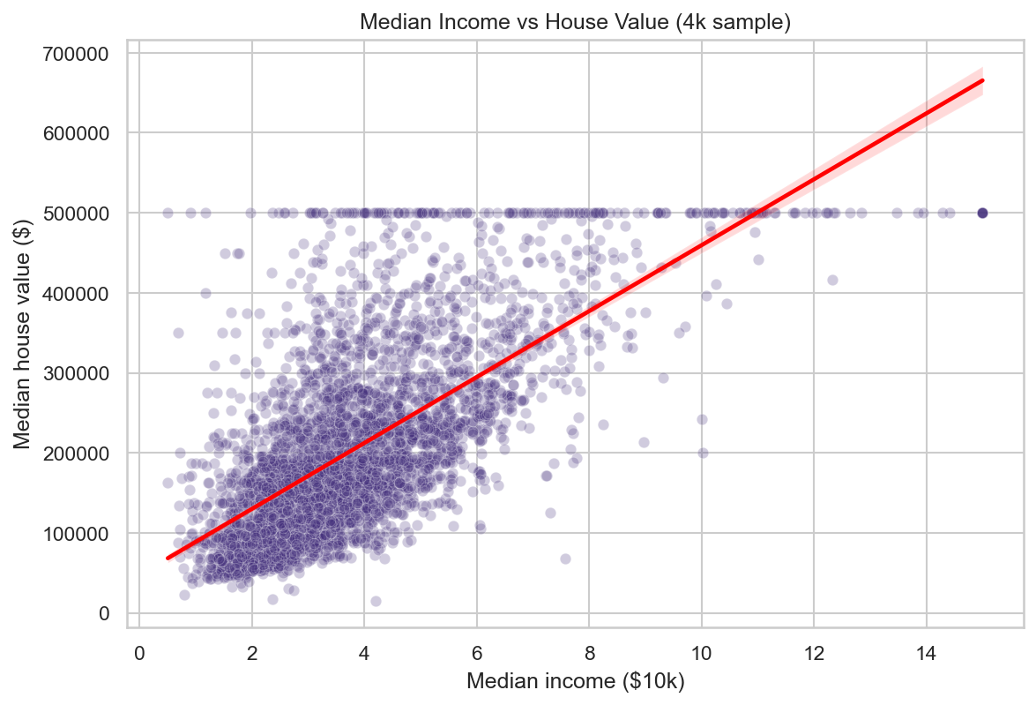
Figure 4 — Median income vs house value: the strongest single relationship (r ≈ 0.69)
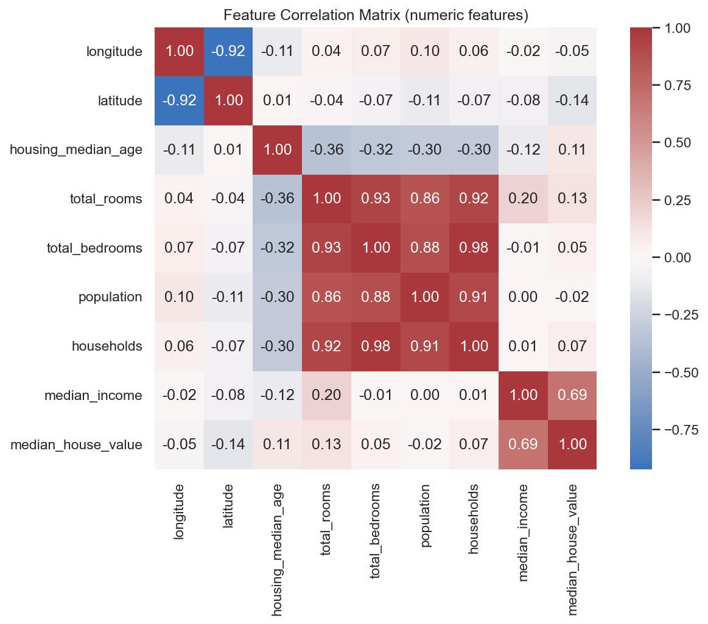
Figure 5 — Correlation matrix of numeric features

6. Stage 3 — Feature Engineering (feature_engineering.py)
This stage converts raw census columns into model-ready features:
- Missing-value imputation: total_bedrooms NaNs are filled with the median computed from training rows only. Computing it on the full dataset would leak information from the test set into training — a subtle but classic mistake this project deliberately avoids. The value is saved to preprocessing.json so the web app imputes identically.
- Ratio features: raw totals describe district size, not housing quality. Ratios fix that: rooms_per_household (bigger homes → richer area), bedrooms_per_room (high share of bedrooms → smaller, cheaper units), population_per_household (crowding indicator).
- log_population tames the heavy right skew of the population counts.
- Distance features: straight-line distance from each district to LA, San Francisco, San Diego, and Sacramento, plus distance to the nearest of the four. This converts raw coordinates into an economically meaningful quantity (proximity to job markets) and became one of the strongest engineered predictors.
- One-hot encoding of ocean_proximity into five 0/1 columns, using a fixed category list so the columns are always identical at prediction time.
- Train/test split: 80/20, stratified on income quintiles. Since income drives price, a random split that under-sampled rich districts in the test set would bias evaluation; stratification guarantees both splits cover the full income range.

7. Stage 4 — Modeling and Results (modeling.py)
Four models are trained and compared, from simplest to strongest:
Model | Why it is included
Linear Regression | Baseline — how far does a straight line get you?
Ridge | Same, with L2 regularization (guards against correlated features)
Random Forest | Ensemble of decision trees; captures non-linear and interaction effects
Gradient Boosting | Trees built sequentially, each correcting the last — usually the strongest on tabular data

Each model is evaluated with 5-fold cross-validation on the training set and on a held-out test set using RMSE (penalizes large errors), MAE (typical error in dollars — the most interpretable number), and R² (share of price variation explained).

Results
Model | CV RMSE | Test RMSE | Test MAE | Test R²
Linear Regression | $66,810 | $66,209 | $47,590 | 0.672
Ridge | $66,809 | $66,211 | $47,592 | 0.672
Random Forest | $48,129 | $46,405 | $30,176 | 0.839
Gradient Boosting ★ | $45,119 | $43,333 | $28,619 | 0.860

What these numbers say:
- The linear baseline explains 67% of price variation — decent, because income alone is a strong linear predictor, but a straight line cannot represent “expensive near SF and near LA, cheap in between.”
- Tree ensembles add ~19 points of R² (0.67 → 0.86). That gap is the non-linear signal: geographic clusters, income×location interactions, and the ocean-proximity effect.
- No overfitting: for every model, cross-validation RMSE and test RMSE are within ~4% of each other (Gradient Boosting: $45,119 CV vs $43,333 test). The model generalizes.
- $28,619 average error in context: the median district value is roughly $180–200k, so the typical prediction is off by about 15% — solid, given the model only sees census aggregates and the target is capped at $500k.
- Ridge ≈ Linear Regression because with 20 features and 16,512 training rows there is little variance to shrink — regularization had nothing to fix.
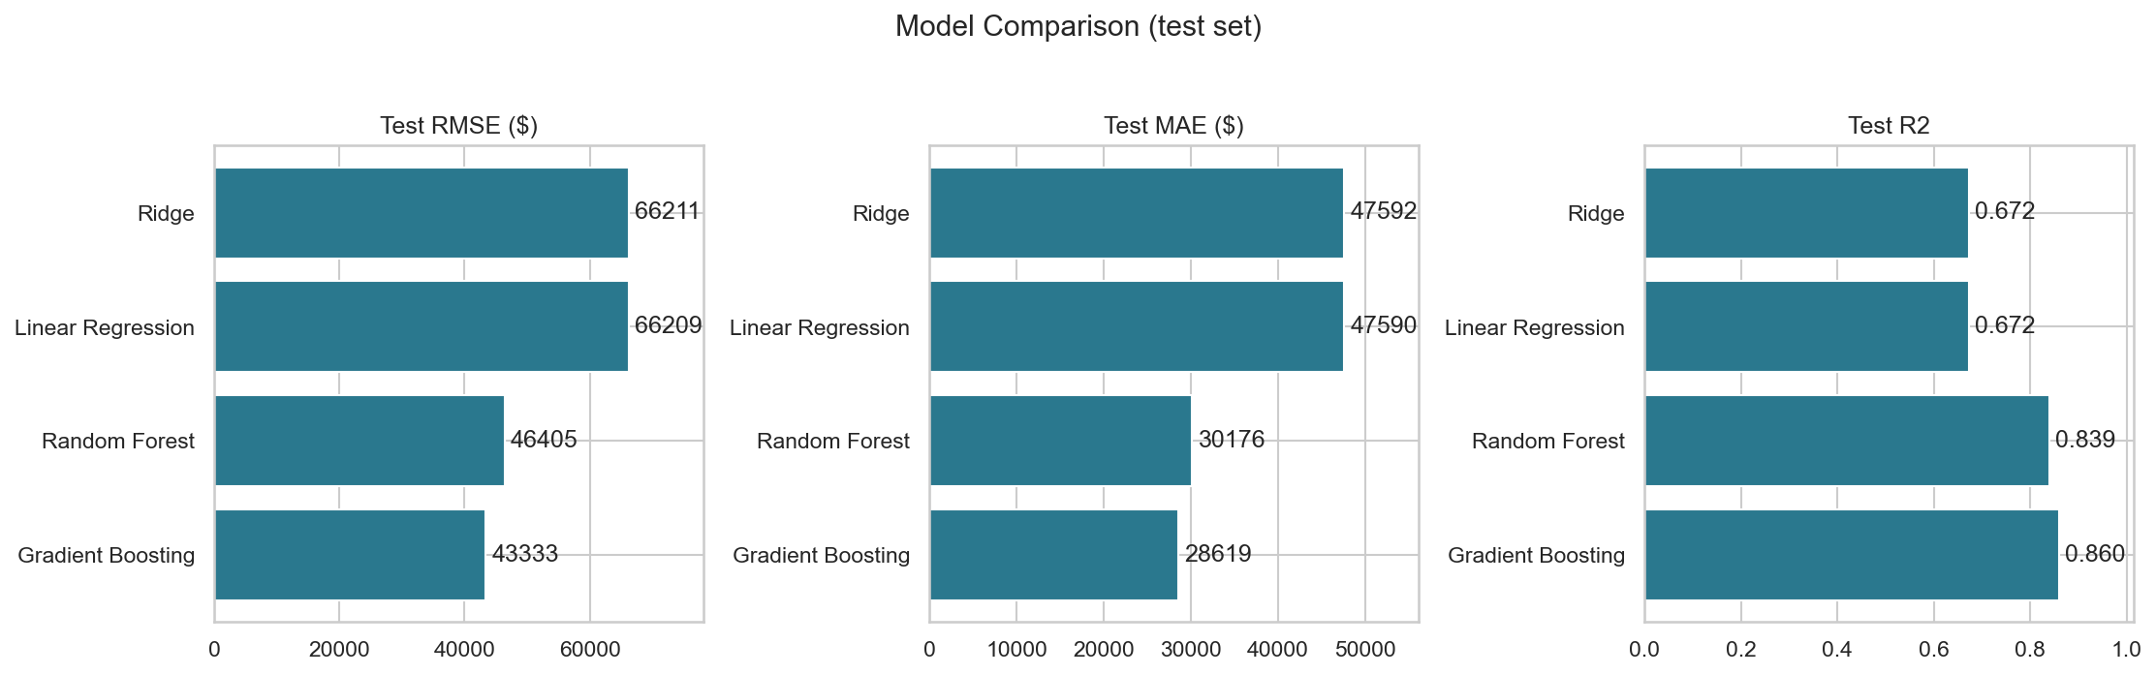
Figure 6 — Model comparison on the held-out test set
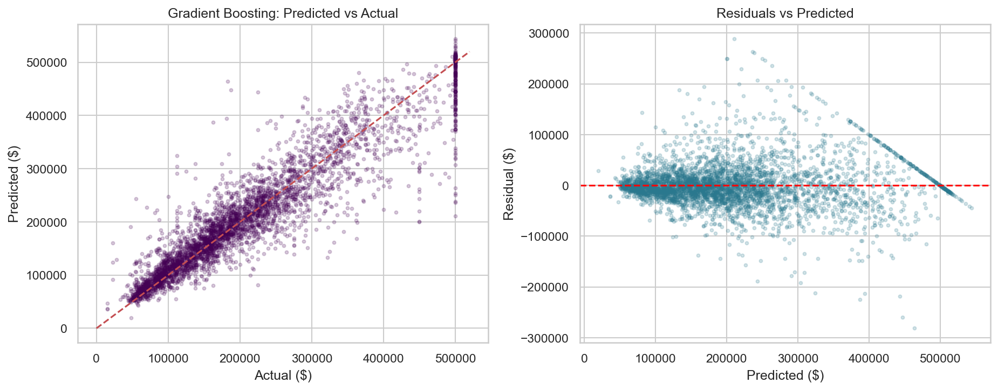
Figure 7 — Best model: predicted vs actual (left) and residuals (right); the vertical stripe at $500k is the capped target
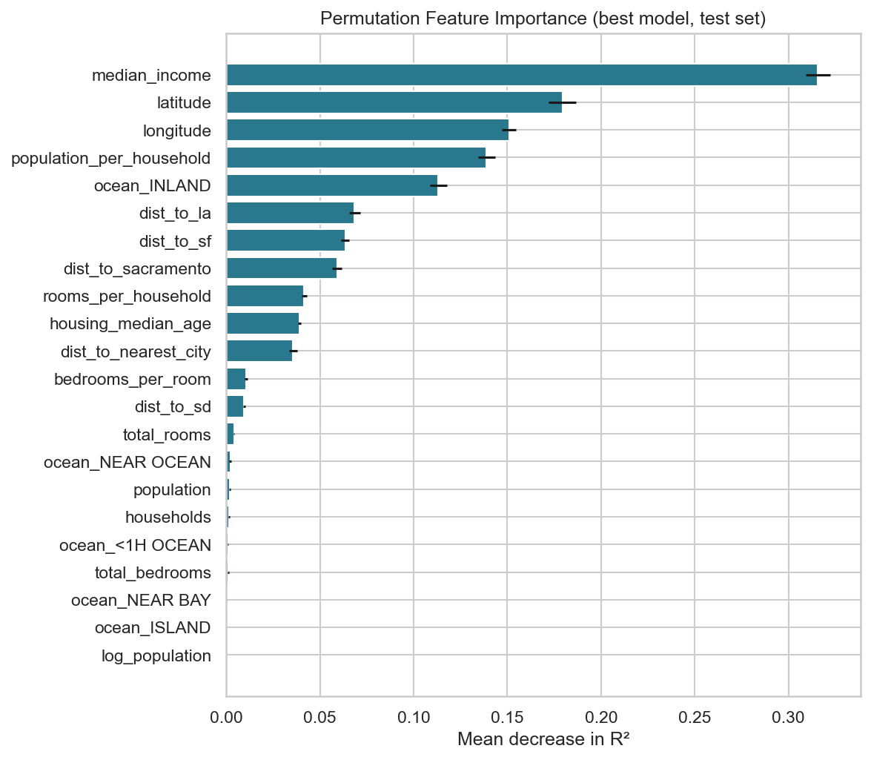
Figure 8 — Permutation feature importance: shuffling median_income hurts accuracy the most
The best model by test RMSE — HistGradientBoostingRegressor — is saved with joblib to outputs/models/best_model.pkl, alongside preprocessing.json which stores the training-set imputation statistics.

8. Stage 5 — Prediction (predict.py)
Loads the saved model and preprocessing.json, applies the same feature engineering to new raw inputs, and outputs a dollar prediction. Demonstrated on three contrasting districts (affluent San Francisco, median Fresno, dense low-income Los Angeles). The key design point: prediction reuses the exact transformations learned in training — same imputation value, same one-hot columns — so there is no training/serving mismatch.

9. Stage 6 — Web Application (app.py)
A Streamlit app turns the model into a live website: sliders and dropdowns for the district’s characteristics, an instant dollar prediction, and a map of the chosen location. It is deployed free on Streamlit Community Cloud directly from the GitHub repository — every git push redeploys the site automatically.

10. Limitations and Future Work
- 1990 data — predictions reflect 1990 prices; the model demonstrates method, not current market values.
- Capped target — nothing above $500k can be learned.
- District-level only — it prices areas, not individual homes.
- Extensions: XGBoost/LightGBM with hyperparameter tuning, k-nearest-neighbor spatial features, quantile regression for prediction intervals, and CI/CD with model versioning.

