|  |
| --- |
| October-WER |
| 2023 |
| WORD ERROR RATE short for WER |

|  |  |
| --- | --- |
| Demystifying WER: A core Metric for Speech Recognition  As an NLP programmer, evaluating the performance of Automatic Speech Recognition (ASR) systems is crucial. Word Error Rate (WER) reigns supreme as a cornerstone metric, offering a quantitative measure of accuracy, but it can be overly sensitive to disfluencies and doesn't consider semantic meaning. But what exactly is WER, and how do we use it effectively? | Understanding Word Error Rate (WER) in Automatic Speech Recognition (ASR) |  Clari |

1. ASR: Understanding Automatic Speech Recognition

ASR technology acts as a bridge, seamlessly translating the nuances of spoken language into a machine-understandable text format. From voice assistants to dictation software and automated call centers, ASR empowers a plethora of applications.

1. Unpacking WER: What it Stands For and Why it Matters

WER stands for Word Error Rate. It essentially calculates the percentage of errors an ASR system makes compared to the reference transcript.

Lower WER signifies a more accurate transcription, while a higher WER indicates shortcomings in capturing the spoken words.

1. The Anatomy of WER Calculation: Insertions, Deletions, and Substitutions

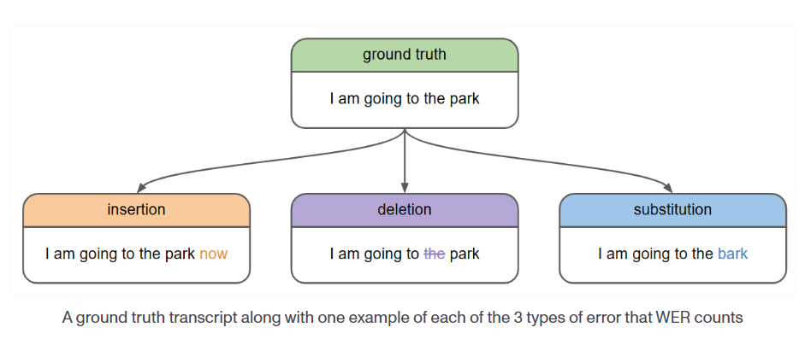So, how do we calculate WER? Three basic edit operations:

* **Insertions:** When the ASR system adds a word not present in the reference text.
* **Deletions:** When the system omits a word from the reference.
* **Substitutions:** When it replaces a word in the reference with a different word.

WER takes the total number of these edits and divides it by the total number of words in the reference transcript, then multiplies by 100 to express it as a percentage.

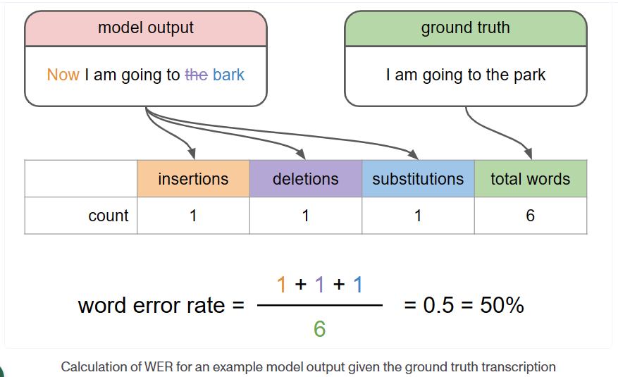

1. Interpreting WER Scores: A Balancing Act

A lower WER generally indicates a better performing ASR system. For instance, if the WER is 10%, it means the system made errors in 10% of the words compared to the reference.

However, WER has limitations. It treats all errors equally, regardless of their impact on meaning. For example, mistaking "ship" for "sheep" might have a lesser impact than confusing "doctor" with "lawyer."

1. Disfluency's Impact: Artificially Inflated WER and Addressing Filler Words

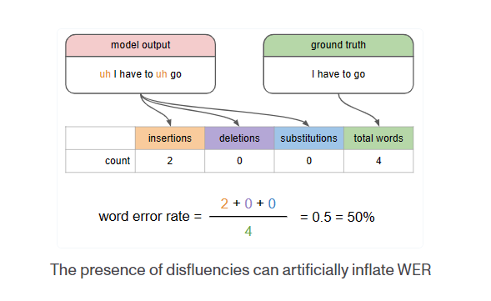

However, WER has limitations. Disfluencies, such as "um," "uh," and "like," can lead to artificially inflated WER scores. These filler words don't carry meaning and shouldn't be penalized.

Here are some strategies to address disfluencies:

Speech Pre-processing: Techniques like silence detection and energy-based segmentation can identify and remove disfluencies before feeding the audio into the ASR system.

Language Models with Disfluency Awareness: Advanced language models can be trained to recognize and account for disfluencies, reducing the magnitude of WER inflation.

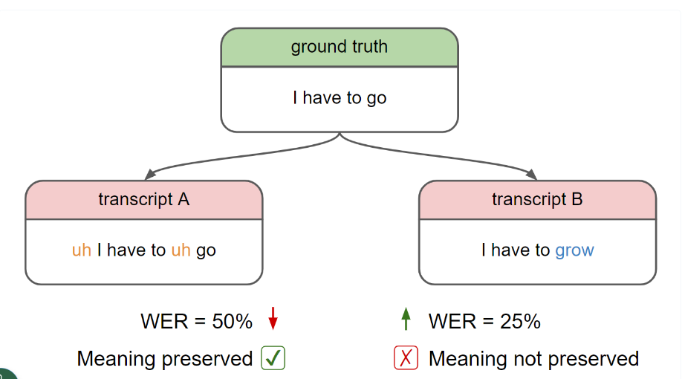

1. Beyond WER: Addressing Proper Nouns and Real-World Challenges

Proper nouns like names and locations pose a specific challenge for WER. A single-letter difference can significantly impact meaning.

To address this, Jaro-Winkler distance, a string similarity measure, can be employed alongside WER for a more nuanced evaluation.

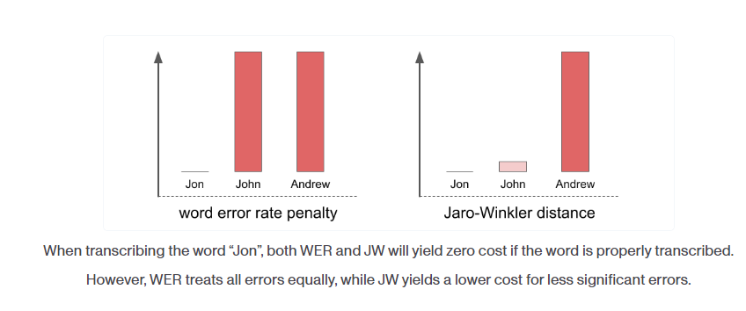

1. Real-World Challenges and Speech Recognition Normalization

The real world throws a wild card at ASR systems – background noise, accents, and variations in speech patterns can all degrade performance.

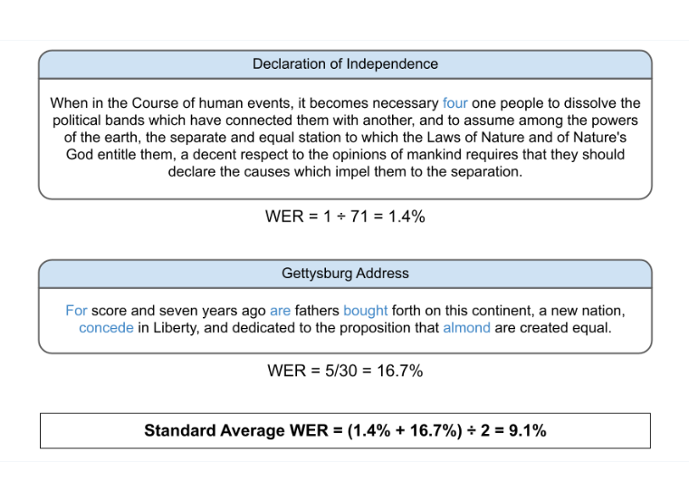

To tackle these challenges, speech recognition normalizers can be deployed as a pre-processing step to improve WER scores.

Here are a couple of techniques that can be employed:

Noise Reduction: Filtering out background noise, such as traffic sounds or air conditioning hum, can significantly improve ASR accuracy. Spectral subtraction or Wiener filtering are common techniques used for noise reduction.

Volume Normalization: Fluctuations in speech volume can confuse ASR models. Normalizing the audio to a consistent level ensures all parts of the speech are treated equally.

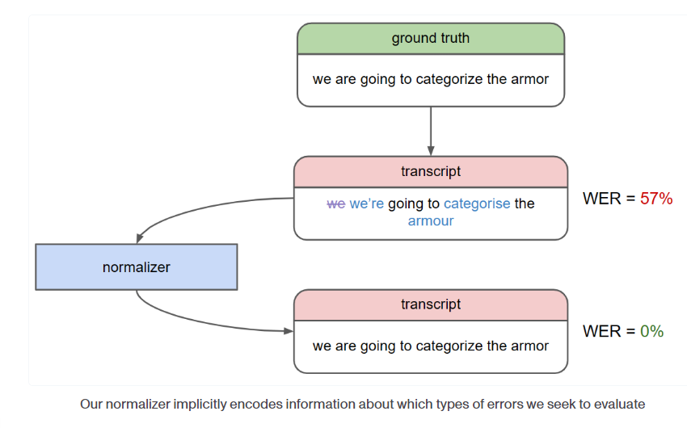

Summary: WER – A Stepping Stone, Not the Final Destination

While WER serves as a valuable starting point for evaluating ASR accuracy, it's essential to consider its limitations, especially regarding disfluencies. Jaro-Winkler distance, proper averaging techniques, incorporating real-world noise factors, and addressing disfluencies are all crucial for a comprehensive assessment. As NLP developers, we strive to continuously refine our evaluation methods to build increasingly robust and effective ASR systems that can handle the complexities of natural human speech.

In the context of mitigating the impact of disfluencies and real-world noise factors on WER scores, open-source normalizers like the Whisper normalizer can be a valuable tool. For a robust and scientifically sound comparison of Speech Recognition models, maintaining consistency in the normalization process is of critical importance. This ensures that any observed performance differences are attributable to the models themselves, rather than variations introduced by pre-processing steps.

Reference: <https://en.wikipedia.org/wiki/Word_error_rate>, <https://medium.com/nlplanet/two-minutes-nlp-intro-to-word-error-rate-wer-for-speech-to-text-fc17a98003ea>, <https://huggingface.co/spaces/evaluate-metric/wer>, <https://www.assemblyai.com/blog/how-to-evaluate-speech-recognition-models/>.