**API Documentation**

1. **Keyword Endpoint : /prediction**

**Type** : POST

**Input Parameters**

**Text**

DataType : String

Schema : no length constraint

**Model**

Datatype : String

Schema : no length constraints

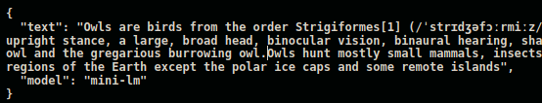

**Curl command**

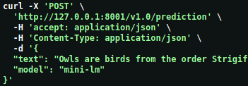

**Return**

Returns output as JSON object with timestamp

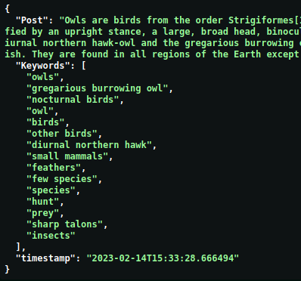

**Error Codes**

**500 - Prediction Module Error :** when error occurs inside the module

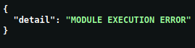

**404 - Invalid model name**

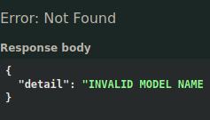

1. **Hashtag Endpoint: /prediction**

**Type** : POST

**Input Parameters**

**Text**

DataType : String

Schema : no length constraint

**Model**

Datatype : String

Schema : no length constraints

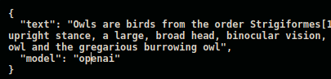

**Curl command**

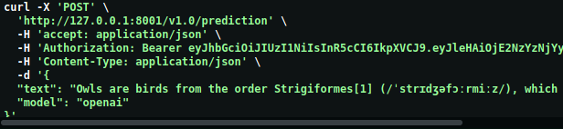

**Return**

Returns output as JSON object with timestamp and token usage info.

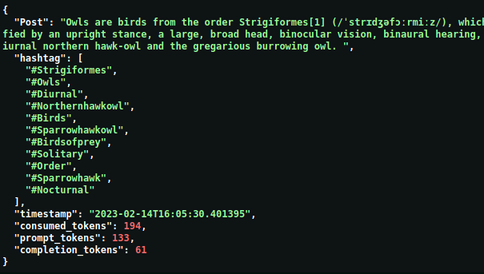

**Error Codes**

**500 - Prediction Module Error :** when error occurs inside the module



**401 – API Key is Invalid, Expired or Revoked**



**429 – Rate Limit Reached –** When maximum api calls per minute reached

**404 - Invalid model name**

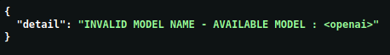

1. **Topic Endpoint : /prediction**

**Type** : POST

**Input Parameters**

**Text**

DataType : String

Schema : no length constraint

**Model**

Datatype : String

Schema : no length constraints

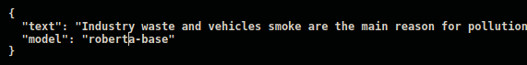

**Curl command**

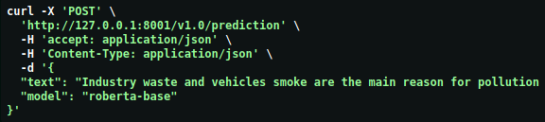

**Return**

Returns output as JSON object with timestamp

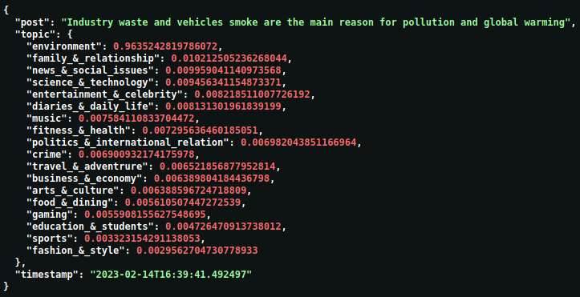

**Error Codes**

**500 - Prediction Module Error :** when error occurs inside the module



**404 - Invalid model name**



1. **Zero-shot Endpoint : /prediction**

**Type** : POST

**Input Parameters**

**Text**

DataType : String

Schema : no length constraint

**Model**

Datatype : String

Schema : no length constraints

**labels**

DataType : List of strings

Schema : List length constraint [min(2) - max(20)]

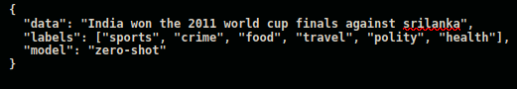

**Curl command**

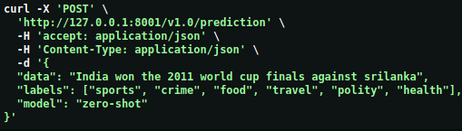

**Return**

Returns output as JSON object with timestamp

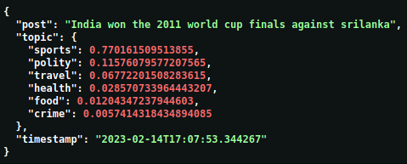

**Error Codes**

**500 - Prediction Module Error :** when error occurs inside the module



**404 - Invalid model name**



**::: END :::**