**API Documentation**

1. **Endpoint : /register**

**Type - GET**

**Input Parameters**

**Username ( Required)**

Datatype : String

Schema : String length (6-15)

**Password (Required)**

Datatype : String

Schema - String length (8-15)

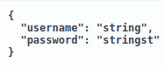

**Returns**

Returns a response message in below format

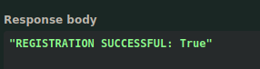

**Curl command**

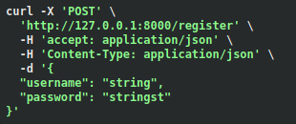

**Error codes**

**400** - Error : Failed to register - username already taken

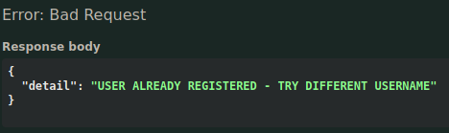

1. **Endpoint : /login**

**Type** : GET

**Input Parameters**

**Username**

DataType : String

Schema : String length (6-15)

**Password**

DataType : String

Scheme : String length (8-15)



**Curl** **command**

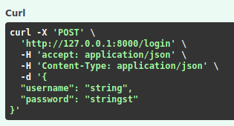

**Return**

Temporary token returned to access authenticated endpoints

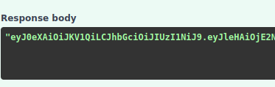

**Error Codes**

**401 -** Error : Invalid username/password

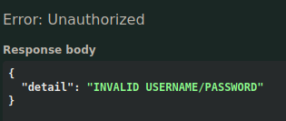

**500 -** Token Generation failed

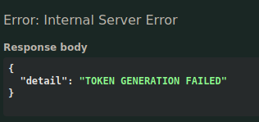

1. **Keyword Endpoint : /prediction**

**Type** : POST

**Input Parameters**

**Token**

Expiry : 20 minutes

Algorithm : HS256

**Text**

DataType : String

Schema : no length constraint

**Model**

Datatype : String

Schema : no length constraints

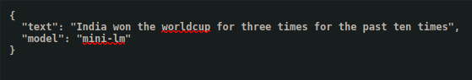

**Curl command**

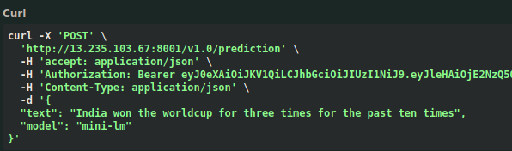

**Authorization**

Token need to be provided to access the authorized endpoints

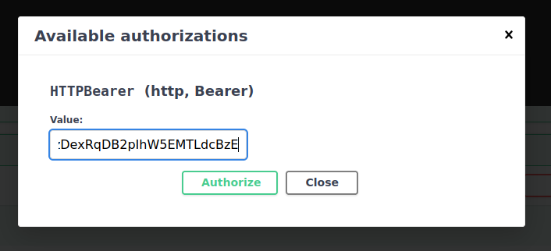

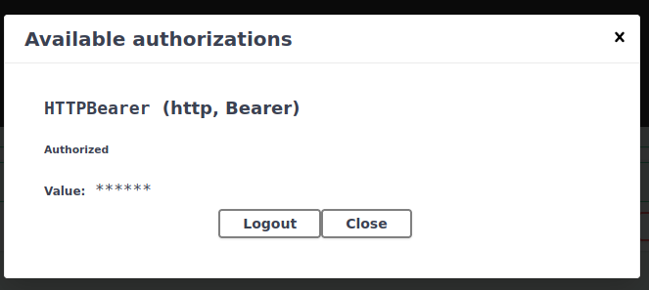

**Return**

Returns prediction as JSON object with timestamp

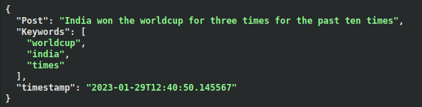

**Error Codes**

**401 - Authentication Error :** when accessed without provided token

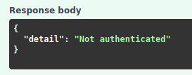

**500 - Prediction Module Error :** when error occurs inside the keyword module

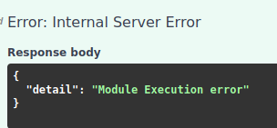

**401 - Invalid token Error** : when provided with wrong or expired token

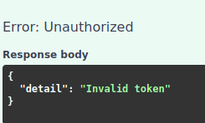

**489 - Expired Token :** When accessed prediction module after 20 minutes

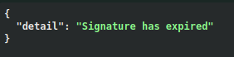

**401 - Invalid model name**

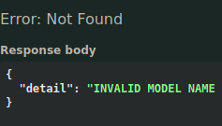

1. **Topic Endpoint : /prediction**

**Type** : POST

**Input Parameters**

**Token**

Expiry : 20 minutes

Algorithm : HS256

**Text**

DataType : String

Schema : no length constraint

**Model**

Datatype : String

Schema : no length constraints

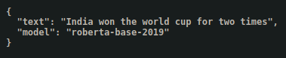

**Return**

Returns prediction as JSON object with timestamp

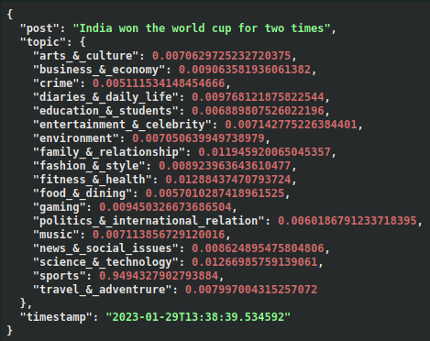

**Error Codes**

**401 - Authentication Error :** when accessed without provided token



**500 - Prediction Module Error :** when error occurs inside the keyword module



**401 - Invalid token Error** : when provided with wrong or expired token



**489 - Expired Token :** When accessed prediction module after 20 minutes



**401 - Invalid model name**



1. **Zero-shot Endpoint : /prediction**

**Type** : POST

**Input Parameters**

**Token**

Expiry : 20 minutes

Algorithm : HS256

**Text**

DataType : String

Schema : no length constraint

**Model**

Datatype : String

Schema : no length constraints

**labels**

DataType : List

Schema : List length constraint (2-20)

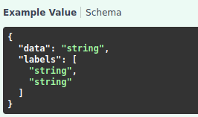

**Curl command**

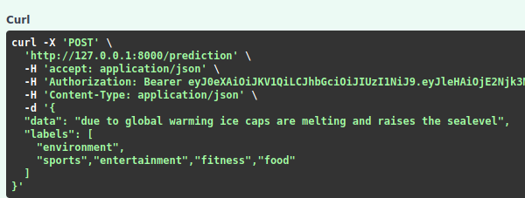

**Return**

Returns prediction as JSON object with timestamp

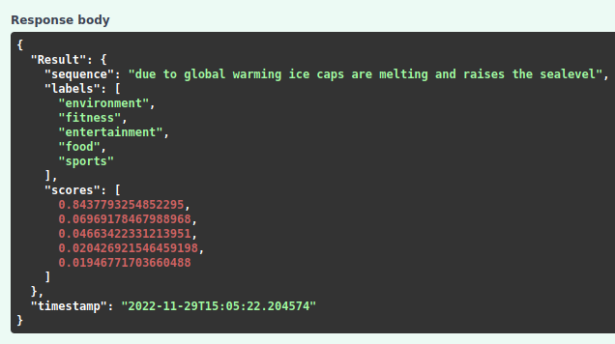

**Error Codes**

**401 - Authentication Error :** when accessed without provided token



**500 - Prediction Module Error :** when error occurs inside the keyword module



**401 - Invalid token Error** : when provided with wrong or expired token



**489 - Expired Token :** When accessed prediction module after 20 minutes



**401 - Invalid model name**

