**API Documentation**

1. **Endpoint : /register**

**Type - GET**

**Input Parameters**

**Username ( Required)**

Datatype : String

Schema : String length (6-15)

**Password (Required)**

Datatype : String

Schema - String length (8-15)

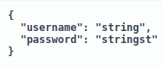

**Returns**

Returns a response message

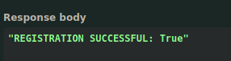

**Curl command**

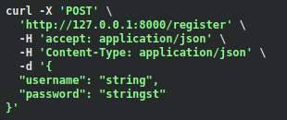

**Error codes**

**400** - **Failed to register** **:** username already taken

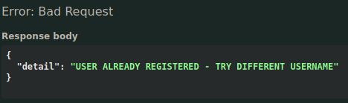

**422 - Invalid Input Format :** username and password constraint not met

**`** 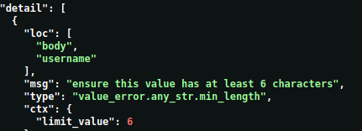

1. **Endpoint : /login**

**Type** : GET

**Input Parameters**

**Username**

Datatype : String

Schema : String length (6-15)

**Password**

Datatype : String

Scheme : String length (8-15)



**Curl** **command**

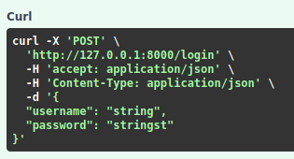

**Return**

Temporary token for 20 mins

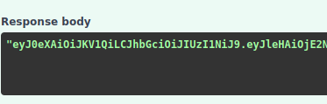

**Error Codes**

**401 -** Invalid username/password

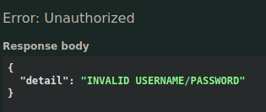

**500 -** Token Generation failed

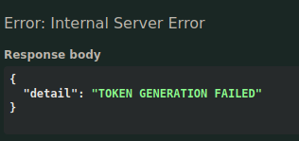

**422 - Invalid Input Format :** username and password constraint not met

**` **

1. **Keyword Endpoint : /prediction**

**Type** : POST

**Input Parameters**

**Token**

Expiry : 20 minutes

Algorithm : HS256

**Title**

Datatype : String

Schema : no length constraint

**Transcript**

Datatype : String

Schema : Minimum 30 characters

**Summary**

Datatype : String

Schema : Minimum 30 characters

**Model**

Datatype : String

Schema : no length constraints

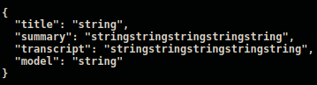

**Curl command**

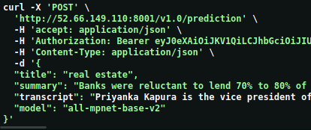

**Authorization**

Token need to be provided to access the authorized endpoints

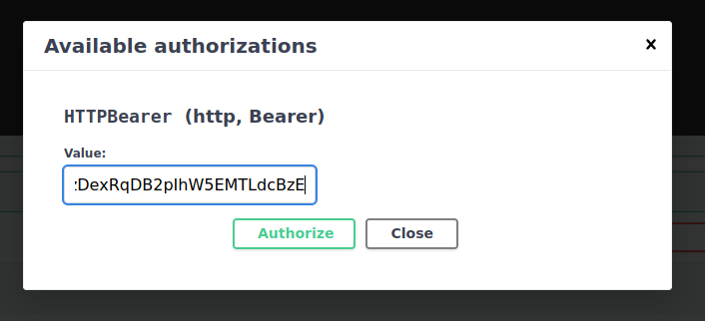

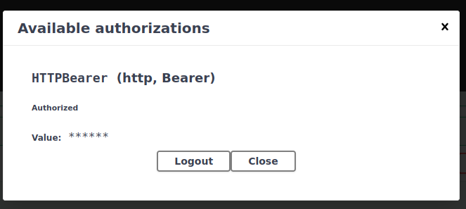

**Return**

Returns output in JSON format with timestamp

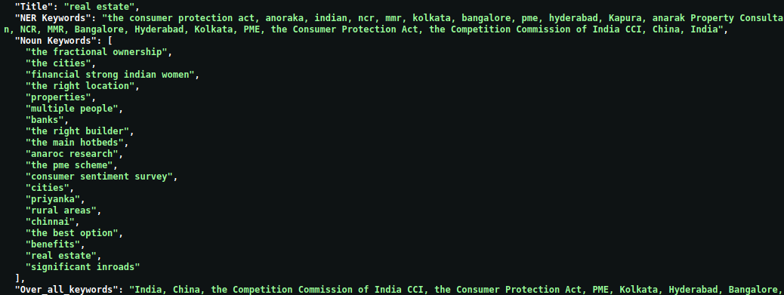

**Error Codes**

**401 - Authentication Error :** when accessed without token



**500 - Prediction Module Error :** Occurs when a module fails to execute successfully. Look the list of possible modules

* PRELIMINARY INITIALIZATION ERROR
* MODEL INITIALIZATION ERROR
* SENTENCE TOKENIZING ERROR
* KEYWORD EXTRACTION ERROR
* ERROR IN SCORING KEYWORDS
* TRANSCRIPT CLEANING ERROR
* ERROR IN DIVIDE_CHUNKS MODULE
* ERROR IN CHUNK_KEYWORDS MODULE
* ERROR IN OVER_ALL_KEYWORDS MODULE
* ERROR IN TRANSCRIPT_KEYWORDS MODULE
* ERROR IN FINAL_PROCESSING MODULE
* ERROR IN RETURNING THE OUTPUT



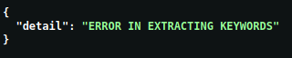

**422 - Invalid Input Format :** When the input constraint is not followed

**401 - Invalid token Error** : when accessed with incorrect token



**489 - Expired Token :** When accessed prediction module after 20 minutes



**401 - Invalid model name**



1. **Topic Endpoint : /prediction**

**Type** : POST

**Input Parameters**

**Token**

Expiry : 20 minutes

Algorithm : HS256

**Title**

Datatype : String

Schema : no length constraint

**Summary**

Datatype : String

Schema : Minimum 30 characters

**Model**

Datatype : String

Schema : no length constraints

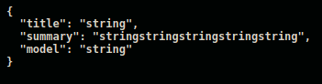

**Authorization**

Token need to be provided to access the authorized endpoints





**Curl command**

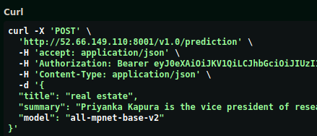

**Return**

Returns output in JSON format with timestamp

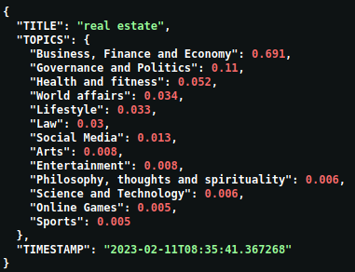

**Error Codes**

**401 - Authentication Error :** when accessed without token

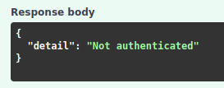

**500 - Prediction Module Error :** Occurs when a module fails to execute successfully. Look the list of possible modules

* PRELIMINARY INITIALIZATION
* MODEL INITIALIZATION
* TOPIC EMBEDDING
* SUB TOPIC EMBEDDING
* SUMMARY EMBEDDING
* ERROR IN RETURNING THE OUTPUT
* RESULT SCORING FAILED
* COSINE SIMILARITY CALCULATION



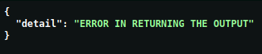

**422 - Invalid Input Format :** When the input constraint is not followed

**401 - Invalid token Error** : when accessed with incorrect token



**489 - Expired Token :** When accessed prediction module after 20 minutes



**401 - Invalid model name**



1. **Hashtag Endpoint : /prediction**

**Type** : POST

**Input Parameters**

**Token**

Expiry : 20 minutes

Algorithm : HS256

**Title**

Datatype : String

Schema : no length constraint

**Summary**

Datatype : String

Schema : Minimum 30 characters

**Model**

Datatype : String

Schema : no length constraints



**Authorization**

Token need to be provided to access the authorized endpoints





**Curl command**

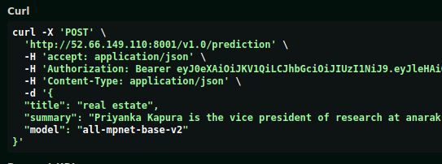

**Return**

Returns output in JSON format with timestamp 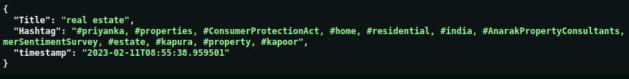

**Error Codes**

**401 - Authentication Error :** when accessed without token



**500 - Prediction Module Error :** when error occurs inside the keyword module

* PRELIMINARY INITIALIZATION ERROR
* MODEL INITIALIZATION ERROR
* SENTENCE TOKENIZING ERROR
* KEYWORD EXTRACTION ERROR

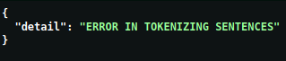



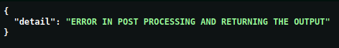

**422 - Invalid Input Format :** When the input constraint is not followed

**401 - Invalid token Error** : when accessed with incorrect token



**489 - Expired Token :** When accessed prediction module after 20 minutes



**401 - Invalid model name**



1. **Summary Endpoint : /prediction**

**Type** : POST

**Input Parameters**

**Token**

Expiry : 20 minutes

Algorithm : HS256

**Title**

Datatype : String

Schema : no length constraint

**Transcript**

Datatype : String

Schema : Minimum 30 characters

**Model**

Datatype : String

Schema : no length constraints

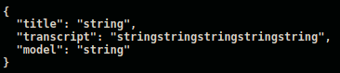

**Authorization**

Token need to be provided to access the authorized endpoints





**Curl command**

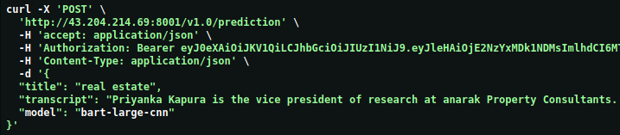

**Return**

Returns output in JSON format with timestamp

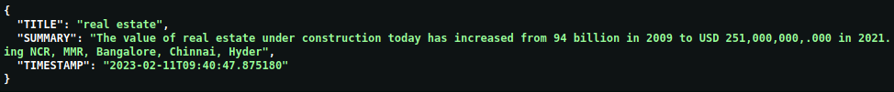

**Error Codes**

**401 - Authentication Error :** when accessed without token



**500 - Prediction Module Error :** when error occurs inside the keyword module

* ERROR IN EXTRACTING SUMMARY MODULE
* MODEL INITIALIZATION FAILED
* PRELIMINARY INITIALIZATION FAILED
* ERROR IN DISPLAYING THE OUTPUT
* TRANSCRIPT CLEANING ERROR
* PREPROCESSING ERROR
* DIVIDING CHUNKS ERROR





**422 - Invalid Input Format :** When the input constraint is not followed

**401 - Invalid token Error** : when accessed with wrong token



**489 - Expired Token :** When accessed prediction module after 20 minutes



**401 - Invalid model name**



**END**