Name: Gaurang Vaghela
Rollno: BEAD-22561
CI Practical 1
Problem Statement: Design a distributed application using RPC for remote computation where client submits an integer value to the server and server calculates factorial and returns the result to the client program.

Server.py
from xmlrpc.server import SimpleXMLRPCServer
from xmlrpc.server import SimpleXMLRPCRequestHandler

class RPCServer:
def calculate_factorial(self, n):
if n < 0:
raise ValueError("Input must be a non-negative integer.")
result = 1
for i in range(1, n + 1):
result *= i
return result

# Restrict to a particular path.
class RequestHandler(SimpleXMLRPCRequestHandler):
rpc_paths = ('/api/v1/rpc_handler',)

# Create server
with SimpleXMLRPCServer(('localhost', 8000), requestHandler=RequestHandler) as server:
server.register_introspection_functions()
# Register the FactorialServer class"
server.register_instance(RPCServer())
print("FactorialServer is ready to accept requests.")
# Run the server's main loop\n",
server.serve_forever()

Client.py
import xmlrpc.client
# Create an XML-RPC client
with xmlrpc.client.ServerProxy("http://localhost:8000/api/v1/rpc_handler") as proxy:
try:
input_value = int(input("Enter number: "))
result = proxy.calculate_factorial(input_value)
print(f"Factorial of {input_value} is: {result}")

except Exception as e:
print(f"Error: {e}")

OUTPUT:
Server:
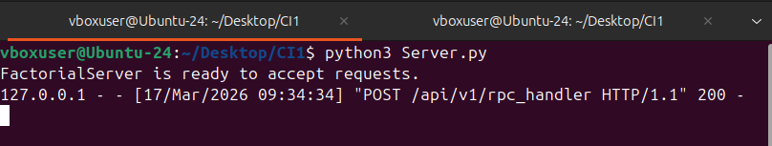

Client:
