Name: Gaurang Vaghela
Rollno: BEAD-22561
CI Practical 3
Problem Statement: Design a distributed application using MapReduce under Hadoop for:

input.txt
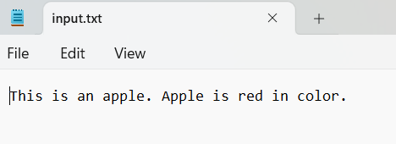

a) Character counting in a given text file.
CharMapper.py
import sys
for line in sys.stdin:
line = line.strip()
for char in line:
if char.strip() != "":
print(f"{char}\t1")

CharReducer.py
import sys

current_char = None
current_count = 0
for line in sys.stdin:
char, count = line.strip().split('\t')
count = int(count)

if current_char == char:
current_count += count
else:
if current_char:
print(f"{current_char}\t{current_count}")
current_char = char
current_count = count

if current_char:
print(f"{current_char}\t{current_count}")

OUTPUT:
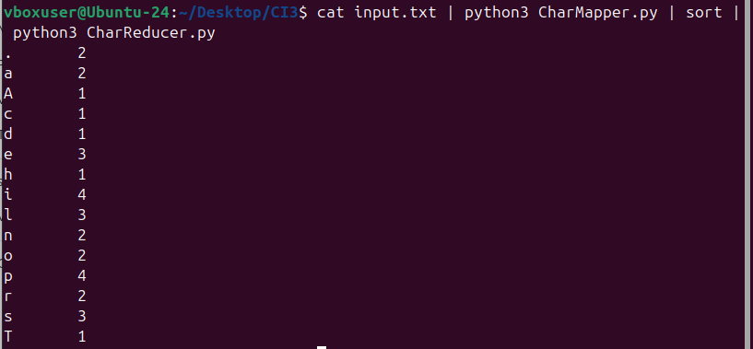
b) Counting no. of occurrences of every word in a given text file.
WordReducer.py
import sys

for line in sys.stdin:
line = line.strip()
words = line.split()

for word in words:
print(f"{word.lower()}\t1")

WordMapper.py
import sys

current_word = None
current_count = 0

for line in sys.stdin:
word, count = line.strip().split('\t')
count = int(count)

if current_word == word:
current_count += count
else:
if current_word:
print(f"{current_word}\t{current_count}")
current_word = word
current_count = count

if current_word:
print(f"{current_word}\t{current_count}")

OUTPUT:
