Name: Gaurang Vaghela
Rollno: BEAD-22561
DC Practical 9
Problem Statement: Design and develop a distributed Hotel booking application using Java RMI. A distributed hotel booking system consists of the hotel server and the client machines. The server manages hotel rooms booking information. A customer can invoke the following operations at his machine.
i) Book the room for the specific guest
ii) Cancel the booking of a guest.

- Create Project
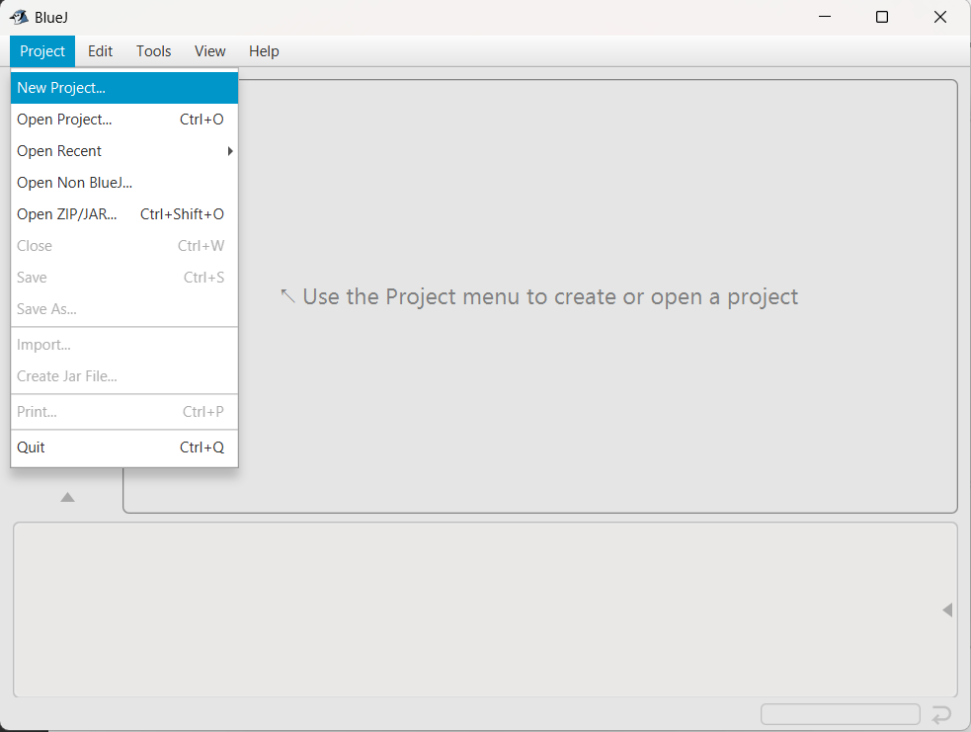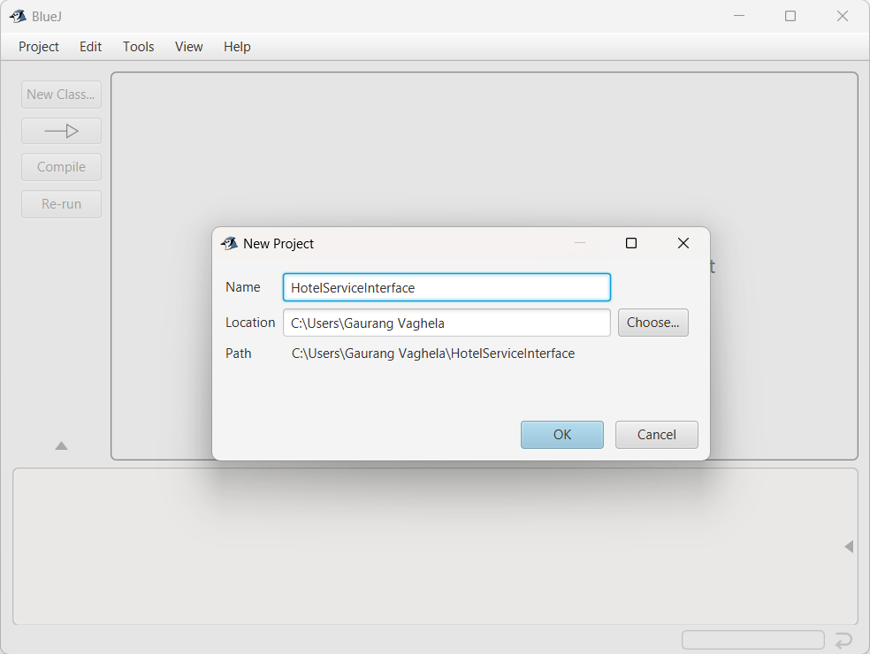

- Create Interface – HotelServiceInterface and Class – HotelServer and HotelClient
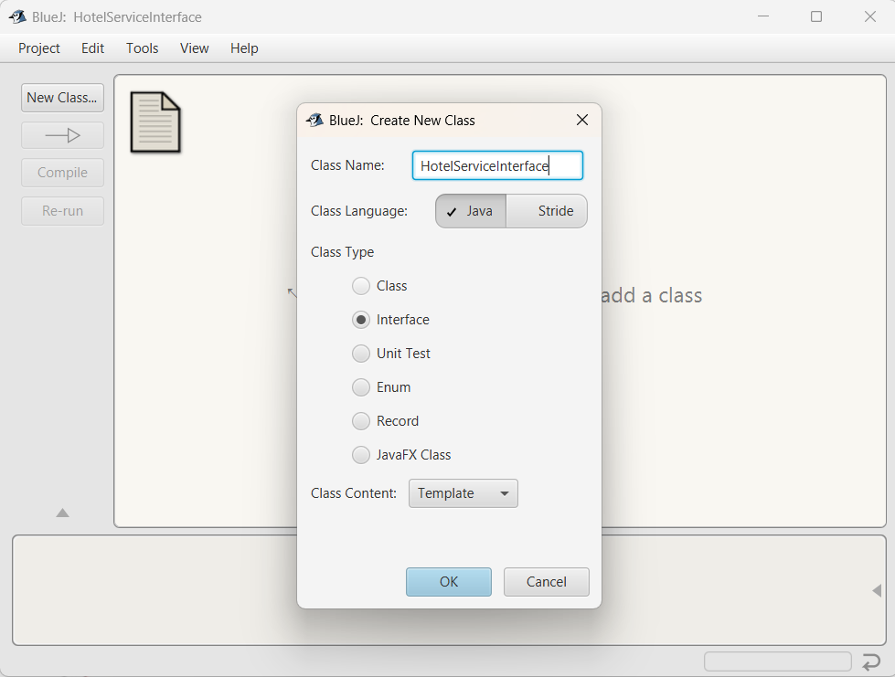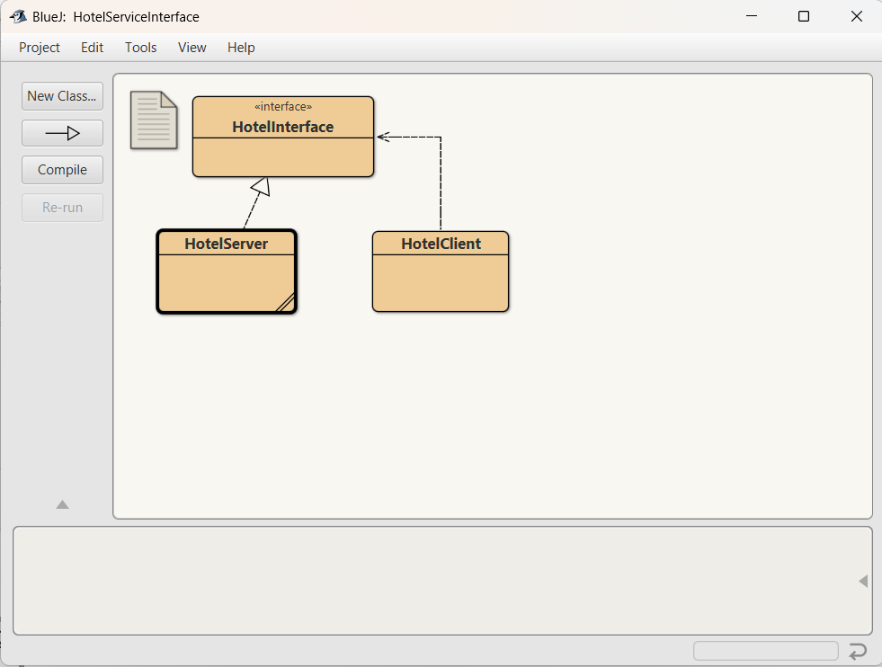

- Write code in the Classes
HotelInterface.java
import java.rmi.Remote;
import java.rmi.RemoteException;
public interface HotelInterface extends Remote {
String bookRoom(String guestName) throws RemoteException;
String cancelBooking(String guestName) throws RemoteException;
}

HotelServer.java
import java.rmi.server.UnicastRemoteObject;
import java.rmi.RemoteException;
import java.rmi.registry.LocateRegistry;
import java.rmi.registry.Registry;
import java.util.HashMap;

public class HotelServer extends UnicastRemoteObject implements HotelInterface {

HashMap<String, Boolean> bookings;

protected HotelServer() throws RemoteException {
bookings = new HashMap<>();
}

public String bookRoom(String guestName) throws RemoteException {
if (bookings.containsKey(guestName)) {
return "Room already booked for " + guestName;
}
bookings.put(guestName, true);
return "Room booked successfully for " + guestName;
}

public String cancelBooking(String guestName) throws RemoteException {
if (!bookings.containsKey(guestName)) {
return "No booking found for " + guestName;
}
bookings.remove(guestName);
return "Booking cancelled for " + guestName;
}

public static void main(String[] args) {
try {
HotelServer server = new HotelServer();

Registry registry = LocateRegistry.createRegistry(1099);
registry.rebind("HotelService", server);

System.out.println("Hotel Server is running...");
} catch (Exception e) {
e.printStackTrace();
}
}
}

HotelClient.java
import java.rmi.registry.LocateRegistry;
import java.rmi.registry.Registry;
import java.util.Scanner;

public class HotelClient {

public static void main(String[] args) {
try {
Registry registry = LocateRegistry.getRegistry("localhost", 1099);
HotelInterface hotel = (HotelInterface) registry.lookup("HotelService");

Scanner sc = new Scanner(System.in);

while (true) {
System.out.println("\n1. Book Room");
System.out.println("2. Cancel Booking");
System.out.println("3. Exit");
System.out.print("Enter choice: ");

int choice = sc.nextInt();
sc.nextLine();

if (choice == 1) {
System.out.print("Enter guest name: ");
String name = sc.nextLine();
System.out.println(hotel.bookRoom(name));

} else if (choice == 2) {
System.out.print("Enter guest name: ");
String name = sc.nextLine();
System.out.println(hotel.cancelBooking(name));

} else {
break;
}
}

} catch (Exception e) {
e.printStackTrace();
}
}
}

- Run main() function of HotelServer
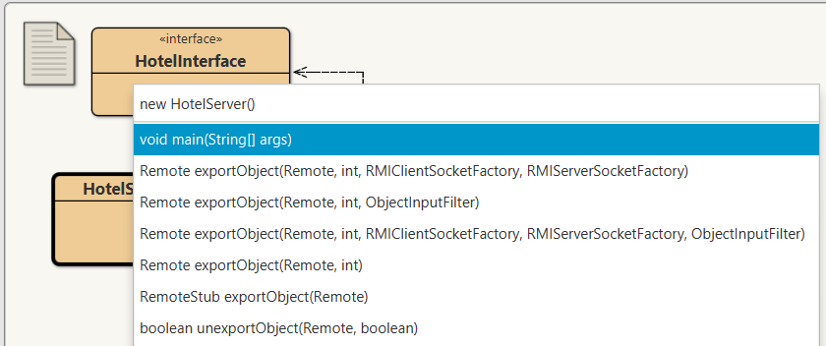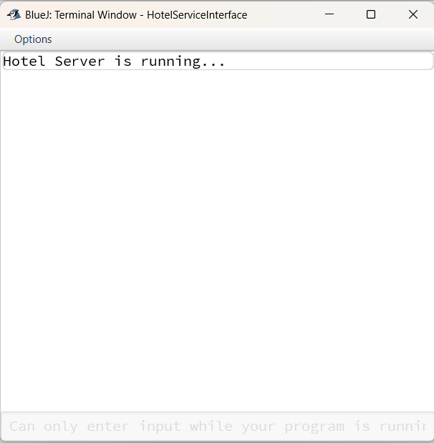

- Run main() function of HotelClient
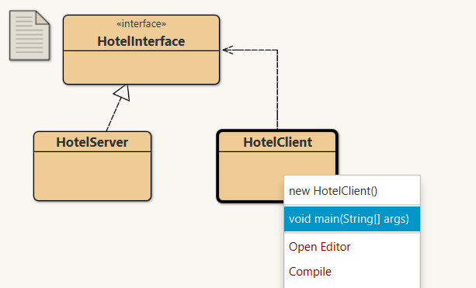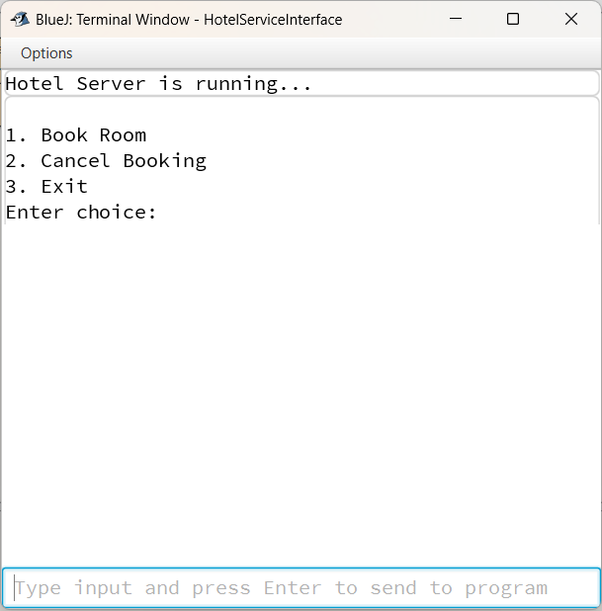

- Provide appropriate Input
