

Topics Covered:
- Software engineering problem and software product

- Software product attributes

- Definition of a Software Project (SP)

- SP Vs. other types of projects activities covered by SPM,

- Categorizing SPs

- Project management cycle

- SPM framework

- Types of project plan

SOFTWARE ENGINEERING PROBLEM AND SOFTWARE PRODUCT

Software is more than just a program code. A program is an executable code, which serves some computational purpose. Software is considered to be collection of executable programming code, associated libraries and documentations. Software, when made for a specific requirement is called software product. Engineering on the other hand, is all
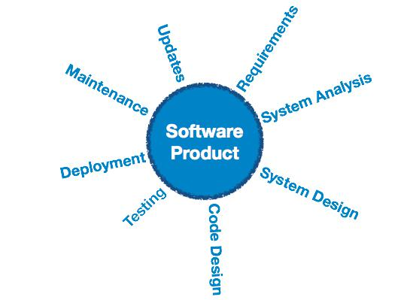
about developing products, using well-defined, scientific principles and methods.

Software engineering is an engineering branch associated with development of software product using well-defined scientific principles, methods and procedures. The outcome of software engineering is an efficient and reliable software product.

PROBLEMS RELATED TO

SOFTWARE ENGINEERING

- The Problem of scale: A fundamental problem of software engineering is the problem of scale; development of a very

large system requires a very different set of methods compared to developing a small system. While dealing with a small software project, the technology requirement is low and the project management requirement is also low. However, when the scale changes to large systems, to solve such problems properly, it is essential that, and the project management for the development project also needs to be more formal.

- Cost, schedule and quality: The cost of developing a system is the cost of the resources used for the system, which, in the case of software, are the manpower, hardware, software, and the other support resources. Generally, the manpower component is predominant, as software development is largely labor-intensive and the cost of the computing systems is now quite low.

Hence, the cost of software project is measured in terms of person-months, i.e. the cost is considered to be the total number of person-months spent in the project. Schedule is an important factor in many projects. Business trends are dictating that the time to market of a product should be reduced; that is, the cycle time from concept to delivery should be small. Any business with such a


Compiled by: Smn 1

Unit: 1 Introduction to Software Project Management (SPM) 5 Hrs.

requirement will also require that the cycle time for building a software needed by the business be small.

One of the major factors driving any production discipline is quality. We can view quality of a software product as having three dimensions:

  - Product Operation
  - Product Transition
  - Product Revision
- The Problem of consistency: Though high quality, low cost and small cycle time are the primary

objectives of any project, for an organization there is another goal: consistency. An organization involved in software development does not just want low cost and high quality for a project, but it
wants these consistently.

SOFTWARE PRODUCT ATTRIBUTES
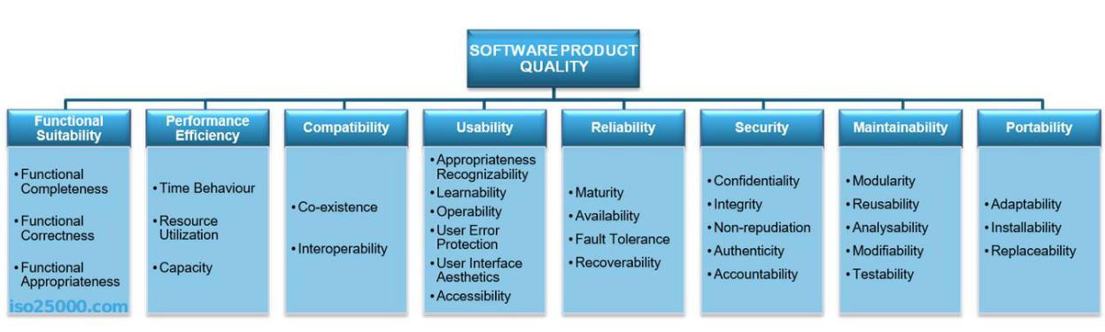

- Performance shows the response of the system to performing certain actions for a certain period of time. There are two ways how to measure performance:

  - Latency: Time spent on responding to an event
  - Channel capacity. The number of events that occur at a certain point in time.

In practice, the possible performance indicators include, for example:
  - Average/maximum number of system users per time unit.
  - Average page load time.
  - Average method execution time.

- Interoperability is an attribute of the system or part of the system that is responsible for its operation and the transmission of data and its exchange with other external systems. A well-designed system facilitates integration with third-party systems. To improve the interoperability, you can use well-designed external interfaces, standardization systems, etc.

Naturally, there are a lot of problems for interaction:
  - Outdated external systems.
  - Different formats of data in similar external systems.
  - Different versions of the API in external systems.
  - Backwards compatibility of the API for integration.

  - Poor quality and lack of standards of external systems.

- Usability is one of the most important attributes, because, unlike in cases with other attributes, users can see directly how well this attribute of the system is worked out. One of the key problems of usability is too much interaction or too many actions necessary to accomplish a task. Incorrect sequences of steps in multistage interfaces are also a problem of usability. Data elements and controls may be designed not according to the accepted patterns of user experience, which also complicates the interaction. For example, if you are developing an iOS application, then it is important to use the guidelines from Apple, or the guidelines from Microsoft— for Windows desktop applications.

Examples of important indicators for this attribute are:

  - List of supported devices, OS versions, screen resolutions, and browsers and their versions.


Compiled by: Smn 2

Unit: 1 Introduction to Software Project Management (SPM) 5 Hrs.

  - Elements that accelerate user interaction, such as “hot keys”, “lists of suggestions”, and so on.

  - Average time a user needs to perform individual actions.
  - Support of accessibility for people with disabilities.

- Reliability is an attribute of the system responsible for the ability to continue to operate under predefined conditions. Most often, the system fails due to the inaccessibility of external elements, such as databases, systems, and network connections.

- Availability is part of reliability and is expressed as the ratio of the available system time to the total working time. Important indicators for this attribute are:

  - Availability.
  - Planned downtime.
  - Time needed to update the software, and so on.

- Security is responsible for the ability of the system to reduce the likelihood of malicious or accidental actions as well as the possibility of theft or loss of information. There are a number of measures that are used to protect systems: authentication, encryption, audit, and others.

Examples of this attribute in the work of the system are:
  - The ability of the system to detect DDoS attacks and respond to them.
  - Restrictions of user access in accordance with authentication/authorization.
  - Prevention of SQL injection.
  - Encryption of passwords and content.
  - Secure connection.

- Maintainability is the ability of the system to support changes. Changes can be related to new business requirements or correction of old errors and affect system components or separate methods. Also, maintainability affects the time needed to restore the system after a failure. Excessive dependencies between components have a very negative effect on maintainability.

- Modifiability determines how many common changes need to be made to the system to make changes to each individual item. Ideal is the case where each change affects only one element.

- Testability shows how well the system allows performing tests, according to predefined criteria. In addition to testing performance, testability makes it possible to effectively divide the system into subsystems.

The main indicators for this attribute are:
  - Percentage of coverage with modular, integration, or unit tests.

  - The final list of required test environments as well as the final list of used approaches to testing (manual/automatic, regression, integration, etc.)

- Scalability is the ability of the system to handle load increases without decreasing performance, or the possibility to rapidly increase the load.

There are two ways to improve scalability:

  - Vertical: To increase, we add more resources, such as memory, disks or processors into one system.

  - Horizontal: We increase the number of computing units and divide the load.

- Reusability is a chance of using a component or system in other components/systems with small or no change. Allocation of responsibilities, modularization, decreasing of copy-paste are all about reusability. Copying code, or worse, using different components for the same result in different places, is one of the biggest problems of reusability.

- Supportability is the ability of the system to provide useful information for identifying and solving problems. The main problems in ensuring supportability can be addressed with the following means:

  - No diagnosis: How the activity and performance of the system are controlled. This includes various types of logging.


Compiled by: Smn 3

Unit: 1 Introduction to Software Project Management (SPM) 5 Hrs.

- No tools for troubleshooting: This includes backups, various systems for creating snapshots of the system, and tools for auditing the system. When the system fails, it is always more pleasant to wait for an automatic restart than to solve the issue manually.

- No health checking: This includes a variety of systems for measuring compilation time,
deployment time, database size, or mobile application size.

A Software Project is the complete procedure of software development from requirement gathering to testing and maintenance, carried out according to the execution methodologies, in a specified period of time to achieve intended software product.

Software Project Management is the art and science of planning and leading software projects. It is a sub-discipline of project management in which software projects are planned, implemented, monitored and controlled.

Fundamentals of Software Project Management

- clearly defining the vision for the end result
- gathering the requirements in detail

- breaking down the work effort into tasks
- establishing measurable milestones that the team accepts
- obtaining commitment on meeting the project objectives
- tracking progress using metrics that are simple and fair
- implementing quality controls that everyone understands
- staffing the project appropriately to meet the project goals
- selecting adequate tools and training to get the job done
- assessing risks and mitigating them

STAKEHOLDERS: These are people who have a stake or interest in the project. Stakeholders can be categorized as:
- Internal to the project team: They will be under the direct managerial control of the project leader.

- External to the project team but within the same organization: The project leader might need the assistance of the users to carry out systems testing.

- External to the both project team and the organization: External stakeholders may be customers (users) who will benefit from the system that the project implements. The relation here is usually

based on contract.

Stakeholders include
- The project sponsor and project team

- Support staff

- Customers

- Users

- Suppliers

SP VS. OTHER TYPES OF PROJECTS ACTIVITIES COVERED BY SPM

Many techniques in general project management also apply to software project management, but Fred Brooks identified some characteristics of software projects which make them particularly difficult:

- Invisibility: When a physical artifact such as a bridge is constructed the progress can actually be seen. with software, progress is not immediately visible. Software project management can be the process of making the invisible visible.

- Complexity: Per dollar, pound or euro spent, software products contain more complexity than other engineered artifacts.

- Conformity: The 'traditional' engineer usually works with physical systems and materials like cement and steel. These physical systems have complexity, but are governed by consistent physical laws. Software developers have to conform to the requirement of human clients. It is not just that individuals can be inconsistent. Organizations, because of lapses in collective memory, in internal communication or in effective decision making, can exhibit remarkable, 'organizational stupidity'.


Compiled by: Smn 4

Unit: 1 Introduction to Software Project Management (SPM) 5 Hrs.

- Flexibility: That software is easy to change is seen as a strength. However, where the software system interfaces with a physical or organizational system, it is accommodating the other components rather than vice versa. Thus software systems are particularly subject to change.

ACTIVITIES COVERED BY SOFTWARE PROJECT MANAGEMENT

A software project is not only concerned with the actual writing of software. In fact, where a software application is bought "off the shelf “, there may be no software writing as such, but this is still fundamentally a software project because so many of the other activities associated with software will still be present.
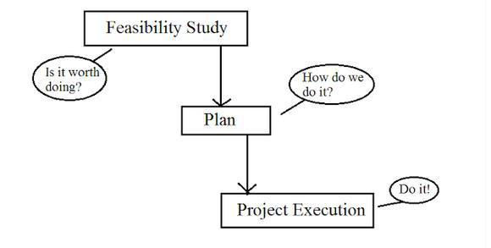

The feasibility Study: - assesses whether a project is worth starting-that it has a valid ' business case '. Information is gathered about the requirements of the proposed application. Requirements elicitation can, at least initially, be complex and difficult. The stakeholders may know the aim they wish to pursue, but not be sure about the means of achievement. The developmental and the operational costs, and the value of the benefits of the new system, will also have to be estimated.

Planning: - If the feasibility study indicates that the prospective project appears viable, then project planning can start. We create an outline plan for the whole project and a detailed one for the first stage. Because we will have more detailed and accurate project information after the earlier stages of the project have been completed, planning of the later stages is left to nearer their start.

Project execution: - The project can now be executed. The execution of a project often contains design and implementation sub-phases. Design is making decision about the form of the products to be created. This could relate to the external appearance of the software, that is, the user interface, or the internal architecture. The plan details the activities to be carried out to create these products. Planning and design can be confused because at the most detailed level. planning decisions are influenced by design decisions.


Compiled by: Smn 5

Unit: 1 Introduction to Software Project Management (SPM) 5 Hrs.
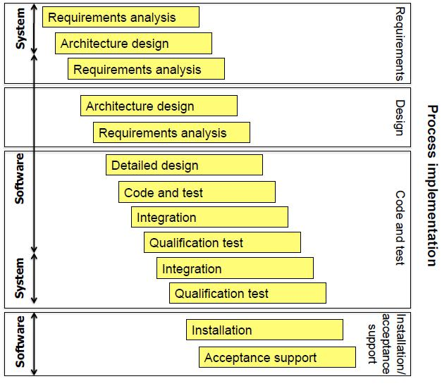

Fig: Project Management with software engineering approach

CATEGORIES SOFTWARE PROJECTS

- Compulsory versus voluntary users: In workplace there are systems that staff have to use if they want to do something such as recording a sale. However, use of a system is increasingly voluntary as in the case of computer game.

- Information systems versus embedded systems: Information system enable staff to carry out office processes e.g. Stock control system. Embedded system control machines. E.g. System might control air conditioning systems in a building.

- Outsourced Projects: While developing a large project, sometimes, it makes good commercial sense for a company to outsource some parts of its work to other companies.

- Objectives versus products: Project may be distinguished by whether their aim is to produce a product or to meet certain objectives.

  - A project might be to create a product, the details of which have been specified by the client. The client has the responsibility for justifying the project.

  - The project requirement might be meet certain objectives which could be met in a no of ways. An organization might have a problem and ask a specialist to recommend a solution.

  - Many software projects have 2 stages
- An objective driven project resulting in recommendations, it identifies the need for

a new system.
- A project actually to create a software project.

PROJECT MANAGEMENT CYCLE


Compiled by: Smn 6

Unit: 1 Introduction to Software Project Management (SPM) 5 Hrs.

The project management cycle consists of five phases: initiation, planning, implementation, monitoring and closure. The cycle represents a continuous process in which each phase provides the foundation for the next.
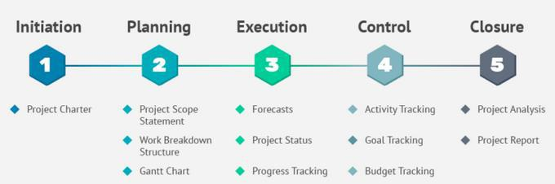

- Initiation: A solid initiation will set a project up for success and lay the foundation for all the other stages in its life cycle. During this phase, PMs first measure the feasibility and value of a project in order to determine whether or not it is worth pursuing.

Once a project is given the green light, team members will be briefed on the project’s objective and assigned goals during the Initiation Phase. PMs should be working closely with their clients and execs to properly prepare for the upcoming planning process. It is also during this phase that PMs should be rallying the team together and building support for the project. One way to do this is to pull the team tighter and to present the project significance and value to them. It will be important to have everyone on board.

- Planning: The planning stage focuses on building a blueprint for achieving the project’s goals, on time and on budget. This roadmap will be used to guide the team through the execution of the project. It is in this phase that the scope is defined and a solid project management plan will be developed. The plan involves identifying costs, available resources, potential financing options, and risks, as well as setting a realistic timeframe. Moreover, it should also include performance measures or baselines to measure progress and determine if the project is on track.

During the planning stage, project managers clearly define roles, responsibilities and tasks, so that all team members are aware of what they’re accountable for. Here are a few of the essential documents PMs typically create to ensure that everyone knows what needs to be done and that the project progresses properly:

  - Scope statement – a document that clearly describes the project’s benefits, objectives, key milestones and deliverables.

  - Work breakdown structure – a diagram that breaks down the project’s scope into manageable sections

  - Gantt chart – a project management visual used to illustrate the project timeline and to plan out the tasks identified in the work breakdown diagram.

  - Risk management plan – a document that identifies all foreseeable risks and possible strategies to mitigate them.

  - Communication plan – an essential plan if the project involves outside stakeholders. It should include communication objectives, frequency and methods, as well key content to share with the parties involved in the project. When planning project communications, the best PMs ensure their message will get across by adapting their approach to fit each particular audience. For instance, using simple, familiar PowerPoint visuals when reporting to stakeholders who may not understand PM jargon can be an effective way to share key data.

- Execution: Execution is the stage that is most commonly associated with actual project management. PMs should expect intensive activity during this time, from allocating


Compiled by: Smn 7

Unit: 1 Introduction to Software Project Management (SPM) 5 Hrs.

resources and building deliverables, to creating development updates, status reviews and performance reports. Project Managers should arrange a kick-off meeting to officially mark the onset of the execution phase, get the team started on the right track, and ensure everything is properly prepared for team members to begin executing their assignments.

The execution phase is active and PMs will be required to leverage their management skills and their soft skills to keep the project team motivated, performing and on track. PMs may need to:

  - eliminate all unnecessary distractions or activities
  - get underperformers back on track
  - manage morale to prevent burnout
  - find needed resources to overcome stalls
  - solve conflicts that may occur

- Monitoring and Control: Although it is sequenced as the 4th stage in the project management life cycle, the monitoring phase is actually most often implemented during the execution stage, not afterwards. While the team executes the project plan, PMs begin monitoring and controlling it to ensure progression is on track with the schedule. To achieve this, PMs will be:
  - monitoring the tasks that are on the critical path
  - verifying and controlling scope creep and taking measures to counter it

  - updating stakeholder with status reviews according to the pre-established communication plan

  - comparing planned costs versus actual costs
  - seeking ways to optimize performance

- Closure: The final stage of the project management life cycle is the closure phase, which requires a series of essential tasks and activities, such as delivering the finished project to the client, communicating its completion to stakeholders, releasing resources, and terminating contractors hired specifically for the project. During the closure stage, PMs also hold a post-mortem meeting to evaluate what went wrong, highlight successes, and learn what improvements can be made for future projects. Using this meeting to recognize and appreciate valuable team members is a best practice that can help build a PM’s credibility and brand.

Managing a project, regardless of its magnitude or complexity, can become overwhelming at times. Breaking it down into these 5 phases and mastering each stage can help PMs and their teams handle even the most complex projects successfully.

SOFTWARE PROJECT MANAGEMENT FRAMEWORK

- Managing integration: Projects have all types of activities going on and there is a need to keep the “whole” thing moving collectively – integrating all of the dynamics that take place. Managing integration is about developing the project charter, scope statement, and plan to direct, manage, monitor, and control project change.

- Managing scope: Projects need to have a defined parameter or scope, and this must be broken down and managed through a work breakdown structure or WBS. Managing scope is about planning, definition, WBS creation, verification, and control.

- Managing time/schedule: Projects have a definite beginning and a definite ending date. Therefore, there is a need to manage the budgeted time according to a project schedule. Managing time/schedule is about definition, sequencing, resource and duration estimating, schedule development, and schedule control.


Compiled by: Smn 8

Unit: 1 Introduction to Software Project Management (SPM) 5 Hrs.

- Managing costs: Projects consume resources, and therefore, there is a need to manage the investment with the realization of creating value (i.e., the benefits derived exceed the amount spent). Managing costs is about resource planning, cost estimating, budgeting, and control.

- Managing quality: Projects involve specific deliverables or work products. These deliverables need to meet project objectives and performance standards. Managing quality is about quality planning, quality assurance, and quality control.

- Managing human resources: Projects consist of teams and you need to manage project team(s) during the life cycle of the project. Finding the right people, managing their outputs, and keeping them on schedule is a big part of managing a project. Managing human resources is about human resources planning, hiring, and developing and managing a project team.

- Managing communication: Projects invariably touch lots of people, not just the end users (customers) who benefit directly from the project outcomes. This can include project participants, managers who oversee the project, and external stakeholders who have an interest in the success of the project. Managing communication is about communications planning, information distribution, performance reporting, and stakeholder management.
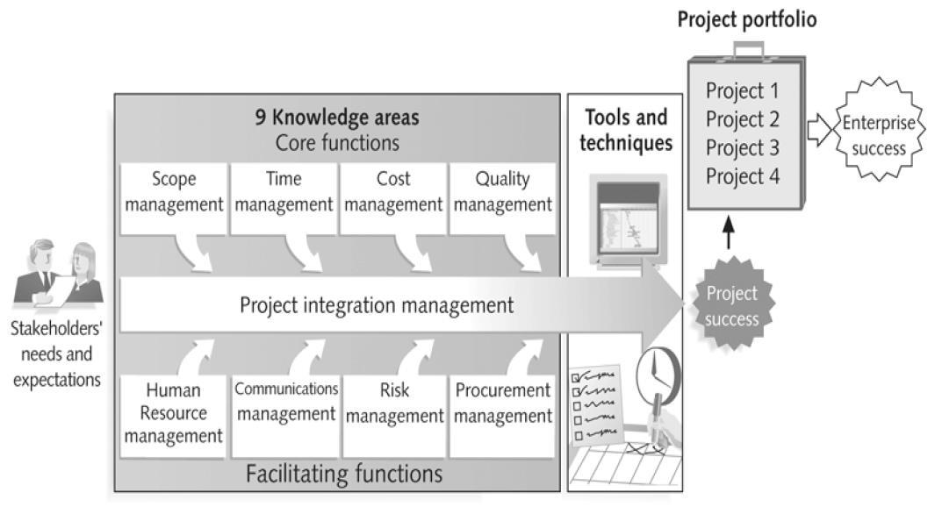

- Managing integration: Projects have all types of activities going on and there is a need to keep the “whole” thing moving collectively – integrating all of the dynamics that take place. Managing integration is about developing the project charter, scope statement, and plan to direct, manage, monitor, and control project change.

- Managing scope: Projects need to have a defined parameter or scope, and this must be broken down and managed through a work breakdown structure or WBS. Managing scope is about planning, definition, WBS creation, verification, and control.

- Managing time/schedule: Projects have a definite beginning and a definite ending date. Therefore, there is a need to manage the budgeted time according to a project


Compiled by: Smn 9

Unit: 1 Introduction to Software Project Management (SPM) 5 Hrs.

schedule. Managing time/schedule is about definition, sequencing, resource and duration estimating, schedule development, and schedule control.

- Managing costs: Projects consume resources, and therefore, there is a need to manage the investment with the realization of creating value (i.e., the benefits derived exceed the amount spent). Managing costs is about resource planning, cost estimating, budgeting, and control.

- Managing quality: Projects involve specific deliverables or work products. These deliverables need to meet project objectives and performance standards. Managing quality is about quality planning, quality assurance, and quality control.

- Managing human resources: Projects consist of teams and you need to manage project team(s) during the life cycle of the project. Finding the right people, managing their outputs, and keeping them on schedule is a big part of managing a project. Managing human resources is about human resources planning, hiring, and developing and managing a project team.

- Managing communication: Projects invariably touch lots of people, not just the end users (customers) who benefit directly from the project outcomes. This can include project participants, managers who oversee the project, and external stakeholders who have an interest in the success of the project. Managing communication is about communications planning, information distribution, performance reporting, and stakeholder management.

- Managing risk: Projects are a discovery-driven process, often uncovering new customer needs and identifying critical issues not previously disclosed. Projects also encounter unexpected events, such as project team members resigning, budgeted resources suddenly changing, the organization becoming unstable, and newer technologies being introduced. There is a real need to properly identify various risks and manage these risks. Managing risk is about risk planning and identification, risk analysis (qualitative and quantitative), risk response (action) planning, and risk monitoring and control.

- Managing procurement: Projects procure the services of outside vendors and contractors, including the purchase of equipment. There is a need to manage how vendors are selected and managed within the project life cycle. Managing procurement is about acquisition and contracting plans, sellers’ responses and selections, contract administration, and contract closure.

- Managing stakeholders: Every project impacts people and organizations and is impacted by people and organizations. Identifying these stakeholders early, and as they arise and change throughout the project, is a key success factor. Managing stakeholders is about identifying stakeholders, their interest level, and their potential to influence the project; and managing and controlling the relationships and communications between stakeholders and the project.

TYPES OF PROJECT PLAN

There are several types of planning involved in any project. That may depend upon the project manager how he defines / sees /fits the project into the overall planning process. Generally, there are three major types of project planning:

- Strategic planning (corporate planning): It involves the high level selection of the project objectives. It is the long term vision of what a project wants to achieve and it is for long term planning. This type of strategic planning is prepared by the top level management.


Compiled by: Smn 10

Unit: 1 Introduction to Software Project Management (SPM) 5 Hrs.

- Tactical planning (divisional planning): It identifies the divisional activities required to achieve goal. It is prepared for each department or division. It should be consistent with strategic planning. This type of planning is prepared by the middle manager and generally for one year.

- Operational planning: It involves the detailed planning required to meet the strategic objectives. It is the action plan of each activity of the unit. This type of planning is prepared by lower level management. These are short term, monthly or quarterly. Operational planning should be consistent with the tactical planning.

Planning Process Overview: The project planning process is the main tool used to ensure that tasks are completed in timely manner. A project may best be defined as a venture taken to ensure that a deliverable is completed within a specific timeframe and that
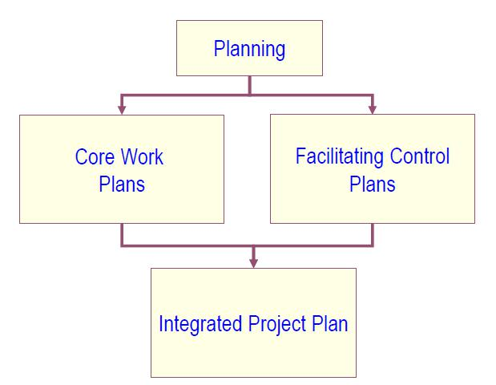

certain criteria or objectives are met. In order to make certain that a project has the best chance of success and risk of failure has been minimized, a plan is devised to determine the most effective strategy for completion. Simply put, project planning involves the processes used to ensure that tasks are completed in an efficient manner. Those in positions of leadership often need to understand various project planning process steps and tools in order to facilitate communication between team members and ensure that all responsibilities are handled.

Structure of a Software Project Management plan: Projects require a plan of what is intended and a description of what happens. Following is pro-forma that can be used for a project plan.
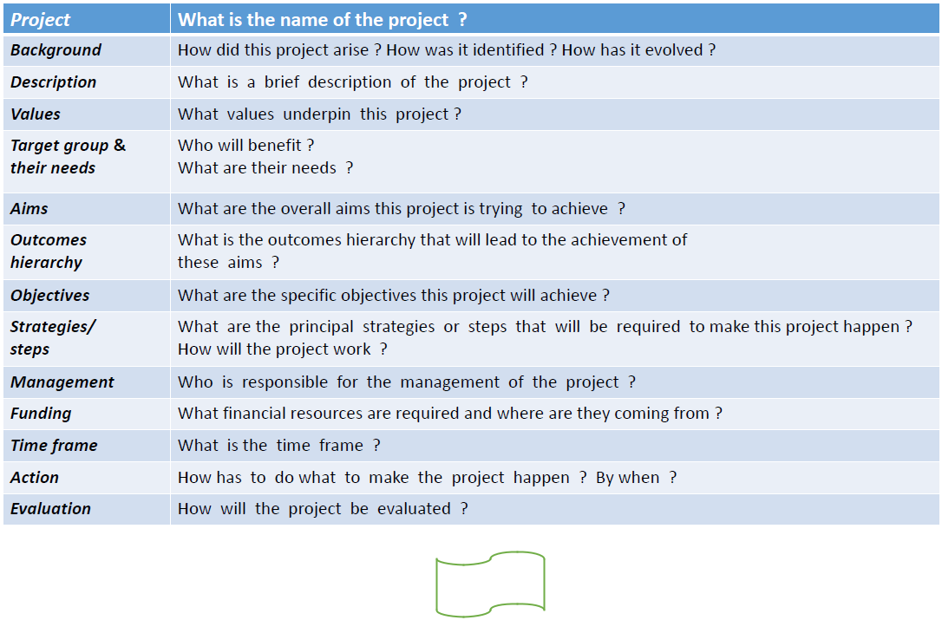

Compiled by: Smn 11

