Topics Covered:

❖ Project life cycle and product life cycle
❖ Project planning and scheduling
❖ Resource allocation

Product management and project management are both essential concepts for companies aiming to stay competitive in today’s business landscape. However, project management and product management are often confused by even the most experienced business professionals.
A product is anything that can be offered to a market to solve a problem, or to satisfy a want or need. Products have a life cycle that consists of multiple stages. First the product is conceived, then developed, then introduced and managed in the market, and finally the product is retired when the need for it diminishes.
A project is a temporary endeavor that is undertaken to create a unique product or service. With a project, there is a clear definition of what needs to be delivered by a specified date in time.
It’s important to note that a product can only be developed within the context of a project, and multiple
projects can occur within a product’s life cycle.
Product management is an organizational function within a company that deals with the planning, forecasting, and production or marketing of a product or products at all stages of the product life cycle. Project management, on the other hand, consists of the application of processes, methods, knowledge, skills, and experience to achieve the objectives of a specific project.
Project Management Life Cycle
Whether you’re working on a small project with modest business goals or a large, multi-departmental initiative with sweeping corporate implications, understanding the project management life cycle is
essential. Every project has essential milestones at the beginning, in the middle, and at the end, following a path from initiation to completion to evaluation.
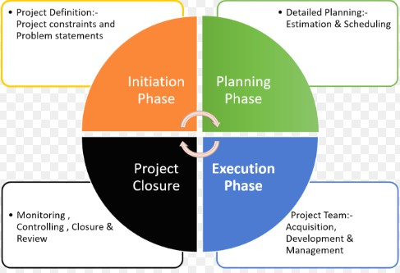
The project management life cycle is usually broken down into four phases: initiation, planning, execution, and
closure—these make up the path that takes your project from the beginning to
the end. Some methodologies also include a fifth phase, controlling or monitoring. For our purposes, this
phase is covered under the execution and closure phases.

1. Initiation Phase
During the first of these phases, the initiation phase, the project objective or need is identified; this can be a business problem or opportunity. An appropriate response to the need is documented in a business case with recommended solution options. A feasibility study is conducted to investigate
whether each option addresses the project objective and a final recommended solution is
determined. Issues of feasibility (“can we do the project?”) and justification (“should we do the project?”) are addressed.
Once the recommended solution is approved, a project is initiated to deliver the approved solution
and a project manager is appointed. The major deliverables and the participating work groups are

identified, and the project team begins to take shape. Approval is then sought by the project manager to move onto the detailed planning phase.

2. Planning Phase
The next phase, the planning phase, is where the project solution is further developed in as much
detail as possible and the steps necessary to meet the project’s objective are planned. In this step, the team identifies all of the work to be done. The project’s tasks and resource requirements are identified, along with the strategy for producing them. This is also referred to as “scope management.” A project plan is created outlining the activities, tasks, dependencies, and timeframes. The project manager coordinates the preparation of a project budget by providing cost estimates for the labor, equipment, and materials costs. The budget is used to monitor and control cost expenditures during project implementation.
Once the project team has identified the work, prepared the schedule, and estimated the costs, the three fundamental components of the planning process are complete. This is an excellent time to
identify and try to deal with anything that might pose a threat to the successful completion of the
project. This is called risk management. In risk management, “high-threat” potential problems are identified along with the action that is to be taken on each high-threat potential problem, either to reduce the probability that the problem will occur or to reduce the impact on the project if it does occur. This is also a good time to identify all project stakeholders and establish a communication plan describing the information needed and the delivery method to be used to keep the stakeholders informed.
Finally, you will want to document a quality plan, providing quality targets, assurance, and control measures, along with an acceptance plan, listing the criteria to be met to gain customer acceptance.
At this point, the project would have been planned in detail and is ready to be executed.

3. Implementation (Execution) Phase
During the third phase, the implementation phase, the project plan is put into motion and the work of the project is performed. It is important to maintain control and communicate as needed during
implementation. Progress is continuously monitored and appropriate adjustments are made and
recorded as variances from the original plan. In any project, a project manager spends most of the time in this step. During project implementation, people are carrying out the tasks, and progress information is being reported through regular team meetings. The project manager uses this information to maintain control over the direction of the project by comparing the progress reports with the project plan to measure the performance of the project activities and take corrective action as needed. The first course of action should always be to bring the project back on course (i.e., to return it to the original plan). If that cannot happen, the team should record variations from the original plan and record and publish modifications to the plan. Throughout this step, project sponsors and other key stakeholders should be kept informed of the project’s status according to the agreed-on frequency and format of communication. The plan should be updated and published on a regular basis.
Status reports should always emphasize the anticipated end point in terms of cost, schedule, and quality of deliverables. Each project deliverable produced should be reviewed for quality and
measured against the acceptance criteria. Once all of the deliverables have been produced and the
customer has accepted the final solution, the project is ready for closure.

4. Closure Phase
During the final closure, or completion phase, the emphasis is on releasing the final deliverables to the customer, handing over project documentation to the business, terminating supplier contracts,
releasing project resources, and communicating the closure of the project to all stakeholders. The last remaining step is to conduct lessons-learned studies to examine what went well and what didn’t. Through this type of analysis, the wisdom of experience is transferred back to the project
organization, which will help future project teams.

Product Life Cycle
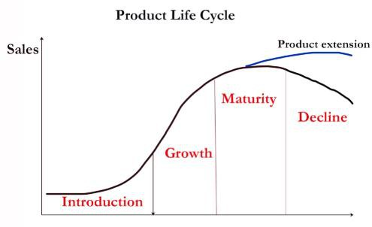
The product life cycle describes the period of time over which an item is developed, brought to market and eventually removed from the market. The cycle is broken into four stages: introduction, growth, maturity and decline. The idea of the product life cycle is used in marketing to decide when it is appropriate to advertise, reduce prices, explore new markets or create new packaging.

1. Introduction Stage – This stage
of the cycle could be the most expensive for a company launching a new product. The size of the market for the product is small, which means sales are low, although they will be increasing. On the other hand, the cost of things like research and development, consumer testing, and the marketing needed to launch the product can be very high, especially if it’s a competitive sector.
2. Growth Stage – The growth stage is typically characterized by a strong growth in sales and profits, and because the company can start to benefit from economies of scale in production, the profit
margins, as well as the overall amount of profit, will increase. This makes it possible for businesses
to invest more money in the promotional activity to maximize the potential of this growth stage.
3. Maturity Stage – During the maturity stage, the product is established and the aim for the manufacturer is now to maintain the market share they have built up. This is probably the most
competitive time for most products and businesses need to invest wisely in any marketing they undertake. They also need to consider any product modifications or improvements to the production
process which might give them a competitive advantage.
4. Decline Stage – Eventually, the market for a product will start to shrink, and this is what’s known as the decline stage. This shrinkage could be due to the market becoming saturated (i.e. all the
customers who will buy the product have already purchased it), or because the consumers are switching to a different type of product. While this decline may be inevitable, it may still be possible
for companies to make some profit by switching to less-expensive production methods and cheaper markets.

Project Planning
Project planning is a procedural step in project management, where required documentation is created to ensure successful project completion. Documentation includes all actions required to define, prepare,
integrate and coordinate additional plans. The project plan clearly defines how the project is executed,
monitored, controlled and closed. Project planning is never truly finished until a project is completed. A well-prepared plan should address and consequently answer the following questions:
Why? -This question is about the reasons why a project is sponsored and the problem it addresses.

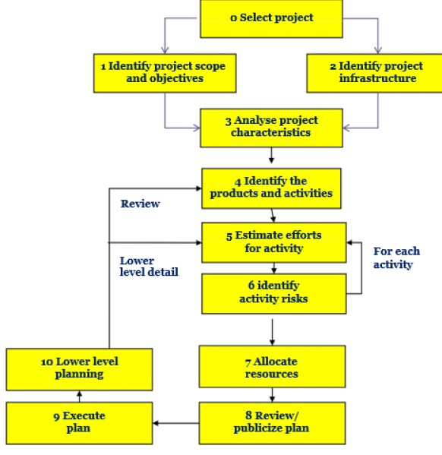
What? -This question is about the work that is to be done to deliver products/results, etc. and deliverables themselves.
Who? - This is about involved people, their roles and responsibilities as well as the way they are supposed to be organized.
When? - This is about project’s
schedule/timeline.

Step in Project Planning Process
➢ Step 0: Select project
➢ Step 1: Identify project scope and objectives
➢ Step 2: Identify project infrastructure
➢ Step 3: Analyze project characteristics
➢ Step 4: Identify project products
and activities
➢ Step 5: Estimate effort for each activity
➢ Step 6: Identify activity risks
➢ Step 7: Allocate resources
➢ Step 8: Review/publicize plan
➢ Step 9: Execute plan
➢ Step 10: Execute lower levels of planning

Step 1: Identify project scope and objectives
❖ Identify objectives and practical measures of the effectiveness in meeting those objectives
❖ Establish a project authority
o To ensure the unity of purpose among all persons concerned
❖ Identify all stakeholders in the project and their interests
❖ Modify objectives in the light of stakeholder analysis
❖ Establish methods of communication between all parties

Step 2: Identify Project Infrastructure
❖ Identify relationship between the project and strategic planning
➢ To determine the order of related projects (in the organization) being carried out
➢ To establish a framework within which the system fits
➢ To ensure the hardware and software standards are followed
❖ Identify installation standards and procedures
➢ more appropriate name: “Identify standards and procedures related to the software
project”
❖ Identify project team organization

Step 3: Analyze Project Characteristics
❖ Distinguish the project as either objective-driven or product-driven
❖ Analyze other project characteristics (including quality-based ones)
❖ Identify high level project risks

❖ Take into account user requirements concerning implementation
❖ Select general lifecycle approach in the light of the above
❖ Review overall resource estimates
Up to this stage,
➢ the major risks of the project are identified
➢ the overall approach of the project is decided
So, it is a good place to re-estimate the required effort and other resources for the project

Step 4: Identify Project Products and Activities
❖ Identify and describe project products
➢ Identify all the products related to the project
➢ Account for the required activities
❖ Document generic product flows
➢ To document the relative order of the products
❖ Recognize product instances
❖ Produce an ideal activity network
➢ Activity network shows the tasks that have to be carried out as well as their sequence of execution for the creation of a product from another
❖ Modify the ideal to take into account need for stages and checkpoints
➢ To check compatibility of products of previous activities

Step 5: Estimate Effort for Each Activity
❖ Carry out bottom-up estimates
➢ need to estimate staff effort, time for each activity, and other resources
❖ Revise plan to create controllable activities
➢ need to break a task into a series of manageable sub-tasks

Step 6: Identify Activity Risks
❖ Identify and quantify the risks of each activity
❖ Plan risk reduction and contingency measures where appropriate
❖ Adjust overall plans and estimates to take account of risks

Step 7: Allocate Resources (Staffing)
❖ Identify and allocate resources
➢ type of staff needed for each activity
➢ staff availabilities are identified
➢ staff are provisionally allocated to task
❖ Revise plans and estimates to take into account resource constraints
➢ staffing constraints
➢ staffing issues

Step 8: Review/publicize Plan
❖ Review quality aspects of the project plan
➢ To ensure each activity is completed with a quality product
➢ Each activity should have ‘exit requirements’.
➢ This ensures the quality of the product on each activity.
❖ Document plans and obtain agreement
➢ all parties understand and agree to the commitments in the plan

Step 9 and 10: Execute Plan/Lower Level of Planning
❖ Build the physical project deliverables and present them to the customer for signoff.

Once the project is under way, plans will need to be drawn up in greater detail for each activity as it becomes due. Detailed and lower level of planning of the later stages will need to be delayed because more information will be available nearer the start of the stage.

SCHEDULING
Software Project Scheduling is an activity that distributes Estimated Effort across the Planned Project
Duration by allocating the Effort to specific Software Engineering Task. Project Scheduling is the culmination of a Project Planning activity that is a primary component of Software Project Management.
Project Scheduling establishes a “Road Map” for the Project Manager When combined with Estimation
Methods and Risk Analysis.
Scheduling begins with Process Decompositions. The characteristics of the Project are used to adapt an appropriate task set for the Work to be done. A Task Network depicts each engineering task, its dependency
on other tasks and its projected duration. The Task Network is used to compute the Critical Path, a Timeline
Chart and a variety of project information. Using the Project Schedule as a guide, the Project Manager can track and control each step in the Software process.

Project scheduling
The reality of a Technical Project is that hundreds of small tasks must occur in order to accomplish a large goal. Some of these tasks lie outside the main stream and may be completed without worry abut impact On
Project Completion Date. Other tasks lie on the “Critical Path”. These tasks are called “Critical Tasks” fall behind schedule the completion date on the entire project is put into jeopardy. The Project Managers
Objectives with regards to Project Scheduling are:
1. Define all Tasks.
2. Build a Network that depicts that’s dependencies.
3. Identify the tasks that are Critical within the Network.
4. Track task progress to ensure that delay is recognized. “One Day at a time “.

Scheduling Techniques
❖ Program Evaluation and Review Technique (PERT)
❖ Gantt Chart
❖ Critical Path Method (CPM)
❖ Work Breakdown Structure (WBS)
❖ Bar Chart
❖ Linked Bar Chart
❖ Network Diagram

RESOURCE ALLOCATION
Resource allocation in project management is concerned with creating a plan which can help achieve future goals. There are many resources which have to be allocated when managing a project, beginning from
budget to equipment and tools, to data and the project’s plan.
Resource allocation in project management is so important because it gives a clear picture on the amount of work that has to be done. It also helps to schedule ahead and have an insight into the team’s progress,
including allocating the right amount of time to everyone on the team.
Resource allocation allows to plan and prepare for the project’s implementation or achieving goals. It is
also possible to analyze existing threats and risks to the project.
But above all, resource allocation in project management helps to control all the workload. This, as a result, contributes to team’s effectiveness at work and what follows later is a satisfying and exhaustive
project.

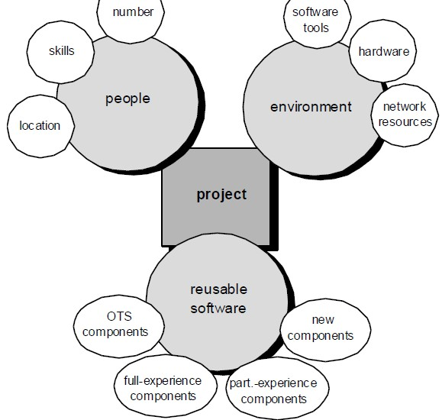
How to Allocate Resources Since resources refer to quite an extensive list of things and aspects of project management, it may be confusing when trying to properly allocate them all. But it’s not difficult and requires certain dedication and involvement. Here’s what you can do to allocate resources in the right way when managing a project:
❖ know the scope – to know what is project
about, what will be needed to achieve it, and to be able to
properly allocate resources;
❖ identify resources – to know which tools, equipment, etc. will be needed for completing the project;
❖ track time – to have a deep analysis of the progress and current situation as well as be able to
control it in the real-time;
❖ Don’t look only at the big picture – the process of working on a project is not done with task allocation. Once resources are allocated keep track of all of them. If you lose at least one tiny detail,
your project may fail;
❖ Don’t over-allocate – because your team will experience burnout and their productivity will significantly drop.

