Topics Covered:

Introduction, strategic assessment, technical assessment, economic analysis: Present worth, future worth, annual worth, internal rate of return (IRR) method, benefit-cost ratio analysis, including uniform gradient cash flow and comparison of mutually exclusive alternatives.

Cost benefit analysis: Cost-benefit analysis is a simple technique for comparing the business value a project will produce with the cost of producing it. Project managers use cost-benefit analysis in the project initiation phase to show the value of doing a project. During project initiation, the sponsor and project manager must justify the project to get the organization’s approval to spend the money. The cost-benefit analysis compares the project’s costs to the business value it will deliver. Few organizations want to go ahead with projects that will cost more than the value they will produce. So project managers conduct the cost-benefit analysis by gathering data on the value of the benefits and the cost of the project.

The Purpose of Cost Benefit Analysis
The purpose of cost benefit analysis in project management is to have a systemic approach to figure out the pluses and minuses of various paths through a project, including transactions, tasks, business requirements and investments. Cost benefit analysis gives you options, and it offers the best approach to achieve your goal while saving on investment.
There are two main purposes in using CBA:
1. To determine if the project is sound, justifiable and feasible by figuring out if its benefits outweigh costs.
2. To offer a baseline for comparing projects by determining which project’s benefits are greater than
its costs.
The benefits of a software project include four types:
❖ Cost-savings benefits
❖ Cost-avoidance benefits
❖ Improved-service-level benefits
❖ Improved Information benefits

The cost of a software project include five types:
❖ Hardware Costs
❖ Personnel Costs
❖ Facility Costs
❖ Operating Costs
❖ Supply Costs

Classification of Costs and Benefits: Costs and benefits can be classified as follows: (a) Tangible or Intangible Costs and Benefits
(b) Fixed or Variable Costs and Benefits
(c) Direct or Indirect Costs and Benefits

❖ Tangible Cost: An out lay of cash for any specific item or activity is referred to as a tangible cost.
These costs are known and can be estimated quite accurately. Hardware costs, salaries for professionals, software cost are all tangible costs. Included tangible costs are the cost of equipment
such as computers and terminals, the cost of resources, the cost of systems analysts’ time, the cost of program’s time, and other employees’ salaries.
❖ Intangible Cost: Costs that are known to exist but their financial value cannot be exactly measured are referred to as intangible costs. The estimate is only an approximation. It is difficult to fix exact intangible costs. For example, employee morale problem because of installing new system is an
intangible cost. The cost of breakdown of an online system during banking hours will cause the bank lose deposits, loss of customer goodwill etc.
Tangible Benefits Intangible Benefits Increased Sales Increased market share Reduction in staff Increased brand recognition Reduction in inventory Higher quality products Reduction in IT cost Improved customer service Better supplier price Better supplier relation

❖ Direct Costs: Direct costs are those which are directly associated with a system. Direct costs are having rupee value associated with it. They are-applied directly to the operator. For example, the purchase of pen drive for NRs.2, 000/- is a direct cost because we can associate the pen drive with money spent.
❖ Indirect Costs: Indirect costs result from the operations that are not directly associated with the system. They are often referred to as overhead expenses. For example, cost of space to install a
system, insurance, maintenance of computer center, heat, light and air-conditioning are all indirect
costs.
❖ Direct Benefits: Direct benefits also can be specifically attributable to a given project. For example, if the proposed system that can handle more transactions say25% more than the present system
then it is direct benefit.
❖ Indirect Benefits: Indirect benefits are realized as a by-product of another system. For example, a system that tracks sales-calls on customers provides an indirect marketing benefit by giving
additional information about competition. In this case, competition information becomes an
indirect benefit although its work in terms of money cannot be exactly measured.
❖ Fixed Costs: Fixed costs are considered as sunk costs. They don't change. Once encountered, they will not recur. For example, the purchase of equipment for a computer center is called as fixed cost
as it remains constant whether in equipment is being used extensively or not. Similarly, the insurance, and purchase of software, etc.
❖ Variable Costs: Variable costs are incurred on a regular basis. Recurring period may be weekly or
monthly depending upon the system. They are generally proportional to world volume and continue as long as the system is in operation. For example, the cost of computer forms vary in proportion to the amount of processing or the length of the reports desired.
❖ Fixed Benefits: Fixed benefits also remain constant by using a new system. They also don’t change.
If 20% of staff member are reduced, we can call it a fixed benefit.
❖ Variable Benefits: Variable benefits, on the other hand, are realized on a regular basis. For example the library information system that saves two minutes in providing information about particular

book whether it is issued or not, to the borrower compared with the manual system. The amount of time saved varies with the information given to the number of borrowers.

The Process of Cost Benefit Analysis:
CBA is a process that presents a picture of various costs & benefits associated with an information system. CBA as a process consists of 3 basic activities:
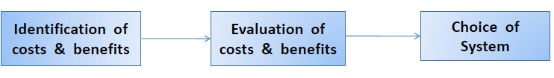

1. Identification of Costs & Benefits: Identify the costs & benefits associated with a task / operation, or investment project.
2. Evaluation of costs (tangible, intangible, fixed, variable, direct, & indirect) & benefits associated
with each task / operation / investment project.
3. Choice of system: Select the best system which involves least cost & yields maximum benefits.

Steps in Cost Benefit Analysis:
Step-1: Identifying and estimating all of the costs and benefits of carrying out the project and expressing these costs and benefits in common units. It includes
➢ Development cost of system.
➢ Operating cost of system.
➢ Benefits obtained by system.
When new system is developed by the proposed system, then new system should reflect the above three as same as proposed system.
Example: sales order processing system which gives benefit due to use of new system.
Step-2: Expressing these costs and benefits in common units. Calculates net benefit.
Net benefit=total benefit – total cost. (Cost should be expressed in monetary terms)

Three types of cost and benefits
➢ Development costs: includes salary and other employment cost of staff involved.
➢ Setup costs: includes the cost of implementation of system such as hardware, and also file conversion, recruitment and staff training.
➢ Operational cost: cost require to operate system, after it is installed.
➢ Direct benefits: directly obtained benefit by making use of/operating the system.
o Example: reduction of salary bills, through the introduction of a new, computerized system.
➢ Assessable indirect benefits: these benefits are obtained due to updating / upgrading the
performance of current system. It is also referred as “secondary benefits”.
o Example: “use of user – friendly screen”, which promotes reduction in errors, thus
increases the benefit.
➢ Intangible benefits: these benefits are longer term, difficult to quantify. It is also referred as
“indirect benefits”.
o Example: enhanced job interest leads reduction of staff turnover, in turn leads lower recruitment costs.

Cost benefit evaluation techniques
Cost-benefit analysis (CBA) is a technique used to compare the total costs of a program/project with its benefits, using a common metric (most commonly monetary units). This enables the calculation of the net cost or benefit associated with the program.
As a technique, it is used most often at the start of a program or project when different options or courses of action are being appraised and compared, as an option for choosing the best approach. It can also be
used, however, to evaluate the overall impact of a program in quantifiable and monetized terms.
CBA adds up the total costs of a program or activity and compares it against its total benefits. The technique assumes that a monetary value can be placed on all the costs and benefits of a program, including tangible and intangible returns to other people and organizations in addition to those immediately impacted. As such, a major advantage of cost-benefit analysis lies in forcing people to explicitly and systematically consider the various factors which should influence strategic choice.
Decisions are made through CBA by comparing the net present value (NPV) of the program or project’s costs with the net present value of its benefits. Decisions are based on whether there is a net benefit or cost to the approach, i.e. total benefits less total costs. Costs and benefits that occur in the future have less weight attached to them in a cost-benefit analysis. To account for this, it is necessary to ‘discount’ or reduce the value of future costs or benefits to place them on a par with costs and benefits incurred today. The ‘discount rate’ will vary depending on the sector or industry, but public sector activity generally uses a discount rate of 5-6%. The sum of the discounted benefits of an option minus the sum of the discounted costs, all discounted to the same base date, is the ‘net present value’ of the option.
We would consider proceeding with a project only where the benefits outweigh the costs. However, in order to choose among projects, we need to take into account the timing of the costs and benefits as well as the
benefits relative to the size of the investment.

Net profit: The net profit of a project is the difference between the total costs and the total income over the life of the project. It shows what the company has earned (or lost) in a given period of time (usually one year). It is also called net income or net earnings.
Net profit=total costs-total incomes
Calculate net profit for the following
Year Project 1 Project 2 Project 3
0 -100000 -1000000 -120000
1 10000 200000 30000
2 10000 200000 30000
3 10000 200000 30000
4 20000 200000 30000
5 100000 300000 75000

Solution

Year Project 1 Project 2 Project 3
0 -100000 -1000000 -120000
1 10000 200000 30000
2 10000 200000 30000
3 10000 200000 30000
4 20000 200000 30000
5 100000 300000 75000
Net Profit 50000 100000 75000

Payback period: The payback period is the time taken to break even or pay back the initial investment. Normally, the project with the shortest payback period will be chosen on the basis that an organization will wish to minimize the time that a project is 'in debt'.
Advantages
➢ simple and easy to calculate.
➢ It is also a seriously flawed method of evaluating investments
Disadvantages
➢ It attaches no value to cash flows after the end of the payback period.
➢ It makes no adjustments for risk.
➢ It is not directly related to wealth maximization as NPV is.
➢ It ignores the time value of money.
➢ The "cut off" period is arbitrary.

Calculate Payback period if original investment is Rs. 12000.
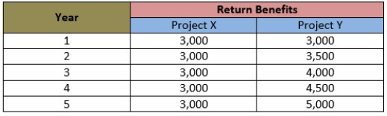
Solution:
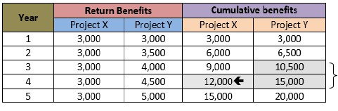
Therefore, the cumulative benefit of project X at year 4 is equal to the cost (i.e. NRs. 12,000) and that of project Y lies between year 3 and year 4. So, the payback period is 4 years for the project X and for project Y is calculated below:
Payback Period = (Amount not covered in lower year / Difference in cumulative amounts of HY & LY)
+ LY
= (1500/4500) +3
=3.33yr.
Return on investment: The return on investment (ROI), also known as the accounting rate of return (ARR), provides a way of comparing the net profitability to the investment required. There are some variations on the formula used to calculate the return on investment but a straightforward common version is

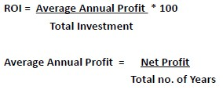
Disadvantages of ROI
➢ Takes no account of the timing of the cash flows
➢ It is tempting to compare the rate of return with current interest rates. (No compound interest calculated)
Calculate ROI for following.
Year Project 1
0 -100000
1 10000
2 10000
3 10000
4 20000
5 100000
Net Profit 50000
Answer: Total Investment = 1,00,000
Net Profit = 50,000
Total no. of Year = 5
Average Annual Profit = 50,000/5
= NRs. 10,000

ROI = (10,000/1,00,000) *100
= 10%
Note: The higher the ROI, the better.

Discounted Cash Flow (DCF) is a cash flow summary adjusted to reflect the time value of money. DCF can be an important factor when evaluating or comparing investments, proposed actions, or purchases. Other things being equal, the action or investment with the larger DCF is the better decision. When discounted cash flow events in a cash flow stream are added together, the result is called the Net Present Value (NPV).
When the analysis concerns a series of cash inflows or outflows coming at different future times, the series is called a cash flow stream. Each future cash flow has its own value today (its own present value). The sum of these present values is the Net Present Value for the cash flow stream. The size of the discounting effect depends on two things: the amount of time between now and each future payment (the number of discounting periods) and an interest rate called the Discount Rate.
➢ As the number of discounting periods between now and the cash arrival increases, the present value decreases.
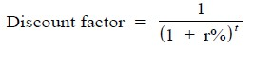
➢ As the discount rate (interest rate) in the present value calculations increases, the present value decreases.

Net present value (NPV): It is the sum of the present values of all future amounts. Present value is the value which a future amount is worth at present. It takes into account the profitability of a project and the timing of the cash flows.
Discount rate: Is the annual rate by which we discount future earnings. e.g. If discount rate is 10% and the return of an investment in a year is $110, the present value of the investment is $100.

Let n be the number of year and r be the discount rate, the present value (PV) is given by
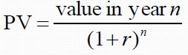
Disadvantage: May not be directly comparable with earnings from other investments or the costs of borrowing capital.

Issues in NPV
➢ Choosing an appropriate discount rate is difficult
➢ Ensuring that the rankings of projects are not sensitive to small changes in discount rate
Guidelines:
➢ Use the standard rate prescribed by the organization
➢ Use interest rate + premium rate
➢ Use a target rate of return
➢ Rank the projects using various discount rates

Consider two competing investments in computer equipment. Each calls for an initial cash out lay of
$100, and each returns a total a $200 over the next 5 years making net gain of $100. But the timing of the returns is different, as shown in the table below (Case A and Case B), and therefore the present
value of each year’s return is different. The sum of each investments present values is called the
Discounted Cash flow (DCF) or Net Present Value (NPV). Using a 10% discount rate.
Case A Case B

Timing
Discount rate
(10%)
Net cash flow
Present value
Net cash flow
Present value
now 0 1 100 100 100 100 year 1 0.9091 60 54.55 20 18.18 year 2 0.8264 60 49.59 20 16.53 year 3 0.7513 40 30.05 40 30.05 year 4 0.6830 20 13.66 60 40.98 year 5 0.6209 20 12.42 60 37.26
Total 100 62.67 100 33.83
Using NPV function of excel

Assuming a 10% discount rate, the NPV for project 1 would be calculated as in the following table. Using a 10% discount rate, calculate the net present values for projects 2, 3 and 4 and decide which, on the basis of this, is the most beneficial to pursue.

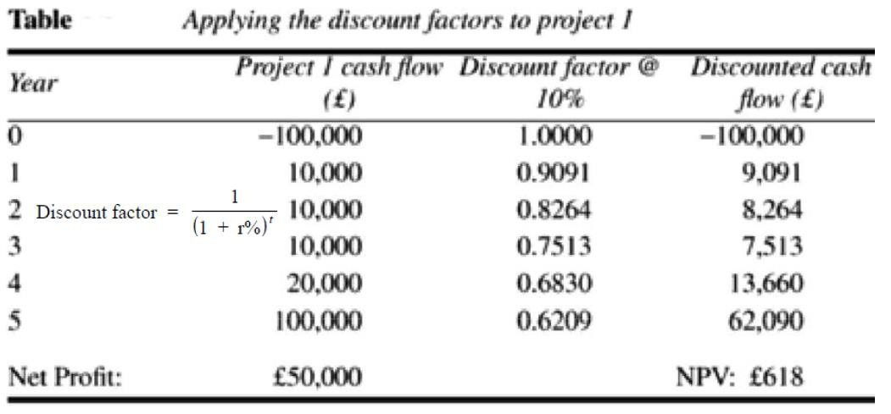
Calculate the NPV for each of the projects A, B and C shown in the table below using each of the discount rates 8%, 10% and 12%. For each of the discount rates, decide which is the best project.
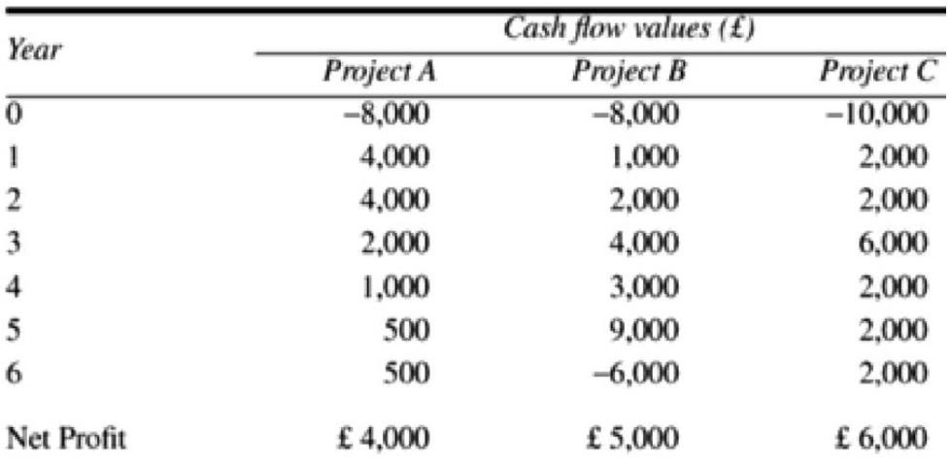
What can you conclude from this result?

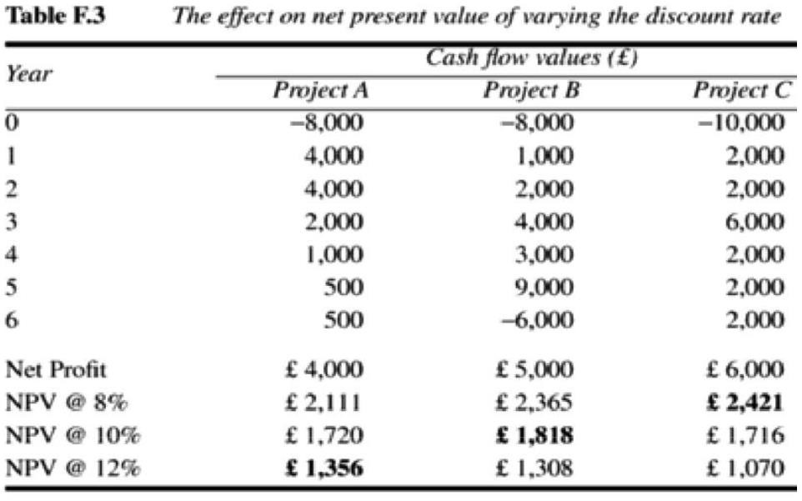

NPV –Decision Rule (If the NPV is positive, accept the project)
A positive NPV means that the project is expected to add value to the firm and will therefore increase the wealth of the owners. Since our goal is to increase owner wealth, NPV is a direct
measure of how well this project will meet our goal.

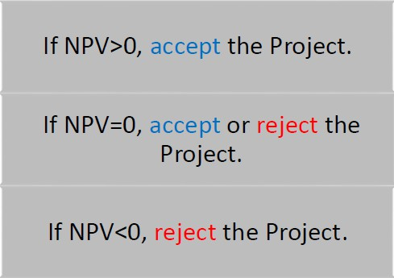
Internal rate of return: One disadvantage of NPV as a measure of profitability is that, although it may be used to compare projects, it might not be directly comparable with earnings from other investments or the costs of borrowing
capital. Such costs are usually quoted. It is based entirely on the estimated cash flows and is independent of interest rates found elsewhere. IRR is calculated by following formula here CF stands for Cash Flow and r is the internal rate of return
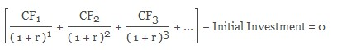

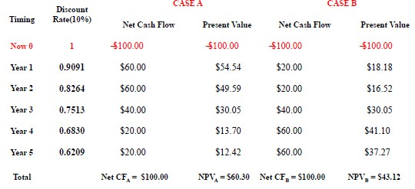
The IRR compares returns to costs by asking: "What is the discount rate that would give the cash flow stream a net present value of 0?"

Decision Rule: Accept the project if the IRR is greater than the required return

Internal Rate of Return Rules: In IRR decisions, if we have only one project, most of the time we need the basic rule «independent project»:
IRR > Cost of capital (should be accepted)
IRR = Cost of capital (provides the minimum return) IRR < Cost of capital (shouldn’t be accepted)
In addition, we need to take other situations into account too. Especially, even though NPV and IRR will
generally give us the same decision, there are some exceptions:
➢ Nonconventional cash flows–cash flow signs change more than once
➢ Mutually exclusive projects

Project Analysis is the process of evaluating a proposed software project to decide whether it should be undertaken, how it should be executed, and whether it will be successful.
It is usually done before project approval.

Objectives of Project Analysis
- Ensure the project aligns with business goals
- Check feasibility and practicality
- Estimate cost, time, and resources
- Reduce project risks
- Support decision-making

1. Strategic Assessment (Why should we do the project?)
Strategic assessment evaluates whether a project supports the organization’s long-term goals and strategy.

Key points:
- Alignment with organizational vision and mission
- Support for business objectives (growth, efficiency, innovation)
- Market demand and competitive advantage
- Identification of strategic risks and opportunities
- Priority of the project compared to other projects
Outcome: Decides whether the project is worth pursuing strategically.

2. Technical Assessment (Can we do the project?)
Technical assessment checks the feasibility of implementing the project using available technology and skills.

Key points:
- Availability of required technology and tools
- Technical complexity of the project
- Availability of skilled manpower
- Compatibility with existing systems
- Performance, scalability, and reliability issues
- Identification of technical risks
Outcome/expected: Confirms whether the project is technically feasible.

3. Economic Analysis (Is the project financially viable?)
Economic analysis evaluates whether the benefits of the project justify its costs.

Key points:
- Estimation of development, operation, and maintenance costs
- Estimation of tangible and intangible benefits
- Comparison of costs and benefits over time
- Use of financial evaluation techniques:
  - Cost–Benefit Analysis
  - Present Worth (PW)
  - Future Worth (FW)
  - Annual Worth (AW)
  - Internal Rate of Return (IRR)
  - Payback Period
Outcome /result: Determines financial profitability and return on investment.

4. Relationship among the three assessments
Assessment Type | Main Question Answered
Strategic | Should we do it?
Technical | Can we do it?
Economic | Is it worth the cost?

1. Present Worth (PW) Method
Meaning:
Present Worth converts all future cash flows (costs(cash out like hardware ,tools ) and benefits(cash in like maintaince member fee…)) into their equivalent value at the present time using an interest rate.
“How much are future benefits worth today?”

Formula (basic):
PW=F/(1+i)^{n}
Where:
- PW = Present worth
- F = Future amount
- i = interest rate per period
- n = number of periods

Decision rule:
- Accept project if: PW ≥ 0
- Choose project with higher PW (for mutually exclusive projects)

Use:
- Long-term projects
- Comparison of alternatives
Example:
You will receive 10,000 after 2 years. Interest rate = 10%.
10000/(1+.10)²
=10000/(1.10)²
=10000/1.21
=8264 is present worth.

2. Future Worth (FW) Method/ Future Value (FV)
Introduction :
Future Worth converts all present and future cash flows into their equivalent value at a future time.
“What will today’s investment be worth in the future?”

Formula (basic):
FW=P×(1+i)^{n}
Where:
- FW = Future worth
- P = Present amount
- i = interest rate
- n = number of periods

Decision rule:
- Accept project if: FW ≥ 0
- Select project with higher FW

Example:
You invest 5,000 today at 8% for 3 years:
FW=5000*(1+.08)³
=5000*(1.08)³
=5000*1.259
=6298

3. Annual Worth (AW) Method
Introduction :
Annual Worth converts all costs and benefits into an equal uniform annual amount over the project life. “What is the equivalent yearly benefit or cost of the project?”, What fixed amount per year is equivalent to this project?”

Decision rule:
- Accept project if: AW ≥ 0
- Select project with higher AW

Use cases:
- Projects with different lifespans
- Budget planning and yearly evaluation

Basic Formula:
AW=PW×i(1+i)^{n}/(1+i)^{n}​-1

Simple example
If a project has PW = 50,000, life = 5 years, interest = 10%
AW=50000*.10(1+.10)⁵ /(1+.10)⁵ -1
=50000*.10*1.61/.61
=50000*.16/.61
=50000*.26=13114
AW ≈ 13114per year (approx)
Meaning:
This project is equivalent to earning 13,114 every year for 5 years.

4. Internal Rate of Return (IRR) Method
Meaning:
IRR is the interest rate at which the present worth of benefits equals the present worth of costs.
In IRR:
PW=0
“What is the project’s actual rate of return?”
IRR is
The value today of all money received from the project
=
The value today of all money spent on the project.
at IRR:
- Present Worth (Benefits) = Present Worth (Costs)
- Net Present Value (NPV) = 0
The project is neither making profit nor loss at this rate. This rate shows how strong the project is financially.

Decision rule:
- Accept project if: IRR ≥ Minimum Acceptable Rate of Return (MARR)
- Reject if: IRR < MARR

Advantages:
- Easy to understand
- Popular in business decisions

Limitation:
- Difficult to compute
- May give multiple IRRs in some cases

Example:
You invest 10,000 today in a small project.
You receive:
- 4,000 at the end of Year 1
- 4,000 at the end of Year 2
- 4,000 at the end of Year 3

Step 1: Try an interest rate (say 10%)
- Calculate present worth of returns:
- PW=4000/1.10+4000/1.102+4000/1.103
- ie, 4000/(1+.10)¹ +4000/(1+.10)² +4000/(1+.10)³
- =3636+3306+3005=9,947
- This is less than 10,000, so 10% is too high.
SETP 2 :Again lets Check for 8%
PW=4000/1.08+4000/1.08² +4000/1.08³

5. Comparison Analysis
Method | Focus | Decision Basis
Present Worth | -Value today | PW ≥ 0
Future Worth | -Value in future | FW ≥ 0
Annual Worth | -Equal yearly value | AW ≥ 0
IRR | -Rate of return | IRR ≥ MARR

Benefit–Cost Ratio (BCR) Analysis

Meaning
BCR compares present value of benefits to present value of costs.
BCR=PW(Benefits)/PW(Costs)

Decision Rule
BCR value | Decision
BCR > 1 | Accept
BCR = 1 | Indifferent
BCR < 1 | Reject

Example (Software System)
Cost of system = 200,000
Annual benefit = 70,000 for 5 years
Interest = 10%

Step 1: Find PW of benefits

PW=A×(P/A,i,n)

(P/A,i,n)=(1+i)^{n}-1/i*(1+i)^{n}

=(1+.10)⁵-1/.10*(1+.10)⁵

= 3.7908

Now present worth of benefit =70000*3.7808=265356

Compute BCR= benefit cost/cost
BCR=265356/200,000=1.33

Uniform Gradient Cash Flow
Uniform Gradient = cash flow increases (or decreases) by a constant amount every year.
Uniform Gradient Cash Flow is when a cash amount increases or decreases by the same amount every year.
In software projects, this usually happens with:
- maintenance cost increasing each year
- staff salary increments
- server/cloud cost growth
- support cost escalation
- Salary increments of developers
- Technical debt cost growth
Example:
10,000 in year 1
15,000 in year 2
20,000 in year 3
25,000 in year 4
Gradient G = 5,000

Example (Software context)
Maintenance cost:
Year | Cost (rs)
1 | 10,000
2 | 12,000
3 | 14,000
4 | 16,000
Increase every year = 2,000
So,
Gradient G=2,000

Formula (Present Worth of Gradient)
P=G×(P/G,i,n)
Where:
- P = Present worth of gradient series
- G = yearly increase/decrease
- i = interest rate
- n = number of years

(P/G,i,n)=(1+i)^{n}-i^{n}-1/i² (1+i)^{n}

Cash flow forecasting: A cash flow forecast is an estimate of the amount of money you expect to flow in and out of your business. It includes all your projected income and expenses and usually covers the next

year, though it can also cover a shorter period such as a week or month. It estimate overall cost and benefits of a product with respect to time. Cash flow is negative during development stage where as it is positive during operating life. How often management should forecast cash flow is dependent on the financial security of the business. If the business is struggling, or is keeping a watchful eye on its finances, the business owner should be forecasting and revising his or her cash flow on a daily basis. However, if the finances of the business are more stable and 'safe', then forecasting and revising cash flow weekly or monthly is enough. Here are the key reasons why a cash flow forecast is so important:
• Identify potential shortfalls in cash balances in advance—think of the cash flow forecast as an
"early warning system". This is, by far, the most important reason for a cash flow forecast.
• Make sure that the business can afford to pay suppliers and employees. Suppliers who don't get paid will soon stop supplying the business; it is even worse if employees are not paid on time.
• Spot problems with customer payments—preparing the forecast encourages the business to look
at how quickly customers are paying their debts. Note—this is not really a problem for businesses
(like retailers) that take most of their sales in cash/credit cards at the point of sale.
• As an important discipline of financial planning—the cash flow forecast is an important management process, similar to preparing business budgets.
• External stakeholders such as banks may require a regular forecast. Certainly, if the business has
a bank loan, the bank will want to look at the cash flow forecast at regular intervals. The clash flow during development stage includes
➢ Staff wages
➢ Borrowing money from bank
➢ Paying interest to bank
➢ Payment of salaries
➢ Amount spent for installation, buying hw and sw

Cash flow expected after completion of project is also termed as income and income is expected by 2 ways.
➢ Payment on completion
➢ Stage payment
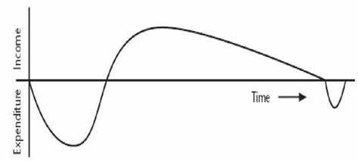

Risk evaluation
Software development is activity that uses a variety of technological advancements and requires high levels of knowledge. Because of these and other factors, every software development project contains elements of uncertainty. This is known as project risk. The success of a software development project depends quite heavily on the amount of risk that corresponds to each project activity. As a project manager, it’s not enough to merely be aware of the risks. To achieve a successful outcome, project leadership must identify, assess, prioritize, and manage all of the major risks.
Risk evaluation is meant to decide whether to proceed with the project or not, and whether the project is meeting its objectives. Risk occurs, When the project exceed its original specification and deviations from achieving it objectives and so on.
➢ Risk identification and ranking: In any project evaluation we should attempt to identify the risks
and quantify their potential effects. One common approach to risk analysis is to construct a project risk matrix utilizing a checklist of possible risks and to classify each risk according to its relative importance and likelihood. Note that the importance and likelihood need to be separately assessed
- we might be less concerned with something that, although serious, is very unlikely to occur than with something less serious that is almost certain.
➢ Risk and net present value: Where a project is relatively risky it is common practice to use a
higher discount rate to calculate net present value. This addition or risk premium, might, for example, be an additional 2% for a reasonably safe project or 5% for a fairly risky one. Projects may be categorized as high, medium or low risk using a scoring method and risk premiums designated for each category. The premiums, even if arbitrary, provide a consistent method of taking risk into account.
➢ Cost-benefit analysis: A rather more sophisticated approach to the evaluation of risk is to consider
each possible outcome and estimate the probability of its occurring and the corresponding value of the outcome. Rather than a single cash flow forecast for a project, we will then have a set of cash flow forecasts, each with an associated probability of occurring. The value of the project is then obtained by summing the cost or benefit for each possible outcome weighted by its corresponding probability.
➢ Risk profile analysis: An approach which attempts to overcome some of the objections to cost-
benefit averaging is the construction of risk profiles using sensitivity analysis.
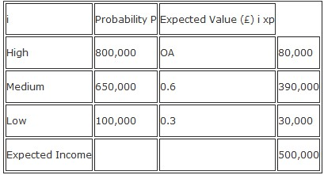
This involves varying each of the parameters that affect the project's cost or benefits to ascertain how sensitive the project's profitability is to each factor. We might, for example, vary one of our original estimates by plus or minus 5% and recalculate the expected costs and benefits for the project. By repeating this exercise for each of our estimates in turn we can evaluate the sensitivity of the project to each factor.
By studying the results of a sensitivity analysis we can identify those factors that are most important to the success of the project. We then need to decide whether we can exercise greater control over them or otherwise mitigate their effects. If neither is the case, then we must live with the risk or abandon the project. For an explanation of the Sensitivity analysis demands that we vary each factor one at a time. It does not Monte Carlo technique easily allow us to consider the effects of combinations of circumstances, neither see any textbook on does it evaluate the chances of a particular outcome occurring.
➢ Using decision trees: The approaches to risk analysis discussed previously rather assume that we
are passive bystanders allowing nature to take its own course - the best we can do is to reject over- risky projects or choose those with the best risk profile. There are many situations, however, where we can evaluate whether a risk is important and, if it is, indicate a suitable course of action.
Many such decisions will limit or affect future options and, at any point, it is important to be able to see into the future to assess how a decision will affect the future profitability of the project.
Selection of appropriate project Approach: To develop a project an appropriate technology as well as model needs to be selected. The appropriate technology and process model leads to a successful project management, resource management and project is completed with in deadline.
Choosing technologies:
➢ Is a data oriented or process oriented system to be implemented?
➢ Will the software that is to be produced be a general package or application specific?
➢ Is the system to be implemented of a particular type for which specific tools have been developed?
➢ Is the system to be created safety critical?
➢ What is the nature of the hardware/software environment in which the system will operate?

Uncertainty: The greater the uncertainties at the beginning of the project, the greater the risk that the project will be unsuccessful.
The product becomes uncertain if the requirements are not understood properly. And the users themselves
could be uncertain about what a proposed Information System is to do.
The process becomes uncertain if the project under consideration is the first where an organization has tried to use a method that is new to them. As well as any changes in the way that the systems are developed is
going to introduce uncertainty.
The resource become uncertain mainly because of unavailability of staff of the right ability and experience. As well as the larger the number of resources need or the longer the duration of the project, the more
inherently risky it is likely to be.

Choice of Process Model: A software process (also knowns as software methodology) is a set of related activities that leads to the production of the software. These activities may involve the development of the software from the scratch, or, modifying an existing system. Any software process must include the following four activities:
1. Software specification (or requirements engineering): Define the main functionalities of the software and the constrains around them.
2. Software design and implementation: The software is to be designed and programmed.
3. Software verification and validation: The software must conform to its specification and meets the customer needs.
4. Software evolution (software maintenance): The software is being modified to meet customer and market requirements changes.
In practice, they include sub-activities such as requirements validation, architectural design, unit testing, …etc.
There are also supporting activities such as configuration and change management, quality assurance, project management, user experience. Along with other activities aim to improve the above activities by introducing new techniques, tools, following the best practice, process standardization (so the diversity of
software processes is reduced), etc.
When we talk about a process, we usually talk about the activities in it. However, a process also includes the process description, which includes:

1. Products: The outcomes of an activity. For example, the outcome of architectural design maybe a model for the software architecture.
2. Roles: The responsibilities of the people involved in the process. For example, the project manager,
programmer, etc.
3. Pre and post conditions: The conditions that must be true before and after an activity. For example, the pre-condition of the architectural design is the requirements have been approved by the customer,
while the post condition is the diagrams describing the architectural have been reviewed.
Software process is complex; it relies on making decisions. There’s no ideal process and most organizations have developed their own software process.

Rapid Application Development: Rapid application development is a software development methodology that uses minimal planning in favor of rapid prototyping. A prototype is a working model that is functionally equivalent to a component of the product. In the RAD model, the functional modules are developed in parallel as prototypes and are integrated to make the complete product for faster product delivery. Since there is no detailed preplanning, it makes it easier to incorporate the changes within the development process.
RAD projects follow iterative and incremental model and have small teams comprising of developers, domain experts, customer representatives and other IT resources working progressively on their component or prototype. The most important aspect for this model to be successful is to make sure that the prototypes developed are reusable.
RADModelDesign:RAD model distributes the analysis, design, build and test phases into a series of short, iterative development cycles. Following are the various phases of the RAD Model –

➢ Business Modeling: The business model for the product under development is designed in terms of flow of information and the distribution of information between various business channels. A complete business analysis is performed to find the vital information for business, how it can be obtained, how and when is the information processed and what are the factors driving successful flow of information.

➢ Data Modeling: The information gathered in the Business Modeling phase is reviewed and analyzed to form sets of data objects vital for the business. The attributes of all data sets is identified and defined. The relation between these data objects are established and defined in detail in relevance to the business model.
➢ Process Modeling: The data object sets defined in the Data Modeling phase are converted to establish the business information flow needed to achieve specific business objectives as per the business model. The process model for any changes or enhancements to the data object sets is defined in this phase. Process descriptions for adding, deleting, retrieving or modifying a data object are given.

➢ Application Generation: The actual system is built and coding is done by using automation tools to convert process and data models into actual prototypes.
➢ Testing and Turnover: The overall testing time is reduced in the RAD model as the prototypes are independently tested during every iteration. However, the data flow and the interfaces between all the components need to be thoroughly tested with complete test coverage. Since most of the programming components have already been tested, it reduces the risk of any major issues.
The following illustration describes the RAD Model in detail.
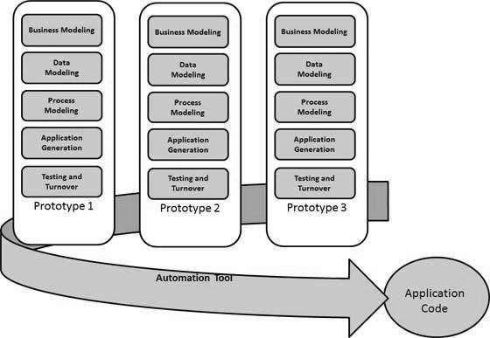

Waterfall model: The Waterfall Model was the first Process Model to be introduced. It is also referred to as a linear-sequential life cycle model. It is very simple to understand and use. In a waterfall model, each phase must be completed before the next phase can begin and there is no overlapping in the phases.
The Waterfall model is the earliest SDLC approach that was used for software development.

The waterfall Model illustrates the software development process in a linear sequential flow. This means that any phase in the development process begins only if the previous phase is complete. In this waterfall model, the phases do not overlap.

Waterfall Model – Design: Waterfall approach was first SDLC Model to be used widely in Software Engineering to ensure success of the project. In "The Waterfall" approach, the whole process of software development is divided into separate phases. In this Waterfall model, typically, the outcome of one phase acts as the input for the next phase sequentially. The following illustration is a representation of the different phases of the Waterfall Model.

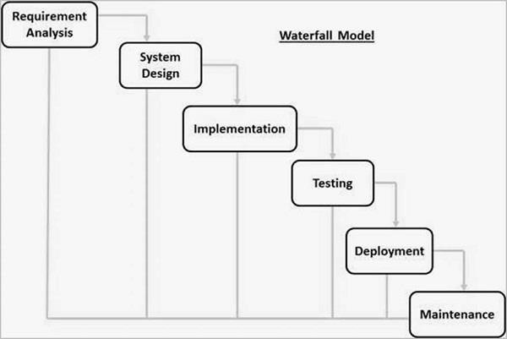

The sequential phases in Waterfall model are −

• Requirement Gathering and analysis − All possible requirements of the system to be developed

are captured in this phase and documented in a requirement specification document.

• System Design − The requirement specifications from first phase are studied in this phase and the system design is prepared. This system design helps in specifying hardware and system requirements and helps in defining the overall system architecture.
• Implementation − With inputs from the system design, the system is first developed in small programs called units, which are integrated in the next phase. Each unit is developed and tested for its functionality, which is referred to as Unit Testing.
• Integration and Testing − All the units developed in the implementation phase are integrated into a system after testing of each unit. Post integration the entire system is tested for any faults and failures.
• Deployment of system − Once the functional and non-functional testing is done; the product is deployed in the customer environment or released into the market.
• Maintenance − There are some issues which come up in the client environment. To fix those issues, patches are released. Also to enhance the product some better versions are released. Maintenance is done to deliver these changes in the customer environment.
All these phases are cascaded to each other in which progress is seen as flowing steadily downwards (like a waterfall) through the phases. The next phase is started only after the defined set of goals are achieved for previous phase and it is signed off, so the name "Waterfall Model". In this model, phases do not overlap.

Spiral Model: The spiral model combines the idea of iterative development with the systematic, controlled aspects of the waterfall model. This Spiral model is a combination of iterative development process model and sequential linear development model i.e. the waterfall model with a very high emphasis on risk

analysis. It allows incremental releases of the product or incremental refinement through each iteration around the spiral.
SpiralModel–Design:The spiral model has four phases. A software project repeatedly passes through these phases in iterations called Spirals.
➢ Identification: This phase starts with gathering the business requirements in the baseline spiral.

In the subsequent spirals as the product matures, identification of system requirements, subsystem requirements and unit requirements are all done in this phase. This phase also includes understanding the system requirements by continuous communication between the customer and the system analyst. At the end of the spiral, the product is deployed in the identified market.
➢ Design: The Design phase starts with the conceptual design in the baseline spiral and involves architectural design, logical design of modules, physical product design and the final design in the subsequent spirals.
➢ Construct or Build: The Construct phase refers to production of the actual software product at every spiral. In the baseline spiral, when the product is just thought of and the design is being developed a POC (Proof of Concept) is developed in this phase to get customer feedback. Then in the subsequent spirals with higher clarity on requirements and design details a working model of the software called build is produced with a version number. These builds are sent to the customer for feedback.
➢ Evaluation and Risk Analysis: Risk Analysis includes identifying, estimating and monitoring the technical feasibility and management risks, such as schedule slippage and cost overrun. After testing the build, at the end of first iteration, the customer evaluates the software and provides feedback.
The following illustration is a representation of the Spiral Model, listing the activities in each phase.

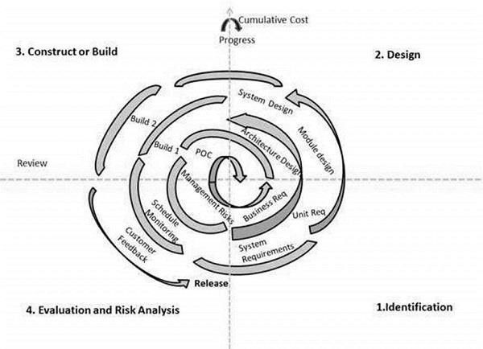

Based on the customer evaluation, the software development process enters the next iteration and subsequently follows the linear approach to implement the feedback suggested by the customer. The process of iterations along the spiral continues throughout the life of the software.

Prototyping Model: Prototype is a working model of software with some limited functionality. The prototype does not always hold the exact logic used in the actual software application and is an extra effort to be considered under effort estimation. Prototyping is used to allow the users evaluate developer proposals and try them out before implementation. It also helps understand the requirements which are user specific and may not have been considered by the developer during product design.
Following is a stepwise approach explained to design a software prototype.

➢ Basic Requirement Identification: This step involves understanding the very basics product requirements especially in terms of user interface. The more intricate details of the internal design and external aspects like performance and security can be ignored at this stage.
➢ Developing the initial Prototype: The initial Prototype is developed in this stage, where the very basic requirements are showcased and user interfaces are provided. These features may not exactly work in the same manner internally in the actual software developed. While, the workarounds are used to give the same look and feel to the customer in the prototype developed.
➢ Review of the Prototype: The prototype developed is then presented to the customer and the other important stakeholders in the project. The feedback is collected in an organized manner and used for further enhancements in the product under development.

➢ Revise and Enhance the Prototype: The feedback and the review comments are discussed during this stage and some negotiations happen with the customer based on factors like – time and budget constraints and technical feasibility of the actual implementation. The changes accepted are again incorporated in the new Prototype developed and the cycle repeats until the customer expectations are met.
Prototypes can have horizontal or vertical dimensions. A Horizontal prototype displays the user interface for the product and gives a broader view of the entire system, without concentrating on internal functions. A Vertical prototype on the other side is a detailed elaboration of a specific function or a sub system in the product.
The purpose of both horizontal and vertical prototype is different. Horizontal prototypes are used to get more information on the user interface level and the business requirements. It can even be presented in the sales demos to get business in the market. Vertical prototypes are technical in nature and are used to get details of the exact functioning of the sub systems. For example, database requirements, interaction and data processing loads in a given sub system.
SoftwarePrototyping–Types:There are different types of software prototypes used in the industry. Following

are the major software prototyping types used widely −

➢ Throwaway/Rapid Prototyping: Throwaway prototyping is also called as rapid or close ended prototyping. This type of prototyping uses very little efforts with minimum requirement analysis to build a prototype. Once the actual requirements are understood, the prototype is discarded and the actual system is developed with a much clear understanding of user requirements.
➢ Evolutionary Prototyping: Evolutionary prototyping also called as breadboard prototyping is based on building actual functional prototypes with minimal functionality in the beginning. The prototype developed forms the heart of the future prototypes on top of which the entire system is built. By using evolutionary prototyping, the well-understood requirements are included in the prototype and the requirements are added as and when they are understood.
➢ Incremental Prototyping: Incremental prototyping refers to building multiple functional prototypes of the various sub-systems and then integrating all the available prototypes to form a complete system.
➢ Extreme Prototyping: Extreme prototyping is used in the web development domain. It consists of three sequential phases. First, a basic prototype with all the existing pages is presented in the HTML format. Then the data processing is simulated using a prototype services layer. Finally, the services are implemented and integrated to the final prototype. This process is called Extreme Prototyping used to draw attention to the second phase of the process, where a fully functional UI is developed with very little regard to the actual services.

