Topics Covered:

➢ Objectives of activity planning
➢ Project schedule
➢ Projects and activities
➢ Sequencing and scheduling activities
➢ Network planning model
➢ Representation of Lagged activities
➢ Adding the time dimension
➢ Backward and Forward Pass
➢ Identifying Critical Path
➢ Activity Throat
➢ Shortening Project
➢ Precedence Network

The next step in project planning is working on the schedule of the project. Several automated tools are available so project managers can schedule the work with efficiency. A Work Breakdown Structure is needed to determine the activity plan. A thoroughly outlined Work Breakdown Structure helps minimize task redundancy and makes certain the work is within the scope of the project.
Activity Planning breaks down into two processes:
• Defining Activities
• Sequencing Activities
Defining Activities: The first task is defining the term activity. In reference to project management, the term activity means a specific event or occurrence. Team members are required to participate in an activity.
This can also mean the project as a whole. Activity planning begins with outlining the structure of work
breakdown. The goal of activity planning is pinpointing activities required to achieve deliverables. It addresses this question: “What activities are to be performed to meet the requirements of the work package?” The data gathered to answer this question is the lineup of activities arranged in a sequence. This sequence is known as activity planning in project management.
Every project cycles through a process known as progressive elaboration. As work progresses, corresponding knowledge is acquired. Additional knowledge indicates an adjustment in planning which
means details will need to be reviewed or reworked. Progressive elaboration is the unfolding of project
progression and details worked through. Project plans should be revisited and reviewed as the project moves forward. This assures the project will meet expectations and plans remain flexible if details need to be
changed. Ongoing planning as the project moves forward is termed rolling wave planning.
Sequencing Activities: Sequence activities is the process of identifying and documenting relationships among the project activities. In the project management, the key benefit of this type of process is that it defines the logical sequence of work to obtain the greatest efficiency given all project constraints.
In the project management process groups and knowledge area mapping the sequence activities fall under the planning process group and project time management knowledge areas. The project schedule development uses the outputs from the processes to define activities, sequence activities, estimate activity resources, and estimate activity durations in combination with the scheduling tool to produce the schedule model.
In the sequence activities data flow diagram, every activity and milestone except the first and last should be connected to at least one predecessor with a finish-to-start logical relationship and at least one successor with the finish-to-start or finish-to-finish logical relationship. Sequencing can be performed by using project management software or by using manual or automated techniques.

Moreover, the schedule management plan identifies the scheduling method and tool to be used for the project, which will guide how the activities may be sequenced.

Objectives of activity planning
In addition to providing project and resource schedules, activity planning aims to achieve a number of other objectives which may be summarized as follows.
➢ Feasibility assessment Is the project possible within required timescales and resource constraints?
It is not until we have constructed a detailed plan that we can forecast a completion date with any reasonable knowledge of its achievability. The fact that a project may have been estimated as requiring two work-years effort might not mean that it would be feasible to complete it within, say, three months were eight people to work on it - that will depend upon the availability of staff and the degree to which activities may be undertaken in parallel.
➢ Resource allocation What are the most effective ways of allocating resources to the project and
when should they be available? The project plan allows us to investigate the relationship between timescales and resource availability (in general, allocating additional resources to a project shortens its duration) and the efficacy of additional spending on resource procurement.
➢ Detailed costing How much will the project cost and when is that expenditure likely to take place?
After producing an activity plan and allocating specific resources, we can obtain more detailed estimates of costs and their timing.
➢ Motivation Providing targets and being seen to monitor achievement against targets is an effective way of motivating staff, particularly where they have been involved in setting those targets in the first place.
➢ Co-ordination When do the staff in different departments need to be available to work on a
particular project and when do staff need to be transferred between projects? The project plan, particularly with large projects involving more than a single project team, provides an effective vehicle for communication and co-ordination among teams. In situations where staff may need to be transferred between project teams (or work concurrently on more than one project), a set of integrated project schedules should ensure that such staff are available when required and do not suffer periods of enforced idleness.
Activity planning and scheduling techniques place an emphasis on completing the project in a minimum time at an acceptable cost or, alternatively, meeting an arbitrarily set target date at minimum cost. These are not, in themselves, concerned with meeting quality targets, which generally impose constraints on the scheduling process.
One effective way of shortening project durations is to carry out activities in parallel. Clearly we cannot undertake all the activities at the same time - some require the completion of others before they can start and there are likely to be resource constraints limiting how much may be done simultaneously. Activity scheduling will, however, give us an indication of the cost of these constraints in terms of lengthening timescales and provide us with an indication of how timescales may be shortened by relaxing those constraints. It is up to us, if we try relaxing precedence constraints by, for example, allowing a program

coding task to commence before the design has been completed, to ensure that we are clear about the potential effects on product quality.
When to Plan?
Planning is the ongoing process of refinement, each iteration becoming more detailed and more accurate than the last. Over successive iterations, the emphasis and purpose of planning will shift. The main purpose of planning is to estimate the time scales and the risks of non-achieving target completion dates or keeping within the budget.
Project schedule
Project scheduling is a mechanism to communicate what tasks need to get done and which organizational resources will be allocated to complete those tasks in what timeframe. A project schedule is a document collecting all the work needed to deliver the project on time.
A project is made up of many tasks, and each task is given a start and end (or due date), so it can be completed on time. Likewise, people have different schedules, and their availability and vacation or leave dates need to be documented in order to successfully plan those tasks. Project scheduling occurs during the planning phase of the project. Following three questions need to be answered before start:
1. What needs to be done?
2. When will it be done?
3. Who will do it?

Creating a project schedule comprises four main stages.

➢ First step in producing the plan is to decide what activities need to be carried out and in what order they are to be done. From this we can construct an ideal activity plan i.e., a plan of when each activity would ideally be undertaken were resources not a constraint.
➢ Second step: Ideal activity plan will then be the subject of an activity risk analysis, aimed at identifying potential problems. This might suggest alterations to the ideal activity plan and will almost certainly have implications for resource allocation.
➢ Third step is resource allocation. The expected availability of resources might place constraints on
when certain activities can be carried out.
➢ Final Step is schedule production. Once resource have allocated to each activity, one can draw and publish the project schedule. Planned start and completion dates and a resource requirement statement for each activity. Activity planning is normally carried out in step 4 and 5.

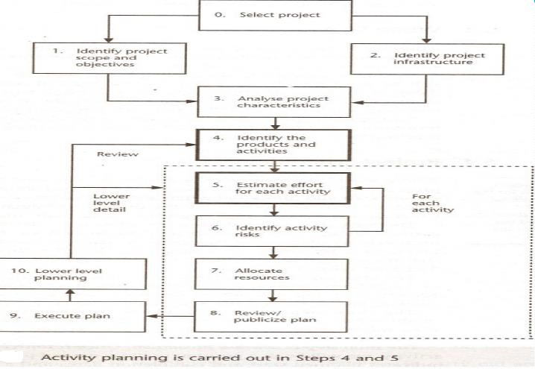

Projects and Activities
Defining activities: Some assumptions (criteria) need to make that will be relevant when we start to produce an activity plan. Activities must be defined so that they meet these assumptions. Any activity that does not meet these criteria must be redefined.
A project is composed of a number of interrelated activities. A project may start when at least one of its activities is ready to start. A project will be completed when all of the activities it encompasses have been completed. An activity must have a clearly defined start and a clearly defined end-point, normally marked by the production of a tangible deliverable. An activity requires a resource (as most do) then that resource requirement must be forecast able and is assumed to be required at a constant level throughout the duration of the activity. The duration of an activity must be forecastable — assuming normal circumstances, and the reasonable availability of resources. Some activities might require that others are completed before they can begin these are known as precedence requirements).
Identifying activities: Essentially there are three approaches to identifying the activities or tasks that make up a project
➢ The activity-based approach,
➢ The product-based approach
➢ The hybrid approach.

The activity-based approach: The activity-based approach consists of creating a list of all the activities that the project is thought to involve. This might involve a brainstorming session involving the whole project team or it might stern from an analysis of similar past projects. When listing activities, particularly for a large project, it might be helpful to subdivide the project into the main life-style stages and consider each of these separately. Generating a task list is to create a Work Breakdown Structure (WBS). This involves identifying the main (or high- level) tasks required to complete a project and then breaking each of these down into a set of lower-level tasks.
Activities are added to a branch in the structure if they directly contribute to the task immediately above — if they do not contribute to the parent task, then they should not be added to that branch. The tasks at each level in any branch should include everything that is required to complete the task at the higher level — if they are not a comprehensive definition of the parent task, then something is missing. When preparing a WBS, consideration must be given to the final level of detail.

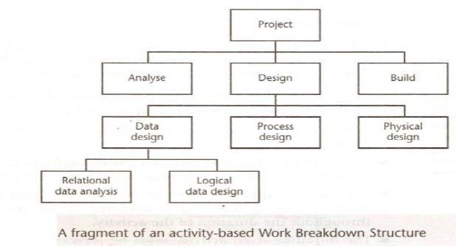

Advantages
➢ The WES approach include the belief that it is much more likely to result in a task catalogue
➢ That is complete and is composed of non- overlapping activities.
➢ Project's activities need to be sequenced in the sense of deciding which activities need to be completed before others can start.

The product based approach: It consists of producing a Product Breakdown Structure and a Product Flow Diagram. The PFD indicates, for each product, which other products are required as inputs. The PFD can therefore be easily transformed into an ordered list of activities by identifying the transformations that turn products into others.

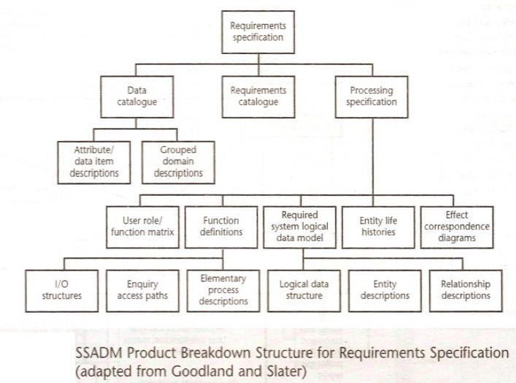
This approach is particularly appropriate if using a methodology such as Structured Systems Analysis and Design Method (SSADM), which clearly specifies, for each step or task, each of the products required and the activities required to produce it.

The SSADM Reference Manual also supplies generic activity networks and, using the project-specific PBS and derived PFD, these may be used as a basis for developing a project-specific activity network. Figure below illustrates an activity network for the activities required to create the products in above Figure. Notice how the development of a PFD leads directly to an activity network that indicates the sequencing of activities — in Figure below, activity 340 (Enhance required data model) requires products from activity
330 and activity 360 needs products from both activities 330 and 340.

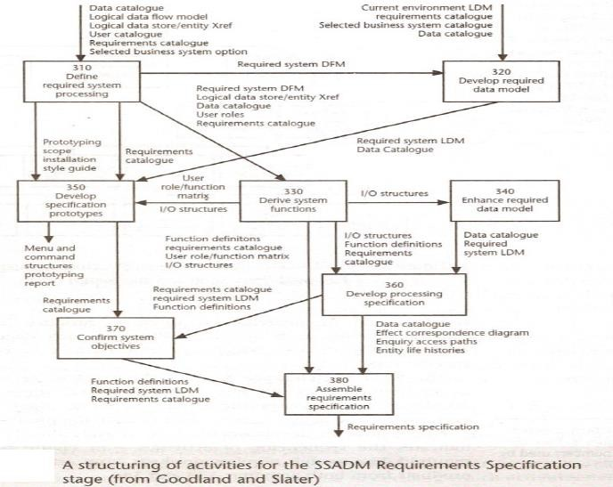
The hybrid approach: The WBS is based entirely on a structuring of activities. WBS may be based upon the project's products as illustrated in Figure below. which is in turn based on a simple list of final deliverables and, for each deliverable, a set of activities required to produce that product. Figure below illustrates a flat WBS and it is likely that, in a project of any size, it would be beneficial to introduce additional levels — structuring both products and activities.
The degree to which the structuring is product-based or activity-based might be influenced by the nature of the project and the particular development method adopted. As with a purely activity-based WBS, having identified the activities we are then left with the task of sequencing them.
A framework dictating the number of levels and the nature of each level in the structure may be imposed on a NVBS. For example, in their Master Intern Training Plan (MITP) methodology, IBM recommend that the following five levels should be used in a WBS:
Level I: Project.
Level 2: Deliverables such as software, manuals and training courses.
Level 3: Components which are the key work items needed to produce deliverables, such as the modules and tests required to produce the system software.

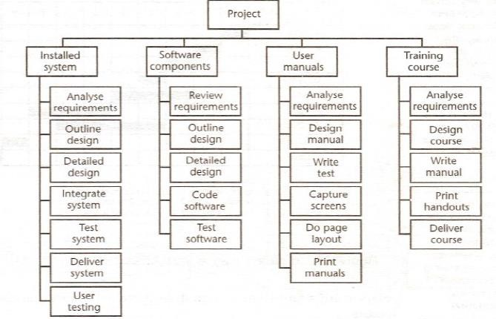
Level 4: Work-packages which are major work items, or collections of related tasks, required to produce a component.
Level 5: Tasks which are tasks that will normally be the responsibility of a single person.

A work breakdown structure based on deliverable
Sequencing and scheduling activities
Throughout a project, we will require a schedule that clearly indicates when each of the project's activities is planned to occur and what resources it will need. The chart shown has been drawn up taking account of the nature of the development process that is. certain tasks must be completed before others may start) and the resources that are available (for example, activity C follows activity B because Andy cannot work on both tasks at the same time).
In drawing up the chart, we have therefore done two things — we have sequenced the tasks (that is, identified the dependencies among activities dictated by the development process) and scheduled them (that is, specified when they should take place). The scheduling has had to take account of the availability of staff and the ways in which the activities have been allocated to them. The schedule might look quite different were there a different number of staff or were we to allocate the activities differently.
In the case of small projects. this combined sequencing—scheduling approach might be quite suitable, particularly where we wish to allocate individuals to particular tasks at an early planning stage.
However, on larger projects it is better to separate out these two activities: to sequence the tasks according to their logical relationships and then to schedule them taking into account resources and other factors.

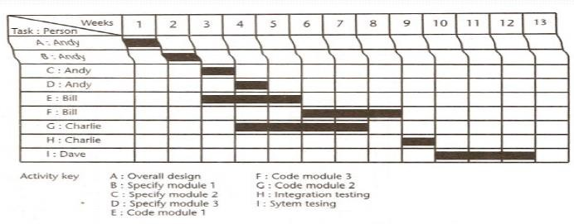
Network planning models: These project scheduling techniques model the project's activities and their relationships as a network. In the network, time flows from left to right. The two best known being CPM (Critical Path Method) and PERT (Program Evaluation Review Technique).
Both of these techniques used an activity-on-arrow approach to visualizing the project as a network where activities are drawn as arrows joining circles, or nodes which represent the possible start and/or completion of an activity or set of activities.
More recently a variation on these techniques, called precedence network, has become popular. This method uses activity-on-node networks where activities are represented as nodes and the links between nodes represent precedence (or sequencing) requirements.
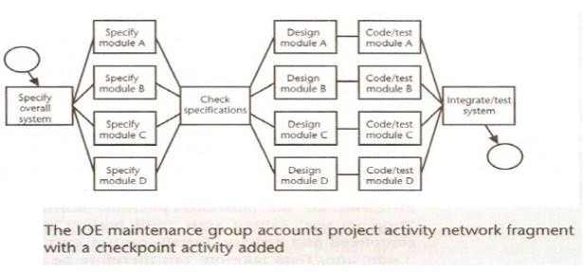
This latter approach avoids some of the problems inherent in the activity-on-arrow representation and provides more scope for easily representing certain situations. It is this method that is adopted in the majority of computer applications currently available. These three methods are very similar and it must be admitted that many people use the same name (particularly CPM) indiscriminately to refer to any or all of the methods.

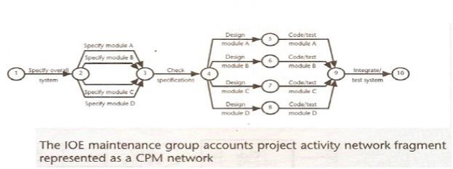
Formulating a network model: The first stage in creating a network model is to represent the activities and their interrelationships as a graph. In activity-on-node we do this by representing activities as links (arrowed lines) in the graph — the nodes (circles) representing the events of activities starting and finishing.

Constructing precedence networks
➢ A project network should have only one start node
➢ A project network should have only one end node
➢ A node has duration
➢ A node represents an activity and, in general, activities take time to execute.
➢ Links normally have no duration
➢ Precedents are the immediate preceding activities in Figure below, the activity 'Program test' cannot start until both 'Code' and 'Data take-on' have been completed and activity 'Install' cannot start until
'Program test' has finished. 'Code' and Data take-on' can therefore be said to be precedents of
'Program test', and 'Program test' is a precedent of 'Install'. Note that we do not speak of 'Code' and
'Data take-on' as precedents of 'Install' - that relationship is implicit in the previous statement.
➢ Time moves front left to right
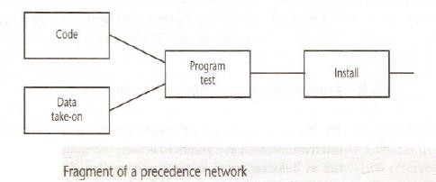

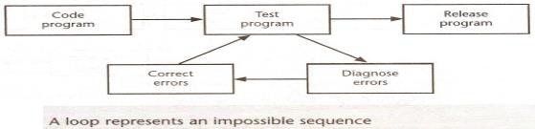
A network may not contain loops Figure below demonstrates a loop in a network. A loop is an error in that it represents a situation that cannot occur in practice. While loops, in the sense of iteration, may occur in practice, they cannot be directly represented in a project network.

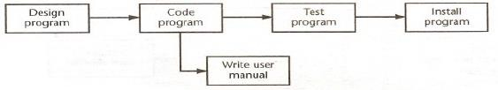
A network should not contain dangles. A dangling activity such as 'Write user manual' in Figure below should not exist as it is likely to lead to errors in sub-sequent analysis.

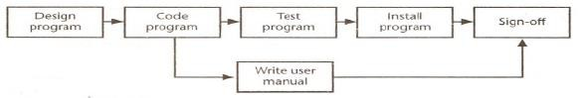
Redraw the network with a final completion activity — which, at least in this case, is probably a more accurate

Representing lagged activities
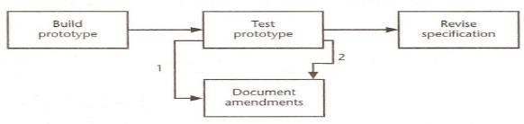
We might come across situations where we wished to undertake two activities in parallel so long as there is a lag between the two. We might wish to document amendments to a program as it was being tested - particularly if evaluating a prototype. Where activities can occur in parallel with a time lag between them we represent the lag with a duration on the linking arrow as shown in Figure below. This indicates that documenting amendments can start one day after the start of prototype testing and will be completed two days after prototype testing is completed.

Labelling conventions: There are a number of differing conventions that have been adopted for entering information on an activity-on-node network. One of the more common conventions for labelling nodes, and the one adopted here, is shown on the left. The activity label is usually a code developed to uniquely identify

the activity and may incorporate a project code. The activity description will normally be a brief activity name such as 'Test take-on module'.

Activity Label Duration

Earliest Start Activity
Description
Earliest Finish

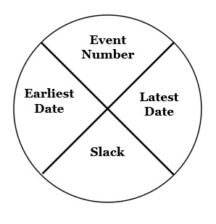
Latest Start Latest Finish

Activity Span Float

Adding the time dimension
Having created the logical network model indicating what needs to be done and the interrelationships between those activities, we are now ready to start thinking about when each activity should be undertaken. The critical path approach is concerned with two primary objectives: planning the project in such a way that it is completed as quickly as possible: and identifying those activities where a delay in their execution is likely to affect the overall end date of the project or later activities' start dates.
The method requires that for each activity we have an estimate of its duration. The network is then analyzed by carrying out a forward pass, to calculate the earliest dates at which activities may commence and the project be completed, and a backward pass, to calculate the latest start dates for activities and the critical path. In practice we would use a software application to carry out these calculations for anything but the smallest of projects. It is important, though, that we understand how the calculations are carried out in order to interpret the results correctly and understand the limitations of the method. The description and example that follow use the small example project outlined below — a project composed of eight activities whose durations have been estimated as shown in the table

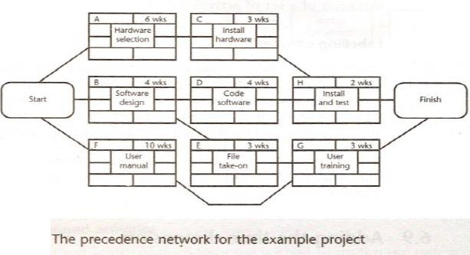
Activity in the Box (AIB)
➢ Also called as Activity-on-node (AON)
➢ nodes represent activities, and arrows show precedence relationships
➢ Each activity is represented by a box.
➢ The activity description is written in the box.
➢ Activity consume time, and their description usually starts with a verb
➢ Each activity is represented by one and only one box.
➢ Each box is assigned a unique activity number.
➢ Activities have a precedential relationship.
➢ Some activities may be done concurrently.

Activity on arrow

➢ Arrows represent activities and nodes are events for points in time
➢ Each activity is represented by an arrow.
➢ The activity description is written above the arrow.
➢ Each activity is represented by one and only one arrow
➢ The tail of the arrow designates the start of the activity.
➢ The head of the arrow designates the completion of the activity.
➢ The length and slope of the arrow are in no way indicative of the activity’s duration or importance

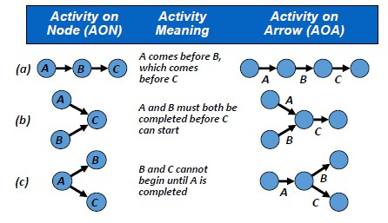
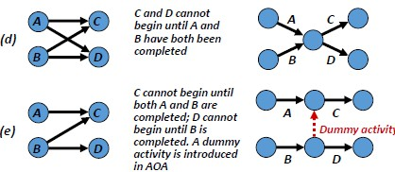
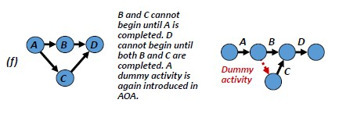
Activity Scheduling
➢ It is necessary to select an estimated start time and a required completion time for the overall project.
➢ The project’s required completion time is normally part of the project objective and stated in the
contract.
➢ If a project must be completed in 130 working days, we define the project’s estimated start time as
0 and its required completion time is day 130.
➢ A project schedule includes:
o the earliest times (or dates) at which each activity can start and finish, based on the project's estimated start time (or date)

o the latest times (or dates) by which each activity must start and finish in order to complete the project by its required completion time (or date)

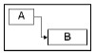
Task Dependency Relationships
➢ Finish-to-Start (FS)
o B cannot start till A finishes
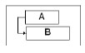
o A: Construct fence; B: Paint Fence
➢ Start-to-Start (SS)
o B cannot start till A starts
o A: Pour foundation; B: Level concrete
➢ Finish-to-Finish (FF)
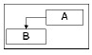
o B cannot finish till A finishes
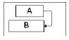
o A: Add wiring; B: Inspect electrical
➢ Start-to-Finish (SF)
o B cannot finish till A starts (rare)

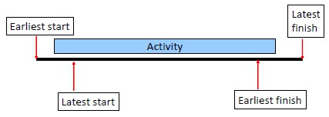
Start and finish times

➢ Earliest start time (ES) is the earliest time at which a particular activity can begin.
➢ Earliest finish time (EF) is the earliest time by which a particular activity can be completed.
➢ EF=ES + Duration Estimate
➢ Latest finish time (LF) is the latest time by which a particular activity must be finished in order for the entire project to be completed by its required completion time, calculated on the basis of the project’s required completion time and the duration estimates for succeeding activities.
➢ Latest start time (LS) is the latest time by which a particular activity must be started in order for the entire project to be completed by its required completion time, calculated by subtracting the activity’s duration estimate from the activity’s latest finish time:
➢ LS=LF– Duration Estimate

Critical Path and Critical Activities
Consider all the paths in a project, beginning with the start event and stopping at the end event. For each path, calculate the time of execution, by adding the time for the individual activities in that path.
The path with the largest time is called the critical path and the activities along this path are called the critical activities or bottleneck activities. The activities are called critical because they cannot be delayed. However, a non-critical activity may be delayed to a certain extent. Any delay in a critical activity will
delay the completion of the whole project. However, a certain permissible delay in a non –critical activity will not delay the completion of the whole project. It shall be noted that delay in a non-critical activity
beyond a limit would certainly delay the completion the whole project. Sometimes, there may be several critical paths for a project. A project manager shall pay special attention to critical activities.
The following details are available regarding a project:
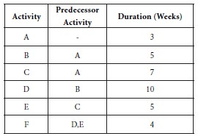
Determine the critical path, the critical activities and the project completion time. Solution
First let us construct the network diagram for the given project. We mark the time estimates along the
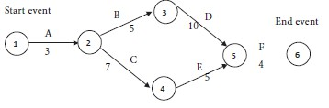
arrows representing the activities. We obtain the following diagram:

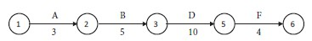
Path I

with a time of 3 + 5 + 10 + 4 = 22 weeks.
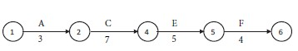
Path II

with a time of 3 + 7 + 5 + 4 = 19 weeks.
Compare the times for the two paths. Maximum of {22,19} = 22.
We see that path I has the maximum time of 22 weeks. Therefore, path I is the critical path. The critical activities are A, B, D and F. The project completion time is 22 weeks.
We notice that C and E are non- critical activities.
Time for path I - Time for path II = 22- 19 = 3 weeks.
Therefore, together the non- critical activities can be delayed up to a maximum of 3 weeks, without delaying the completion of the whole project.

Find out the completion time and the critical activities for the following project:
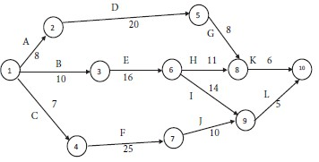
Solution
In all, we identify 4 paths, beginning with the start node of 1 and terminating at the end node of 10. They are as follows:
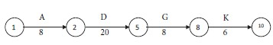
Path I

Time for the path = 8 + 20 + 8 + 6 = 42 units of time.
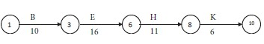
Path II

Time for the path = 10 + 16 + 11 + 6 = 43 units of time.
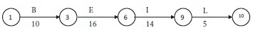
Path III

Time for the path = 10 + 16 + 14 + 5 = 45 units of time.
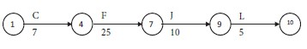
Path IV

Time for the path = 7 + 25 + 10 + 5 = 47 units of time.
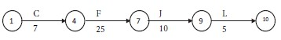
Compare the times for the four paths. Maximum of {42, 43, 45, 47} = 47. We see that the following path has the maximum time and so it is the critical path:

The critical activities are C, F, J and L. The non-critical activities are A, B, D, E, G, H, I and K. The project completion time is 47 units of time.

Draw the network diagram and determine the critical path for the following project:
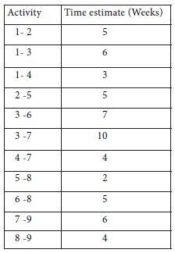
Solution
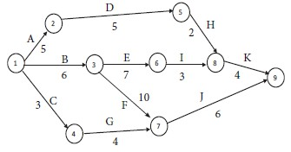
We have the following network diagram for the project:

Solution
We assert that there are 4 paths, beginning with the start node of 1 and terminating at the end node of 9. They are as follows:
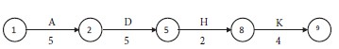
Path I

Time for the path = 5 + 5 + 2 + 4 = 16 weeks.
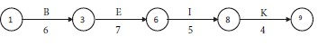
Path II

Time for the path = 6 + 7 + 5 + 4 = 22 weeks.
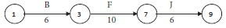
Path III

Time for the path = 6 + 10 + 6 = 16 weeks.
Path IV

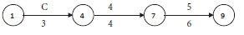
Time for the path = 3 + 4 + 6 = 13 weeks.
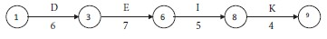
Compare the times for the four paths. Maximum of {16, 22, 16, 13} = 22. We see that the following path has the maximum time and so it is the critical path:

The critical activities are B, E, I and K. The non-critical activities are A, C, D, F, G, H and J. The project completion time is 22 weeks.

Program Evaluation and Review Technique (PERT)
Program Evaluation and Review Technique (PERT) is a tool that would help a project manager in project planning and control? It would enable him in continuously monitoring a project and taking corrective
measures wherever necessary. This technique involves statistical methods.
In PERT, we assume that it is not possible to have precise time estimate for each activity and instead, probabilistic estimates of time alone are possible. A multiple time estimate approach is followed here. In
probabilistic time estimate, the following 3 types of estimate are possible: Pessimistic time estimate (tp)
Optimistic time estimate (to) Most likely time estimate (tm)
The optimistic estimate of time is based on the assumption that an activity will not involve any difficulty
during execution and it can be completed within a short period. On the other hand, a pessimistic estimate is made on the assumption that there would be unexpected problems during the execution of an activity and
hence it would consume more time. The most likely time estimate is made in between the optimistic and the pessimistic estimates of time. Thus the three estimates of time have the relationship
to ≤ tm ≤ tp
Practically speaking, neither the pessimistic nor the optimistic estimate may hold in reality and it is the most likely time estimate that is expected to prevail in almost all cases. Therefore, it is preferable to give
more weight to the most likely time estimate. We give a weight of 4 to most likely time estimate and a weight of 1 each to the pessimistic and optimistic time estimates. We arrive at a time estimate (te ) as the
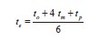
weighted average of these estimates as follows:

Since we have taken 6 units (1 for tp, 4 for tm and 1 for to), we divide the sum by 6. With this time estimate, we can determine the project completion time as applicable for CPM.
Since PERT involves the average of three estimates of time for each activity, this method is very practical and the results from PERT will be have a reasonable amount of reliability.

Measure of Certainty
The 3 estimates of time are such that

to ≤ tm ≤ tp
Therefore the range for the time estimate is tp – to .
The time taken by an activity in a project network follows a distribution with a standard deviation of one
sixth of the range, approximately.

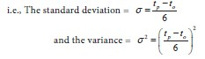
The certainty of the time estimate of an activity can be analyzed with the help of the variance. The greater the variance, the more uncertainty in the time estimate of an activity.

Two experts A and B examined an activity and arrived at the following time estimates.
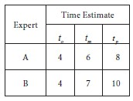
Determine which expert is more certain about his estimates of time:
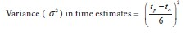
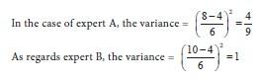
Solution

So, the variance is less in the case of A. Hence, it is concluded that the expert A is more certain about his estimates of time.

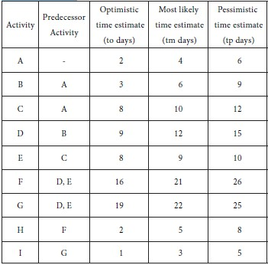
Find out the time required to complete the following project and the critical activities:

Solution

From the three time estimates tp , tm and to , calculate te for each activity. We obtain the following table:
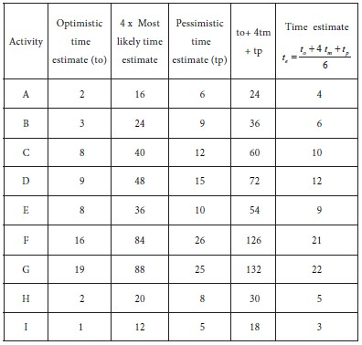
Using the single time estimates of the activities, we get the following network diagram for the project.
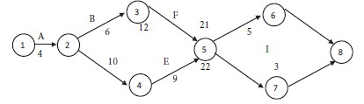
Consider the paths, beginning with the start node and stopping with the end node. There are four such paths for the given project. They are as follows:
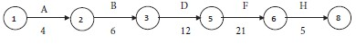
Path I

Time for the path: 4+6+12+21+5 = 48 days.
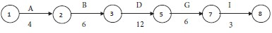
Path II

Time for the path: 4+6+12+ 6+3 = 31 days.
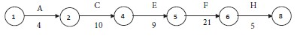
Path III

Time for the path: 4+10+9+ 21+5 = 49 days.
Path IV

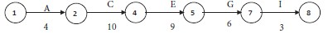
Time for the path: 4+10+9+ 6+3 = 32 days. Compare the times for the four paths. Maximum of {48, 31, 49, 32} = 49.
We see that Path III has the maximum time. Therefore, the critical path is Path III. i.e., 1 2 4 5 6 8.
The critical activities are A, C, E, F and H.
The non-critical activities are B, D, G and I.
Project time (Also called project length) = 49 days.

Calculation of Standard Deviation and Variance for the Critical Activities:
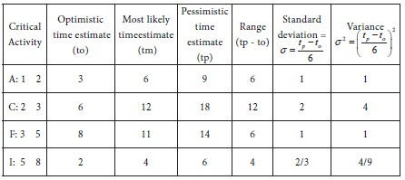
Variance of project time (Also called Variance of project length) = Sum of the variances for the critical activities = 1+4+1+ 4/9 = 58/9 Weeks.
Standard deviation of project time = √Variance = √58/9 = 2.54 weeks.

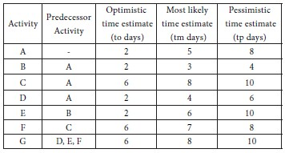
A project consists of seven activities with the following time estimates. Find the probability that the project will be completed in 30 weeks or less.

Solution
From the three time estimates tp , tm and to calculate for each activity.
The results are furnished in the following table:

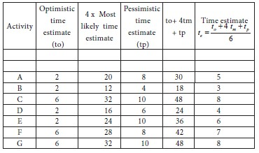
With the single time estimates of the activities, the following network diagram is constructed for the project.
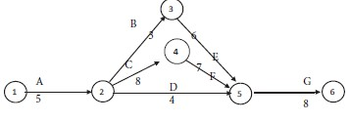
Consider the paths, beginning with the start node and stopping with the end node. There are three such paths for the given project. They are as follows:
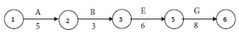
Path I

Time for the path: 5+3+6+8 = 22 weeks.
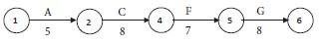
Path II

Time for the path: 5+8+7+ 8 = 28 weeks.
Path III
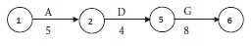
Time for the path: 5+4+8 = 17 weeks. Compare the times for the three paths. Maximum of {22, 28, 17} = 28.
It is noticed that Path II has the maximum time. Therefore, the critical path is Path II. i.e., 1 2 4 5 6. The critical activities are A, C, F and G.
The non-critical activities are B, D and E.
Project time = 28 weeks.

The forward pass: The forward pass is carried out to calculate the earliest dates on which each activity may be started and completed. Where an actual start date is known, the calculations may be carried out

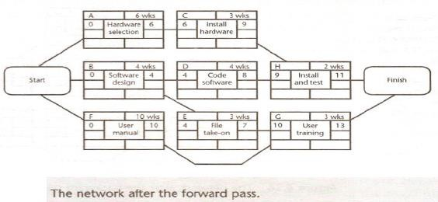
using actual dates. Alternatively, we can use day or week numbers and that is the approach we shall adopt here. By convention, dates indicate the end of a period and the project is therefore shown as starting at the end of week zero (or the beginning of week 1). The forward pass and the calculation of earliest start dates is calculated according to the following reasoning.

Activities A, B and F may start immediately, so the earliest date for their start is zero.
➢ Activity A will take 6 weeks, so the earliest it can finish is week 6.
➢ Activity B will take 4 weeks, so the earliest it can finish is week 4.
➢ Activity F will take 10 weeks, so the earliest it can finish is week 10.
➢ Activity C can start as soon as A has finished so its earliest start date is week 6. It will take 3 weeks so the earliest it can finish is week 9.
➢ Activities D and E can start as soon as B is complete so the earliest they can each start is week 4.
Activity D, which will take 4 weeks, can therefore finish by week 8 and activity E, which will take
3 weeks, can therefore finish by week 7.
➢ Activity G cannot start until both E and F have been completed. It cannot therefore start until week
10 — the later of weeks 7 (for activity E) and 10 (for activity F). It takes 3 weeks and finishes in week 13.
➢ Similarly, Activity H cannot start until week 9 — the later of the two earliest finished dates for the preceding activities C and a
➢ The project will be complete when both activities H and G have been completed. Thus the earliest project completion date will be the later of weeks 11 and 13— that is, week 13.
➢ The results of the forward pass are shown in Figure below.
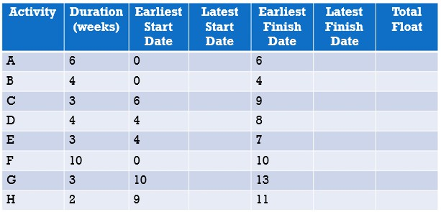
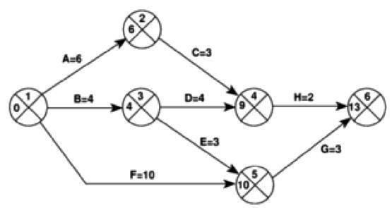
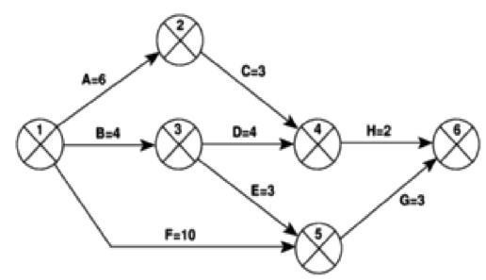
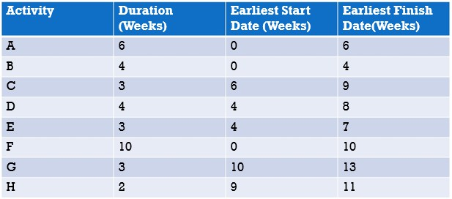

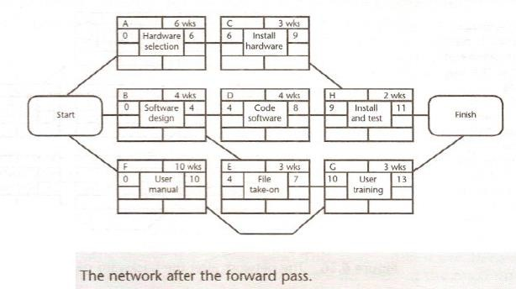

Forward pass example

CPM Network after forward Pass

The backward pass: The second stage in the analysis of a critical path network is to carry out a backward pass to calculate the latest date at which each activity may be started and finished without delaying the end date of the project. In calculating the latest dates, we assume that the latest finish date for the project is the same as the earliest finish date — that is, we wish to complete the project as early as possible.
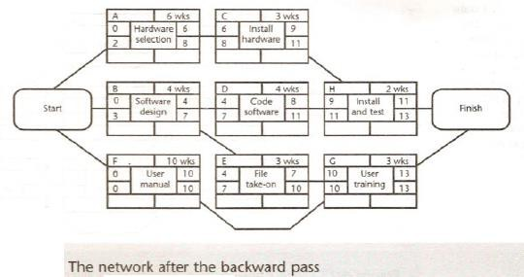
Figure below illustrates our network alter carrying out the backward pass.

The latest activity dates are calculated as follows.
➢ The latest completion date for activities G and is assumed to be week 13.
➢ Activity H must therefore start at week 11 at the latest (13-2) and the latest
➢ start date for activity G is week 10 (13-3).
➢ The latest completion date for activities C and D is the latest date at which
➢ activity H must start — that is. week 11. They therefore have latest start dates of week 8 (11-3) and week 7 (11-4) respectively.
➢ Activities E and F must be completed by week 10 so their earliest start dates are weeks 7 (10-3)
and 0 (10-10 respectively.
➢ Activity B must be completed by week 7 the latest start date for both activities D and El so its latest start is week 3 (7-4).
➢ Activity A must be completed by week 8 (the latest start date for activity C) so its latest start is
week 2 (8-6).
➢ The latest start date for the project start is the earliest of the latest start dates for activities A. B and F. This is week zero. This is, of course, not very surprising since it tells vi that if the project does not start on time it won't finish on time.

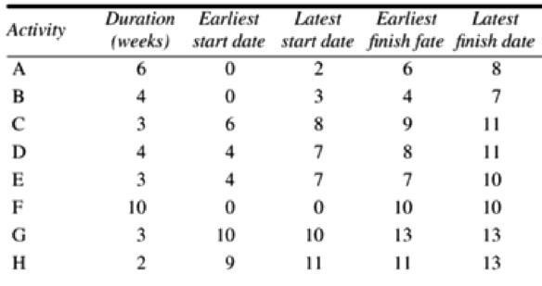
Example backward pass

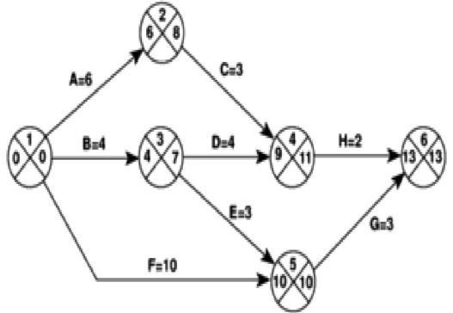
CPM Network after forward Pass

Activity float
Although the total float is shown for each activity, it really 'belongs' to a path through the network. Activities A and C in Figure above each have 2 weeks' total float. If, however, activity A uses up its float (that is, it is not completed until week 8) then activity B will have zero float (it will have become critical). In such circumstances it may be misleading and detrimental to the project's success to publicize total float!
There are a number of other measures of activity float, including the following:
➢ Free float: the time by which an activity may be delayed without affecting any subsequent activity.
It is calculated as the difference between the earliest completion date for the activity and the earliest start date of the succeeding activity. This might be considered a more satisfactory measure of float for publicizing to the staff involved in undertaking the activities.
➢ Interfering float: the difference between total float and free float. This is quite commonly used,
particularly in association with the free float. Once the free float has been used (or if it is zero), the interfering float tells us by how much the activity may be delayed without delaying the project end date - even though it will delay the start of subsequent activities.
Total float = LF –ES –duration (or LS-ES or LF-EF) Free float = ES for following activity -EF for the current Interfering float = total float –free float

Calculate the free float and interfering float for each of the activities shown in the activity network
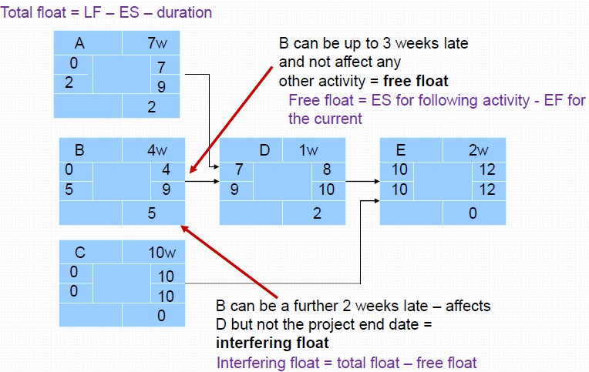
Shortening the project duration
If we wish to shorten the overall duration of a project, we would normally consider attempting to reduce activity durations. In many cases this can be done by applying more resources to the task - working overtime or procuring additional staff, for example. The critical path indicates where we must look to save time - if we are trying to bring forward the end date of the project, there is clearly no point in attempting to shorten non-critical activities. Referring to Figure above, it can be seen that we could complete the project in week
12 by reducing the duration of activity F by one week (to 9 weeks).
Referring to Figure above, suppose that the duration for activity F is shortened to 8 weeks. Calculate the end date for the project.
➢ What would the end date for the project be if activity F were shortened to 7 weeks? Why?
➢ As we reduce activity times along the critical path we must continually check for any new critical path emerging and redirect our attention where necessary.
➢ There will come a point when we can no longer safely, or cost-effectively, reduce critical activity
durations in an attempt to bring forward the project end date. Further savings, if needed, must be sought in a consideration of our work methods and by questioning the logical sequencing of activities. Generally, time savings are to be found by increasing the amount of parallelism in the network and the removal of bottlenecks (subject always, of course, to resource and quality constraints).

Identifying the critical path
Slack: It is the difference between the earliest date and the latest date for an event-it is a measure of how late an event may be without affecting the end date of the project.
➢ The critical path is the path joining all nodes with a zero slack.
➢ The longest path in the overall network diagram is called the critical path.
➢ One way to determine which activities make up the critical path is to find which ones have the least slack.
➢ All the activities with this value are on the critical path of activities.
➢ The values of total slack for the consumer market study project are shown in Figure
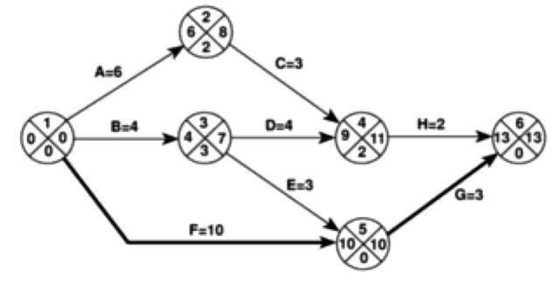
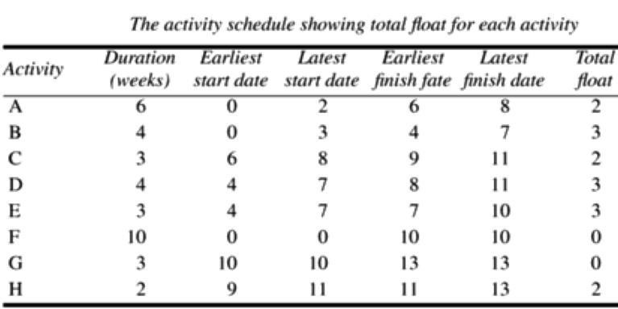
Critical Path = F-G Identifying the critical path

Activity Schedule showing total float for each activity
