Topics Covered:

➢ Introduction
➢ The nature of resources
➢ Identifying resource requirements
➢ Scheduling resources
➢ Creating Critical Paths
➢ Counting the cost
➢ Being Specific
➢ Publishing the resource schedule
➢ Cost schedule
➢ The scheduling sequence

After the activities have been identified using various techniques and tabulated into a Work-Break-Down their sources need to be allocated to complete the identified tasks. Resource allocation in project management is concerned with creating a plan which can help achieve future goals. There are many resources which have to be allocated when managing a project, beginning from budget to equipment and tools, to data and the project’s plan. This process is considered resource allocation

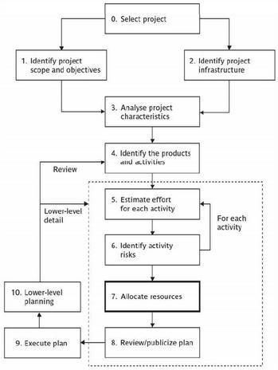

The final result of resource allocation will normally be a number of schedules including:

➢ Activity schedule: indicating start and completion dates for each activity
➢ Resource schedule: indicating dates when resources are needed and level of resources
➢ Cost schedule: shows accumulative expenditures.

Who allocates resources? Project manager
A project manager is a person who has the overall responsibility for the successful initiation, planning, design, execution, monitoring, controlling and closure of a project. Construction, petrochemical,
architecture, information technology and many different industries that produce products and services use
this job title.
The project manager must have a combination of skills including an ability to ask penetrating questions, detect unstated assumptions and resolve conflicts, as well as more general management skills.
Key among a project manager's duties is the recognition that risk directly impacts the likelihood of success and that this risk must be both formally and informally measured throughout the lifetime of a project.
Risks arise from uncertainty, and the successful project manager is the one who focuses on this as their primary concern. Most of the issues that impact a project result in one way or another from risk. A good
project manager can lessen risk significantly, often by adhering to a policy of open communication, ensuring every significant participant has an opportunity to express opinions and concerns.
A project manager is a person who is responsible for making decisions, both large and small. The project
manager should make sure they control risk and minimize uncertainty. Every decision the project manager makes must directly benefit their project.
Project managers use project management software, such as Microsoft Project, to organize their tasks and workforce. These software packages allow project managers to produce reports and charts in a few minutes, compared with the several hours it can take if they do it by hand.
Roles and Responsibilities
The role of the project manager encompasses many activities including:
• Planning and Defining Scope
• Activity Planning and Sequencing
• Resource Planning
• Developing Schedules
• Time Estimating
• Cost Estimating
• Developing a Budget
• Documentation
• Creating Charts and Schedules
• Risk Analysis
• Managing Risks and Issues
• Monitoring and Reporting Progress
• Team Leadership
• Strategic Influencing
• Business Partnering
• Working with Vendors
• Scalability, Interoperability and Portability Analysis
• Controlling Quality
• Benefits Realization
Finally, senior management must give a project manager support and authority if he or she is going to be successful.

The nature of resources
In project management, resources are required to carry out the project tasks. They can be people, equipment, facilities, funding, or anything else capable of definition (usually other than labor) required for the

completion of a project activity. The lack of a resource will therefore be a constraint on the completion of the project activity. Resources may be storable or non-storable. Storable resources remain available unless depleted by usage, and may be replenished by project tasks which produce them. Non-storable resources must be renewed for each time period, even if not used in previous time periods.
Allocation of limited resources is based on the priority given to each of the project activities. Their priority is calculated using the Critical path method and heuristic analysis. For a case with a constraint on the
number of resources, the objective is to create the most efficient schedule possible - minimizing project duration and maximizing the use of the resources available.
Resource will fall into one of following category
➢ Labor
➢ Equipment
➢ Material
➢ Space
➢ Services
➢ Time
➢ Money

Classification of Resources
Resources can be viewed from four standpoints:
1. Availability
• Recurring – such as human resources that are available in the same quantity day-after-day –
spending these resources does not deplete them.
• Depleting – like time and money – spending these resources depletes them.
2. Place of Availability
• Immovable – available wherever they are situated – they cannot be moved from place to place, such as computer resources.
• Movable – these resources can be moved from place to place – such as human resources and money.
3. Elasticity
• Elastic Resources – their supply can be increased or decreased – such as human resources and money.
• Plastic Resources – their supply cannot be extended, such as time.
4. Shared and Dedicated
• Dedicated resources – these should be dedicated to the project for the required duration – such as computer systems and programmers.
• Shared resources – these are resources that are needed for short durations but would not be utilized
for the entire duration of the project – such as DBAs (Database Administrators), programming language experts, functional specialists, etc.

Skill Sets Needed From the Resources
Use different skill sets for human resources required for software development projects, such as:
1. Programmers – to develop the software programs needed for the project – experts in the chosen programming language.
2. Graphic Designers – to design the graphics and the web pages / front-end required for the project.
3. Database Administrator – to design the database and assist the programmers in optimizing data retrieval queries so that the response time is shorter.
4. System Architects – to develop the software architecture for the project.
5. System Integrators – to integrate various components of the project and ensure that the end product is built conforming to the specifications.
6. Functional Experts – who are experts in the application domain of the project?

Next, perform the following resource management activities:
1. Planning Activities
• Estimate requirement of resources
• Request for requisite resources
• Schedule resource utilization
• Resource Leveling
2. Utilization Activities
• Allocation of resources to various activities
• Ensure the activities are performed
3. De-allocation and Release Activities
• Performance appraisals for human resources
• Reconciliation for monetary resources – planned vs. actual utilization
• Document lessons learned in planning and utilization of resources including best and worst practices
• Release resources

Resource Leveling

Resource leveling is a technique in project management that overlooks resource allocation and resolves possible conflict arising from over- allocation. This will benefit the organization without having to face conflicts and not being able to deliver on time. Resource leveling is considered one of the key elements to resource management in the organization. An organization starts to face problems if resources are not allocated properly i.e., some resource may be over-allocated whilst others will be under-allocated. Both will bring about a financial risk to the organization.

Two Key Elements of Resource leveling: As the main aim of resource leveling is to allocate resource efficiently, so that the project can be completed in the given time period. Resource leveling can be broken down into two main areas:

o Projects that can be completed by using up all resources
o Projects that can be completed with limited resources Projects, which use limited resources can be extended for over a period of time until the resources required are available.

Structure of Resource leveling: Many organizations have a structured hierarchy of resource leveling. A
work- based structure is as follows:

➢ Stage/Phase
➢ Task/Deliverable

All of the above-mentioned layers will determine the scope of the project and find ways to organize tasks across the team. In addition, depending on the three parameters above, the level of the resources required (seniority, experience, skills, etc.) may be different.

Establishing Dependencies: The main reason for a project manager to establish dependencies is to ensure that tasks get executed properly. By identifying correct dependencies from that of incorrect dependencies allows the project to be completed within the set timeframe. Here are some of the constraints that a project manager will come across during the project execution cycle. The constraints a project manager will face can be categorized into three categories.

➢ Mandatory - These constraints arise due to physical limitations such as human strength.
➢ Discretionary - These are constraints based on preferences or decisions taken by teams.

➢ External - Often based on needs or desires involving a third party.

Resource leveling Techniques

➢ Fast tracking - This performs critical path tasks. This buys time. The prominent feature of this technique is that although the work is completed for the moment, possibility of rework is higher.
➢ Crashing - This refers to assigning resources in addition to existing resources to get work done
faster, associated with additional cost such as labor, equipment, etc.

Identifying resource requirements

The first step in producing a resource allocation plan is to list the resources that will be required along with the expected level of demand. This w ill normally be done by considering each activity in turn and identifying the resources required. It is likely, however, that there will also be resources required that are not activity specific but are part of the project's infrastructure (such as the project manager) or required to support other resources (office space, for example, might be required to house contract software developers).

For effectively identifying resource requirement for an organization, following points need to be considered.
➢ A program organization chart is essential to allocate staff effectively,
➢ Develop the hierarchical program organization.
➢ Identify Roles and Responsibilities.
➢ Plan for number of staff in each role (at a high level).
➢ Establish Teams. For an activity identified:
➢ Work amount required (in work units)
➢ Basic skill or experience level required (to even under take the task)
➢ Complexity of the task (this will help to determine the experience required)
➢ Task Category (Unskilled, skilled, leadership, expert, management)

Example:
➢ Activity–Install Network Hardware for 20 computers.
➢ Work units-20.
➢ Basic Skill–Bachelor’s Degree in related field.
➢ Task Complexity: 5.
➢ Task Category: Skilled (other categories may be Management, Leadership, Expert)

Resource scheduling refers to the set of actions and methodology used by organizations to efficiently assign the resources they have to jobs, tasks or projects they need to complete, and schedule start and end dates for each task or project based on resource availability. Depending on industry, resources can be people (either employees or independent contractors), equipment and machines (this is frequent for construction, manufacturing or maintenance businesses) or rooms and facilities. There may also be a need for consumable resources (for instance, materials and parts for manufacturing).

Resource scheduling is a key step of project management. When resource availability and work capacity are the primary factors that determine a project’s deadline, project managers sometimes

speak of resource-constrained scheduling. But resource scheduling is also often used for simple operation management, as it allows managers to outline completion dates for tasks assigned to their teams, which they can report to stakeholders such as customers or a board of directors.

➢ After all the required resources have been identified, they need to be scheduled effectively.
➢ The earliest start dates, last start dates will need to be taken into account to schedule resources efficiently.
➢ Resources should be balanced throughout the project.
➢ Human resource scheduling issues such as:
o Planned Leave, Public Holidays.
o Possible sick leave (random, subjective at best and hard to predict).
o General motivation and enthusiasm for the task allocated (If they dislike the task, it will
flow through into the output).
o Work load and stress in project.
o Stress outside work.

Resource histogram

The resource histogram is a tool that is often used by the project management team and or as a means of providing a visual representation to the team and to all of those interested parties. Specifically speaking, the resource histogram is specifically a bar chart that is used for the purposes of displaying the specific amounts of time that a particular resource is scheduled to be worked on over a predetermined and specific time period. Resource histograms may also contain the comparative feature of resource availability, used for comparison on for purposes of contrast. Resource histograms are indeed handy tools to utilize for the project management team and or the project management team leader because they allow a quick and easy single page view of exactly what resources are available, what resources are being utilized at the present time (or at whatever time the project management team and of project management team leader is seeking information on), and how long those resources are expected to be tied up. Resource histogram shows following details.

➢ People (by category) Vs. Week Number
➢ For each individual – estimated number of tasks (including complexity) over weeks
o This helps in reducing work load sometimes to help the individual recover from any heavy load.
➢ Category Vs. Week

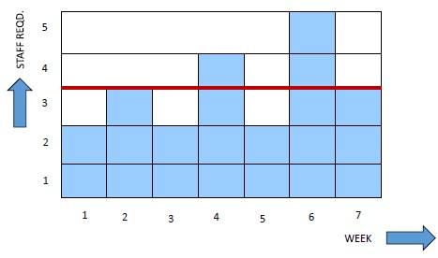

White rectangles indicate when an activity is scheduled and shaded rectangles the total float

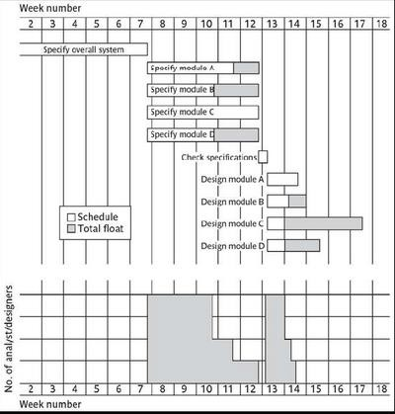

Resource Clashes: During working process same resource may needed in more than one place at the same time, which needs to be managed by project manager. It can be resolved by:

➢ Delaying one of the activities
o taking advantage of float to change start date
o delaying start of one activity until finish of the other activity that resource is being used on - puts back project completion
➢ moving resource from a non-critical activity
➢ bringing in additional resource - increases costs

Prioritizing activities: Depending upon the condition we may need to prioritize activities or sometimes we need to know which activity should be completed first. Which is done in following ways

➢ Total float priority – those with the smallest float have the highest priority
o Ordered according to their total float.
o Smallest total float has highest priority.
o Activities are allocated resources in ascending order of total float.
o Changes to plan will require re-calculation.
➢ Ordered list priority – this takes account of the duration of the activity as well as the float–see
next overhead
o Activities that can proceed at the same time are ordered according to a set of simple criteria.
o Burman’s priority list takes into account activity duration as well as total float.
▪ Gives priority to Shortest critical activities

▪ Gives priority to Other critical activities
▪ Gives priority to Shortest non-critical activities
▪ Gives priority to Non-critical activities with least float
▪ Gives priority to Non-critical activities

Note: Resource usage need to maximize to reduce idle periods between tasks. This balances costs against completion date and allows for contingency.

Creating Critical Paths

Scheduling resources can create new dependencies between activities. Therefore, Resource scheduling will almost always change the activity network. The changes often result in changes to the critical path. It is best not to add dependencies to the activity network to reflect resource constraints. If resources are scheduled, it makes network very messy.

A resource constraint may disappear during the project, but link remains on network. Thus you need to amend dates on schedule to reflect resource constraints. And delaying an activity due to lack of correct resources will cause that activity to become critical after it uses up all its slack time. These changes are often experienced after the project has started which will require adapting during the project (this is normally much harder in practice).
The Critical Path is the longest total duration. Activities on the critical path cannot be delayed or the whole project will be delayed, unless the loss of time can be offset somewhere else later on the critical path. To
find the critical path add up the duration of the activities for each possible path through the network, to
determine which has the longest total duration. The difference between the longest total duration and the shortest path(s) is the total amount of float or slack for the non-critical path activities.
The critical path is in essence the shortest time a project can be completed, even though the critical path is
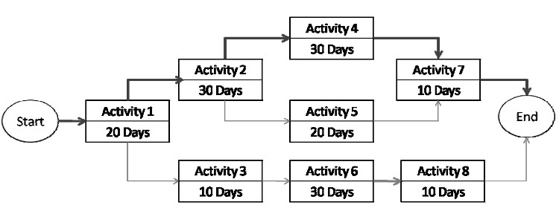
the longest path on the project. It is not the path with the most critical activities it is only concerned with the time dimension; it is not either the shortest path on a project network diagram. There are cases in which a network diagram may have two critical paths that have the same total duration.

To calculate the path using the diagram above use the duration of each activity and all the possible paths on the network.

The critical path is on Path A
Path A, Activities 1-2-4-7, total time = 90 days
Path B, Activities 1-2-5-7, total time = 80 days
Path C, Activities 1-3-6-8, total time = 70 days

Counting the Cost of Resources
The additional cost of employing extra staff or lengthening the overall duration of the project. The additional cost of employing extra staff would need to be compared to the cost of delayed delivery and the

increased the risk of not meeting the scheduled. All projects concentrate on completion in the shortest time span with minimum resources (in planning stage). However, once the project starts all un-planned issues and any risks will cause some strain on the cost.

Allocating individuals to activities (Being Specific)

Allocating resources and smoothing resources histogram is relatively straightforward where all resources of a given type can be considered more or less equivalent. In large building project among individual –there are likely to be many labors and they may be treated as equal so far as skills and productivity are concerned. The initial ‘resource types’ for a task have to be replaced by actual individuals. Factor need to be taken into account:

➢ Availability: We need to know if a particular individual will be available when required.
➢ Criticality: Allocation of more experienced personnel to activities on the critical path often helps in shortening project durations or at least reduces the risk of over run.
➢ Risk: Allocating the most experienced staff to the highest risk activities is likely to have the greatest
effect in reducing overall project uncertainties
➢ Training: It will be benefit to the organization if positive steps are taken to allocate junior staff to appropriate non critical activities where there will be sufficient slack for them to train and develop
skills.
➢ Team building: The selection of individuals must also take account of the final shape of the project team and the way they will work together.

Publishing the resource schedule: Work plans are commonly published either as lists or charts.
➢ Get Schedule Approval: This step also includes negotiations with project stakeholders, for example the time a certain activity is needed by the administrative function of the organization
must be negotiated so that the resources and people are made available. Another negotiation include
meeting with community leaders or beneficiary representatives to agree on specific milestones or dates when the project requires the participation of the beneficiaries. Once all people have agreed,
at least in principle to the schedule, it is ready to be published. These negotiations may include in
changes to the schedule, the skills of the project manager in making negotiations will determine the amount of change on the schedule. Stakeholders and management will often pressure the project team to either shorten or change the start dates of certain activities so that they do not interfere with their own schedules. The project team must learn to defend their estimates and learn to negotiate with these demands.
➢ Schedule Baseline: Once the team has completed the development of the project schedule they need to lock or set a baseline that will be used to monitor the schedule as the project makes progress. This baseline will be reviewed on a regular basis and all approved changes to the schedule will be
updated against this baseline. This is the schedule that will be published to the team and
stakeholders. Communicate the Schedule Once the project has “locked” the schedule with a
baseline version it is ready to be shared with all the people that will be affected by it. This obviously includes the project team, and the best way to communicate the schedule is to draw a large version of the schedule and place it on a wall in a central location of the project office or room, this way the project schedule is visible to all the team and visitors to the project room. A copy of the schedule also needs to reach the organization and the administrative support functions, especially management. Stakeholders also receive a copy of the schedule, although it may include short versions that only highlight the major activities, copies can be distributed to the donor, key representatives of the community or beneficiaries, consultants, and partner organizations. The project schedule is the principal communication tool that graphically shows the progress of the project and it is used to identify activities that are not on track, by publishing a copy of the schedule

the project begins to educate the stakeholders about the project’s complexity and critical dependencies that will impact the project and ensure that all people who are responsible for delivering outputs for the project are aware of their responsibilities along the project timeline.
➢ Schedule Updates: As the project starts to make progress, the project manager will use the activity status reports from the project team to update the schedule and update the information of progress. This information comes from the Work Assignment Sheet or the Scope of Work report. Schedule
progress reporting includes information such as the actual start and actual finish dates and any remaining durations for any unfinished scheduled activities. To facilitate the reporting of schedule
progress a form can be used that maintains a consisted use during the life of the project. The project manager updates the schedule using two methods: by placing the percentage by which each activity has been completed during a reporting period, or by placing the number of days that have been
worked on an activity. These reporting periods could be weekly, monthly or quarterly, all depending on the length and detail of the project schedule. The results of this updates with actual
data, gives the project manager information on the general status of the project, and result in changes to the planned project end

Cost schedules: Cost schedules are used to produce a detailed cost showing weekly or monthly cost over the life of the project schedule. Calculation of cost is straightforward where organization has standard figure for staff & other resources. Cost are categorized as follows:
➢ Staff cost: includes not just staff salaries, but also social security contributions by the employer, pension scheme contribution, holiday pay etc. Timesheets are often used to record actual hours
spent on each project by an individual. One issue can be how much time a staff member is allocated
and available to the project, but is not actually working on the project, is dealt with.
➢ Overheads: Office Space, Interest charges, Travel Costs, Insurance and so on. Some overheads might be directly attributed to the project; in other cases a percentage of departmental overheads
may be allocated to project costs.
➢ Usage charges: some charges can be on a pay as you go basis e.g. telephone charges, car mileage.
At the planning stage an estimate of these may have to be made.

The scheduling sequence: successful project scheduling is not a simple sequence because of the inter- linking of different concerns project planning will need to be iterative. The consequences of decisions will need to carefully access and plans adjusted accordingly. It can be represented as sequence of steps.
➢ Successful resource allocation
➢ cost schedule
➢ Activity plans
➢ The interplay between the plans and schedule is complex

