Birth and Death Registration Implementation in Nepal

By
Ashmi Maskey
Bhumika Neupane
Sajendra Bajracharya
Soniya Ghimire

In partial fulfillment of the requirements for Bachelors of Science in Computer Science and
Information Technology

National College of Computer Studies
Paknajol, Nepal

Dec, 2025

Disclaimer
We hereby declare that this case study entitled Birth and Death Registration Implementation in Nepal is based on our original research and study. All related works and references used in the preparation of this document have been duly acknowledged. We take full responsibility for the accuracy, authenticity, and interpretation of the information presented in this document.

Signature:
Name of the Student:
Date:

Acknowledgment
We express our sincere gratitude to our lecturers and mentors for their continuous guidance, encouragement, and valuable feedback throughout the preparation of this document. Their academic insights and support played a crucial role in shaping our understanding of civil registration systems.
We would also like to acknowledge local government officials and ward representatives whose cooperation and information greatly contributed to the practical understanding of birth and death registration procedures in Nepal.
Finally, we extend our appreciation to the National College of Computer Studies for providing an academic environment conducive to learning and research.

Abstract
Birth and death registration is a vital component of the civil registration system that ensures legal recognition of individuals from birth and accurate documentation of deaths. These registrations provide individuals with legal identity, protect fundamental rights, and generate essential demographic data for governance, planning, and policy formulation. In Nepal, birth and death registration is managed by local governments under the Civil Registration Act. Although significant progress has been made, challenges related to accessibility, public awareness, and system efficiency remain. This study examines the structure, purpose, benefits, implementation process, and challenges of the birth and death registration system in Nepal

Table Of Content
Birth and Death Registration Implementation in Nepal 1
Disclaimer i
Acknowledgment ii
Abstract iii
Chapter 1: Introduction v
1.1. What is Birth and Death Registration? 1
1.2. Origin of Birth and Death Registration 1
1.3. Goals & Objectives of Birth and Death Registration 1
Chapter 2: Literature Review 2
2.1. Background 2
2.2. Birth and Death Registration Practices in Other Countries 2
2.3. Present Scenario in Nepal 2
Chapter 3: Purpose & Benefits 3
3.1. Purpose of Establishing a Birth and Death Registration System 3
3.2. Purpose of Birth and Death Records 3
3.3. Benefits of Birth and Death Registration 3
Chapter 4: Birth and Death Registration in Nepal 4
4.1. Eligibility 4
4.2. Documents Required for Birth and Death Registration 4
4.3. Who Can Register Births and Deaths? 4
4.4. Information Included in Registration Certificates 4
4.5. Issuance of Birth and Death Certificates 4
Chapter 5: Proposed System 5
Chapter 6: Review / Conclusion 10
6.1. Impacts of Birth and Death Registration 10
6.2. Implementation Challenges 10
6.3. Limitations 10
6.4. Conclusion 10
Chapter 7: Reference 11

List of Figures
Figure 1 Home Page of online birth and death registration 11
Figure 2 Creating an account and login 12
Figure 3:Citizen dashboard 12
Figure 4: Birth Registration form 13
Figure 5: Death Registration Certificate 14
Figure 6: Admin Dashboard 15
Figure 7: Managing the Applications 15

Chapter 1: Introduction
Birth and death registration is the official recording of births and deaths by government authorities. In Nepal, these vital events are registered under the civil registration system administered by local governments. Birth registration establishes a person’s legal identity, while death registration provides official confirmation of death, which is essential for legal, administrative, and statistical purposes. Together, these registrations play a crucial role in governance, social protection, and national planning.

1.1. What is Birth and Death Registration?
Birth registration is the permanent and official recording of the birth of a child, including details such as name, date of birth, place of birth, and parent information. Death registration is the official recording of a person’s death, including the date, place, and cause of death. Both registrations are compulsory and continuous processes maintained by the state.[5]

1.2. Origin of Birth and Death Registration
The practice of registering births and deaths dates back to early civilizations where population records were maintained for administrative and religious purposes. Modern civil registration systems developed in Europe during the 19th century and later expanded globally. [5] International recognition of birth and death registration as essential rights has been reinforced through global frameworks such as the United Nations Convention on the Rights of the Child and public health initiatives.

1.3. Goals & Objectives of Birth and Death Registration
a. Legal Identity: To provide individuals with official legal recognition from birth to death.
b. Protection of Rights: To safeguard inheritance, nationality, and social security rights.
c. Public Health Planning: To generate accurate mortality and population data.
d. Administrative Efficiency: To support governance and service delivery.
e. Inclusive Development: To ensure all individuals are counted and recognized by the state.

Chapter 2: Literature Review

2.1. Background
Birth and death registration forms the backbone of Civil Registration and Vital Statistics (CRVS) systems. International organizations emphasize these systems as essential for governance, public health monitoring, and human rights protection. Accurate registration enables governments to track population trends and design effective policies.[1]

2.2. Birth and Death Registration Practices in Other Countries
Many countries have digitized their registration systems to improve coverage and efficiency. [5] Nations such as India, Sri Lanka, and Bangladesh have linked birth and death registration with health facilities, ensuring timely reporting of vital events. These integrated systems have improved data accuracy and accessibility.[2]

2.3. Present Scenario in Nepal
Nepal has decentralized birth and death registration to local governments. [3] While registration rates have improved in urban areas, rural and remote regions still face challenges due to lack of awareness, limited infrastructure, and geographical barriers. Digitization efforts are ongoing but not uniformly implemented.[2]

Chapter 3: Purpose & Benefits

3.1. Purpose of Establishing a Birth and Death Registration System
∙ To officially record all births and deaths occurring within the country
∙ To establish and terminate legal identity
∙ To maintain reliable population and mortality data
∙ To support governance, planning, and service delivery

3.2. Purpose of Birth and Death Records
∙ Provide legal proof of birth and death
∙ Facilitate citizenship, inheritance, and social security processes
∙ Support health, education, and population statistics
∙ Assist in policy-making and national planning

3.3. Benefits of Birth and Death Registration
∙ Legal recognition and protection of rights
∙ Access to government services and benefits
∙ Accurate population and health data
∙ Prevention of identity fraud and misuse
∙ Improved public administration

Chapter 4: Birth and Death Registration in Nepal

4.1. Eligibility
∙ Every birth and death occurring in Nepal must be registered
∙ Registration should be completed within the legally specified time period

4.2. Documents Required for Birth and Death Registration
∙ Application form
∙ Citizenship certificate of parents or informant
∙ Hospital or health facility record (if applicable)
∙ Marriage certificate (for birth registration, if available)

4.3. Who Can Register Births and Deaths?
∙ Parents or legal guardians
∙ Family members or relatives
∙ Authorized informants as specified by law

4.4. Information Included in Registration Certificates
- Personal details of the individual
- Date and place of birth or death
- Parent or informant details
- Registration number

4.5. Issuance of Birth and Death Certificates
Birth and death certificates are issued by the ward office of the local government where the event occurred or where the individual is registered.[2]

Chapter 5: Proposed System
A proposed integrated digital birth and death registration system would link health institutions and local governments to enable real-time reporting of vital events. [2] The system would ensure data security, reduce duplication, and improve accessibility through online platforms and mobile outreach services, especially in remote areas.
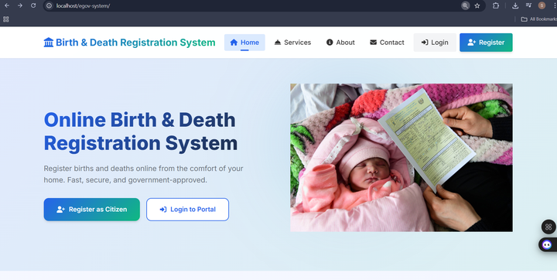
Figure 1 Home Page of online birth and death registration

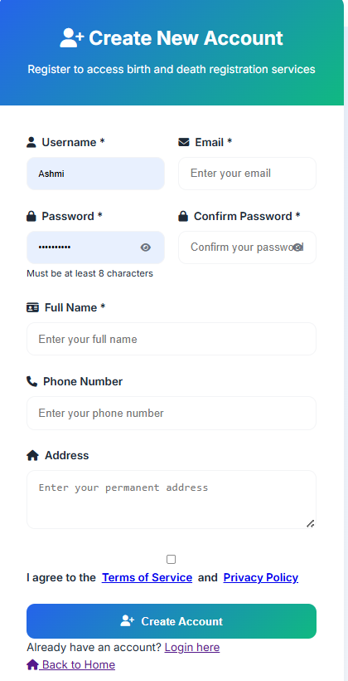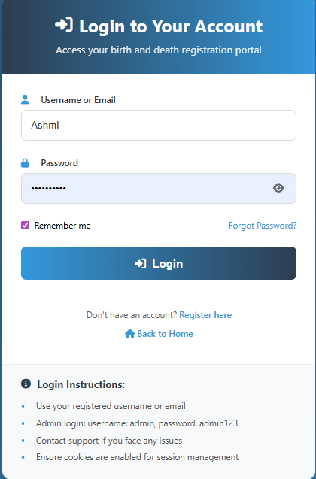
Figure 2 Creating an account and login
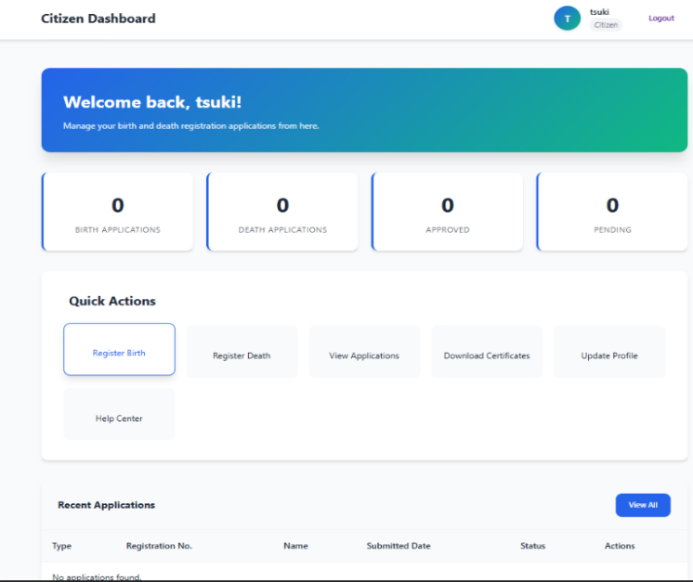
Figure 3:Citizen dashboard

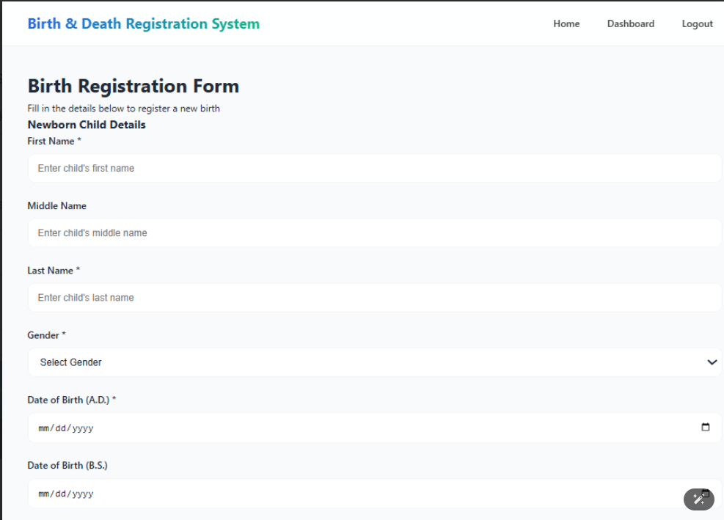
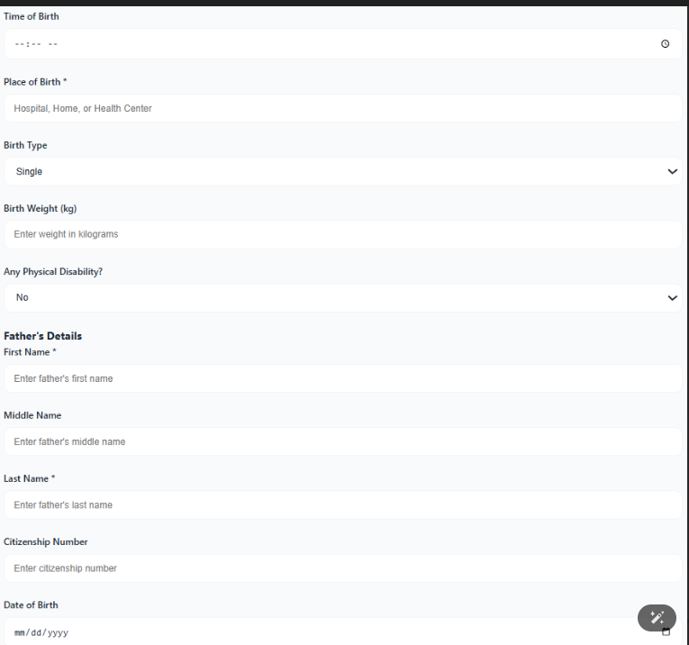

Figure 4: Birth Registration form

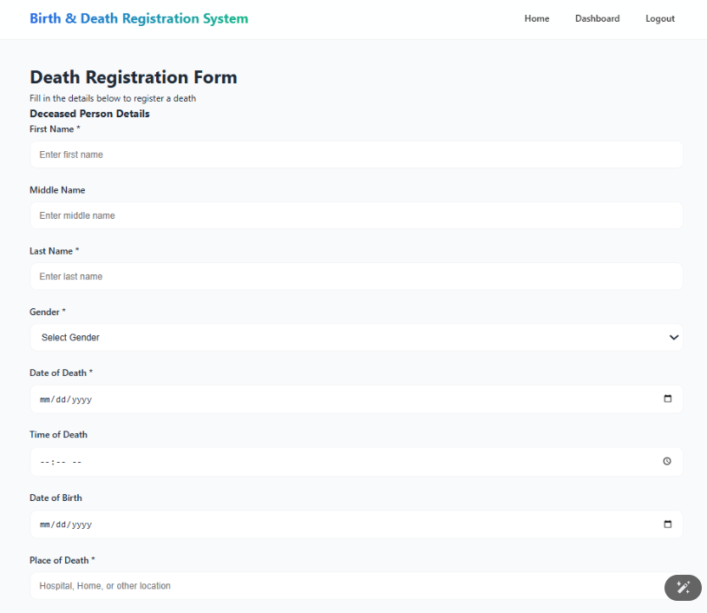
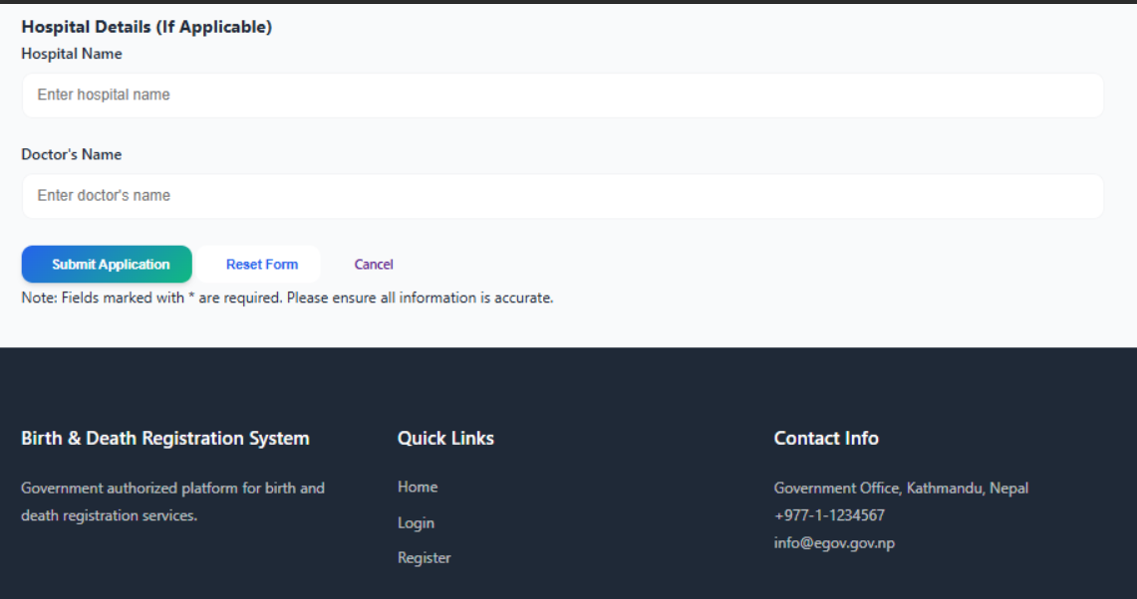
Figure 5: Death Registration Certificate


Figure 6: Admin Dashboard
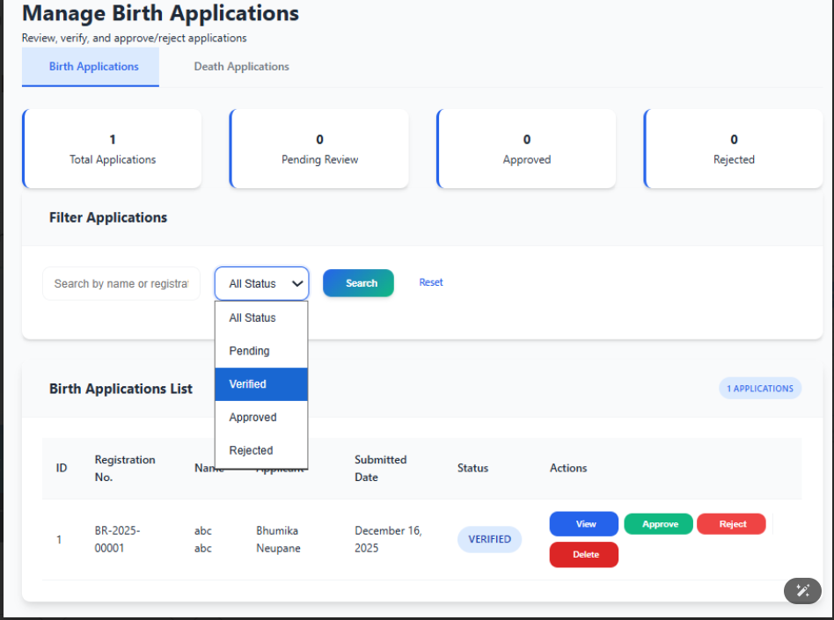
Figure 7: Managing the Applications

Chapter 6: Review / Conclusion

6.1. Impacts of Birth and Death Registration
Birth and death registration strengthens legal identity management, supports public health planning, and improves governance. Accurate records contribute to social protection, service delivery, and national development. [1]

6.2. Implementation Challenges
Challenges include low public awareness, geographical barriers, limited digitization, and weak inter-agency coordination. [3] These issues affect the timeliness and completeness of registrations.

6.3. Limitations
∙ Delayed registration in remote areas
∙ Limited digital integration
∙ Dependence on informant documentation
∙ Insufficient coordination among institutions

6.4. Conclusion
Birth and death registration is a fundamental element of an effective civil registration system. Strengthening awareness, accessibility, and digital infrastructure can significantly improve registration coverage and data quality.[2] An efficient birth and death registration system ensures legal recognition, supports governance, and promotes inclusive national development.

Chapter 7: Reference

[1] Government of Nepal, Civil Registration Act, Nepal Law Commission, Kathmandu, Nepal, 2019.
[2] Ministry of Federal Affairs and General Administration (MoFAGA), Civil Registration and Vital Statistics System of Nepal, Government of Nepal, Kathmandu, Nepal, 2021.
[3] United Nations Children’s Fund (UNICEF), “Birth registration and the right to identity,” UNICEF, New York, NY, USA, 2019.
[4] World Health Organization (WHO), Civil Registration and Vital Statistics (CRVS): Scaling Up Investment Plans, WHO Press, Geneva, Switzerland, 2014.
[5] Department of National ID and Civil Registration, National Civil Registration Procedures, Government of Nepal, Kathmandu, Nepal, 2020.

