National College of Computer Studies

Paknajol, Kathmandu


Project On

“New Panchakanya Enterprises”
as required for the partial fulfillment of the
B.Sc. CSIT 6th Semester affiliated to Tribhuvan University.

Submitted by: Submitted to:
Pranawa K.C & Sahil Bhattarai Teksan Gharti Magar Sec: A Lecturer, BSc. CSIT

NCCS College National College of Computer Studies

Supervisor’s Recommendation

I hereby recommend that this project prepared under my supervision by PRANAWA K.C and SAHIL BHATTARAI entitled “NEW PANCHAKANYA ENTERPRISES E-COMMERCE
WEB APPLICATION” in partial fulfillment of the requirements for the degree of B.Sc. in Computer Science and Information Technology be processed for the evaluation.

…………………………………………
Teksan Gharti Magar
Lecturer, BSc.CSIT
National College of Computer Studies NCCS College

NCCS College National College of Computer Studies Student’s Declaration

I hereby declare that we two are the sole author of this work and that no sources other than that listed here have been used in this work.

………………………………………… Pranawa K.C & Sahil Bhattarai
2025-01-07

NCCS College
National College of Computer Studies

LETTER OF APPROVAL

This is to certify that this project prepared by PRANAWA K.C and SAHIL BHATTARAI entitled “NEW PANCHAKANYA ENTERPRISES E-COMMERCE WEB APPLICATION” in partial
fulfillment of the requirements for the degree of B.Sc. in Computer Science and Information Technology has been well studied. In our opinion it is satisfactory in terms of scope and quality as a project for the required degree.

……………………………………………..
Teksan Gharti Magar Supervisor
Lecturer, BSc.CSIT

ACKNOWLEDGEMENT

We would like to express our deepest gratitude to NCCS College for providing the resources, platform, and unwavering support that made this project possible. The opportunities and guidance offered by the institution have been invaluable in shaping the direction and success of our work.
Our heartfelt thanks go to Mr. Teksan Gharti Magar, our esteemed lecturer, whose invaluable guidance, expertise, and encouragement have been instrumental in overcoming challenges and maintaining the quality of this project. Your mentorship has inspired and motivated us throughout this journey.
We also extend our sincere appreciation to our families, friends, and all the participants for their steadfast encouragement and thoughtful contributions. Your unwavering support has been a constant source of strength, inspiring us to give our best at every stage.
In conclusion, we are profoundly thankful to NCCS College, Mr. Teksan Gharti Magar, and everyone who contributed to bringing this project to fruition. Your collective efforts and support have been the foundation of its success.

Thanking You,

Pranawa K.C, Sahil Bhattarai BSc.CSIT 6th Semester

ABSTRACT

The New Panchakanya Enterprises e-commerce website is a modern online platform designed to enhance the shopping experience for customers seeking high-quality hardware products and Asian Paints. Developed using HTML, CSS, JavaScript, and PHP, this website seamlessly integrates user-friendly navigation, robust functionality, and an appealing interface.

The website allows users to browse a diverse range of products, including hardware tools, construction materials, and a wide selection of Asian Paints, all organized into intuitive categories. Key features include dynamic product displays, a secure shopping cart system, and real-time order management. The inclusion of PHP ensures efficient backend processing, enabling smooth user interactions such as account creation, login authentication, and order tracking.

With a responsive design built on HTML and CSS, the platform ensures optimal usability across various devices, while JavaScript enhances interactivity through features such as search filters and product recommendations. The website is designed to provide a seamless shopping experience, catering to both individual consumers and businesses, ensuring convenience, reliability, and satisfaction.

This project aims to bridge the gap between traditional hardware stores and the growing demand for online shopping, offering a convenient and efficient solution for purchasing quality products from New Panchakanya Enterprises.

Table of Contents

Supervisor’s Recommendation ii
Student’s Declaration iii
LETTER OF APPROVAL iv
ACKNOWLEDGEMENT v
ABSTRACT vi
CHAPTER 1: INTRODUCTION 1
  - INTRODUCTION 1
  - PROBLEM STATEMENT 2
  - OBJECTIVE 3
  - SCOPE 3
  - REPORT ORGANIZATION 4
    - Introduction 4
    - Background Study 4
    - System Analysis and Design 5
    - Implementation and Testing 6
    - Conclusion and Further Recommendations 6
CHAPTER 2: BACKGROUND STUDY 8
  - BACKGROUND STUDY 8
    - STUDY OF EXISTING SYSTEM 8
    - LITERATURE REVIEW 10
CHAPTER 3: SYSTEM ANALYSIS AND DESIGN 12
  - SYSTEM ANALYSIS 12
    - REQUIREMENT IDENTIFICATION 13
      - Functional Analysis 13
      - Non-Functional Analysis 14
    - FESIBILITY STUDY 15
      - Technical Feasibility 15
      - Operational Feasibility 15
      - Economic Feasibility 15
      - Schedule Feasibility 16
    - DATA MODELING 16
      - Data Flow Diagram 16
      - ER Diagram 17
    - PROCESS MODELING 18
      - Flow Chart: 18
      - Use Case Diagram 19
      - Activity Diagram 22
      - Sequence Diagram 25
  - SYSTEM DESIGN 28
    - Architectural Design 28
    - Database Schema Design 29
CHAPTER 4: IMPLEMENTATION AND TESTING 30
  - IMPLEMENTATION 30
    - Tools used. 30
    - Implementation Detail of Module 30
  - TESTING 30
CHAPTER 5: CONCLUSION AND FUTHER RECOMMENDATION 32
  - LESSON LEARNT /OUTCOME 32
  - CONCLUSION 32
  - FUTURE RECOMMENDATION 32
References 33
Appendices 35
Snapshots of output: 35

Table of Figure:

Figure 1: System Analysis and Design 13
Figure 2: DFD Level 0 16
Figure 3 : ER Diagram 17
Figure 4: Flowchart 18
Figure 5: Use Case Diagram 21
Figure 6: Activity Diagram of Admin 22
Figure 7: Activity Diagram of Customer 24
Figure 8:Sequence Diagram 27
Figure 9 : Three tire architecture 28
Figure 10: Database Scheme 29
Figure 11 Home Page of New Panchakanya 36
Figure 12 Product page of New Panchakanya 37
Figure 13 Add to cart page of New Panchakanya 37
Figure 14 Checkout of New Panchakanya 38
Figure 15 Payment of New Panchakanya 38
Figure 16 Login Page 39
Figure 17 Signup page 39

LIST OF ABBREVIATIONS

CSS: Cascading Style Sheets
CRUD: Create, Read, Update and Delete DFD: Data Flow Diagram
ERD: Entity Relationship Diagram HTML: Hypertext Markup Language JS: JavaScript
MySQL: My Structured Query Language
PHP: Hypertext Preprocessor

CHAPTER 1: INTRODUCTION

INTRODUCTION
In today's digital age, advancements in technology have revolutionized the way businesses operate and interact with their customers. Traditional methods of purchasing hardware materials and paints often involve time-consuming visits to physical stores, limiting convenience and accessibility for customers. To address these challenges, digital platforms are increasingly being adopted to streamline the shopping experience, offering customers a faster, more efficient, and user-friendly solution. The proposed project, titled "New Panchakanya Enterprises," aims to modernize the hardware and paint shopping process by leveraging advanced web technologies.
New Panchakanya Enterprises is an e-commerce website designed to provide a comprehensive online platform for purchasing high-quality hardware products and Asian Paints. This system simplifies the shopping process by offering a centralized hub where customers can explore, compare, and purchase products with ease. Instead of relying on traditional in-store visits, the website integrates a variety of features such as dynamic product categories, secure online transactions, and order tracking, enabling users to shop from the comfort of their homes or workplaces.
For customers, the New Panchakanya Enterprises platform delivers unparalleled convenience, allowing them to access a wide range of products anytime, anywhere, using their devices. It offers features like responsive design for seamless usability across devices, interactive search filters for quick product discovery, and a secure shopping cart for a hassle-free checkout experience. For businesses and individual consumers alike, this platform serves as a one-stop destination for all hardware and painting needs, ensuring quality and reliability with every purchase.
Through the implementation of this project, we aim to contribute to the digital transformation of traditional retail, providing a more efficient, accessible, and user-friendly approach to shopping for hardware and paints. This initiative marks a significant step toward modernizing the customer experience in Nepal’s retail sector.

PROBLEM STATEMENT

In the modern digital landscape, consumers increasingly rely on online platforms to explore and purchase hardware products and paints. While numerous e-commerce websites offer these services, users often face several challenges that reduce the overall shopping experience. In the case of New Panchakanya Enterprises, customers encounter difficulties such as limited product visibility, inefficient search functionalities, and an absence of detailed product information that hinders decision-making. Moreover, the lack of an integrated platform prevents customers from seamlessly browsing, purchasing, and tracking orders from the comfort of their homes.

These issues result in several key problems:

- Limited Product Accessibility: Traditional in-store shopping and phone-based inquiries restrict customers' ability to easily browse the full range of available hardware products and Asian Paints, especially outside of business hours.
- Inefficient Shopping Experience: Without an intuitive online platform, customers have trouble navigating product categories, finding specific items, and receiving accurate, up-to- date stock information, leading to frustration and abandoned purchases.
- Lack of Integration: The absence of an integrated e-commerce system means that customers must rely on separate channels for browsing, purchasing, and tracking orders, creating a fragmented and time-consuming experience.

To address these challenges, we propose the development of a comprehensive e-commerce website for New Panchakanya Enterprises. This platform will combine an extensive catalog of products with a user-friendly interface, offering features like advanced search filters, real-time stock updates, and secure order processing. By integrating these elements into a single, cohesive system, the website aims to enhance the overall shopping experience, making it more accessible, efficient, and customer centric.

OBJECTIVE

The objectives of New Panchakanya Enterprises e-commerce website are:

- Enhance Accessibility: Allow customers to browse and purchase products 24/7.
- Streamline Shopping: Provide an easy-to-navigate platform for efficient product discovery and purchasing.
- Improve Product Visibility: Offer detailed product information to assist in decision- making.
- Provide Real-time Updates: Ensure up-to-date stock information and order tracking.
- Ensure Secure Transactions: Offer a safe and reliable online payment system.
- Boost Business Growth: Expand the customer base and increase sales.
- Facilitate Customer Support: Provide quick assistance through integrated support features.
- Support Promotions: Enable targeted marketing and offers for customer engagement.

SCOPE

The main scope of New Panchakanya Enterprises e-commerce website includes:

- Product Catalog Management: Display a comprehensive range of hardware products and Asian Paints with detailed descriptions, images, and pricing.
- Online Shopping and Ordering: Allow customers to browse, select, and securely purchase products through a user-friendly interface.
- Real-time Inventory Updates: Provide live updates on product availability to ensure accurate information for customers.
- Secure Payment System: Enable safe and reliable online transactions through secure payment gateways.

- Order Tracking and Delivery Management: Offer customers the ability to track their orders in real time and receive timely delivery updates.
- Customer Registration and Account Management: Allow customers to create and manage accounts for easier repeat purchases, order history, and personalized experiences.
- Search and Filter Functionality: Implement an intuitive search feature with filters to help customers easily find products based on categories, price range, and specifications.
- Customer Support Integration: Provide integrated customer service features such as live chat or a helpdesk for quick assistance.
- Promotions and Discounts: Support promotional campaigns, discounts, and special offers to attract and retain customers.

REPORT ORGANIZATION

Introduction
The report discusses the development of an e-commerce website for New Panchakanya Enterprises, a business specializing in hardware products and Asian Paints. The website aims to provide a convenient online platform where customers can easily browse and purchase products such as hardware tools, building materials, paints, and related accessories. The objective of this project is to enhance customer reach, streamline purchasing processes, and improve overall customer satisfaction by providing a user-friendly and efficient digital experience.

Background Study
New Panchakanya Enterprises has been operating for several years in the local hardware and paint supply industry. While the business has a strong customer base through traditional retail channels, there has been a growing demand for online shopping, especially in the wake of the digital transformation. This demand has led the company to explore e-commerce solutions to expand their market reach, improve convenience for customers, and compete with other online retail platforms.

The market for hardware and paint products has been increasingly shifting towards e-commerce, where consumers prioritize ease of access, product variety, and price transparency. The growing

preference for home improvement and DIY (Do-It-Yourself) projects further emphasizes the need for a robust online store that offers these goods.

System Analysis and Design
The development of the New Panchakanya Enterprises website requires comprehensive system analysis to ensure it meets the needs of both the business and its customers. This section outlines the process involved in gathering requirements, designing the system architecture, and selecting suitable technologies.

System Requirements:

      - Functional Requirements: The system should allow users to search, and view product details, add products to the shopping cart, proceed with checkout, and make payments. It should support a secure login for users, an admin panel to manage product listings, orders, and customer data, and integration with payment gateways.
      - Non-Functional Requirements: The website should be responsive, easy to navigate, and secure. Performance, scalability, and data integrity are critical to ensure the system can handle large numbers of visitors and transactions without downtime.

System Design:

      - Frontend Design: The user interface (UI) design focuses on simplicity and usability. The homepage should highlight featured products, offers, and categories. The product pages will display high-quality images, descriptions, specifications, and pricing.
      - Backend Design: The backend will be built using reliable server-side language like PHP. A database such as XAMPP will be used to store product data, user information, and order history. The admin panel will allow easy management of product listings, customer orders, and inventory.
      - Technology Stack: The website will use HTML, CSS, and JavaScript for frontend development. For the backend, technologies like PHP and Xampp will handle the database. Payment integration can be done using gateways like Khalti or cash on delivery.

Implementation and Testing
The website development process involves both coding and testing phases to ensure the platform functions as expected.

Implementation:

      - Frontend Development: Creating the UI based on wireframes and mockups, integrating the design with HTML, CSS, and JavaScript, and ensuring responsive behavior on various devices.
      - Backend Development: Setting up the server environment, implementing user authentication, building the product management system, and integrating the shopping cart and checkout functionality.
      - Payment Integration: Ensuring secure and smooth payment processing through third-party gateways.

Testing:

      - Unit Testing: Individual modules and components (such as product search, cart functionality, and payment gateway) are tested to ensure they work as intended.
      - Integration Testing: The interaction between different modules and systems (frontend and backend) is thoroughly tested to detect any issues in communication.
      - User Acceptance Testing (UAT): A group of test users will interact with the website to verify its usability, functionality, and performance.
      - Load Testing: Testing the website's ability to handle multiple users and high traffic volume to ensure it remains responsive under stress.

Conclusion and Further Recommendations
The New Panchakanya Enterprises e-commerce website represents a significant step forward for the business, enabling it to reach a broader audience and facilitate easier access to hardware and paint products. By offering a streamlined, user-friendly platform, the website will improve

customer satisfaction and drive sales. The implementation of modern technologies and robust testing ensures the site is scalable, secure, and capable of meeting future demands.

Further Recommendations

      - Mobile App Development: In addition to the website, developing a mobile application would cater to customers who prefer shopping on their smartphones. This would enhance convenience and increase engagement.
      - Search Engine Optimization (SEO): To improve visibility and attract more traffic, SEO strategies should be implemented, including optimizing content and ensuring that the site ranks higher on search engines.
      - Customer Support: Adding a customer support feature, such as live chat or a chatbot, would further enhance the customer experience by providing real-time assistance for inquiries or issues.
      - Marketing and Promotions: Implementing email marketing, discount codes, and seasonal promotions could boost sales and attract repeat customers.
      - Continuous Updates: Regularly updating the website with new products, features, and promotions will help keep the platform fresh and engaging.
By adopting these strategies, New Panchakanya Enterprises can establish a strong presence in the competitive e-commerce market and foster long-term customer loyalty.

CHAPTER 2: BACKGROUND STUDY

BACKGROUND STUDY

This study focuses on the development of New Panchakanya Enterprises, an e-commerce platform designed for a hardware and Asian paints shop. The goal is to provide customers with an easy and efficient way to browse and purchase tools, construction materials, and paints online. We analyzed existing e-commerce systems in the hardware retail industry to identify key features such as user- friendly navigation, real-time inventory management, and effective product categorization that enhance customer experience.

We also explored various secure and widely used payment gateway options suitable for integration into the platform to ensure safe and smooth transactions. Additionally, literature and case studies on similar businesses were reviewed to understand how digital solutions can support small-to- medium enterprises in transitioning to online platforms. This background forms the foundation for building a reliable, user-centric online shopping experience tailored to both casual buyers and professional customers.

STUDY OF EXISTING SYSTEM

Asian Paints Online Shop

Features:
        - Product Range: Offers a variety of products, including wall stickers, home and personal hygiene items, DIY tools, masks, PPE, wallpapers, color selection tools, and mechanized tools.
        - User Tools: Provides tools like a paint budget calculator, interior design calculator, shade cards, and a contractor finder.
        - Shopping Experience: Features a user-friendly interface with easy navigation and a secure shopping cart system.

        - Mobile Responsiveness: The website is optimized for mobile devices, ensuring a seamless shopping experience across platforms. (Team, 2024)

Hippo Homes

Features:
        - Product Categories: Offers a wide range of products, including bath fittings, home décor, decorative lighting, paints, artificial planters, digital locks, smart bulbs, kitchen appliances, and shower tops.
        - Exclusive Deals: Provides exclusive deals and discounts on various products.
        - User Engagement: Encourages user registration to receive the best deals and updates.
        - Mobile Compatibility: The platform is designed to be mobile-friendly, catering to users on various devices. (Team H. H., 2024)

Paint and Hardware

Features:
        - Product Range: Specializes in paints and hardware, offering a variety of Stanley hand tools and tool kits.
        - Security and Delivery: Emphasizes security with a dedicated policy and offers fast deliveries.
        - User Engagement: Provides options for users to subscribe to the latest news and special sales.
        - Mobile Accessibility: The website is accessible on mobile devices, ensuring convenience for users on the go. (Team P. n., 2024)

Neu's Hardware Tools Paint

Features:
        - Product Offerings: Provides top-brand power tools, pneumatic tools, electrical and plumbing supplies, hardware, paint, stains, and outdoor equipment.

        - User Experience: Focuses on delivering a comprehensive shopping experience for various hardware needs.
        - Mobile Compatibility: The platform is designed to be mobile-friendly, catering to users on various devices. (Team N. H., 2024)

Designing an E-commerce Website for a Hardware Store: A UX Case Study

Insights:
        - User-Centric Design: Highlights the importance of a prominent search bar, clear delivery information, and shopping basket indicators.
        - Prototyping and Testing: Emphasizes the need for detailed wireframes and
screens to reflect the business's local community-led message and ensure quick navigation.
        - Checkout Process: Focuses on creating smooth and short checkout flows to enhance user experience. (Team P. , 2024)

The Best Examples of Successful Shopify Hardware Stores 2023

Insights:
        - Platform Utilization: Explores how businesses have utilized Shopify to create successful hardware stores.
        - Feature Implementation: Discusses the integration of various features to enhance user experience and streamline operations. (Team M. , n.d.)

LITERATURE REVIEW

The rise of e-commerce has transformed industries, including hardware and paint retail, by offering convenient access to products online. The New Panchakanya Enterprises website
exemplifies how traditional businesses, particularly in hardware and construction, embrace digital transformation.

E-Commerce in Hardware Retail
The hardware retail industry is shifting from physical stores to e-commerce platforms, expanding customer reach. Websites need to offer user-friendly interfaces, especially when dealing with
complex product categories. New Panchakanya Enterprises showcases a well-organized catalog for easy product discovery and purchase. (Ghosh, 2017) (Berman, 2018)

Integration of Asian Paints in E-Commerce
Asian Paints, integral to construction projects, is featured on the platform. E-commerce sites now offer specialized features like color matching and customization to enhance the paint-buying
experience. This integration caters to a broad customer base, including homeowners and contractors. (Jayaraman, 2020) (Patel, 2019)

Web Technologies for E-Commerce
Creating an e-commerce platform like New Panchakanya Enterprises requires HTML, CSS,
JavaScript, and PHP. Responsive design ensures accessibility across devices, while JavaScript enhances interactivity, and PHP handles secure transactions and order management. (Fitzgerald, 2019) (Jones, 2021) (Kumar, 2020)

User Experience and Functionality
The platform prioritizes user experience with features like dynamic product displays, secure
transactions, and real-time order tracking, ensuring a secure and efficient shopping experience. (He, 2019)

Conclusion
New Panchakanya Enterprises demonstrates how hardware and paint retailers can succeed in e- commerce by combining modern web technologies to provide a secure, user-friendly platform with diverse product offerings, enhancing the online shopping experience.

CHAPTER 3: SYSTEM ANALYSIS AND DESIGN

SYSTEM ANALYSIS
The system analysis phase for New Panchakanya Enterprises is critical for identifying the website's requirements and ensuring it meets both business goals and customer expectations. This phase guides the design and development of an effective e-commerce platform for hardware products and Asian Paints. The process includes:

- Requirement Analysis: Identifying both functional (product catalog, shopping cart, payment integration, etc.) and non-functional (performance, security, scalability) requirements to create a system that addresses user needs and supports the business.
- System Design: Designing the architecture of the platform, including the frontend (user interface) and backend (server-side logic and database), as well as integrating core features like product listings, payment systems, and order management to provide a seamless shopping experience.
- Implementation and Development: Coding and implementing the technologies needed for the platform's functionality, such as product search, user registration, shopping cart, and secure payment integration, ensuring the system is user-friendly and functional.
- Testing: Performing functional, performance, and security testing to ensure the website operates efficiently under various conditions, handles secure transactions, and provides smooth user experience.
- Deployment: Launching the e-commerce website and monitoring its performance, addressing any issues that arise, and continuously improving the platform based on customer feedback.

This structured approach ensures that New Panchakanya Enterprise’s e-commerce website is designed, developed, and deployed to offer a secure, reliable, and user-friendly online shopping experience for hardware and paint products.

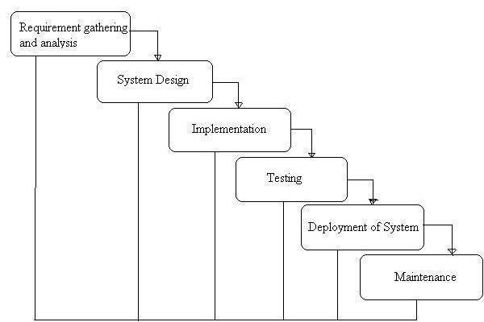
Figure 1: System Analysis and Design

REQUIREMENT IDENTIFICATION
Requirement Identification is a crucial step in the system analysis phase of software development. It involves gathering and defining the essential needs and expectations that the system must meet to serve its intended purpose effectively. This process helps ensure that the system aligns with the business goals and satisfies the users' needs. Requirement identification can be broken down into two main categories: functional and non-functional requirements.

Functional Analysis
The functional requirements are:

        - Product Catalog: The website must list various hardware products and Asian Paints, categorized into sections such as tools, paints, construction materials, etc. Each product will include detailed information such as name, description, price, image, and availability status.
        - User Account Management: Customers should be able to create accounts, log in, and manage their personal information and order history.

        - Shopping Cart: A feature that allows customers to add products to the cart and proceed with the checkout.
        - Order Management: The ability for users to place orders, view order status, and make payments.
        - Payment Integration: Secure payment gateways should be integrated to process payments through various methods (khalti).
        - Admin Panel: The administrator should be able to manage product listings, update inventory, view customer orders, and generate reports.
        - Search and Filtering: A robust search system that allows customers to filter products by category, price range, brand, etc.
        - Customer Support: Integration of a support system like live chat, FAQs, or a helpdesk to assist customers with inquiries.

Non-Functional Analysis
Non-functional requirements are essential aspects of any software application, focusing on how the system behaves rather than what it does. In the context of the " New Panchakanya Enterprise’s e- commerce website " the non-functional requirements are:
        - Scalability: The system should be able to handle an increasing number of users and transactions.
        - Security: User data, especially payment details, should be protected using encryption and secure communication protocols (SSL).
        - Usability: The website should be user-friendly, with an intuitive design that caters to both tech- savvy and less experienced customers.
        - Performance: The website should load quickly, even under heavy traffic, ensuring a smooth shopping experience.

FESIBILITY STUDY
A feasibility study for "New Panchakanya Enterprises", a hardware and software e-commerce website, is essential to determine the project's viability, potential for success, and any challenges that may arise. The feasibility study typically includes several key components:

Technical Feasibility
        - Platform & Technology: The website will be developed using a custom-built solution HTML, CSS, JavaScript for front-end, PHP for back-end, and XAMPP for database management. Alternatively, e-commerce platforms like Shopify, Daraj, Amazon or WooCommerce could be considered based on budget and scale.
        - Payment Gateway Integration: Integrating payment gateways such as Khalti, or local payment options for smooth and secure online transactions.
        - Mobile Responsiveness & Security: Ensuring mobile compatibility for diverse user devices and implementing SSL encryption for data protection.

Operational Feasibility
        - Inventory Management: Implementing an automated inventory system that updates stock levels in real-time for hardware and paints products, with easy categorization.
        - Order Fulfillment: Establishing relationships with local logistics companies to ensure timely product delivery, along with integration for tracking orders on the website.
        - Customer Support: Setting up a live chat, email support, or call center to handle customer inquiries, returns, and service issues efficiently.

Economic Feasibility
        - Initial Investment: Estimated costs for website development, hosting, domain registration, security certificates, and product integration, along with any necessary marketing and branding efforts.
        - Revenue Model: Earning through direct product sales, offering bulk purchase discounts, and possibly setting up a subscription model for frequent buyers.

        - Operating Costs: Ongoing expenses like server hosting, customer service team salaries, shipping costs, product procurement, and digital marketing campaigns.

Schedule Feasibility
        - Development Timeline: The development of the e-commerce site is estimated to take 3–6 months depending on complexity. This includes design, back-end setup, payment integrations, and testing.
        - Launch Plan: A phased launch with initial promotions, discounts for early adopters, and a digital marketing campaign (e.g., SEO, social media, email newsletters) to generate traffic and initial sales.

DATA MODELING
Data modeling is essential to organize and structure the data required for the e-commerce website, ensuring efficiency in storage, retrieval, and management. Here's a breakdown of the data modeling process for New Panchakanya Enterprises:

Data Flow Diagram
A Data Flow Diagram (DFD) is a visual representation of the flow of data within a system, focusing on how data enters, is processed, and exits the system. It helps understand the logical structure of the system, including key processes, data stores, and data sources/destinations.
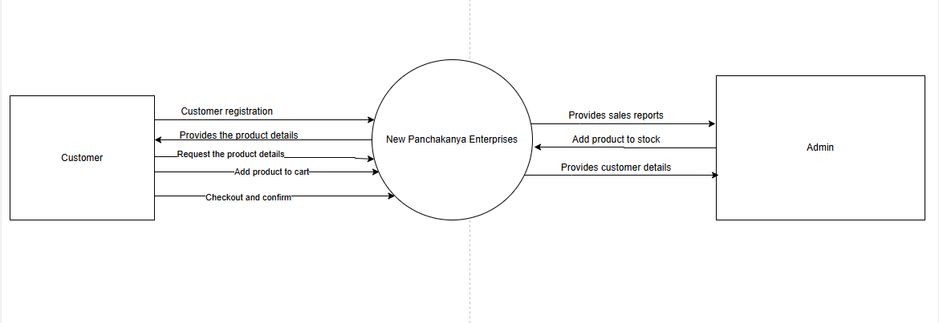

Figure 2: DFD Level 0

ER Diagram

An Entity-Relationship (ER) diagram is a visual representation of the entities within a system and the relationships between them. In the context of the New Panchakanya Enterprises e-commerce website for hardware and Asian Paints, an ER diagram helps to organize and structure data to facilitate efficient database design.

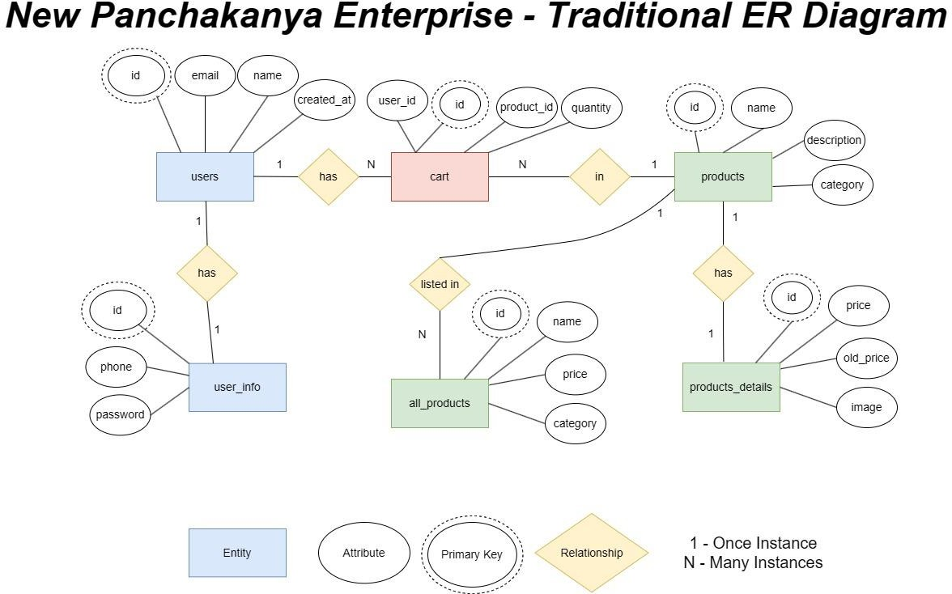
Figure 3 : ER Diagram

PROCESS MODELING
For New Panchakanya Enterprises, a hardware and Asian Paints e-commerce website, the process modeling would describe the flow of operations, from the customer’s browsing experience to the final order placement and delivery. Below is a structured breakdown of the process model using relevant diagrams.

Flow Chart:

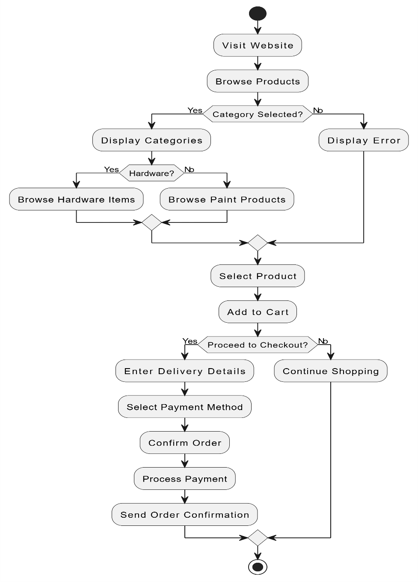
Figure 4: Flowchart

This flowchart illustrates the user journey for the e-commerce website of "New Panchakanya Enterprises." Here's a brief explanation:

- Visit Website: The user accesses the website and chooses to browse products.

- Category Selection: The system checks if a category (e.g., hardware or paint products) has been selected.
  - If not, an error message is displayed.
  - If yes, categories are displayed.
- Browse Items: The user selects either "Hardware" or "Paint Products" to browse specific items.
- Select Product and Add to Cart: After choosing a product, the user adds it to their cart.

Proceed to Checkout:

  - If the user decides to check out, they enter delivery details, choose a payment method, confirm the order, and complete the payment.
  - If the user decides not to check out, they can continue shopping.
- Order Confirmation: After payment, the system sends an order confirmation to finalize the process.
This ensures a streamlined shopping experience for customers browsing and purchasing hardware and painting products.

Use Case Diagram

This diagram illustrates the interactions between users (Customers and Admin) and the Panchakanya Enterprises e-commerce platform.

Key functionalities for Customers include:

        - Browsing hardware and Asian Paints products.
        - Searching for products by category, brand (e.g., Asian Paints), or keywords.

        - Viewing product details, including images, descriptions, and specifications.
        - Adding products to the cart.
        - Check out options for delivery or pickup.
        - Entering billing and shipping information.
        - Selecting payment methods.
        - Tracking order status.
        - Viewing order history.

Admin functionalities include:

        - Managing product catalog (adding, editing, deleting products).
        - Managing inventory levels.
        - Processing orders.
        - Managing customer accounts.
        - Generating sales reports.
        - Handling customer inquiries.
        - Integrating with Asian Paints' APIs (if applicable).

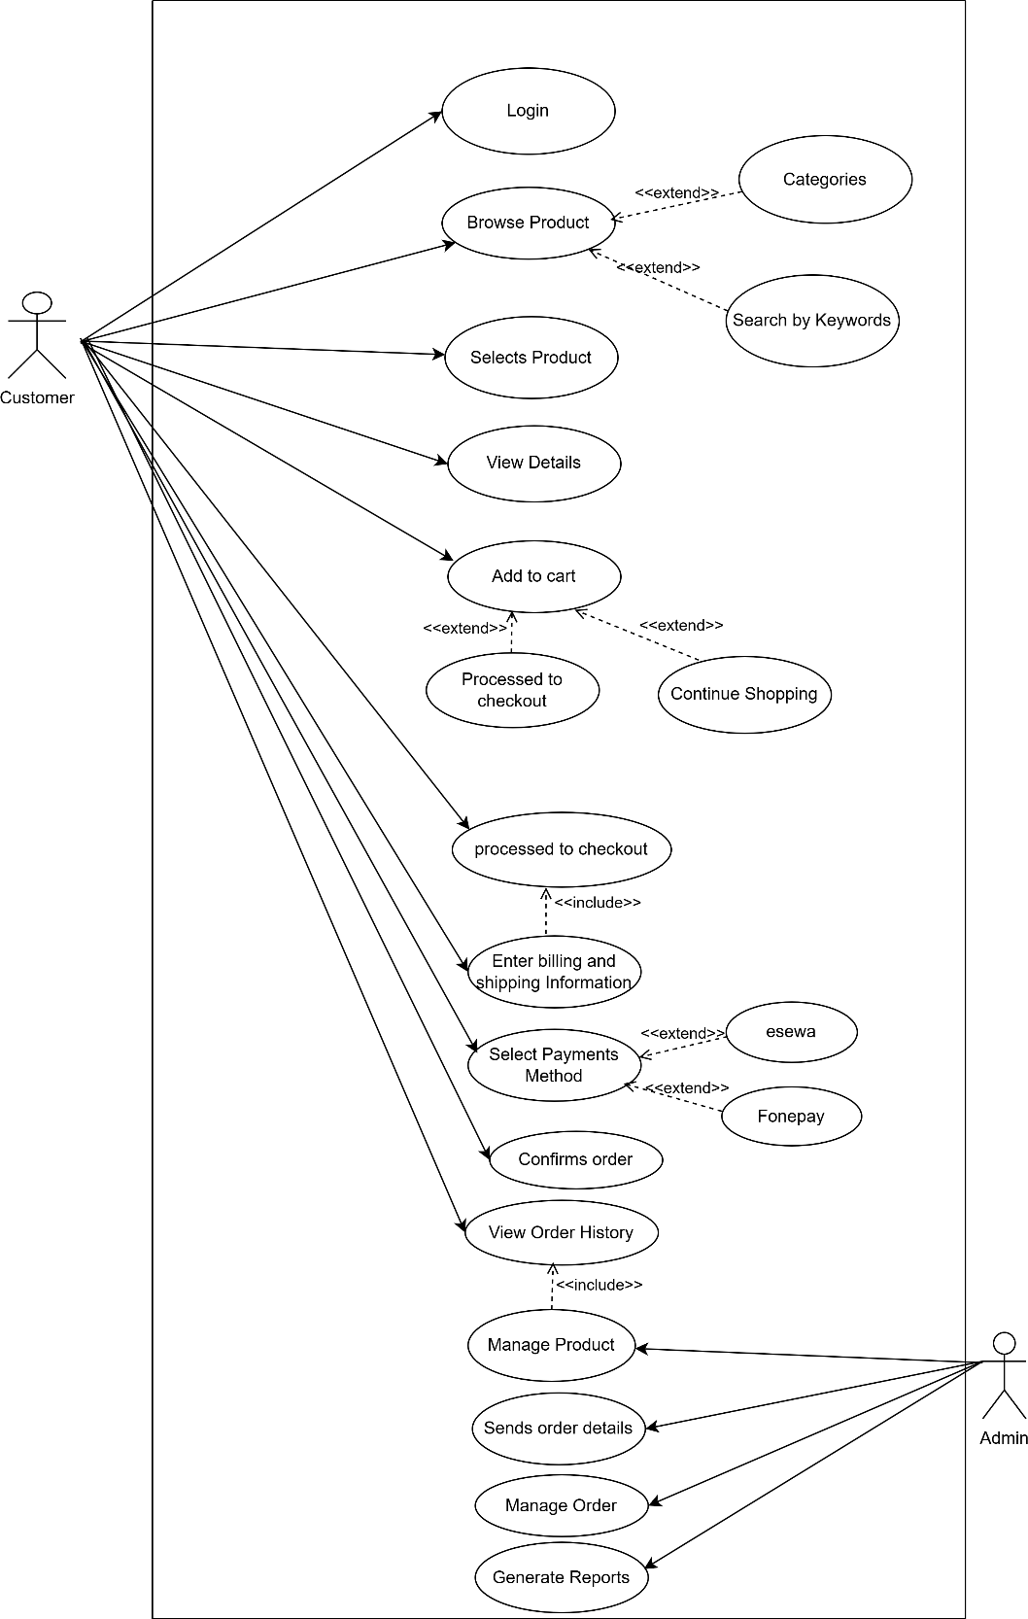
Figure 5: Use Case Diagram

Activity Diagram

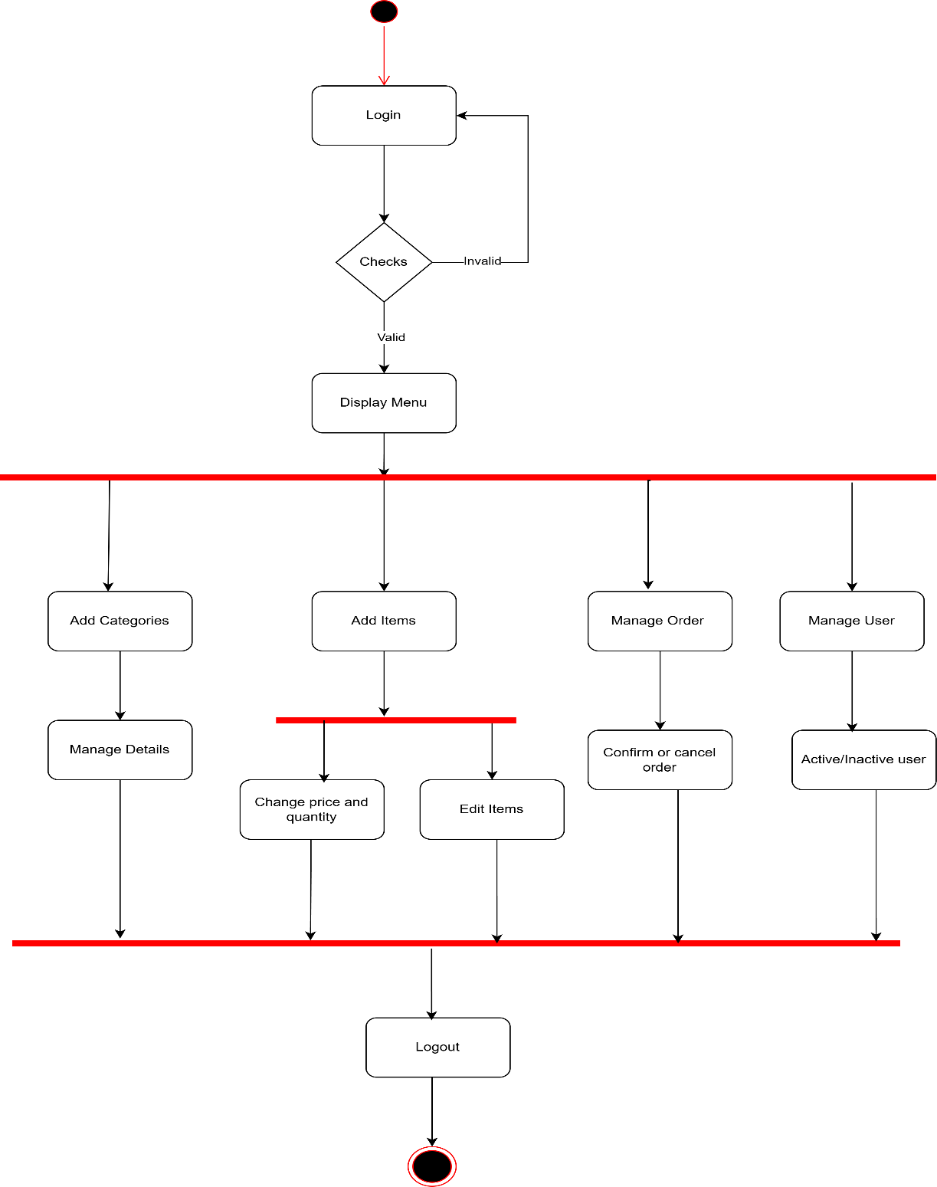
Figure 6: Activity Diagram of Admin

Key activities for admin include:

        - Login and authentication: The process begins with the admin logging into the system, followed by authentication to verify their credentials.
        - Category Management: The admin can add new categories, modify existing ones, and manage their details.
        - Item Management: The admin can add new items, edit existing items, and adjust their price and quantity.
        - Order Management: The admin has the authority to manage orders, including confirming orders and canceling orders as needed.
        - User Management: The admin can manage user accounts within the system, enabling or disabling user accounts based on requirements.

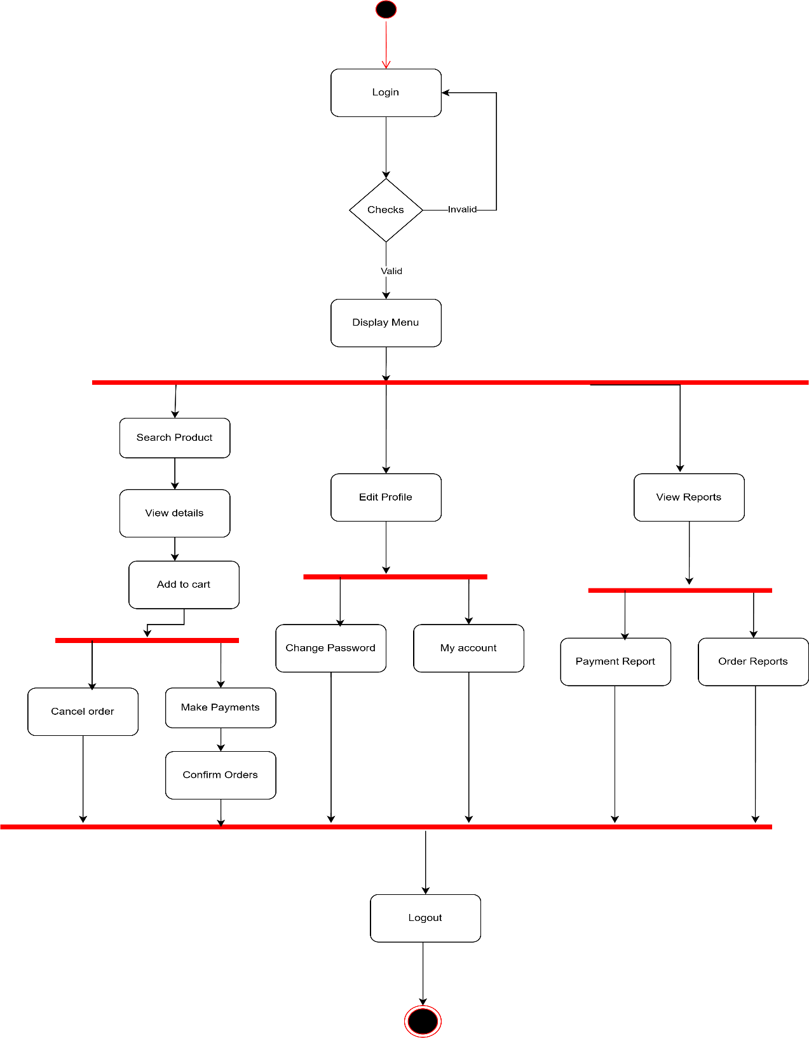
Figure 7: Activity Diagram of Customer

Key activities for customers include:

        - Login and Authentication: The user starts by logging into the system, followed by authentication to verify their credentials.
        - Product Exploration: Users can search for products, view product details, and add items to their cart.
        - Account Management: Users can edit their profile, change their password, and view their account information.
        - Order Management: Users can make payments, confirm orders, and cancel orders if needed.
        - Reporting: The system provides access to view reports, including payment reports and order reports.

Sequence Diagram

This sequence diagram represents the interaction between a User, the Web Browser, the New Panchakanya Enterprises Server, the Database, and the Payment Gateway during various activities on an e-commerce website:

Homepage Access:
The user opens the website, and the browser requests the homepage from the server, which fetches data from the database and displays it to the user.

Product Search:
The user searches for products. The browser sends the query to the server, which retrieves matching products from the database and returns the results.

Viewing Product Details:
The user selects a product to view its details. The browser requests product information from the server, which fetches it from the database and displays it.

Adding Products to Cart:

The user adds a product to their cart. The browser sends this request to the server, which updates the cart information in the database and confirms the action.

Checkout:
The user proceeds to checkout. The server retrieves carts and user details from the database and displays the checkout page.

Payment:
The user initiates payment. The browser communicates with the payment gateway, which notifies the server of payment success. The server updates the order status in the database and confirms the order to the user.
- Logout: The user logs out, and the server processes the logout request, confirming the action to the browser.

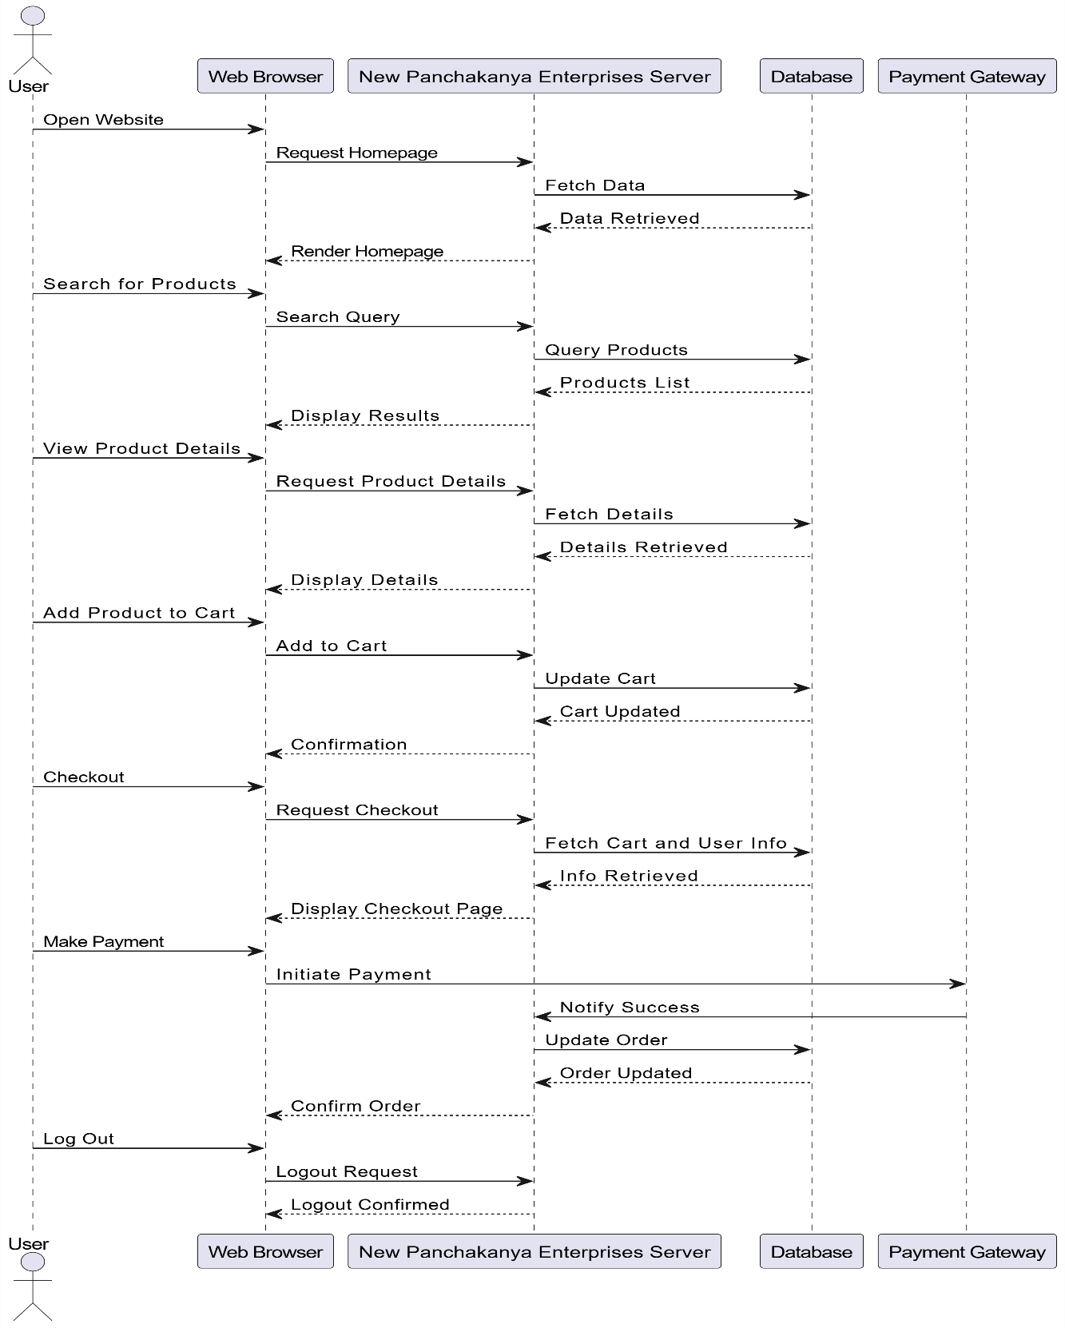

Figure 8:Sequence Diagram

SYSTEM DESIGN

Architectural Design
The three-tier architecture has been used for this project. This architecture is a client server architecture in which the functional process logic, data access, computer data storage and user interface are developed and maintained as independent modules on separate platforms.
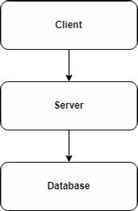

Figure 9 : Three tire architecture

Three-Tier Architecture has the following layers.

Presentation Layer:
Occupies the top level and displays information related to services available on a website. The tier communicates with other tiers by sending results to the browser and other tiers in the network.

Application Layer:
Also called the middle tier, logic tier, business logic or logic tier, this tier is pulled from the presentation tier. It controls application functionality by performing detailed processing. It is managed by a local host.

Data Layer:
Houses database servers where information is stored and retrieved. Data in this tier is kept independent of application servers or the business logic.

The database we have used here is XAMPP’s database.

The following are the reasons behind choosing three tier-architecture:

      - An ability to update the technology stack of one tier, without impacting other areas of the application.
      - It makes the logical separation among three different layers

Database Schema Design
Database schema design is a strategy for constructing a framework for data management. Just like in architecture, a solid database needs to have a blueprint to keep the project on track.

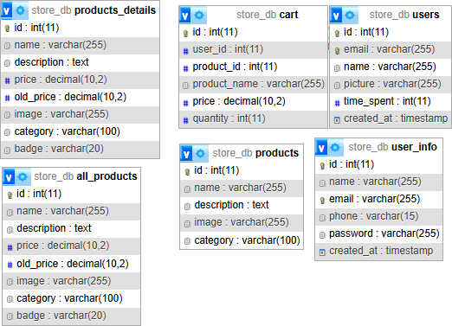

Figure 10: Database Scheme

CHAPTER 4: IMPLEMENTATION AND TESTING

IMPLEMENTATION

Tools used.
      - Platform: Windows
      - Content Management System: HTML, CSS
      - Design and prototyping Tool: Draw.io

Implementation Detail of Module

The implementation of the proposed system for New Panchakanya Enterprises, an e-commerce website for hardware and Asian paints, was carried out using a combination of front-end and back- end technologies. The website was developed using HTML, CSS, and JavaScript for the front-end interface, providing a responsive and user-friendly design. For the server-side functionality, PHP was used to handle backend logic, data processing, and dynamic content rendering.

The system was developed using Visual Studio Code as the code editor, and XAMPP was used to run a local server environment and manage the MySQL database. This setup allowed for efficient testing and development of the e-commerce functionalities, including product listings, user authentication, shopping cart management, and order processing. The implementation was focused on creating a smooth and secure online shopping experience tailored to the needs of hardware customers.

TESTING

System testing is a level of testing that validates the complete and fully integrated software product. The purpose of a system test is to evaluate the end-to-end system specifications. Usually, the software is only one element of a larger computer-based system.

Test Case ID: 1
Test Title: Verify product search and filtering functionality. Test Designed Date: April 2025
Pre-conditions: User has successfully accessed the website.
Dependencies: Product database is populated with hardware and paint products.

Table 1: Test Case 1
Test  Description | Test Data | Expected Result | Actual Result | Status  (Pass/Fail)
1. Navigate to home page  Select "Paint Products" category  Enter "Asian Paints" in  search bar  Click search button | Category: Paint Products Search term: Asian Paints | System should  display all Asian Paints products from the Paint  Products category | System displays filtered Asian Paints products successfully | Pass
Attempt to search with  invalid product name | Search term:  "NonExistentProduct123" | System should display "No products found" message | System displays "No products found" message | Pass
Post-condition: Search results are displayed, and users can view product details by clicking on a product.

CHAPTER 5: CONCLUSION AND FUTHER RECOMMENDATION

LESSON LEARNT /OUTCOME
From this project, we learned about project management, how the Content Management Systems work and its application in the Ecommerce industry. We also learned to build the diagrams that are needed for the system. We learned many things which can lead us to do any work related to such a further project.

CONCLUSION
New Panchakanya Enterprises is an e-commerce platform that provides a convenient and efficient way for customers to purchase hardware tools, construction materials, and paints online. Built using core web technologies such as HTML, CSS, JavaScript, and PHP, and supported by a MySQL database via XAMPP, the platform ensures a functional and user-friendly shopping experience. Through this project, we aimed to simplify the buying process for both individuals and professionals by offering essential products at their fingertips. The system includes essential e- commerce features like product listing, cart management, order processing, and secure backend handling. It demonstrates how a custom-coded solution can effectively support local businesses and specific user needs. System diagrams such as use case, ER, and data flow further illustrate its structure, making it a practical example of a niche-focused e-commerce platform.

FUTURE RECOMMENDATION
The project will be upgraded and extended with the following features:
    - Improving the design, implementation, and documentation in such a way that anyone can use this project for better performance.
    - The web page can be made lighter so that even with low internet speed, the page can be browsed.
    - The web application will be brought to the Android application.
    - Enhance the system with email and SMS (Short Message Service) or email notifications.
    - Evolve the system by developing several versions through users’ feedback if a complete solution has not been worked out.

References

Anderson, L. ( 2018). Pearson. Retrieved from PHP for the Modern Web: A Practical Guide to Web Development with PHP and MySQL: https://www.pearson.com/store/product/PHP-for-the- Modern-Web/9780134855787
Berman, B. &. (2018). Journal of Retail & Distribution Management. Retrieved from Navigating the Complex World of Hardware Retail E-Commerce: https://www.emerald.com/insight/content/doi/10.1108/JRDM-04-2017-0094/full/html
Fitzgerald, A. (2019). Web Development Journal. Retrieved from Responsive Design: The Future of E-Commerce Sites: https://www.webdevjournal.com/responsive-design-future
Ghosh, D. ( 2017). E-Commerce Review. Retrieved from The Evolution of Online Retail: Understanding Hardware E-Commerce Platforms: https://www.ecommercereview.com/understanding-hardware-ecommerce
He, Y. (2019). Journal of Information Security. Retrieved from Cybersecurity and Online Retail: Protecting Users in the Digital Age: https://www.journalofinfosec.com/cybersecurity- online-retail
Jayaraman, M. (2020). Journal of Business & Industry Research. Retrieved from The Impact of E- Commerce on the Asian Paints Industry: https://www.jbirjournal.com/impact-of- ecommerce-on-asianpaints
Jones, R. &. (2021). UX Design Journal. Retrieved from User Experience Design in E-Commerce: A Case Study Approach: https://www.uxdesignjournal.com/user-experience-ecommerce- case-study
Kumar, A. &. (2020). International Journal of Web Development. Retrieved from Enhancing Interactivity in E-Commerce Websites with JavaScript: https://www.ijwdjournal.com/enhancing-interactivity-javascript
Lorincz, N. (2024, May 16). 17 Ecommerce Case Studies to Inspire You. Retrieved from OptiMonk Blog: https://www.optimonk.com/ecommerce-case-studies/
Patel, S. &. (2019). Paint & Coatings Journal. Retrieved from E-Commerce Tools for the Paint Industry: From Color Selection to Customer Satisfaction: https://www.paintcoatingsjournal.com/ecommerce-tools-paint-industry
Team, A. P. (2024). Asian Paints Online Shop. Retrieved from Asian Paints Online Shop: https://www.asianpaints.com/online-shop.html
Team, H. H. (2024). Hippo Homes. Retrieved from Hippo Homes - One Stop Shop for All Home Upgrades: https://www.hippostores.com/
Team, M. (n.d.). Magenest Blog. Retrieved from The Best Examples of Successful Shopify Hardware Stores 2023: https://magenest.com/en/shopify-hardware-store/
Team, N. H. (2024). Neu's Hardware Tools Paint. Retrieved from https://www.neushardware.com/home/

Team, P. (2024). Prototypr.io. Retrieved from Designing an E-commerce Website for a Hardware Store: A UX Case Study: https://blog.prototypr.io/digitool-progress-e-commerce-journey- a-ux-case-study-48067101a6f4
Team, P. n. (2024). Paint n Hardware. Retrieved from Paint n Hardware: https://paintnhardware.com/

Appendices

Snapshots of output:
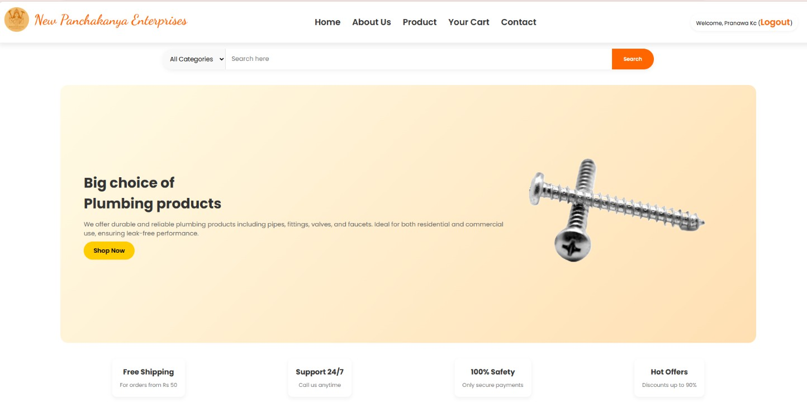

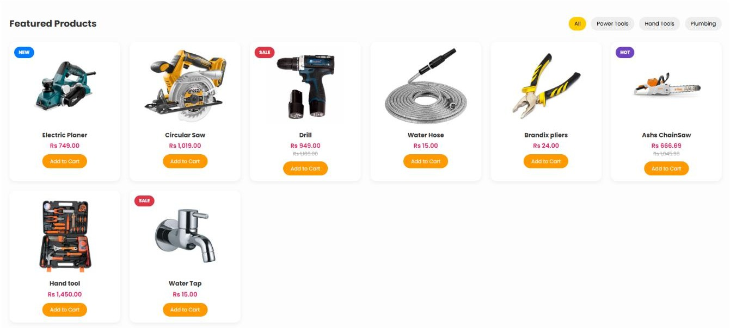

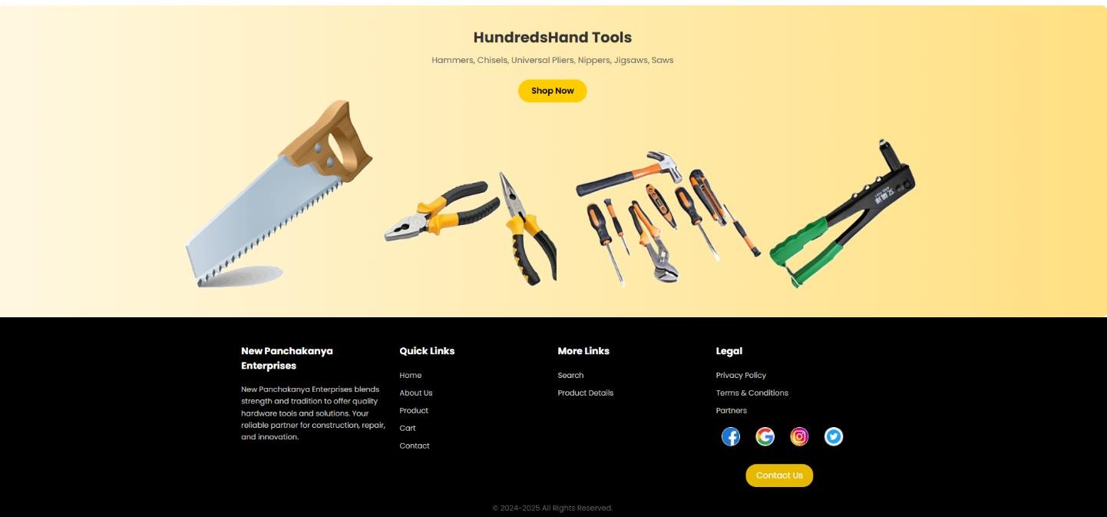

Figure 11 Home Page of New Panchakanya
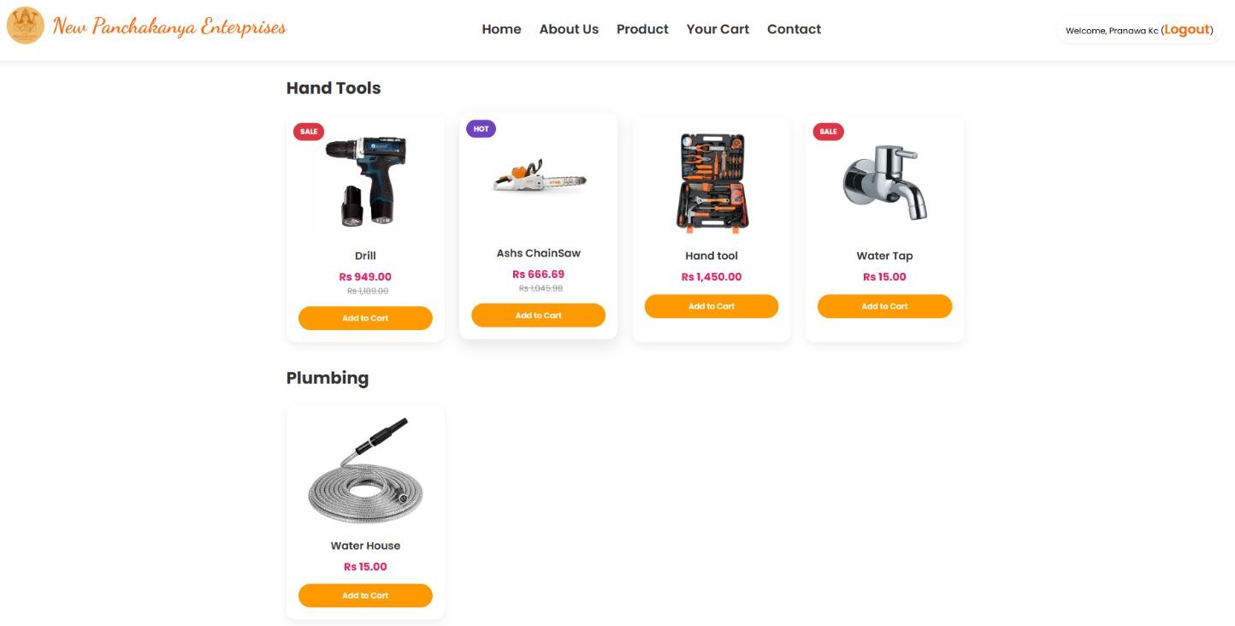

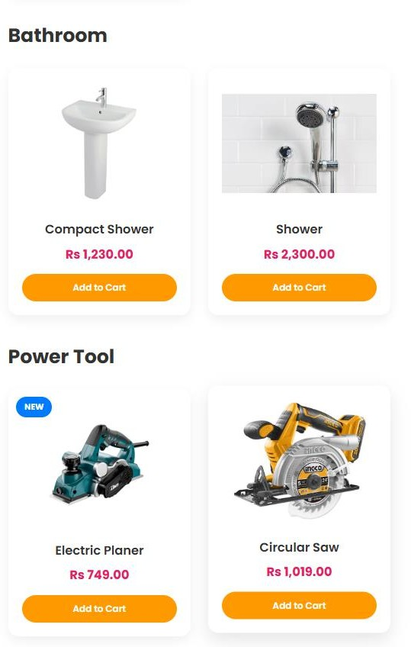
Figure 12 Product page of New Panchakanya

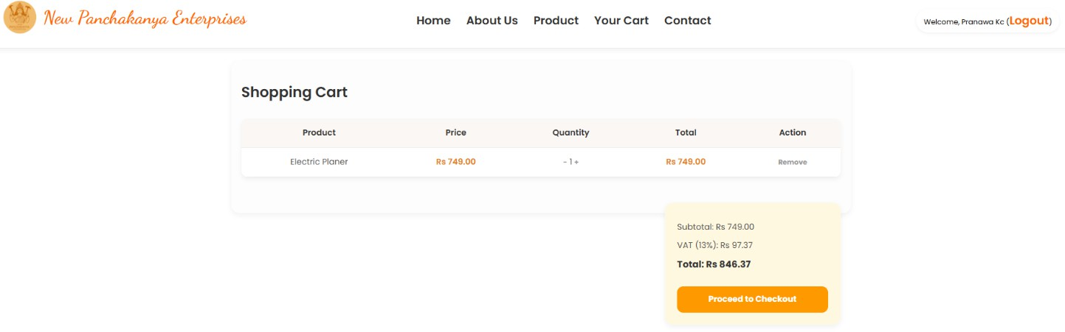
Figure 13 Add to cart page of New Panchakanya

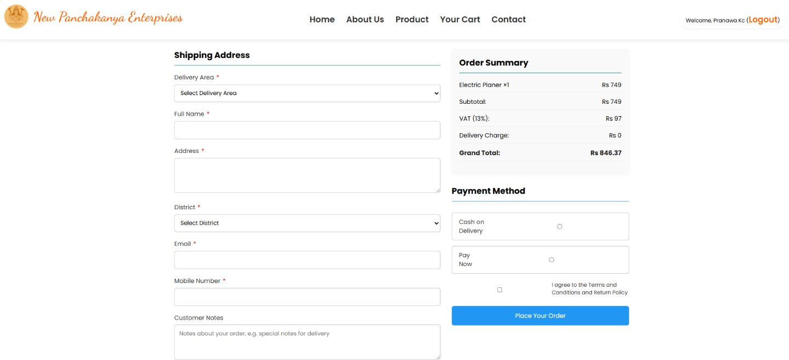
Figure 14 Checkout of New Panchakanya
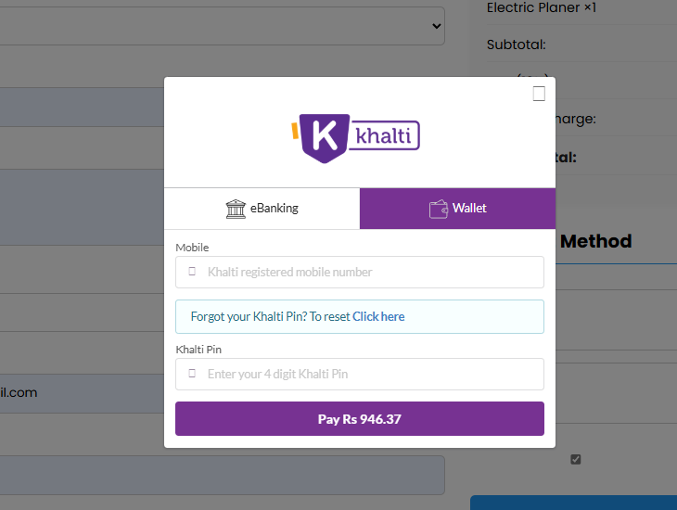

Figure 15 Payment of New Panchakanya

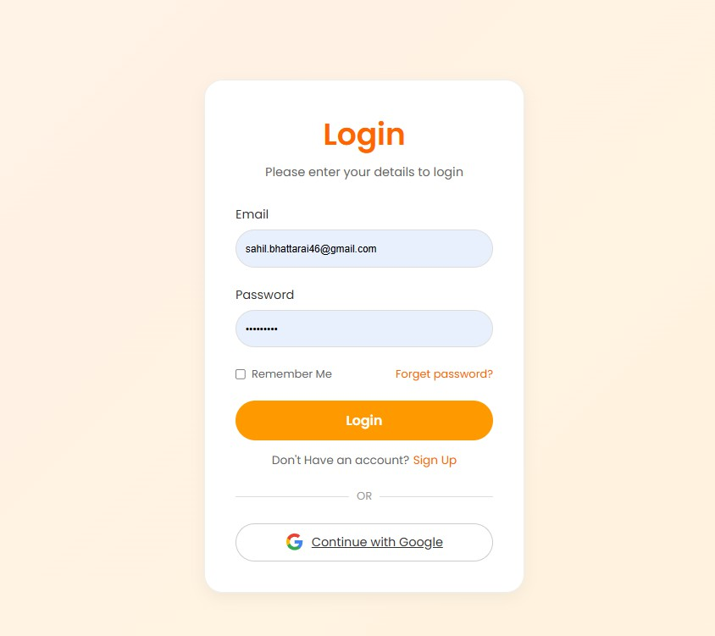
Figure 16 Login Page
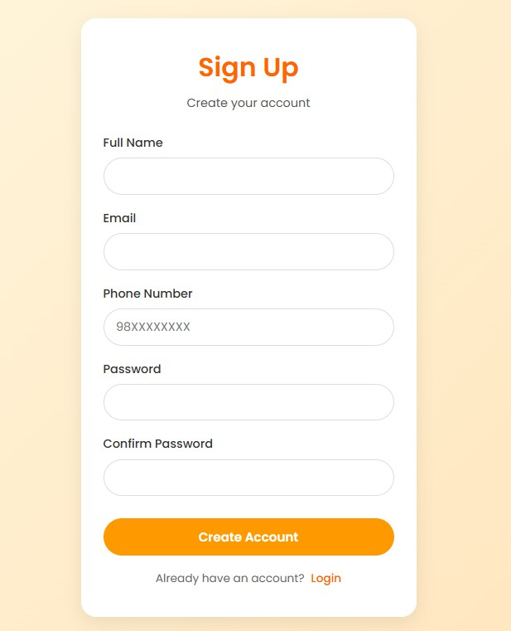

Figure 17 Signup page

