
National College of Computer Studies
Paknajol, Kathmandu

Report on “Feedback Analysis System”

Submitted by: Suraj Timsina Submitted to:
Programme: BSc. CSIT, 5th Semester Yachu Shakya
Section: B
Roll No: 22
Email: surajtimsina321@gmail.com

Declaration
I hereby declare that the project work entitled “Feedback Analysis System” submitted to Institute of Science and Technology, Tribhuvan University, Kathmandu. National College of Computer Studies, Kathmandu, is for the degree is submitted in partial fulfillment of requirements for the degree of Bachelor of Science in Computer Science and Information Technology (Bsc.CSIT). This report contains all the original research and analysis with some information taken from other resources which are properly cited. This project work has not been submitted to any other university or institution for the award of any degree or diploma.

Acknowledgement

This report is my assignment as a partial fulfillment of project work course for the requirement of Bachelor of Science in Computer Science and Information Technology (Bsc.CSIT). I have taken this opportunity to express my respect and gratitude to my respected teacher Mr. Yachu Shakya for their valuable guidance in making this project a reality. I am thankful for their constant support and encouragement and valuable guidance and encouragement throughout this project completion period. I would like to present my teachers gratitude for their guidance, good advices and honest reviews in this entire project session. Project has been completed under the intensive and genuine guidance of National College of Computer Studies.

Suraj Timsina
National College of Computer Studies
Date: June, 2025

Table of Contents
1. Introduction 1
2. Objective 1
3. Challenges 1
4. Technologies used 1
5. Feature and functionalities 2
6. Limitations and Future Enhancements 2
7. System design and development 3
7.1. Source code 3
8. Conclusion 10
9. References 11

List of Figures
Figure 1: User Registration 3
Figure 2: Login 4
Figure 3: Logout 4
Figure 4: Admin Dashboard 5
Figure 5: Create Form 6
Figure 6: View Response 7
Figure 7: User Dashboard 8
Figure 8: View Form 9
Figure 9: Submit Feedback 10

Abstract
The Feedback Analysis System is an advanced platform designed to systematically collect, process, and analyze user feedback to derive meaningful insights and drive data-driven decision-making. By integrating multi-channel feedback collection—including surveys, rating scales, and open-ended responses—the system employs sophisticated analytical techniques such as sentiment analysis, trend tracking, and cross-tabulation to identify patterns, correlations, and emerging issues. The system is developed using HTML, CSS, JavaScript, PHP, and MySQL.

Introduction
The Feedback Analysis System is a cutting-edge platform designed to transform unstructured user feedback into actionable business intelligence. In today's data-driven world, organizations across industries face the challenge of processing large volumes of customer opinions, survey responses, and service evaluations. Feedback Analysis System addresses this need through an integrated suite of analytical tools that automate the entire feedback lifecycle—from collection and processing to visualization and reporting.[3]

Objective
The objectives of this project are given below:
- Collect Feedback – Gather user ratings and comments through simple surveys.
- Analyze Responses – Calculate average ratings and count common responses.
- Improve Decisions – Help businesses make quick adjustments based on feedback.

Challenges
- Manual Data Processing – Time-consuming and error-prone collection/analysis of feedback via spreadsheets.
- Unstructured Feedback – Difficulty in categorizing and interpreting open-ended responses.
- Delayed Insights – Slow detection of trends or recurring issues due to lack of real-time analysis.
- Biased Decisions – Overreliance on anecdotal evidence or small samples instead of data-driven insights.
- Missed Opportunities – Failure to identify customer needs or emerging problems promptly.
- Inefficient Reporting – No centralized dashboard, leading to inconsistent or outdated reports.
- Scalability Issues – Struggles to handle growing feedback volume across multiple channels. [2]

Technologies used
- Frontend: HTML, CSS, JavaScript
- Backend: PHP
- Database: MySQL
- Tools: XAMPP, phpMyAdmin, VS Code

Feature and functionalities
- Feedback Collection
- Simple form templates
- Basic Analysis
- Export Options
- User Roles

Limitations and Future Enhancements
The current basic version of Feedback Analysis System, while functional, has several notable limitations. First, its sentiment analysis relies on simple keyword matching rather than advanced AI, which means it may misinterpret nuanced feedback. The system also lacks real-time processing capabilities, requiring manual updates to reflect new feedback, which delays insights. Additionally, the survey tools offer limited customization, with fixed templates that cannot adapt questions based on user responses. [1]
To address these limitations, several key enhancements are planned for FAS. First, integrating AI and machine learning will enable more accurate sentiment analysis, automatic theme detection, and multilingual support, allowing the system to process feedback in various languages. Real-time dashboards with live data streaming and automated alerts will help businesses respond faster to emerging issues. The survey module will be upgraded with conditional logic, enabling dynamic questions that adapt based on previous answers, as well as mobile-optimized forms for better accessibility

System design and development

Source code
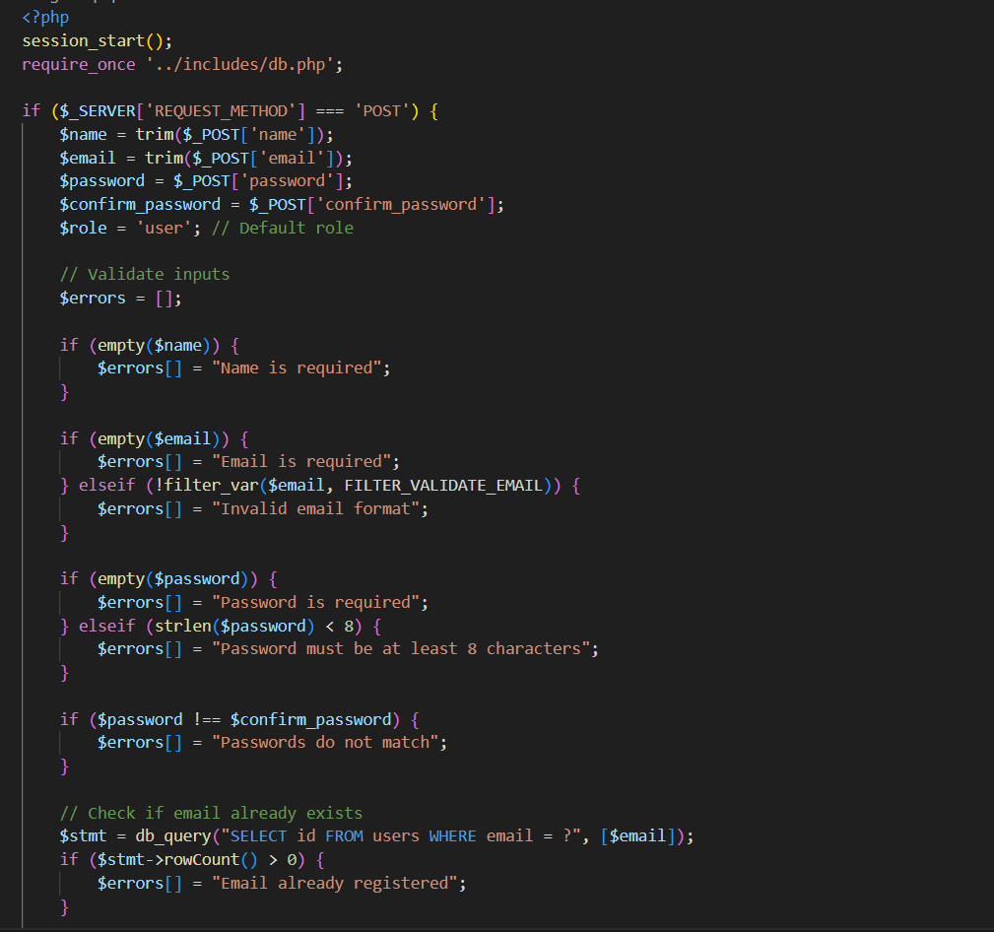
Figure 1: User Registration
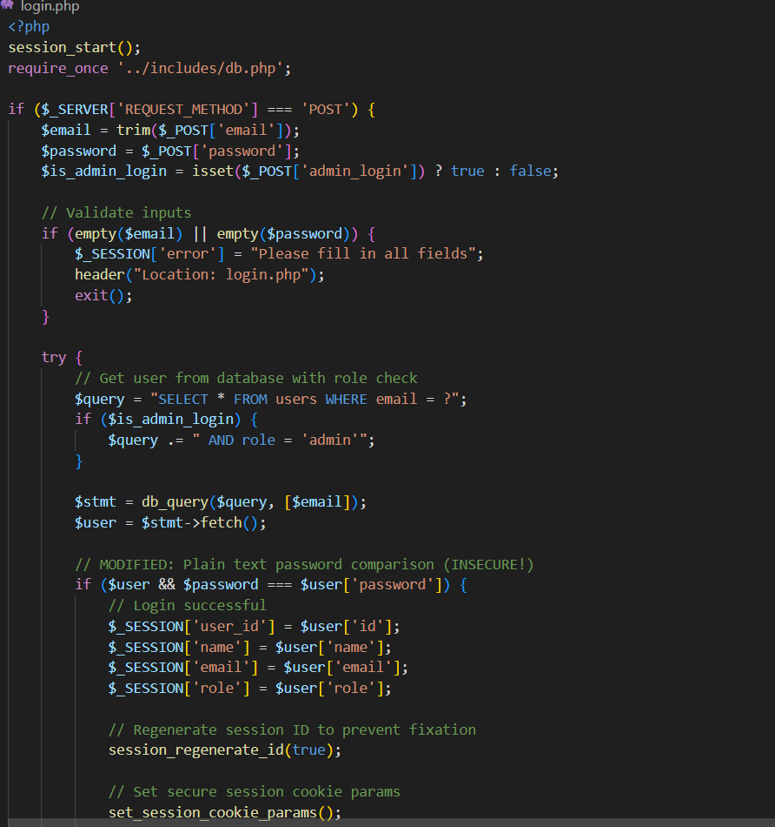
Figure 2: Login

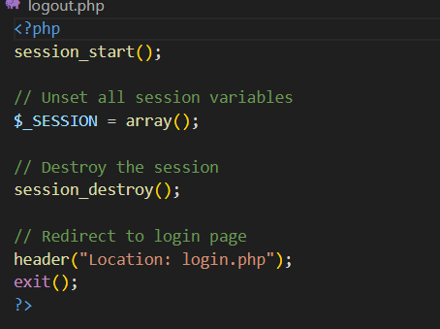
Figure 3: Logout
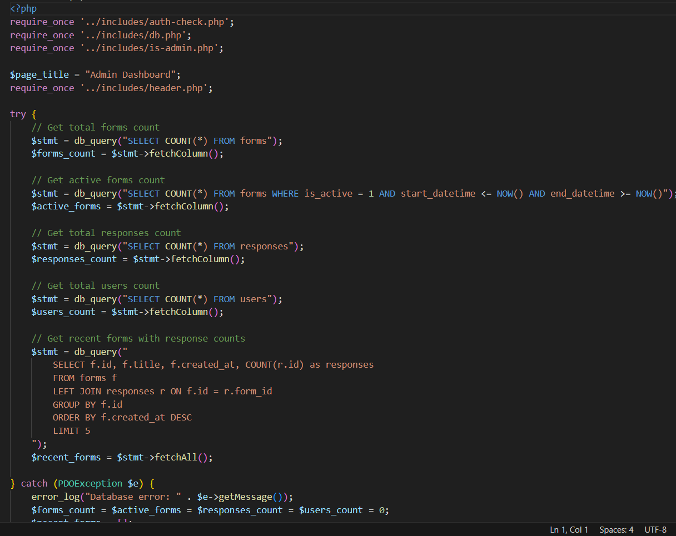
Figure 4: Admin Dashboard
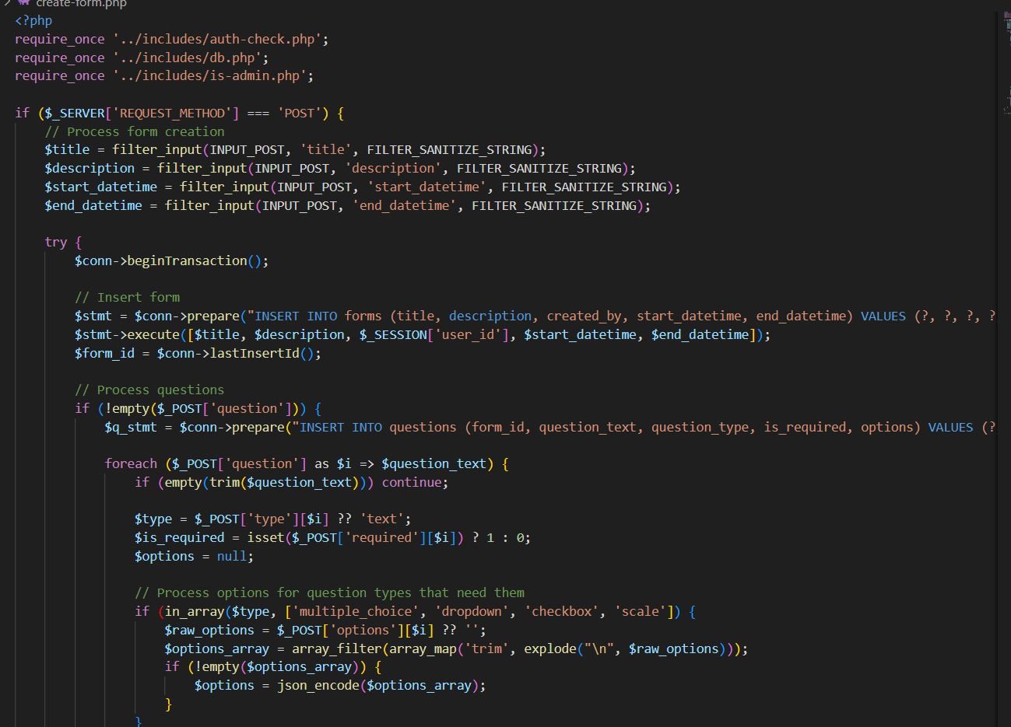
Figure 5: Create Form
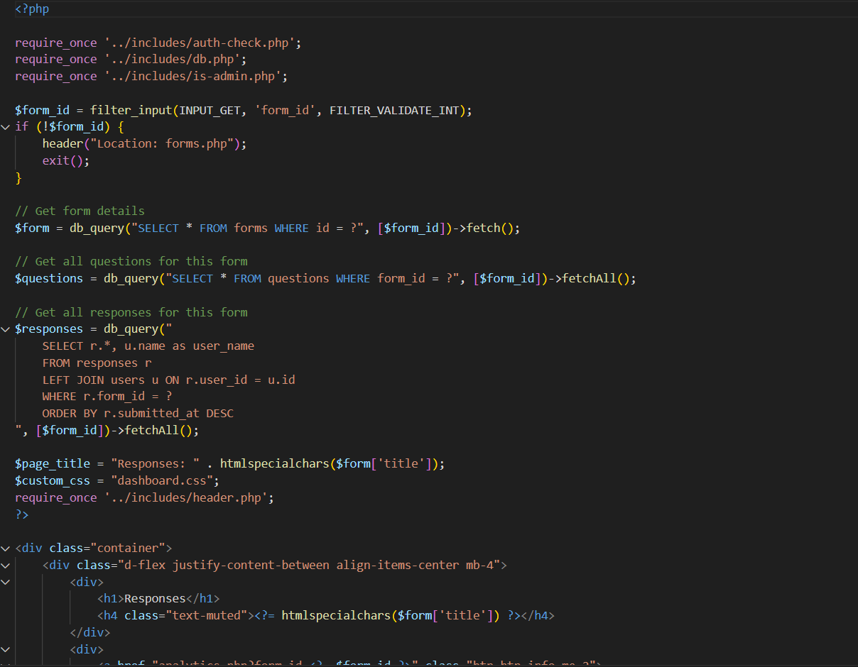
Figure 6: View Response

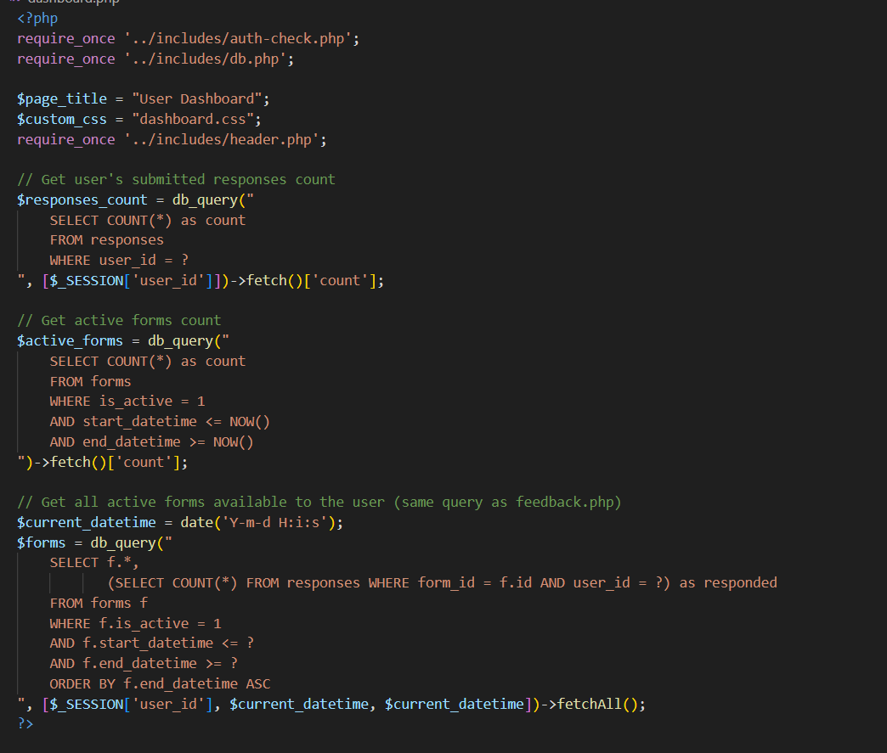
Figure 7: User Dashboard
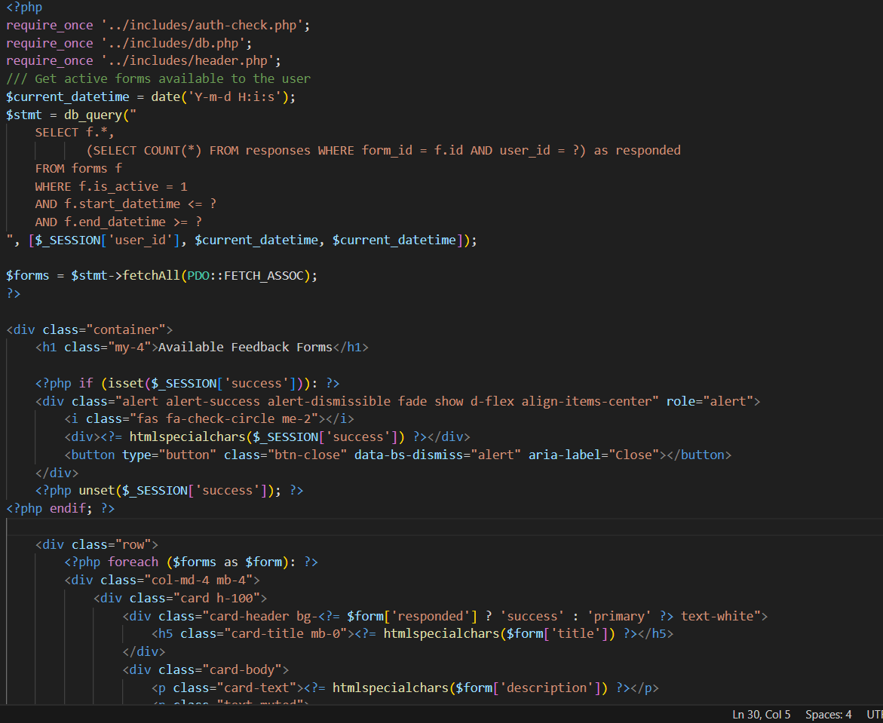
Figure 8: View Form

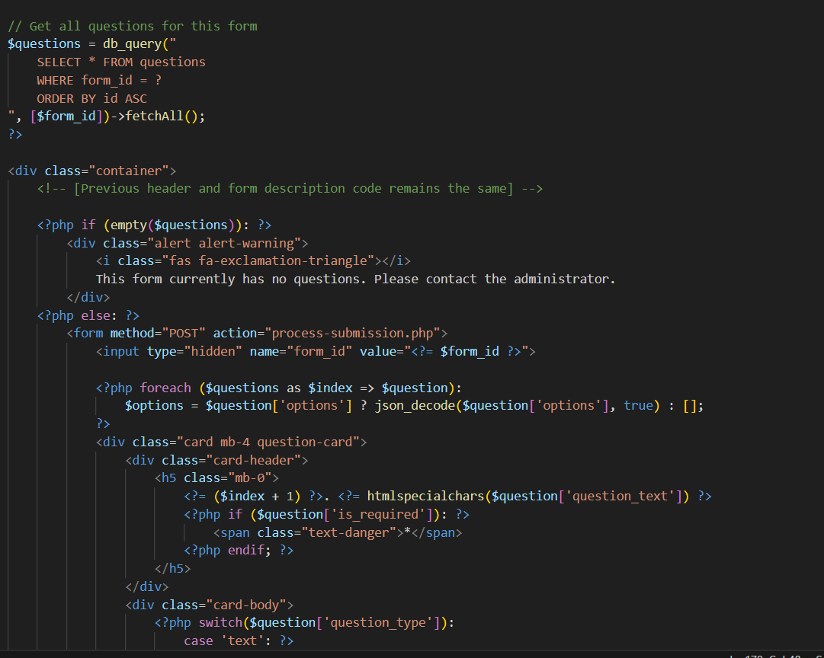
Figure 9: Submit Feedback

Conclusion
A Feedback Analysis System helps businesses understand what customers or employees think quickly and easily. It automatically collects and organizes feedback from surveys, ratings, and comments, saving time compared to manual work. Even a simple Feedback Analysis System can show average ratings, count common responses, and highlight positive or negative opinions.

References

[1] | "revechat," [Online]. Available: https://www.revechat.com/blog/customer-feedback-system/.
[2] | "sprinklr," [Online]. Available: https://www.sprinklr.com/blog/customer-feedback-analysis/.
[3] | "userpilot," [Online]. Available: https://userpilot.com/blog/feedback-management-system/.

