NIST College
Lainchaur, Kathmandu
Affiliated to pOkhara University

Lab Assignment
Net Centric Computing
Submitted by: Submitted To:
Sujal Bahadur Thapa Yuba Raj Devkota
Bsc. CSIT 6th Semester
Sec-B Roll:20

Date: 19th Dec 2025

TABLE OF CONTENT
S.N. | TITLE | DATE OF SUBMITION | SIGNATURE | REMARKS
1 | Write a C# program to display "Hello, yourname!" using the .NET CLI. Compile and execute it to understand the compilation and execution process. Write compilation steps and replace yourname with your real name. | 2 August
2 | Create a class with a constructor, properties (with get/set accessors), and a method to display object data. Instantiate the object and test it. | 2 August
3 | Implement a base class Vehicle and a derived class Car. Use the base keyword to call the base class constructor and override a virtual method. | 10 August
4 | Create an interface IShape with a method CalculateArea(). Implement it in two classes: Circle and Rectangle. | 10 August
5 | Declare a delegate MathOperation that takes two integers and returns an integer. Assign it to methods for addition and multiplication and invoke them. | 10 August
6 | Write a LINQ query using a lambda expression to filter and display even numbers from an integer array. | 15 August
7 | Implement exception handling using try-catch-finally to handle division by zero and display a custom error message. | 15 August
8 | Create a class Button with an event Clicked using a custom delegate ButtonClickHandler. Raise the event when a Click() method is called. Subscribe to the event in the main program and display a message when the button is clicked. | 15 August
9 | Use LINQ to query a list of strings and retrieve all names that start with the letter 'A', are longer than 4 characters, and sort them in ascending order. Display the filtered results. | 22 August
10 | Create an ASP.NET Core MVC application with a view that displays a simple calculator form with two textboxes (for numbers), a dropdown for operation (+, -, *, /), and a submit button. On submission, display the result below the form using a controller action and Razor view. | 22 August
11 | Create an ASP.NET Core application that stores a user's name in Session and displays it on another page. Then, use TempData to pass a one-time notification (e.g., "Login successful") between two actions. | 27 August
12 | Build a page that stores a user's theme preference (light/dark) in a cookie. Also, pass a product ID via query string to another page and display it. | 5 September

1. Write a C# program to display "Hello, yourname!" using the .NET CLI. Compile and execute it to understand the compilation and execution process. Write compilation steps and replace yourname with your real name.

using System;
namespace Program{
class Program
{
static void Main(string[] args)
{
Console.WriteLine("Hello, Sujal Bahadur Thapa!");
}
}
}

Output:
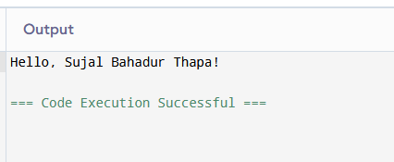

2. Create a class with a constructor, properties (with get/set accessors), and a method to display object data. Instantiate the object and test it.

using System;
namespace Program
{
class Person
{
public string Name { get; set; }
public int Age { get; set; }

public Person(string name, int age)
{
Name = name;
Age = age;
}

public void DisplayInfo()
{
Console.WriteLine("Name: " + Name);
Console.WriteLine("Age: " + Age);
}
}

class Program
{
static void Main()
{
Person person1 = new Person("Sujal Bahadur Thapa", 20);
person1.DisplayInfo();

person1.Name = "Samridhi Shah";
person1.Age = 28;

Console.WriteLine("\nAfter Updating:");
person1.DisplayInfo();
}
}
}

Output:
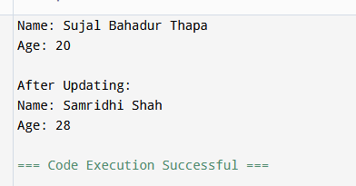

3. Implement a base class Vehicle and a derived class Car. Use the base keyword to call the base class constructor and override a virtual method.

using System;
namespace Program
{
// Base class
class Vehicle
{
public string brand;

// Base class constructor
public Vehicle(string brandName)
{
brand = brandName;
Console.WriteLine("Vehicle constructor called");
}

// Virtual method
public virtual void DisplayInfo()
{
Console.WriteLine("This is a vehicle of brand: " + brand);
}
}

// Derived class
class Car : Vehicle
{
public string model;

// Derived class constructor
public Car(string brandName, string modelName) : base(brandName)
{
model = modelName;
Console.WriteLine("Car constructor called");
}

// Override virtual method
public override void DisplayInfo()
{
base.DisplayInfo(); // Optional: calls base version
Console.WriteLine("This car is model: " + model);
}
}

class Program
{
static void Main(string[] args)
{
Car myCar = new Car("Honda", "Civic");
myCar.DisplayInfo();
}
}
}
Output:
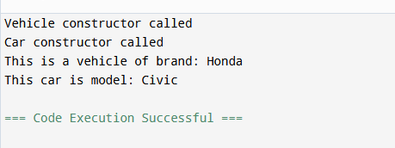
4. Create an interface IShape with a method CalculateArea(). Implement it in two classes: Circle and Rectangle.
using System;

namespace ShapeExample
{
// Step 1: Define the interface
public interface IShape
{
double CalculateArea();
}

// Step 2: Implement the interface in Circle
public class Circle : IShape
{
public double Radius { get; set; }

public Circle(double radius)
{
Radius = radius;
}

public double CalculateArea()
{
return Math.PI * Radius * Radius;
}
}

// Step 3: Implement the interface in Rectangle
public class Rectangle : IShape
{
public double Length { get; set; }
public double Width { get; set; }

public Rectangle(double length, double width)
{
Length = length;
Width = width;
}

public double CalculateArea()
{
return Length * Width;
}
}

// Step 4: Main program to test
class Program
{
static void Main(string[] args)
{
Console.Write("Enter radius of circle: ");
double radius = double.Parse(Console.ReadLine());

Console.Write("Enter length of rectangle: ");
double length = double.Parse(Console.ReadLine());

Console.Write("Enter width of rectangle: ");
double width = double.Parse(Console.ReadLine());

IShape circle = new Circle(radius);
IShape rectangle = new Rectangle(length, width);

Console.WriteLine("\n--- Results ---");
Console.WriteLine($"Circle Area: {circle.CalculateArea():F2}");
Console.WriteLine($"Rectangle Area: {rectangle.CalculateArea():F2}");
Console.writeline(“Sujal Bahadur Thapa”);
Console.ReadLine();
}
}

}

Output:
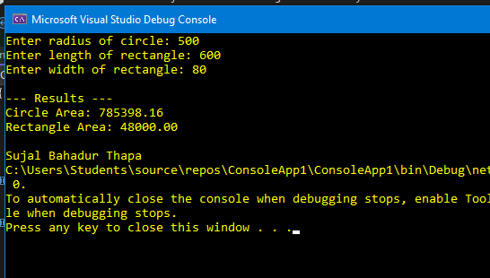

5. Declare a delegate MathOperation that takes two integers and returns an integer. Assign it to methods for addition and multiplication and invoke them
using System;

namespace DelegateExample
{
// Step 1: Declare the delegate
public delegate int MathOperation(int a, int b);

class Program
{
// Step 2: Methods matching the delegate signature
static int Add(int x, int y)
{
return x + y;
}

static int Multiply(int x, int y)
{
return x * y;
}

static void Main(string[] args)
{
Console.Write("Enter first number: ");
int num1 = int.Parse(Console.ReadLine());

Console.Write("Enter second number: ");
int num2 = int.Parse(Console.ReadLine());

// Step 3: Assign delegate to Add method
MathOperation operation = Add;
Console.WriteLine($"Addition: {operation(num1, num2)}");

// Step 4: Assign delegate to Multiply method
operation = Multiply;
Console.WriteLine($"Multiplication: {operation(num1, num2)}");
Console.writeline(“Sujal Bahadur Thapa”);

Console.ReadLine();
}
}

}

Output: 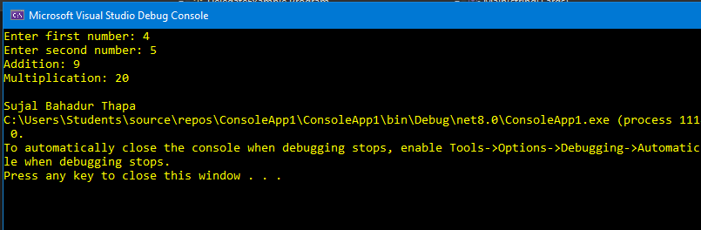
6. Write a LINQ query using a lambda expression to filter and display even numbers from an integer array.

using System;
using System.Linq; // Required for LINQ

namespace LINQExample
{
class Program
{
static void Main(string[] args)
{
// Step 1: Create an integer array
int[] numbers = {1,2,3,4,5,6,7,8,9,10 };

// Step 2: Show the original array
Console.WriteLine("Original array:");
Console.WriteLine(string.Join(", ", numbers));

// Step 3: Use LINQ with lambda to filter even numbers
var evenNumbers = numbers.Where(n => n % 2 == 0);

// Step 4: Display the even numbers
Console.WriteLine("\nEven numbers:");
Console.WriteLine(string.Join(", ", evenNumbers));
Console.writeline(“Sujal Bahadur Thapa”);

Console.ReadLine();
}
}

}
Output:
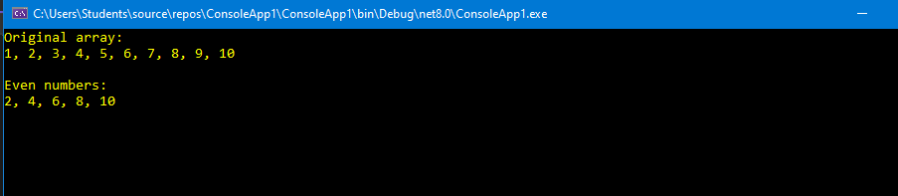
7. Implement exception handling using try-catch-finally to handle division by zero and display a custom error message.
using System;

namespace ExceptionHandlingExample
{
class Program
{
static void Main(string[] args)
{
try
{
// Input from user
Console.Write("Enter numerator: ");
int numerator = int.Parse(Console.ReadLine());

Console.Write("Enter denominator: ");
int denominator = int.Parse(Console.ReadLine());

// Division operation
int result = numerator / denominator;

Console.WriteLine($"Result: {result}");
}
catch (DivideByZeroException)
{
Console.WriteLine("Error: Division by zero is not possible.");
}
catch (FormatException)
{
Console.WriteLine("Error: Enter valid integer values.");
}
finally
{
Console.WriteLine("Program Completed!!!");
}
Console.writeline(“Sujal Bahadur Thapa”);
Console.ReadLine();
}
}

}
Output:
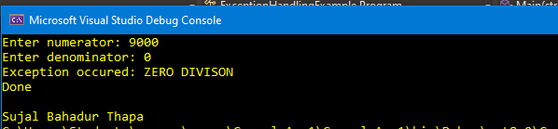
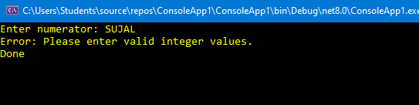
8. Create a class Button with an event Clicked using a custom delegate ButtonClickHandler. Raise the event when a Click() method is called. Subscribe to the event in the main program and display a message when the button is clicked.

using System;

namespace ButtonEventExample
{
// Step 1: Declare a custom delegate for the event handler
public delegate void ButtonClickHandler(object sender, EventArgs e);

// Step 2: Define the Button class with the Clicked event
public class Button
{
public event ButtonClickHandler Clicked;

// Method to raise the event
public void Click()
{
Console.WriteLine("Button.Click() called.");

// Raise the event only if there are subscribers
Clicked?.Invoke(this, EventArgs.Empty);
}
}

class Program
{
static void Main(string[] args)
{
// Step 3: Create a button instance
Button myButton = new Button();

// Step 4: Subscribe to the Clicked event
myButton.Clicked += MyButton_Clicked;

// Simulate button click
myButton.Click();
Console.writeline(“Sujal Bahadur Thapa”);
Console.ReadLine();
}

// Event handler method
private static void MyButton_Clicked(object sender, EventArgs e)
{
Console.WriteLine("Button was clicked! Event handler executed.");
}
}

}
Output:
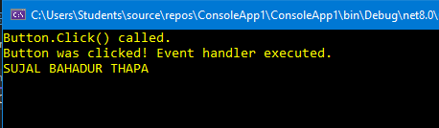

9. Use LINQ to query a list of strings and retrieve all names that start with the letter 'A', are longer than 4 characters, and sort them in ascending order. Display the filtered results.
using System;
using System.Collections.Generic;
using System.Linq;

namespace LINQNameFilter
{
class Program
{
static void Main(string[] args)
{
// Sample list of names
List<string> names = new List<string>
{
"Ambani", "sujal", "Ram”, "Sanjay", "Bigroot", "Raj", "Alucard”
};

// LINQ query with lambda expression:
// - names starting with 'A' (case-sensitive)
// - length > 4
// - sorted ascending
var filteredNames = names
.Where(name => name.StartsWith("A") && name.Length > 4)
.OrderBy(name => name);

// Display results
Console.WriteLine("Filtered names:");
foreach (var name in filteredNames)
{
Console.WriteLine(name);
}
Console.writeline(“Sujal Bahadur Thapa”);

Console.ReadLine();
}
}

}
Output:
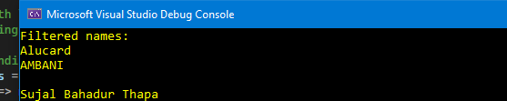

10. Create an ASP.NET Core MVC application with a view that displays a simple calculator form with two textboxes (for numbers), a dropdown for operation (+, -, *, /), and a submit button. On submission, display the result below the form using a controller action and Razor view.

SimpleCalculatorController Code:
using Microsoft.AspNetCore.Mvc;
namespace SimpleCalculatorMVC.Controllers
{
public class CalculatorController : Controller
{
[HttpGet]
public IActionResult Index()
{
return View();
}
[HttpPost]
public IActionResult Index(double num1, double num2, string operation)
{
double result = 0;
switch (operation)
{
case "+":
result = num1 + num2;
break;
case "-":
result = num1 - num2;
break;
case "*":
result = num1 * num2;
break;
case "/":
result = num2 != 0 ? num1 / num2 : 0;
break;
}
ViewBag.Result = result;
return View();
}
}
}
Index.cshtml code:
@{
ViewData["Title"] = "Simple Calculator";
}
<h2>Simple Calculator</h2>
<form method="post">
<div>
<label>Number 1:</label>
<input type="number" name="num1" step="any" required />
</div>
<div>
<label>Number 2:</label>
<input type="number" name="num2" step="any" required />
</div>
<div>
<label>Operation:</label>
<select name="operation">
<option value="+">Addition (+)</option>
<option value="-">Subtraction (-)</option>
<option value="*">Multiplication (*)</option>
<option value="/">Division (/)</option>
</select>
</div>
<br />
<button type="submit">Calculate</button>
</form>
@if (ViewBag.Result != null)
{
<h3>Result: @ViewBag.Result</h3>
}
Output:
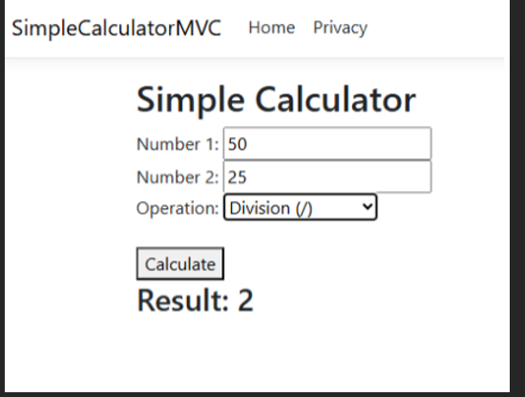
12. Create an ASP.NET Core application that stores a user's name in Session and displays it on another page. Then, use TempData to pass a one-time notification (e.g., "Login successful") between two actions.
#Program.cs
var builder = WebApplication.CreateBuilder(args);
// Add services to the container.
builder.Services.AddControllersWithViews();
// Add session support
builder.Services.AddDistributedMemoryCache(); // Store session in memory
builder.Services.AddSession(options =>
{
options.IdleTimeout = TimeSpan.FromMinutes(30); // Session timeout
options.Cookie.HttpOnly = true;
options.Cookie.IsEssential = true;
});
var app = builder.Build();
// Configure the HTTP request pipeline.
if (!app.Environment.IsDevelopment())
{
app.UseExceptionHandler("/Home/Error");
app.UseHsts();
}
app.UseHttpsRedirection();
app.UseStaticFiles();
app.UseRouting();
// Enable session
app.UseSession();
app.UseAuthorization();
app.MapControllerRoute(
name: "default",
pattern: "{controller=Home}/{action=Index}/{id?}");
app.Run();
#Homecontroller.cs
using Microsoft.AspNetCore.Mvc;
namespace SessionTempDataDemo.Controllers
{
public class HomeController : Controller
{
// Step 1: Page to enter name
[HttpGet]
public IActionResult Index()
{
return View();
}
[HttpPost]
public IActionResult Index(string userName)
{
// Store user name in session
HttpContext.Session.SetString("UserName", userName);
// Set TempData notification
TempData["Notification"] = "Login successful";
return RedirectToAction("Welcome");
}
// Step 2: Page to display stored name
public IActionResult Welcome()
{
// Retrieve user name from session
var name = HttpContext.Session.GetString("UserName");
ViewBag.UserName = name;
// Retrieve TempData (one-time message)
ViewBag.Notification = TempData["Notification"];
return View();
}
}
}
#Index.cshtml
@{
ViewData["Title"] = "Login Page";
}

<h2>Enter Your Name</h2>

<form asp-action="Index" method="post">
<div>
<label>Name:</label>
<input type="text" name="userName" required />
</div>
<br />
<button type="submit">Submit</button>
</form>
#Welcome.cshtml
@{
ViewData["Title"] = "Welcome Page";
}

<h2>Welcome Page</h2>

@if (ViewBag.Notification != null)
{
<div style="color: green;">
<strong>@ViewBag.Notification</strong>
</div>
}

<p>Hello, <strong>@ViewBag.UserName</strong>!</p>

Output:
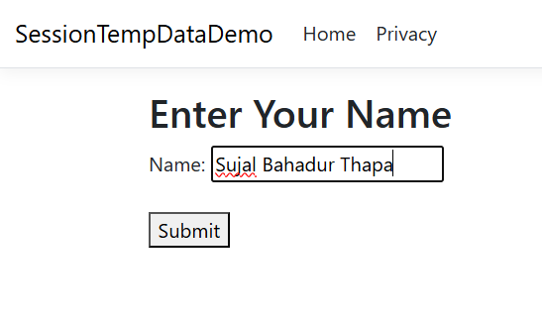
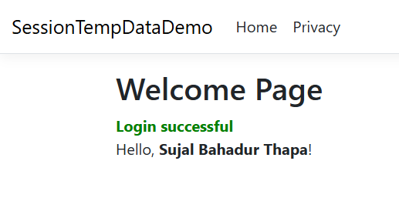

Build a page that stores a user's theme preference (light/dark) in a cookie. Also, pass a product ID via query string to another page and display it.

#Program.cs
var builder = WebApplication.CreateBuilder(args);
builder.Services.AddControllersWithViews();
var app = builder.Build();
app.UseHttpsRedirection();
app.UseStaticFiles();
app.UseRouting();
app.UseAuthorization();
app.MapControllerRoute(
name: "default",
pattern: "{controller=Home}/{action=Index}/{id?}");
app.Run();
#HomeController.cs
using Microsoft.AspNetCore.Mvc;
namespace ThemeCookieDemo.Controllers
{
public class HomeController : Controller
{
[HttpGet]
public IActionResult Index()
{
// Read the theme cookie (optional)
ViewBag.CurrentTheme = Request.Cookies["Theme"] ?? "light";
return View();
}
[HttpPost]
public IActionResult Index(string theme)
{
// Store theme preference in a cookie (expires in 30 days)
Response.Cookies.Append(
"Theme",
theme,
new CookieOptions { Expires = DateTimeOffset.Now.AddDays(30) }
);
ViewBag.CurrentTheme = theme;
ViewBag.Message = $"Theme set to {theme}";
return View();
}
public IActionResult Product(int productId)
{
ViewBag.ProductId = productId;
return View();
}
}
}
#Index.html
@{
ViewData["Title"] = "Theme Selector";
}
<h2>Select Theme</h2>
<p>Current Theme: <strong>@ViewBag.CurrentTheme</strong></p>
@if (ViewBag.Message != null)
{
<div style="color: green;">
@ViewBag.Message
</div>
}
<form asp-action="Index" method="post">
<label>
<input type="radio" name="theme" value="light" @(ViewBag.CurrentTheme == "light" ? "checked" : "") />
Light
</label>
<label>
<input type="radio" name="theme" value="dark" @(ViewBag.CurrentTheme == "dark" ? "checked" : "") />
Dark
</label>
<br /><br />
<button type="submit">Save Theme</button>
</form>
<hr />
<h3>Test Query String for Product</h3>
<p>
<a asp-action="Product" asp-route-productId="101">Go to Product 101</a>
</p>
<p>
<a asp-action="Product" asp-route-productId="202">Go to Product 202</a>
</p>
#Product.cshtml
@{
ViewData["Title"] = "Product Page";
}
<h2>Product Page</h2>
<p>Product ID received via query string: <strong>@ViewBag.ProductId</strong></p>
<p>
<a asp-action="Index">Back to Theme Selector</a>
</p>
