National College of Computer Studies (NCCS)
[Affiliated to TU]


Case Study on Birth and Death Registration System
E-Governance (CSC 377)
Submitted by: Submitted to:
Ashmi Maskey Dinesh Khadka Sir
Bhumika Neupane
Sajendra Bajracharya
Soniya Ghimire
6th semester, BSc. CSIT

Abstract
Digital transformation has become increasingly important in improving the efficiency of local government services. Among these services, birth and death registration plays a vital role in maintaining legal identity, population records, and access to public services. This case study examines the birth and death registration system of a Ward Office with a focus on understanding its existing manual procedures and identifying areas where digital solutions can enhance service delivery.
The study is based on a field visit to the ward office, where current practices such as form submission, document verification, manual record entry, and certificate issuance were closely observed. Information was collected through direct observation and discussions with ward staff, along with a review of government guidelines and official resources related to vital registration. This approach helped in analyzing the actual workflow followed at the ward level.
To address the identified issues, a simple digital birth and death registration system was conceptually designed to reflect real ward office operations. The proposed system demonstrates how digital data entry, centralized record storage, and automated certificate generation can reduce manual workload, minimize errors, and improve record management. The system also supports basic monitoring and reporting for administrative use.
The study highlights that reliance on manual records leads to delays, difficulty in retrieving past data, and increased effort for both citizens and staff. By introducing a practical and realistic digital system, ward offices can improve service efficiency, accuracy, and transparency without adding unnecessary complexity. This case study provides useful insights into the digitization of vital registration services and supports the broader goal of strengthening citizen-centric local governance.

Acknowledgement
We would like to express our sincere gratitude to Mr. Dinesh Khadka for his continuous support, guidance, and encouragement throughout the completion of this case study entitled “Case Study on Birth and Death Registration System of Ward Office.” His valuable suggestions and clear direction greatly helped us understand the administrative, procedural, and system-related aspects of vital registration services at the ward level.
We are also thankful to our teachers, classmates, and peers for their constructive feedback and discussions during the course of this study. Their insights and shared learning experiences contributed significantly to analyzing the ward office processes from both academic and practical perspectives, thereby improving the overall quality of this case study.
A special note of appreciation goes to our team members Ashmi Maskey, Bhumika Neupane, Sajendra Bajracharya, Soniya Ghimire for their cooperation, dedication, and effective teamwork. From field observation and data analysis to system documentation and review, every phase of this case study was completed through mutual support and shared responsibility.
Finally, we extend our sincere thanks to the Ward Office staff for their cooperation during the field visit and for providing valuable information regarding the birth and death registration process. This study has enhanced our understanding of local government service delivery and the important role of digital systems in strengthening efficient, transparent, and citizen-focused governance.

Table of Contents
1. Introduction 1
1.1 Background of Birth and Death Registration at Ward Level 1
1.2 Purpose of the Case Study 1
2. Organizational Overview of Ward Office 2
3. Organizational Structure 3
4. Services Provided by Ward Office 4
5. Current System & Technology Used 6
6. Problems and Challenges Faced by Ward Office 7
7. Proposed Solutions/ Recommendations 7
10. Conclusion 9
Field Visit 10

List Of Figures

Figure 1 Birth Registeration Form 9
Figure 2 13
Figure 3 14

Introduction
Birth and death registration is a fundamental government service that ensures legal recognition of citizens and accurate population records. In Nepal, this responsibility is handled by the Ward Office under the local municipality. These records play an important role in citizenship issuance, education enrollment, inheritance claims, social security benefits, and national statistics.
Despite its importance, the registration process at the ward level is still largely manual. This case study examines the existing birth and death registration system practiced at the ward office and highlights the role of information systems in improving efficiency and service delivery.

Background of Birth and Death Registration at Ward Level
Ward offices are the first point of contact for citizens when registering birth and death events. The process involves collecting personal information, verifying documents, recording details in official registers, and issuing certificates. With increasing population and service demand, managing records manually has become increasingly challenging.

Purpose of the Case Study
The purpose of this case study is to analyze the existing manual birth and death registration system at the ward office and identify challenges related to record management, service efficiency, and data accuracy. The study also aims to propose a practical digital system that can support ward-level operations while remaining realistic and implementable.

Organizational Overview of Ward Office
The Ward Office (Ward Office) is the lowest administrative unit of local government in Nepal, operating under the municipality. It plays a crucial role in delivering essential government services directly to citizens at the community level. The ward office acts as the first point of contact between the local government and residents for civil registration, recommendation letters, social security services, and other administrative functions.
Official Status
The Ward Office functions under the authority of the concerned municipality, in accordance with the Local Government Operation Act. It is responsible for implementing municipal policies and providing public services within its designated ward area.
Service Area
The ward office provides services to residents living within its ward boundary. Each ward covers a defined geographical area and population under the municipality. The number of service seekers varies depending on population size, urban density, and administrative demand.
To provide safe, reliable, and sustainable drinking water services to the people of Kathmandu Valley.
Major Responsibilities
The Ward Office is responsible for a wide range of administrative and civil services, including:
- Birth registration
- Death registration
- Recommendation and verification letters
- Record maintenance of households
- Support for social security allowance registration
- Coordination with municipal offices
Among these, birth and death registration is one of the most important and legally required services Among these, birth and death registration is one of the most important and legally required services provided by the ward office.
Vision
To deliver efficient, transparent, and citizen-friendly local government services through effective administrative practices.

Mission
To provide accurate and timely civil registration services by maintaining reliable records, supporting citizens’ legal identity, and improving service delivery through the appropriate use of technology.
Objectives
- Ensure timely registration of birth and death events
- Maintain accurate and secure vital records
- Reduce administrative delays and manual workload
- Improve accessibility of services for citizens
- Support municipal-level data management and reporting

Organizational Structure
Ward Karlaya follows a hierarchical organizational structure to manage civic services efficiently, including birth and death registration, citizen documentation, and local development programs.
Ward Committee / Office: The Ward Office is the primary governing body at the local level, responsible for policy implementation, service delivery, and coordination with the Municipal Office.
Ward Secretary / Officer: The Ward Secretary or Officer manages daily operations, supervises staff, and ensures timely delivery of services.
Major Departments/Unit:
- Civil Registration Unit: Handles birth and death registration, issues certificates, and maintains records.
- Citizenship and Identity Services Unit: Manages applications for citizenship, identity cards, and other official documents.
- Finance & Administration Unit: Collects fees for services, manages ward budgets, and handles office administration.
- Public Services & Community Development Unit: Facilitates local development initiatives, welfare programs, and community awareness campaigns.
- IT / Record Management Unit: Maintains digital records, manages databases of registered citizens, and supports online services where available.
Field Staff / Support: Ward officials and field staff visit households for registration verification, public awareness programs, and monitoring local development projects.
Hence, the organization structure is:
Ward Committee → Ward Secretary/ Officer → Unit Heads (Civil Registration Unit, IT / Record Management Unit, Finance & Admin Unit) → Field Staff / Support Staff → Citizens

Services Provided by Ward Office
Ward office provides a variety of citizen-centric services with a focus on civil registration and local governance:
- Birth Registration
- Registers all births occurring within the ward.
- Issues official birth certificates required for school admission, identity verification, and other legal purposes.
- Maintains permanent birth records in physical and digital registers.
- Death Registration
- Registers all deaths occurring within the ward jurisdiction.
- Issues death certificates for legal procedures such as inheritance, insurance, and pension claims.
- Maintains accurate and updated death records.
- Citizenship and Identity Services

- Facilitates applications for new or updated citizenship certificates.
- Assists residents in obtaining identity documents, including voter registration where applicable.

- Fee Collection and Payment Services

- Collects nominal fees for registration services, certificates, and other official documents.
- Provides receipts and maintains financial records for transparency.

- Complaint Handling and Citizen Support

- Receives complaints related to delayed registration, missing certificates, or document errors.
- Resolves issues in-person at the ward office or via phone/limited online channels.

- Public Awareness and Community Communication

- Educates residents on registration requirements, deadlines, and processes.
- Shares information on local development programs, health campaigns, and civic initiatives.
- Local Development and Welfare Services

- Implements small-scale development projects like road maintenance, street lighting, and sanitation.
- Coordinates social welfare programs for vulnerable groups in the ward.
Figure 1 Birth Registeration Form

Current System & Technology Used
Ward Office employes a mix of traditional and basic digital systems to manage registrations and citizen records:
i. Record Management
- Maintains paper-based registers for births, deaths, and other civil records.
- Digital copies may exist but are not fully integrated across services.
ii. Certificate Issuance
- Certificates are mostly issued manually; citizens must visit the office for collection.
- Limited use of digital templates or online verification.
iii. Online Services
- Some wards may offer online registration or appointment booking, but services are often partial and require in-person follow-up.
iv. IT Infrastructure
- Basic computers and local databases support limited digital record-keeping.
- Lack of full automation and centralized database slows reporting and service delivery.
v. Reporting
- Annual or periodic reports are compiled manually from ward records.
- Real-time monitoring of registrations or service requests is not feasible.
Overall: The current system is functional but lacks full digitization, real-time tracking, and efficient integration, leading to delays and occasional inaccuracies.\

Problems and Challenges Faced by Ward Office
Despite providing essential civil services, Ward Karlaya faces several operational, technical, and administrative challenges:
i. Delayed Registrations
- Manual processes and staff limitations can cause delays in issuing birth/death certificates.

ii. Incomplete or Inaccurate Records
- Paper-based record keeping may lead to missing information or duplication.
iii. Limited Access to Digital Services
- Many residents still need to visit the ward office physically due to limited online services.
iv. Staff Shortage and Workload
- High population growth in the ward increases service demand, putting pressure on available staff.
v. Citizen Awareness Issues
- Some residents are unaware of registration requirements or deadlines, causing late reporting.
vi. Coordination Challenges
- Coordination with municipal offices, hospitals, and other institutions is sometimes slow, affecting timely registration and certificate issuance.
vii. Financial and Administrative Constraints
- Limited budgets and resources hinder infrastructure improvement, digitization, and expansion of services.

Proposed Solutions/ Recommendations
To improve the efficiency and reliability of birth and death registration services, as well as other citizen services in Ward Karlaya, the following recommendations are proposed. Each suggestion addresses specific challenges and is practical for implementation.
i. Centralized Digital Record System
Ward Karlaya should implement a fully digital platform to manage all birth and death registrations, citizen records, certificate issuance, and fee collection. This will reduce manual errors, ensure real-time data updates, and allow field staff and unit heads to access and update records efficiently.
ii. Online Registration and Status Tracking
Introduce an online system where citizens can submit registration applications, track the progress, and receive status updates with a unique reference ID. This will reduce repeated visits to the ward office and increase transparency.
iii. Document Verification Automation
Use digital tools to verify submitted documents for completeness and accuracy. This will minimize errors, reduce delays, and streamline certificate issuance.
iv. GIS-Based Planning and Monitoring
Adopt Geographic Information System (GIS) technology to map households, registered births and deaths, and field staff coverage areas. This will help in planning home visits, monitoring service coverage, and identifying areas with missing registrations.
v. Improved Citizen Communication and Awareness
Regularly communicate with citizens via SMS, social media, public notices, and local announcements to inform them about registration requirements, deadlines, and ward services. Awareness campaigns will encourage timely registration and reduce errors.
vi. Staff Capacity Development
Provide continuous training for ward staff and field personnel on digital tools, registration procedures, and citizen interaction. Skilled staff will ensure faster, accurate service delivery and enhance citizen satisfaction.
vii. Mobile / Field Registration Services
Deploy field staff with mobile devices to register births and deaths directly at households, particularly for citizens unable to visit the office. This will increase accessibility and reduce delays.

10. Conclusion
This case study highlights the importance of digitizing birth and death registration services at the ward level. While the existing manual system fulfills basic legal requirements, it faces challenges such as inefficiency, data retrieval difficulty, and increased administrative workload.
The proposed digital Birth and Death Registration System offers a practical and realistic solution to these challenges. By introducing digital data entry, centralized record storage, and certificate generation, ward offices can significantly improve service efficiency and data accuracy.
Overall, this study demonstrates how simple and well-designed digital systems can strengthen local government services and contribute to more transparent, reliable, and citizen-focused public service delivery.

Field Visit
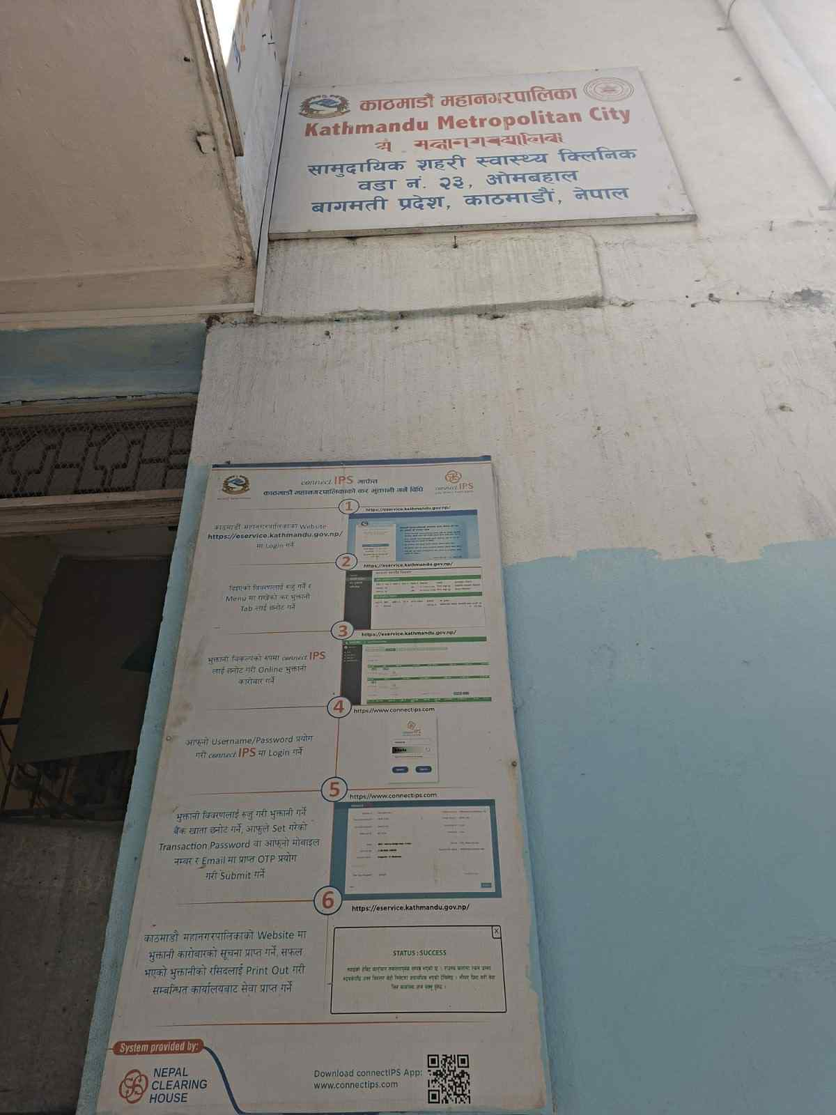
Figure 2
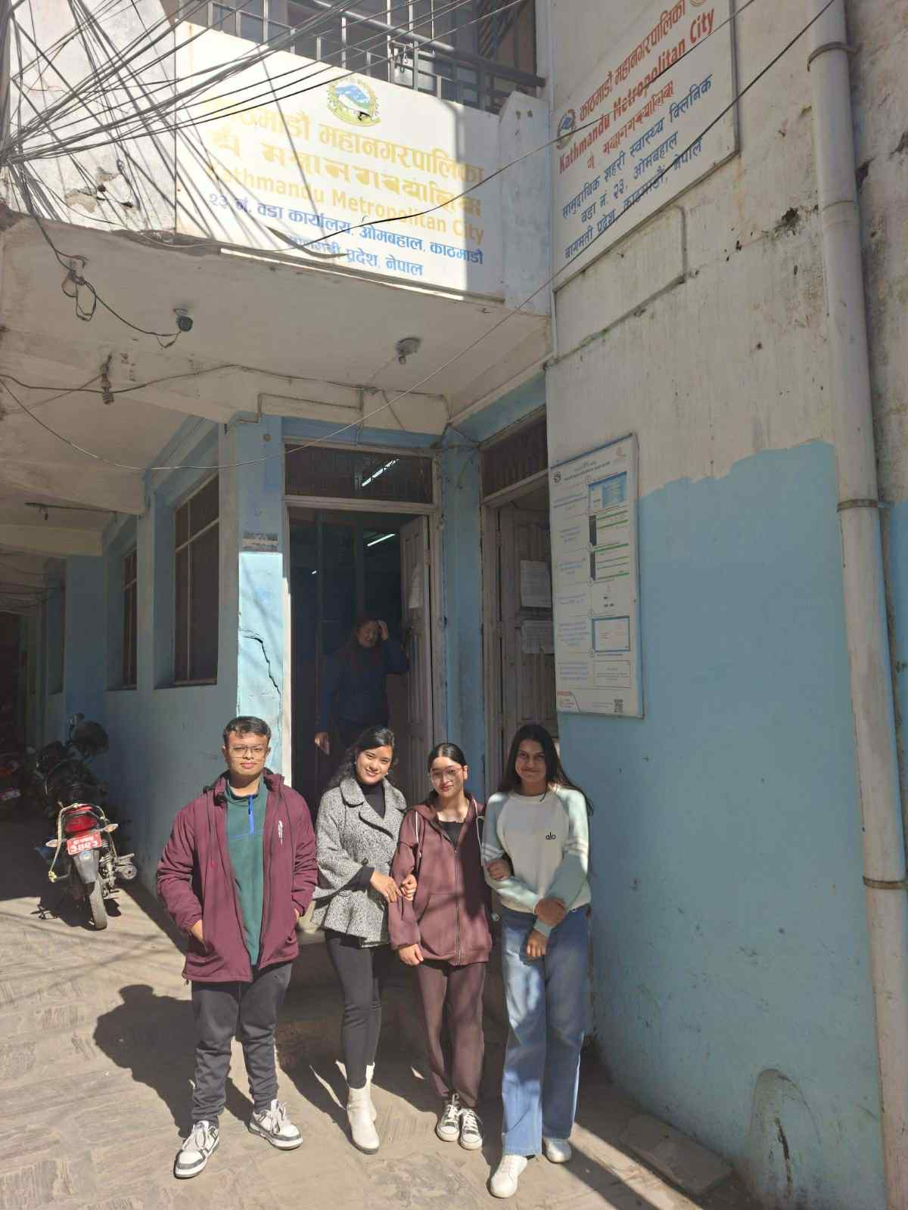
Figure 3

