A PROJECT ON ONLINE BOOK STORE


By
Sabhyata Aryal
Soniya Ghimire

A project submitted in partial fulfillment of the requirements for the
degree of Bachelor of Science (B.Sc.) in
Computer Science and Information Technology awarded by
IOST, Tribhuvan University

National College of Computer Studies (NCCS)
Paknajol, Kathmandu
Nepal

December, 2025

ABSTRACT
The rapid growth of internet technologies has significantly transformed the way businesses operate, leading to an increased demand for efficient and user-friendly online shopping platforms. This project focuses on the design and development of an E-Commerce Website that allows users to browse products, add items to a shopping cart, and complete purchases through an online system. The primary goal of the system is to provide a secure, reliable, and convenient platform for customers while enabling administrators to effectively manage products, orders, and user information.
The system is developed following standard software engineering practices, including requirement analysis, system modeling, and structured design. Key functionalities such as user registration and authentication, product management, cart management, and order processing are implemented to ensure smooth system operation. Emphasis is placed on usability, data security, and efficient system performance to enhance the overall user experience.
This project demonstrates the practical application of software engineering principles in building a real-world web-based application. By integrating system analysis and design techniques with implementation strategies, the project provides insight into the development lifecycle of an e-commerce system. The completed system serves as a functional prototype that highlights the importance of well-planned design and effective implementation in modern web application development

ACKNOWLEDEGEMENT
This project presents the design and development of the E-Commerce Website, undertaken by Sabhyata Aryal and Soniya Ghimire, as part of our academic requirements. The primary objective of this project is to design and implement a web-based system that enables users to browse products, add items to a shopping cart, and complete purchases online in a secure and efficient manner. The system is developed with a strong emphasis on usability, data integrity, and smooth user interaction, while also providing administrators with effective tools to manage products, orders, and user information.
We would like to express our sincere gratitude to our instructors and mentors for their continuous guidance, valuable feedback, and encouragement throughout the development of this project. Their expertise and support played a crucial role in helping us understand core concepts of software engineering, system analysis, and system design, which were essential for the successful completion of this work.
This project provided us with the opportunity to apply theoretical knowledge gained during our coursework to a real-world application. Through the process of requirement analysis, system modeling, database design, and implementation, we enhanced our understanding of web application development and learned how to address practical challenges related to functionality, security, and performance. The use of proper software engineering methodologies allowed us to design a structured, maintainable, and scalable system.
We also acknowledge the support of our peers and all those who directly or indirectly contributed to the completion of this project. Their suggestions, feedback, and cooperation were invaluable during different stages of development.
Finally, we are grateful for the opportunity to work on this project, as it significantly enhanced our technical skills, problem-solving abilities, and teamwork experience. This project stands as a meaningful learning experience and a strong foundation for our future endeavors in software development and related fields.

Contents

CHAPTER 1: INTRODUCTION 1
1.1 Background 1
1.2 Problem Statement 1
1.3 Objectives 1
1.4 Scope 1
1.5 Development Methodology 2
CHAPTER 2: SYSTEM ANALYSIS 3
2.1 Requirement Analysis 3
2.1.1 Functional Requirements 3
2.1.2 Non-Functional Requirements 3
2.2 Feasibility Analysis 4
2.2.1 Technical Feasibility 4
2.2.2 Operational Feasibility 4
2.2.3 Legal Feasibility 4
2.3 Data Flow Diagrams (DFD) 4
2.4 Use Case Diagram 6
CHAPTER 3: SYSTEM DESIGN 7
3.1 Architecture 7
3.2 Technologies Used 7
Frontend: 7
Backend: 7
Database: 7
3.3 Database Design 7
3.3.1 Class Diagram 7
3.3.2 Object Diagram 8
CHAPTER 4 : IMPLEMENTATION AND DESIGN 10
4.1 Implementation 10
Tools Used 10
4.2 Testing 10
4.2.1. Test Cases for book browsing 10
4.2.2. Test Cases for cart management 11
4.2.3. Test Cases for checkout 11
4.2.4. Test Cases for payment (eSewa) 11
4.2.5. Order Confirmation Test Cases 12
4.3 Gantt Chart 12
CHAPTER 5: RESULTS AND DISCUSSION 13
Chapter 6: Conclusion 14
Summary of Achievements 14
Lessons Learned 14
Future Enhancements 14
Appendix 15
References 17

List Of Figures
Figure 1 Waterfall Model 2
Figure 2 level 0 DFD 5
Figure 3 level 1 DFD 5
Figure 4 level 2 DFD 6
Figure 5:Use case diagram 6
Figure 6:Class Diagram 8
Figure 7:Object diagram 9
Figure 8 Gantt Chart 12
Figure 9 Home Page 15
Figure 10:Shopping cart 15
Figure 11:Checkout 16
Figure 12:validation during checkout 16

CHAPTER 1: INTRODUCTION

1.1 Background
With the rapid growth of the internet and digital technologies, online shopping has become an essential part of modern commerce. E-commerce websites provide customers with convenience, wider product choices, and timesaving purchasing methods. Businesses benefit from reduced operational costs and global reach. This project focuses on developing a simple e-commerce website suitable for small-scale online businesses.

1.2 Problem Statement
Traditional shopping methods require physical presence, consume time, and limit product accessibility. Many small businesses lack affordable and simple e-commerce solutions. There is a need for a basic, easy-to-use, and secure e-commerce system that enables online product browsing, ordering, and payment.

1.3 Objectives
- To design and develop a simple e-commerce website
- To provide user registration and authentication
- To enable product browsing and cart management
- To implement secure online payment functionality
- To allow users to review purchased products

1.4 Scope
The scope of this project includes customer and admin functionalities, product management, shopping cart, and payment processing. Advanced features like AI recommendations and multi-vendor support are beyond the scope of this system.

1.5 Development Methodology
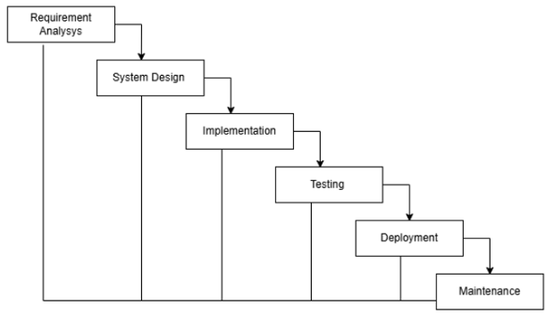
Figure 1 Waterfall Model

CHAPTER 2: SYSTEM ANALYSIS

2.1 Requirement Analysis

2.1.1 Functional Requirements
- User registration and login – Allows users to create accounts and securely access the system.
- Product listing and search – Displays products and enables users to search them easily.
- Add products to cart – Allows users to select products and add them to the cart.
- Update and remove cart items – Enables users to modify quantities or remove items from the cart.
- Place orders – Allows users to confirm orders.
- View order history – Enables users to view their past orders.
- Add product reviews – Allows users to submit ratings and reviews for products.
- Admin product and order management – Enables admins to manage products and customer orders.

2.1.2 Non-Functional Requirements
- Security – Ensures secure access using JWT-based authentication and authorization.
- Performance – Provides fast response time and smooth page loading.
- Usability – Ensures a simple and user-friendly interface.
- Reliability – Ensures consistent system operation with proper error handling.
- Scalability – Supports system growth with increasing users and products.

2.2 Feasibility Analysis

2.2.1 Technical Feasibility
The Book E-Commerce Website uses widely adopted and well-supported web technologies such as HTML, CSS, JavaScript for the frontend, PHP with PHP for the backend, and MySQL for data storage. These technologies are commonly available, open-source, and have extensive documentation, making development, deployment, and maintenance technically feasible. The system architecture supports scalability, allowing the website to handle a growing number of users, books.

2.2.2 Operational Feasibility
The system is designed to be user-friendly and intuitive for both customers and administrators. Customers can easily browse books, manage their shopping cart, and complete purchases without prior training. Administrators can manage books, orders, and payments through a simple dashboard interface. All workflows, with minimal manual intervention, ensuring smooth day-to-day operations. The responsive design ensures accessibility across devices such as desktops, tablets, and mobile phones, further enhancing operational convenience.

2.2.3 Legal Feasibility
The Book E-Commerce Website is designed to comply with basic legal and regulatory requirements. User data is handled securely and stored in the database using safe practices, respecting data privacy standards. Additionally, the website can include a privacy policy and terms of service, ensuring transparency and compliance with local laws regarding online commerce.

2.3 Data Flow Diagrams (DFD)
- Level 0 DFD: Shows interaction between users, admin, and the e-commerce system
- Level 1 DFD: Details processes like browse and search books, order management, and admin management.
- Level 2 DFD: With more detailed flow of application.

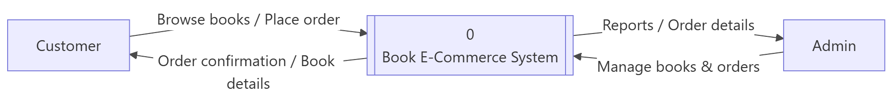
Figure 2 level 0 DFD

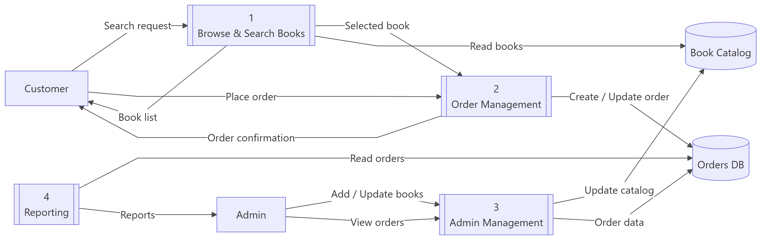
Figure 3 level 1 DFD

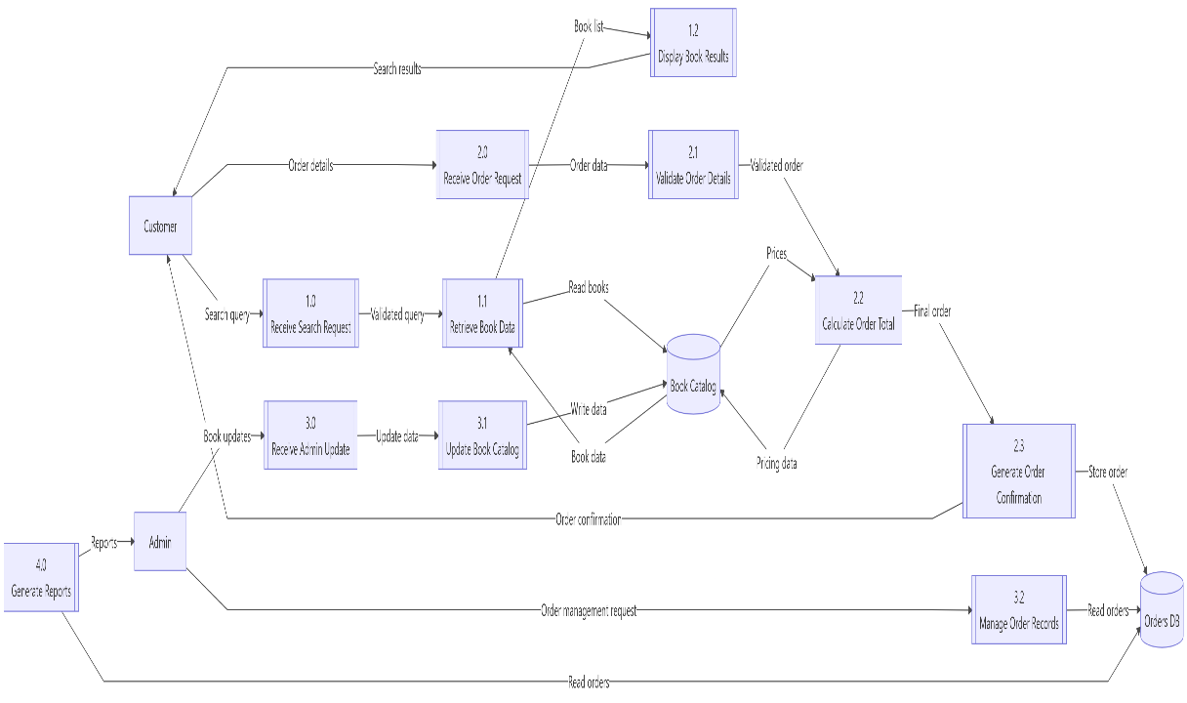
Figure 4 level 2 DFD

2.4 Use Case Diagram
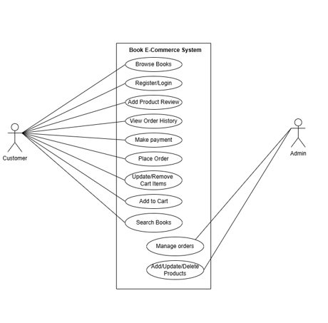
Figure 5:Use case diagram

CHAPTER 3: SYSTEM DESIGN

3.1 Architecture
The Book E-Commerce Website uses three-tier architecture. The frontend is built with HTML, CSS, JavaScript to provide a responsive user interface, the backend uses PHP and PHP to handle business logic, orders and the MySQL database stores books, users, and order data. This structure ensures a secure, maintainable, and scalable system with clear separation between user interface, application logic, and data storage.

3.2 Technologies Used

Frontend:
- HTML
- CSS
- JavaScript

Backend:
- PHP

Database:
- MySQL

3.3 Database Design

3.3.1 Class Diagram
The Class diagram shows the static representation of the system. This extends on the Entity Relationship of a system and shows how the data tables are shown in the database. The Class Diagram for books e commerce is shown below:
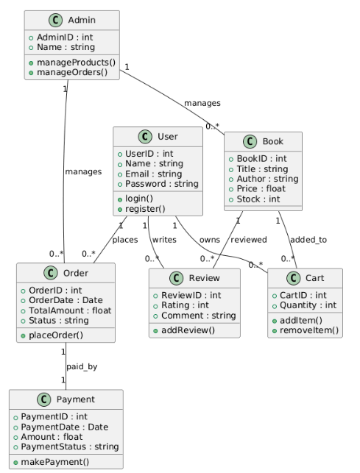
.

Figure SEQ Figure \* ARABIC 6:Class Diagram

3.3.2 Object Diagram
An object diagram is a snapshot of the system at a specific point in time, showing objects (instances of classes) and their relationships. The Object Diagram of book e commerce site is shown below:

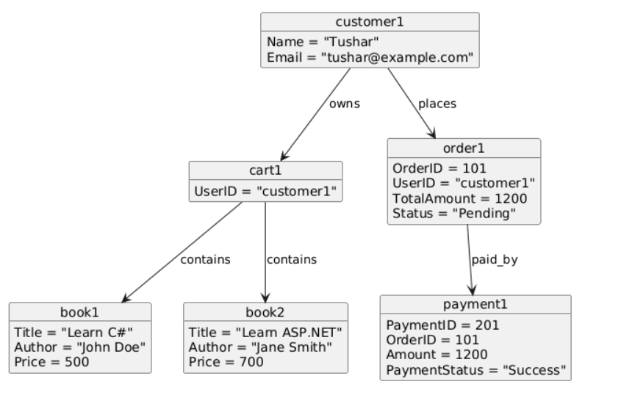

Figure SEQ Figure \* ARABIC 7:Object diagram

CHAPTER 4 : IMPLEMENTATION AND DESIGN

4.1 Implementation

Tools Used
Frontend:
- HTML, CSS, JavaScript: Framework for building a dynamic, responsive, and interactive web interface for browsing books, managing carts, and checkout.
Backend:
- PHP: Server-side JavaScript runtime for building scalable and high-performance backend services.

4.2 Testing
To verify the functionality of the e-commerce system, we conducted comprehensive testing with different scenarios using test cases.

4.2.1. Test Cases for book browsing
SN | Description | Input | Expected Result | Observed Result | Assertion
1 | View Book List | Open Home page | Books displayed with title, author, price | Books displayed correctly | Pass
2 | View Book Details | Click a book | Book details page opens | Book details displayed | Pass
3 | Invalid Book ID | Open invalid book URL | Error or redirect page shown | Redirected to error page | Pass

4.2.2. Test Cases for cart management
SN | Description | Input | Expected Result | Observed Result | Assertion
1 | Add Book to Cart | Click “Add to Cart” | Book added successfully | Book added to cart | Pass
2 | Update Quantity | Increase quantity | Total price updates | Total price updated | Pass
3 | Remove Book | Click Remove | Book removed from cart | Book removed | Pass
4 | Empty Cart | Remove all items | Cart shows empty message | Empty cart message displayed | Pass

4.2.3. Test Cases for checkout
SN | Description | Input | Expected Result | Observed Result | Assertion
1 | Open Checkout | Click Checkout | Checkout page opens | Checkout page opened | Pass
2 | Empty Form Submission | Submit without data | Validation error shown | Error message displayed | Pass

4.2.4. Order Confirmation Test Cases
SN | Description | Input | Expected Result | Observed Result | Assertion
1 | Order Creation | Successful payment | Order stored in database | Order saved in DB | Pass
2 | Confirmation Page | Payment success | Order confirmation displayed | Confirmation page shown | Pass
3 | Duplicate Order Prevention | Refresh success page | No duplicate order created | No duplicate created | Pass

4.3 Gantt Chart
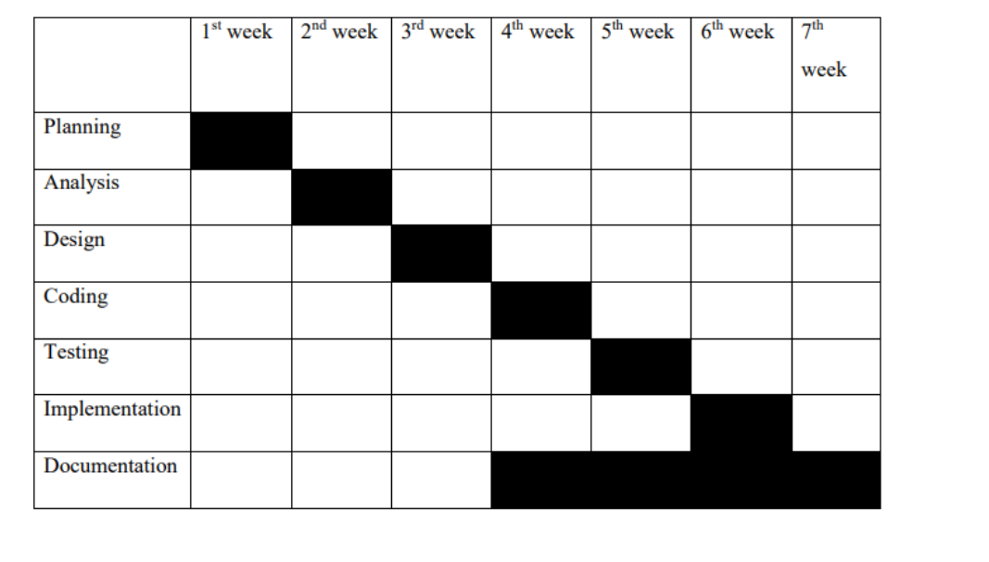
Figure 8 Gantt Chart

CHAPTER 5: RESULTS AND DISCUSSION

The Kitab Pasal Website was successfully designed and implemented according to project objectives. The system allows users to browse available books, view detailed information, add books to the shopping cart, and complete purchases.
Key Outcomes:
- Successfully developed a functional online book shopping platform
- Users can browse books, view details, and check prices easily
- Shopping cart allows adding, updating, and removing books
- Smooth checkout process with customer detail validation
- Orders are stored securely in the database after payment
- Website provides a responsive and user-friendly interface

Chapter 6: Conclusion

Summary of Achievements
This project successfully developed a simple and functional Book E-Commerce Website that allows users to browse books, add them to a shopping cart, and complete purchases through a clean and user-friendly interface. The system includes:
- A responsive and intuitive UI developed using HTML, CSS, JavaScript for web platforms
- A robust backend implemented using PHP
- A MySQL database supporting essential CRUD operations for books, orders, and payments
- Core features such as book listing, cart management, checkout validation, order confirmation.

Lessons Learned
- Gained practical experience in full-stack web application development using HTML, CSS, JavaScript and PHP
- Enhanced knowledge of secure data handling, form validation, and database operations

Future Enhancements
- Implement user authentication and order history features
- Add an admin panel for book and order management
- Introduce advanced search, filtering, and recommendations for books
- Integrate additional payment methods and wallet support
- Improve UI with better responsiveness and performance optimization

Appendix

Figure SEQ Figure \* ARABIC 9 Home Page

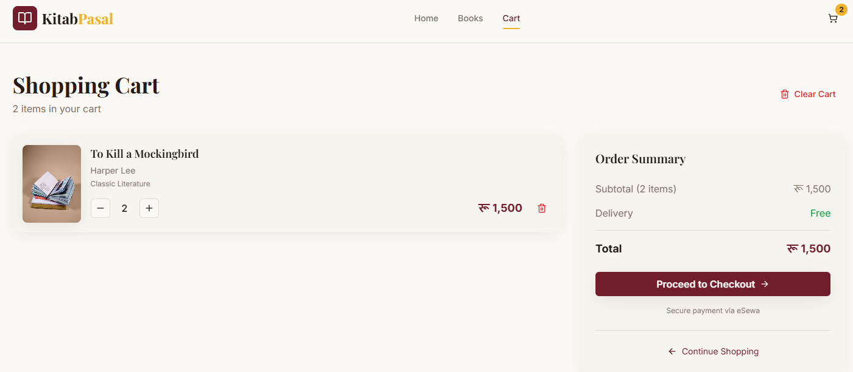

Figure SEQ Figure \* ARABIC 10:Shopping cart

Figure SEQ Figure \* ARABIC 12:validation during checkout

References
- HTML, CSS, JavaScript Documentation – Official guide for component-based UI development.
URL: https://reactjs.org/docs/getting-started.html
- PHP Documentation – Official documentation for backend development.
URL: https://nodejs.org/en/docs/
- MySQL Documentation – Reference for database design and operations.
URL: https://dev.mysql.com/doc/

