National College of Computer Studies (NCCS)
Paknajol, Kathmandu
Affiliated to Tribhuvan University

REPORT ON
CONSOLE GAME
SUBMITTED BY: SUBMITTED TO:
NAME: Aarya Manandhar Janak Joshi
B.Sc. CSIT 2nd Semester Kajol Ramtel
SEC: A ROLL:01
Email: aaryamanandhar2060@gmail.com
DECLARATION
I hereby declare that the project work entitled “Console Game” submitted to Institute of Science and Technology, Tribhuvan University, Kathmandu. National College of Computer Studies, Kathmandu, is for the degree is submitted in partial fulfillment of requirements for the degree of Bachelor of Science in Computer Science and Information Technology (B.Sc.CSIT). This report contains all the original research and analysis with some information taken from other resources which are properly cited. This project work has not been submitted to any other university or institution for the award of any degree or diploma.

ACKNOWLEDGEMENT

This report is my assignment as a partial fulfillment of project work course for the requirement of Bachelor of Science in Computer Science and Information Technology (B.Sc.CSIT). I have taken this opportunity to express my respect and gratitude to my respected teacher Mr. Janak Joshi for their valuable guidance in making this project a reality. I am thankful for their constant support and encouragement and valuable guidance and encouragement throughout this project completion period. I am also thankful to the lab teacher Kajol Ramtel for her help during the completion of the project. I would like to present my teachers gratitude for their guidance, good advices and honest reviews in this entire project session. Project has been completed under the intensive and genuine guidance of National College of Computer Studies.

ABSTRACT

The Console Game Compilation project encapsulates the essence of classic console gaming, combining three iconic games - Dodge the Car, Dino Game, and Snake Game. Rooted in the nostalgia of early console experiences, this C++ project employs a modular and object-oriented approach to deliver engaging gameplay within a console environment.

Table of Contents
1.INTRODUCTION 1
2.BACKGROUND 1
3.PROJECT STRUCTURE 2
4. TECHNICAL DETAILS 4
5.FEATURES 5
6.CODE STRUCTURE 6
6.1. Main Functionality 6
6.2. Game Classes 7
6.3. Console Interface Design 8
6.4. User Input Handling 9
6.5. Game Logic and Control 9
7. FUTURE ENHANCEMENTS 10
8. CONCLUSION 11

LIST OF FIGURES

Figure 1: Console Interface 2
Figure 2 : Dodge The Car 2
Figure 3 : Dino Game 3
Figure 4 : Snake Game 3
Figure 5 : Main Function 6
Figure 6 : Classes 7
Figure 7 : Interface Function 8
Figure 8 : Input Function 9
Figure 9 : Algorithm Function 9

1.INTRODUCTION

The Console Game Compilation project stands as a testament to the enduring legacy of gaming, offering a nostalgic journey through the rich history of classic consoles. Seamlessly blending three iconic titles – Dodge The Car, Dino Game, and Snake Game – this project is more than a mere collection; it's a curated experience designed to resonate with gaming enthusiasts across generations. By harnessing the expressive power of C++ programming, the project goes beyond lines of code; it breathes life into pixelated landscapes and brings forth the charm of a bygone era.
Meticulously crafted, the immersive and visually appealing gaming environment within the console realm is a nod to the creativity that fueled early gaming experiences. In this compilation, every pixel and every line of code converges to recreate the simplicity and pure joy that defined the roots of interactive entertainment. As users navigate through familiar titles, the project pays homage to the iconic games that laid the foundation for the vibrant and diverse gaming landscape we enjoy today. The Console Game Compilation isn't just a project; it's a celebration of gaming's evolution, encapsulated within the confines of a console interface.

2.BACKGROUND

Console gaming has a rich history that has evolved significantly over the years. The introduction of gaming consoles marked a pivotal moment in the world of electronic entertainment. One iconic console that played a crucial role in shaping the gaming industry is the Game Boy. Released by Nintendo in 1989, the Game Boy became a cultural phenomenon, offering users a portable gaming experience with its monochromatic display and a vast library of games. This project pays homage to the nostalgia associated with classic consoles like the Game Boy and aims to recreate that retro gaming atmosphere within a console environment.

3.PROJECT STRUCTURE

- Console Interface Design
The console interface is designed creatively, resembling a Game Boy for all the games. Clear instructions and a scoring system are incorporated, ensuring an intuitive user experience.
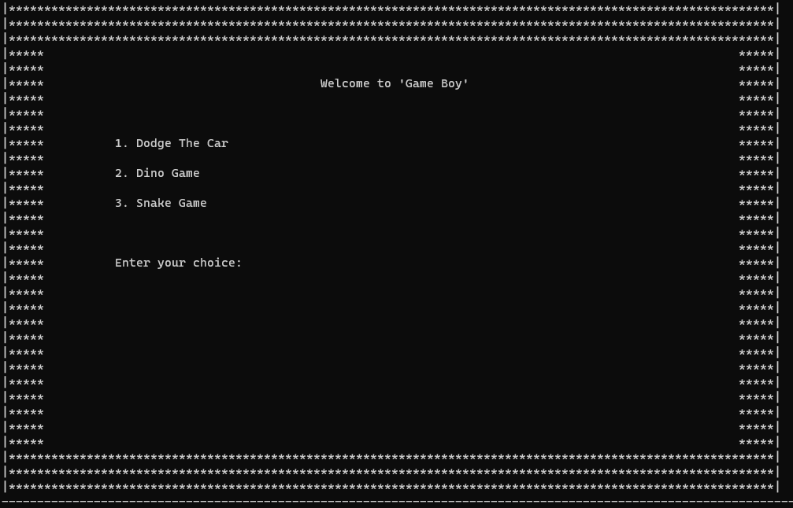
Figure 1: Console Interface
- Dodge The Car
A simple game where the player controls a car to avoid colliding with randomly generated cars on the road.
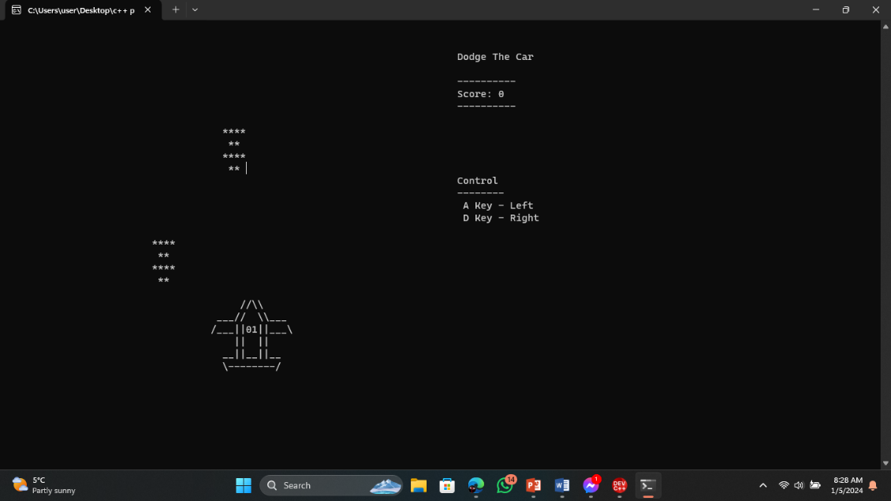
Figure 2: Dodge the car
- Dino Game
Inspired by the classic Chrome browser game, the Dino Game challenges players to control a dinosaur to jump over obstacles. The game features a dynamic and responsive control system, allowing the dinosaur to jump with the 'Space' key.

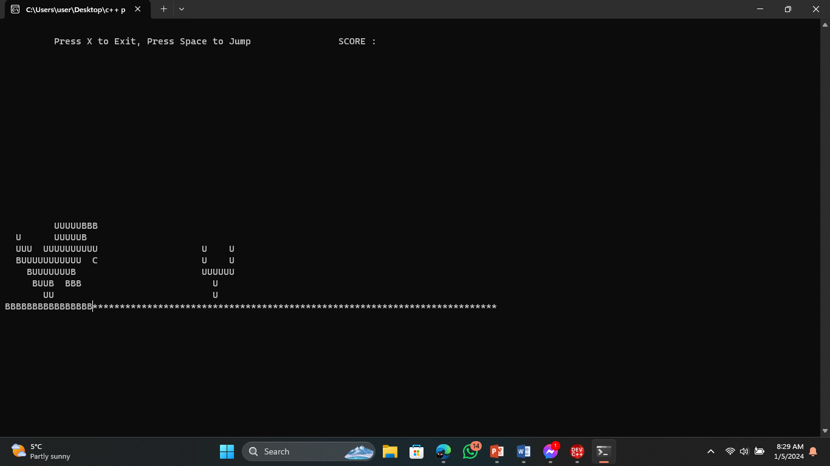
Figure 3: Dino Game

- Snake Game
A traditional Snake Game where the player controls a snake to collect fruits and grow in size. The snake moves in four directions - up, down, left, and right - based on user input. The objective is to eat fruits to increase the score while avoiding collisions with the snake's own body.
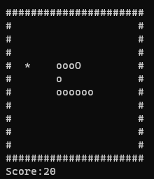
Figure 4: Snake Game

4. TECHNICAL DETAILS

- C++ Language
The project is written in C++ and demonstrates the use of core language features, including functions, loops, and conditional statements.
It leverages C++ libraries such as <iostream>, <conio.h>, and <windows.h> for console-based input/output and interface design.

- Object-Oriented Programming (OOP)
The project follows an object-oriented approach by implementing classes for each game - CarGame, DinoGame, and SnakeGame.
Each class encapsulates game-specific functionalities, enhancing code modularity and maintainability.

- Game Logic and Control
Each game exhibits unique logic and control systems tailored to its gameplay.
Collision detection, scoring mechanisms, and player controls are implemented to provide engaging and challenging gameplay.

- Console Interaction
The project showcases robust console interaction, utilizing C++ libraries for input handling and graphical interface design. It employs <conio.h> for keyboard input, allowing real-time responses to user actions. The <windows.h> library contributes to console manipulation, enabling features like cursor positioning for a dynamic and visually appealing user interface. This emphasis on console interaction not only enhances the user experience but also demonstrates the project's adaptability to diverse gaming environments.

5.FEATURES

- Diverse Gameplay
The project offers a compilation of three classic console games with distinct gameplay styles - Dodge the Car, Dino Game, and Snake Game.

- Game Boy-Like Interface
The console interface design emulates the aesthetics of the Game Boy, enhancing the retro feel and visual appeal.

- Object-Oriented Approach
The use of classes and encapsulation follows an object-oriented approach, promoting code modularity and reusability.

- User-Friendly Interface
Clear instructions, scoring systems, and interactive menus ensure a user-friendly experience.

- Dynamic Console Graphics
The console graphics dynamically change based on user input and game events, providing an engaging and responsive interface.

6.CODE STRUCTURE

The Console Game Compilation project is structured in a modular and organized manner, utilizing core principles of object-oriented programming (OOP) for code clarity and maintainability.

6.1. Main Functionality
The main function acts as the entry point of the program and orchestrates the execution of different game modules based on user input.
It handles the initialization of game objects, menu displays, and user choices.
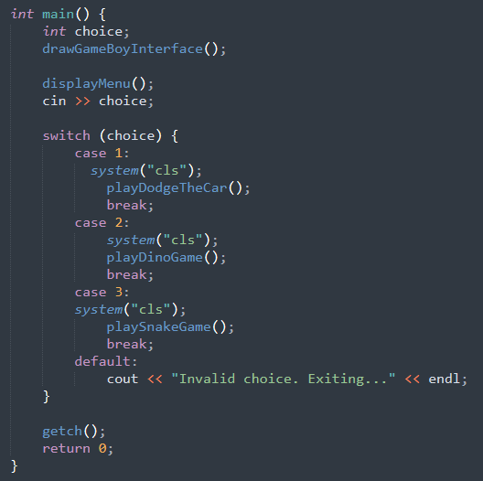
Figure 5: Main Function

6.2. Game Classes
Each game (Dodge The Car, Dino Game, Snake Game) is encapsulated within a separate class.
Classes handle specific game logic, user input, and interface rendering.
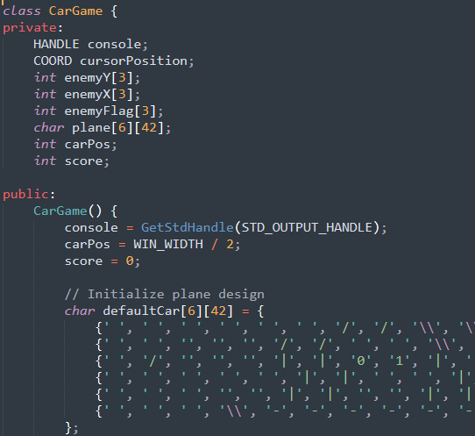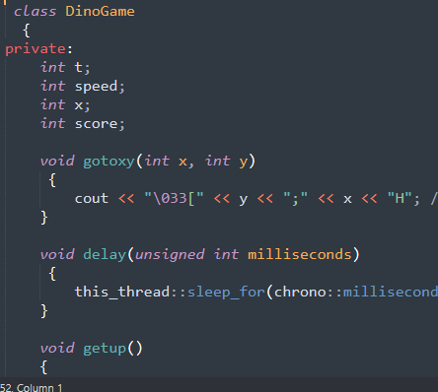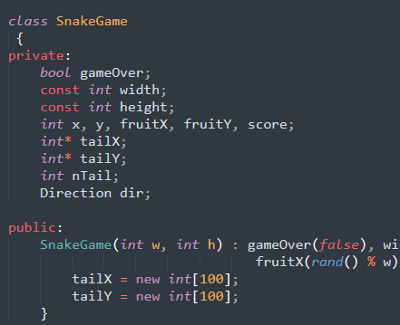
Figure 6: Classes

6.3. Console Interface Design

The drawGameBoyInterface() function is responsible for creating a visually appealing
Game Boy-like console interface, setting the stage for a nostalgic gaming experience.

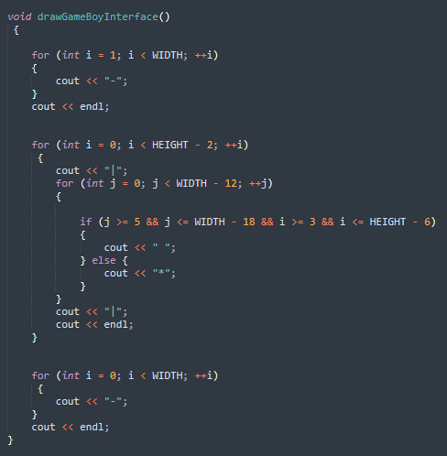
Figure 7: Interface function

6.4. User Input Handling
User input is crucial for game interactions. The project uses ‘_getch()’ and ‘_kbhit()’ functions for capturing keypresses.
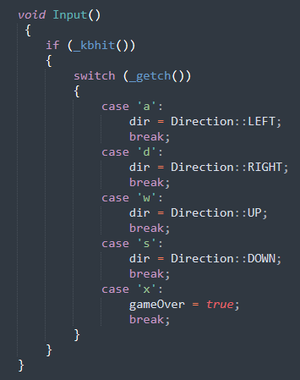
Figure 8: Input fucntion

6.5. Game Logic and Control
Each game class implements unique game logic, scoring mechanisms, and control systems, providing diverse gameplay experiences.
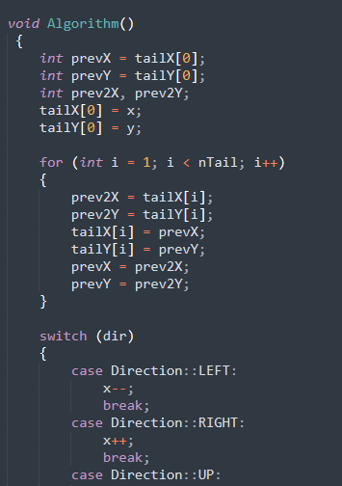
Figure 9: Algorithm function

7. FUTURE ENHANCEMENTS

- Integration of additional games to expand the compilation.
- Enhancements to the graphics and visual elements for a more immersive experience.
- Inclusion of sound effects and music to enhance the gaming atmosphere.

8. CONCLUSION

The Console Game Compilation project bridges the gap between the past and present, offering a glimpse into the golden era of console gaming. By encapsulating classic gameplay within a modern C++ environment, the project invites users to relive the joy and simplicity of early console experiences. This compilation stands as a tribute to the timeless appeal of console gaming, showcasing the evolution of electronic entertainment through the lens of iconic games and interfaces.

