
National College of Computer Studies
Paknajol, Kathmandu

Report on
M-BANKING SYSTEM
Submitted by: Submitted to:
Aarya Manandhar Sumit Ghising
Program: Bsc. CSIT 1st Semester Kajol Ramtel
Roll. No: 01
Email:aaryamanandhar2060@gmail.com

Declaration
I hereby declare that the project work entitled “Mobile Banking System” submitted to Institute of Science and Technology, Tribhuvan University, Kathmandu. National College of Computer Studies, Kathmandu, is for the degree is submitted in partial fulfillment of requirements for the degree of Bachelor of Science in Computer Science and Information Technology (Bsc.CSIT). This report contains all the original research and analysis with some information taken from other resources which are properly cited. This project work has not been submitted to any other university or institution for the award of any degree or diploma.

………………………..
Aarya Manandhar
Date: August 20, 2023
Acknowledgement

This report is my assignment as a partial fulfillment of project work course for the requirement of Bachelor of Science in Computer Science and Information Technology (Bsc.CSIT). I have taken this opportunity to express my respect and gratitude to my respected teacher Mr. Sumit Ghising for their valuable guidance in making this project a reality. I am thankful for their constant support and encouragement and valuable guidance and encouragement throughout this project completion period. I am also thankful to the lab teacher Mrs. Kajol Ramtel for her help during the completion of the project. I would like to present my teachers gratitude for their guidance, good advices and honest reviews in this entire project session. Project has been completed under the intensive and genuine guidance of National College of Computer Studies.

Aarya Manandhar
National College of Computer Studies
Date: August 20, 2023

Abstract
This project presents a basic mobile banking system developed using the C programming language. The project aims to create a text-based application that allows users to perform essential banking operations such as account creation, logging in, checking balances, transferring money, and logging out. The program employs a user-friendly interface and file handling techniques to manage user data and transaction history.

Table of Contents
1. INTRODUCTION 1
2. OBJECTIVE 1
3. Problem and Definition and analysis 1
3.1. User Account Creation: 2
3.2. Login and Authentication: 2
3.3. Account Dashboard: 2
3.4. Checking Balance: 2
3.5. Transferring Money: 2
3.6. Logging Out: 2
3.7. File Handling: 2
4. Methology 3
5. EXPERIMENT RESULT AND EXPECTED OUTCOME 3
6. SYSTEM REQUIREMENT 4
7. SYSTM DESIGN AND DEVELOPMENT 4
7.1. User Interface (UI): 4
7.2. Data Storage: 5
7.3. Authentication and Security: 5
7.4. Functionality: 6
7.5. User Experience: 7
7.6. Flow Control: 7
REFERENCES 8

LIST OF FIGURES

Figure 1 User interface 4
Figure 2 Data Storing 5
Figure 3 Security 5
Figure 4 Details 6
Figure 5 Transferring money 6
Figure 6 MENU 7
Figure 7 Flow Control 7

INTRODUCTION
‘C’ is a general-purpose computer programming language. It was created in the 1970s by Dennis Ritchie and is still widely used today. Despite application software using it less frequently, operating systems, device drivers, and protocol stacks have continued to use it.C is one of the most frequently used programming languages and works with almost all modern computer architectures and operating systems. [1]
Structured programming, lexical variable scoping, and recursion are all supported by the imperative procedural language C. A static type system is also included. The language was developed to facilitate cross-platform development, despite its low-level capabilities. [2]

OBJECTIVE
The objective of the program is to provide
- A basic mobile banking system that allows users to
- Create accounts
- Log in

- Perform banking operations such as
- Checking balances
- Transferring money
- Log out.

Problem and Definition and analysis
This code attempts to solve the issue by building a fundamental mobile banking platform that enables users to log in, check their account balance, transfer money between accounts, and log out, among other banking tasks. The system offers a text-based user interface and keeps track of user information and transactional information in files.

User Account Creation:
Users can create a bank account by providing personal information, including their name, address, date of birth, phone number, and account type.
A username and password are required for login purposes.

Login and Authentication:
Users can log in using their username and password.
The system checks whether the provided username exists in the records. If found, the user is prompted to enter their password.

Account Dashboard:
Upon successful login, users are presented with an account dashboard displaying their personal information, such as name, birthdate, address, etc.
Users can choose from different options like checking balance, transferring money, logging out, and exiting.

Checking Balance:
Users can check their account balance, and the system displays transaction history for funds transferred to their account.

Transferring Money:
Users can transfer money from their account to another user's account.
The system prompts users to provide the recipient's username and the amount to transfer. It then records the transaction in a separate file.

Logging Out:
Users can log out of their account.

File Handling:
User account details are stored in a file called "username.txt."
Transaction details, including sender, recipient, and amount, are stored in a file called "mon.txt."

Methodology

1. User Account Creation: The program allows users to create a bank account
2. User Login: Users can log in using their usernames and passwords.
3. Display User Information: The application shows the user's account details after a successful login, including name, date of birth, address, account type, etc.
4. Check Balance: Users can check their account balance.
5. Transfer Money: Users can transfer money from their account to another user's account.
6. Logout: Users can log out of their account, and the program displays a logout message.

EXPERIMENT RESULT AND EXPECTED OUTCOME
To provide a simple text-based mobile banking system which allows users to create accounts, log in, check balances, and transfer money. The program uses files to store user data and transaction history. It provides a basic interface for users to interact with the system's functionalities. However, the program lacks advanced security and error handling features and is more suitable for learning purposes than real-world use.

SYSTEM REQUIREMENT

- Though M-banking system is designed to run on a Windows environment. Mobile devices typically run on operating systems like Android (Linux-based) or iOS (Unix-based), which have different APIs and development environments.
- To implement a similar program on a mobile device, you would need to use a mobile app development platform. For Android, we can use Android Studio and Java/Kotlin, while for iOS, we can use Xcode and Swift/Objective-C.

SYSTM DESIGN AND DEVELOPMENT

User Interface (UI):
The code displays user interface elements using printf statements, presenting menus, prompts, and account information. User input is taken using the scanf function.
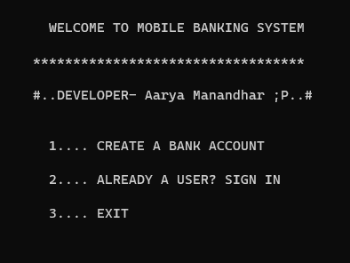
Figure 1 User interface

Data Storage:
User data, including account details and transactions, is stored in text files (username.txt and mon.txt) using the fwrite and fread functions.
In a real-world scenario, using a more robust and secure database (e.g., SQLite, MySQL, etc.) would be recommended.
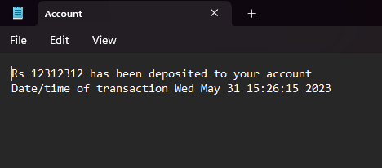
Figure 2 Data Storing

Authentication and Security:
User passwords are masked using asterisks while being entered. Basic username and password authentication is used for logging in.
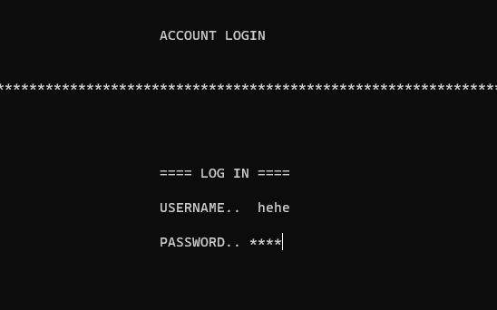
Figure 3 Security

Functionality:
The code provides functionality for creating an account, logging in, displaying account details, checking balance, transferring money, and logging out.
User inputs are validated to some extent (e.g., checking for valid dates).
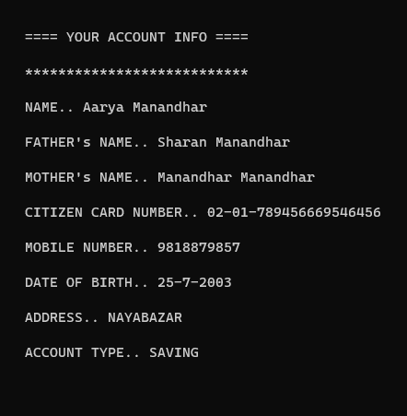
Figure 4 Details

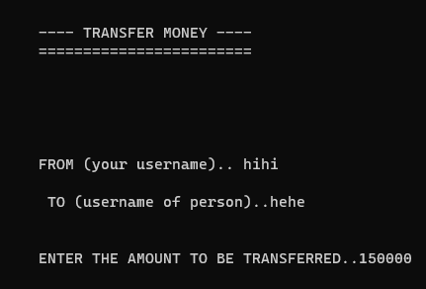
Figure 5 Transferring money

User Experience:
The program gives feedback on successful account creation, login, and logout. User interactions are simple, based on menu choices.
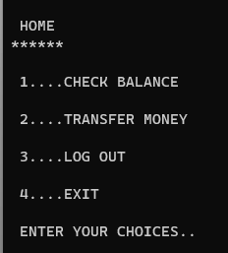
Figure 6 MENU

Flow Control:
The program uses conditional statements (e.g., if, switch) to control the flow of execution based on user choices. Functions are used to modularize code and enhance readability.
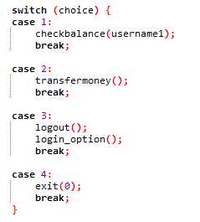
Figure 7 Flow Control

REFERENCES

[1] | Wikipedia, [Online]. Available: https://en.wikipedia.org/wiki/C_(programming_language). [Accessed 19 8 2023].

