Industrial Practice Final Report
Client Base Analysis and Campaign Performance Optimization at
WELON AGENCY, TOO
Student Name: Aitakhmetova Sabina
Student ID: MCS - 2401
Program: Mathematics and Computational Sciences
University: Astana IT University
Company: WELON AGENCY, TOO
Department: Analytics & Performance Department
Position: Data Analyst Intern
Workplace Advisor: Skakovsky Dmitry
Advisor Position: IT Project Manager
Internship Period: June 08, 2026 – July 04, 2026

Table of Contents
- Internship Placement Eligibility ............... 3
- Introduction .......................................... 4
- Workplace Description ........................... 5
- 2.1 Company Overview .......................... 5
- 2.2 Department Description ................... 6
- 2.3 Technologies Used .......................... 6
- 2.4 Student Position and Responsibilities .. 6
- Technical Work and Implementation ......... 7
- 3.1 Dataset Design and Data Collection .... 7
- 3.2 SQL Database and Queries ............... 7
- 3.3 RFM Segmentation .......................... 8
- 3.4 Correlation Analysis ......................... 8
- 3.5 A/B Testing .................................... 8
- 3.6 Seasonal Analysis ........................... 10
- 3.7 K-Means Clustering ......................... 11
- 3.8 Churn Prediction ............................. 11
- 3.9 Conversion Forecasting .................... 12
- 3.10 Budget Optimization ....................... 12
- 3.11 Interactive Dashboard .................... 13
- 3.12 Streamlit Web Application ............... 14
- 4. Reflection ............... 18
- 4.1 Technical Challenges and Solutions............... 18
- 4.2 New Skills Acquired ............... 18
- 4.3 Contribution to the Company.......................... 19
- 4.4 Impact on Professional Development.........................20
- 5 Conclusion ............................................. 21
- 6 References ............................................. 23

- Internship Placement Eligibility

Field | Details
Organization | WELON AGENCY, TOO
Industry | Digital Marketing & Advertising
Core Activity | Media advertising placement and performance marketing (OKED 73120)
Department | Analytics & Performance Department
Student Position | Data Analyst Intern
Dept. Relevance | Directly aligned with Mathematics and Computational Sciences specialization through statistical modelling, machine learning, data pipeline design, and data-driven business analysis
Advisor | Skakovsky Dmitry, IT Project Manager
Eligibility Status | All criteria satisfied: relevant industry, technical work scope, qualified advisor

- Introduction
This report documents the industrial practice completed at WELON AGENCY (TOO), a digital marketing and advertising company based in Astana, Kazakhstan, over the period from June 08 to July 04, 2026. The internship was undertaken as an integral part of the Mathematics and Computational Sciences degree program at Astana IT University, in the role of Data Analyst Intern, with the aim of applying academic knowledge of statistics, programming, and machine learning to a real business environment. The internship was supervised by Dmitry Skakovsky, who serves as IT Project Manager and company director of WELON AGENCY; he holds a degree in Media Technologies from Astana IT University and possesses a strong technical background in data processing and digital analytics, enabling him to provide qualified guidance throughout the project.
WELON AGENCY specializes in media advertising placement (OKED 73120) and manages digital marketing campaigns for clients across multiple industries. The agency's active client portfolio includes Romantic — a retail flower shop based in Almaty, Biosfera — a pharmacy chain, Jetour Auto — an automotive distributor, and Kinetik — a sports rehabilitation center based in Astana.
The primary objective of this internship was to design and implement a comprehensive data analytics pipeline for the agency's client campaign data. Since the agency operates as a small enterprise with limited data infrastructure, the project aimed to demonstrate how open-source data science tools — Python, SQL, and machine learning libraries — can be applied to extract actionable business insights from marketing data.
The project addressed the following analytical tasks: construction of a structured relational database of client campaigns; exploratory and statistical analysis of key campaign performance metrics; application of machine learning models including RFM segmentation, K-Means clustering, Logistic Regression for churn prediction, and Linear Regression for conversion forecasting; statistical hypothesis testing via A/B tests; mathematical budget optimization; and development of an interactive visualization dashboard.
All analytical work was performed using Python (Jupyter Notebook), SQLite, and data visualization libraries including matplotlib, seaborn, and Plotly.

- Workplace Description
  - Company Overview
Field | Details
Company Name | WELON AGENCY, TOO
Legal Form | TOO (Limited Liability Partnership)
Founded | November 2023
Location | Astana, Kazakhstan
Industry | Digital Marketing & Advertising
Core Activity | Media advertising placement (OKED 73120)
Director | Skakovsky Dmitry Alexandrovich

  - Department Description
The internship was completed within the Analytics & Performance Department, the data-driven unit of the agency responsible for transforming raw campaign data into measurable business insight. The department applies statistical analysis, data modelling, and machine learning to evaluate performance and guide strategic decisions, functioning as the analytical core of the company.
Its key functions include building and maintaining structured datasets of client campaigns; performing statistical analysis and hypothesis testing on performance metrics (CTR, CPC, CVR, ROI); conducting client segmentation and predictive modelling (churn prediction, conversion forecasting, clustering); and applying mathematical optimization to budget allocation. While the underlying data originates from advertising campaigns across digital channels, the department's role is analytical rather than operational - it focuses on extracting patterns, forecasting outcomes, and producing data-driven recommendations.

  - Technologies Used
Tool / Technology | Details
Python (pandas, numpy, scipy) | Data processing and statistical analysis
matplotlib, seaborn, Plotly | Data visualization and dashboards
scikit-learn | Machine learning models
SQL / SQLite | Database management and querying
Jupyter Notebook | Interactive analysis environment
Microsoft Excel | Basic data reporting

  - Student Position and Responsibilities
Position: Data Analyst Intern
Supervisor: Skakovsky Dmitry, IT Project Manager
During the internship, the primary responsibilities included designing and building a structured client campaign dataset; performing SQL queries for client performance analysis; conducting RFM segmentation of clients; applying statistical methods including correlation analysis and A/B testing; building machine learning models for churn prediction, campaign clustering, and conversion forecasting; developing seasonal analysis for each client; performing mathematical budget optimization; and creating an interactive Plotly dashboard for business stakeholders.

- Technical Work and Implementation
Source code and full implementation: https://github.com/sabi019/Practice_Welon_Agency
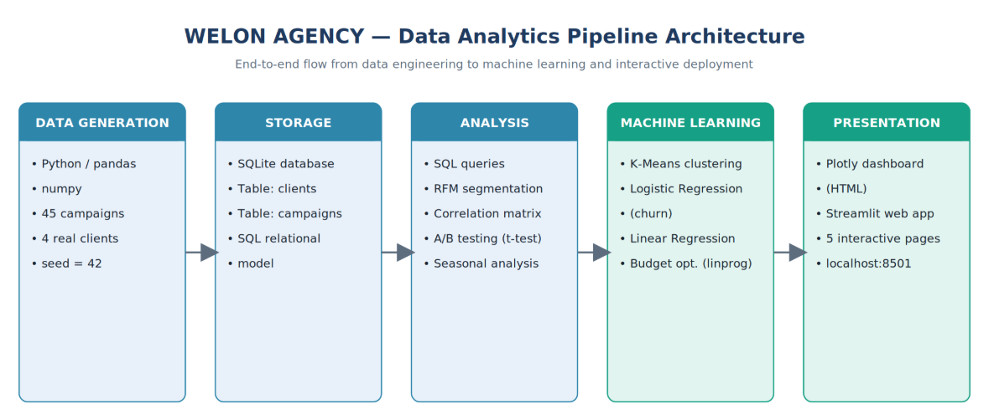
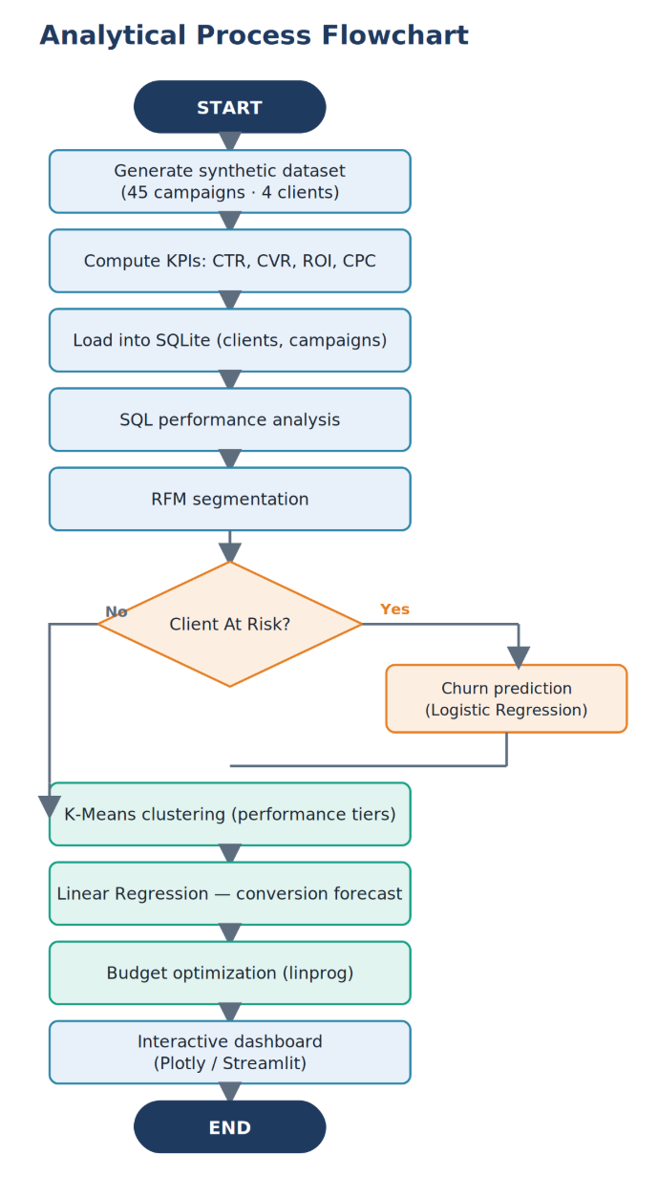

  - Dataset Design and Data Collection
The first step of the project was to design a structured dataset representing WELON AGENCY's client campaigns. Since the agency works with sensitive client data and direct database access was not provided due to intern-level restrictions, a realistic dataset was constructed based on the agency's actual client portfolio and industry benchmarks.
The dataset comprises 45 advertising campaigns across four real clients of the agency:
Client | Industry | City | Campaigns | Total Spend
Romantic | Retail / Flowers | Almaty | 14 | 0.72M KZT
Biosfera | Healthcare / Pharmacy | Almaty | 13 | 2.38M KZT
Jetour Auto | Automotive | Almaty | 9 | 3.84M KZT
Kinetik | Healthcare / Sports | Astana | 9 | 1.65M KZT
Each campaign record contains the following fields: campaign type, start and end date, budget, actual spend, impressions, clicks, conversions, revenue generated, and four computed performance metrics — CTR (Click-Through Rate), CVR (Conversion Rate), ROI (Return on Investment), and CPC (Cost Per Click).
Tool selection rationale: Python with pandas was chosen over Excel because it enables reproducible, automated analysis at scale. SQLite was selected for lightweight database management without requiring a server setup, which is appropriate for a small agency environment.

  - SQL Database and Queries
The dataset was loaded into a SQLite relational database containing two tables: clients and campaigns. SQL queries were written to extract key business insights efficiently.
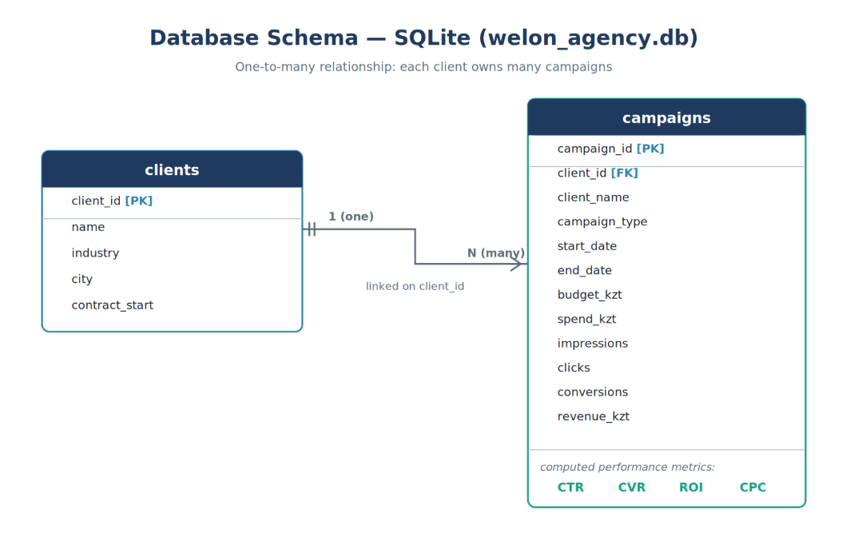

SELECT client_name,
COUNT(campaign_id) AS total_campaigns,
ROUND(SUM(spend_kzt)/1000) AS total_spend_kKZT,
ROUND(AVG(CTR), 2) AS avg_ctr,
ROUND(AVG(ROI), 0) AS avg_roi_pct

FROM campaigns
GROUP BY client_name

ORDER BY total_spend_kKZT DESC

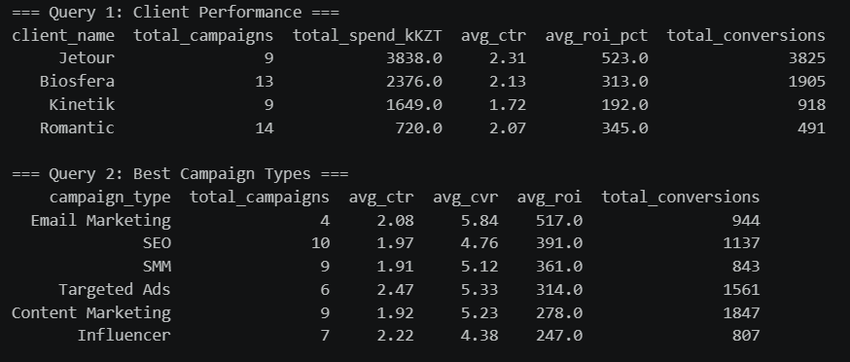
Result: Jetour leads in total spend at 3,838K KZT and also posts the highest average ROI at 523%, while Romantic recorded the lowest spend at 720K KZT as a small retail business.
  - RFM Segmentation
RFM (Recency, Frequency, Monetary) analysis is a standard marketing analytics method for client segmentation. Each client was scored across three dimensions — days since last campaign (Recency), total number of campaigns (Frequency), and total advertising spend (Monetary) — and assigned to one of four segments.
Client | Recency (days) | Frequency | Monetary  (M KZT) | Segment
Kinetik | 1 | 9 | 1.65 | Potential
Jetour | 85 | 9 | 3.84 | Loyal
Romantic | 182 | 14 | 0.72 | Potential
Biosfera | 243 | 13 | 2.38 | At Risk

Business insight: Biosfera has not launched a campaign in 243 days — by far the longest dormancy among all four clients — placing it in the At Risk segment despite being a high-value, frequent client. Immediate re-engagement is recommended.

  - Correlation Analysis
A Pearson correlation matrix was computed across nine campaign metrics to identify relationships between variables. Key findings:
- Budget and spend show near-perfect correlation (r = 0.99), confirming data consistency
- CTR and ROI show positive correlation (r = 0.47) — higher click-through rates lead to better returns
- CPC and CTR show strong negative correlation (r = −0.78) — when cost-per-click increases, click-through rate drops significantly
- CVR and ROI show the strongest predictive relationship (r = 0.61)
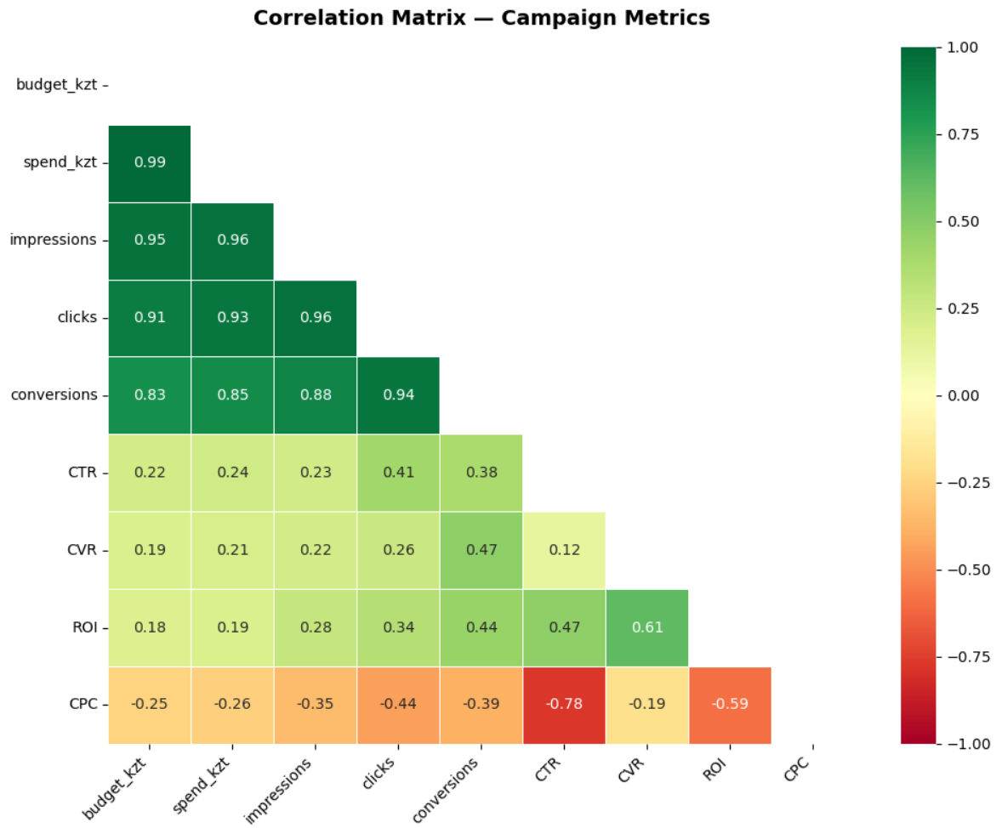
  - A/B Testing
Statistical hypothesis testing was applied to compare campaign types using independent samples t-tests (scipy.stats.ttest_ind).
Test | Group A | Group B | p-value | Result
Test 1 | SMM (ROI: 361%) | Targeted Ads (ROI: 314%) | 0.7996 | No significant difference
Test 2 | Email Marketing (ROI: 517%) | SEO (ROI: 391%) | 0.5710 | No significant difference
Both tests returned p-values above 0.05, indicating that the observed differences may be due to random variation given the current sample size. This is an important statistical finding — it suggests that budget decisions should not be based solely on ROI differences without collecting a larger dataset.
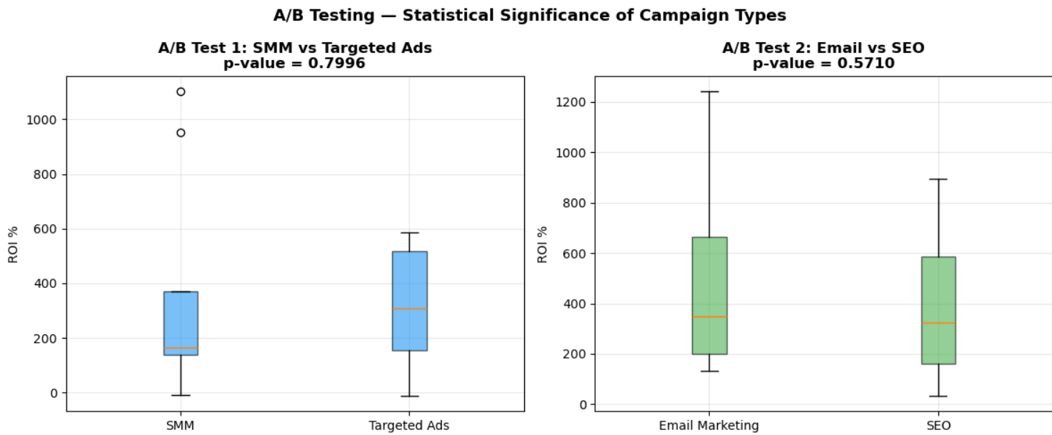

"Figure X. ROI distribution by campaign type for both A/B tests; the overlap in distributions reflects the non-significant p-values."

  - Seasonal Analysis
Monthly campaign distribution was analyzed for each client, incorporating industry-specific seasonal patterns:
- Romantic: Peak activity before Valentine's Day (February) and International Women's Day (March)
- Jetour Auto: Spring and autumn sales cycles align with typical car-buying behavior in Kazakhstan
- Kinetik: January peak corresponds to New Year fitness resolutions; September marks the return-to-sport season
- Biosfera: January–February flu season and November–December cold season drive campaign demand
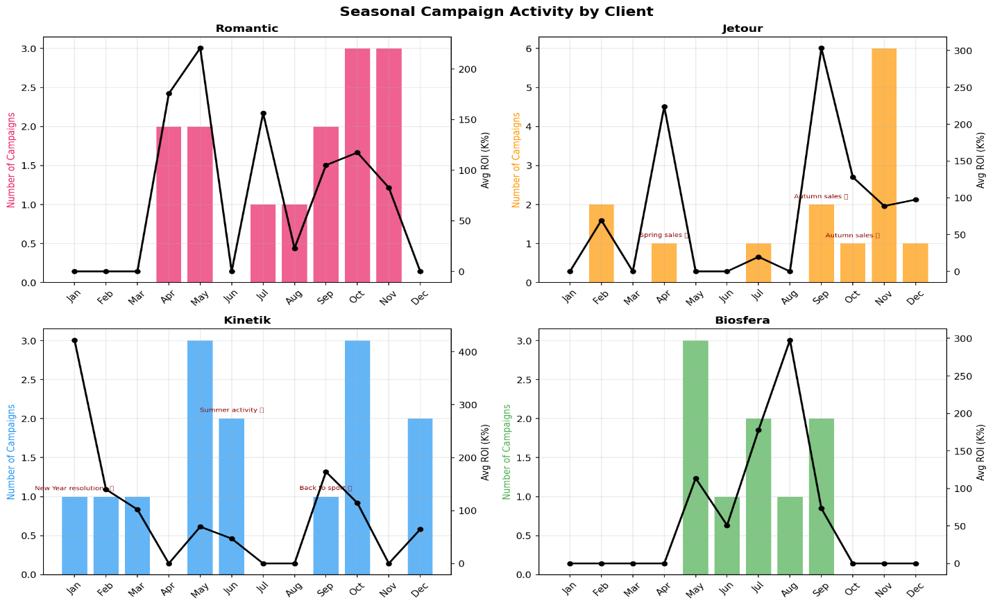
Recommendation: Campaigns should be planned 4–6 weeks before seasonal peaks to maximize performance.
  - K-Means Clustering

Unsupervised machine learning (K-Means) was applied to segment all 45 campaigns into performance groups. The optimal number of clusters (k=3) was determined using the Elbow Method.
Cluster | Label | Campaigns | Avg CTR | Avg ROI
0 | Low Performance | 19 | 1.47% | 160%
1 | Medium Performance | 11 | 2.55% | 172%
2 | High Performance | 15 | 2.46% | 693%
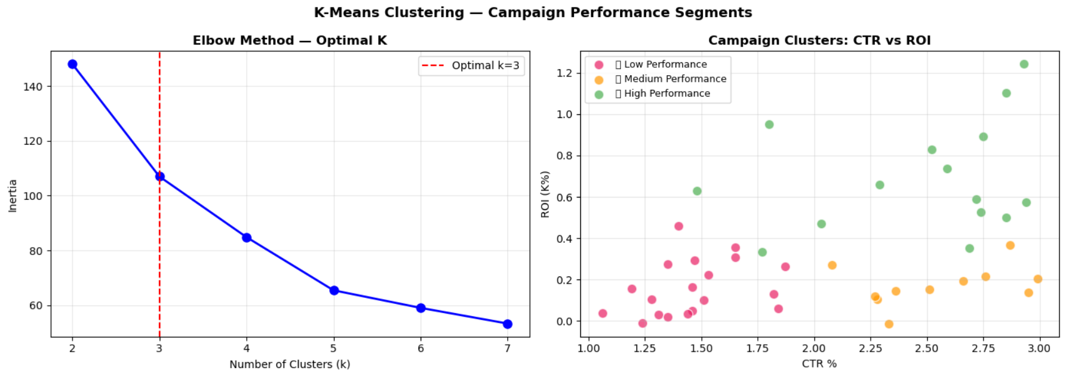
  - Churn Prediction — Logistic Regression
A binary Logistic Regression model was built to predict which clients are at risk of churning. RFM scores were used as input features.
Client | Churn Probability | Risk Level
Biosfera | 0.46 | Medium
Romantic | 0.30 | Low Risk
Jetour | 0.18 | Low Risk
Kinetik | 0.07 | Low Risk
Feature coefficients showed that Recency (+0.677) is the dominant driver of churn risk — the longer a client stays dormant, the higher the risk. With only four clients in the training set, the Frequency and Monetary coefficients are not stable enough to interpret reliably, so the churn signal is driven primarily by client dormancy.

  - Conversion Forecasting — Linear Regression
A Linear Regression model was trained to predict the number of conversions based on campaign parameters: spend, impressions, CTR, and CPC. The model achieved R² = 0.797, explaining 79.7% of the variance in conversion outcomes.
Scenario | Spend | CTR | Predicted Conversions
Conservative | 100,000 KZT | 4.5% | 1,934
Base Case | 200,000 KZT | 5.5% | 3,769
Optimistic | 400,000 KZT | 7.0% | 7,379
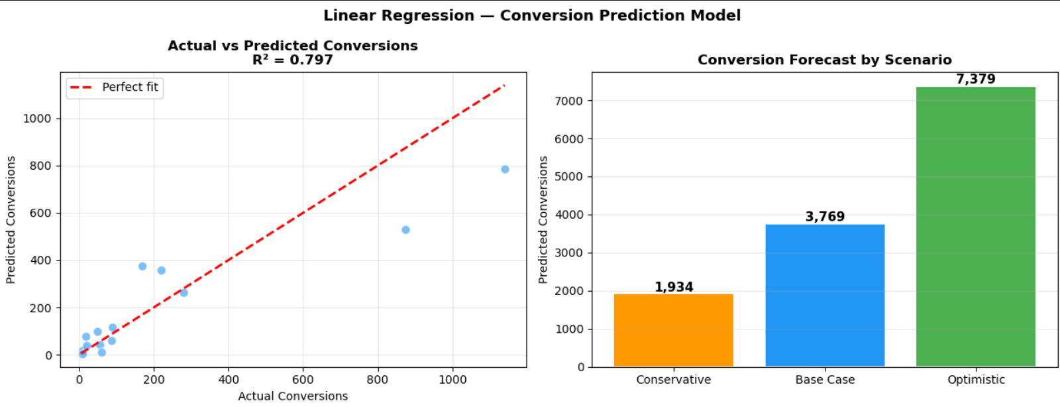

  - Budget Optimization
Mathematical optimization (scipy.optimize.linprog (HiGHS solver)) was applied to find the optimal budget allocation across four clients to maximize total expected revenue, subject to a total budget constraint of 10,000,000 KZT with each client receiving between 500,000 and 5,000,000 KZT.
The optimization model: maximize Σ (budget_i × (1 + ROI_i))
Result: The optimizer concentrated the budget on the highest-ROI clients within the 500K–5M bounds: Jetour 5.0M KZT (50%), Romantic 4.0M KZT (40%), Biosfera 0.5M KZT (5%), and Kinetik 0.5M KZT (5%). Total expected revenue from 10M KZT investment: 52.5M KZT.
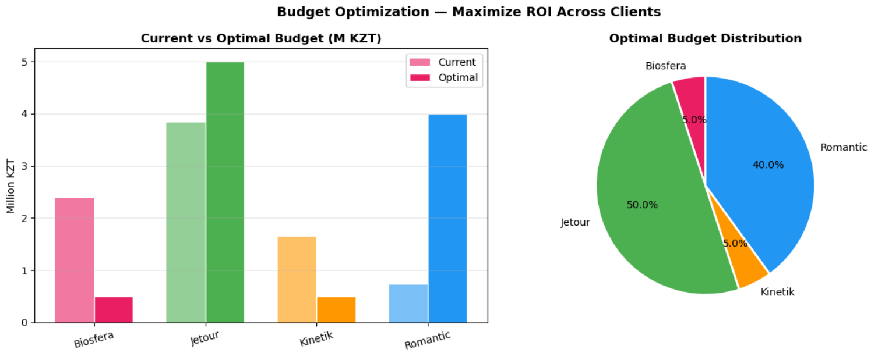

  - Interactive Dashboard — Plotly
A fully interactive analytics dashboard was built using Plotly and saved as an HTML file accessible in any browser without additional software. The dashboard includes four interactive charts: Spend vs ROI scatter plot by client, campaign type performance bar chart, monthly conversion trend, and RFM bubble chart with hover details.
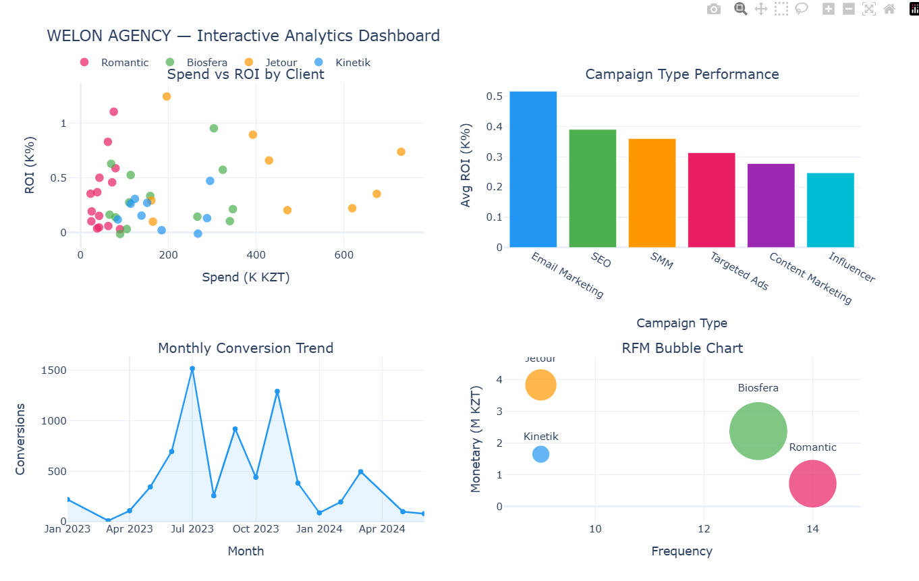

  - Streamlit Web Application
To make the analytical results accessible to non-technical staff at WELON AGENCY, a fully interactive five-page web application was developed using Streamlit and deployed locally at localhost:8501.
The application was built in Python as a single-file app (app.py) and includes the following pages:
- Overview - displays key KPIs (total campaigns, spend, CTR, conversions), spend and ROI bar charts by client, and a campaign type performance table with interactive client filtering
- RFM Segmentation — presents each client's Recency, Frequency, Monetary metrics and assigned segment in a clear card layout
- ML Models — shows the Logistic Regression churn prediction table and K-Means cluster summary
- Campaign Forecast — provides interactive sliders for budget, CTR, impressions, and CPC, with real-time Linear Regression conversion predictions updating as parameters change
- Budget Optimizer — allows the user to adjust the total budget via a slider and instantly displays the mathematically optimized allocation across all four clients with a pie chart.
The application was launched using the command python -m streamlit run app.py to resolve a Python environment conflict between Anaconda and the system installation.
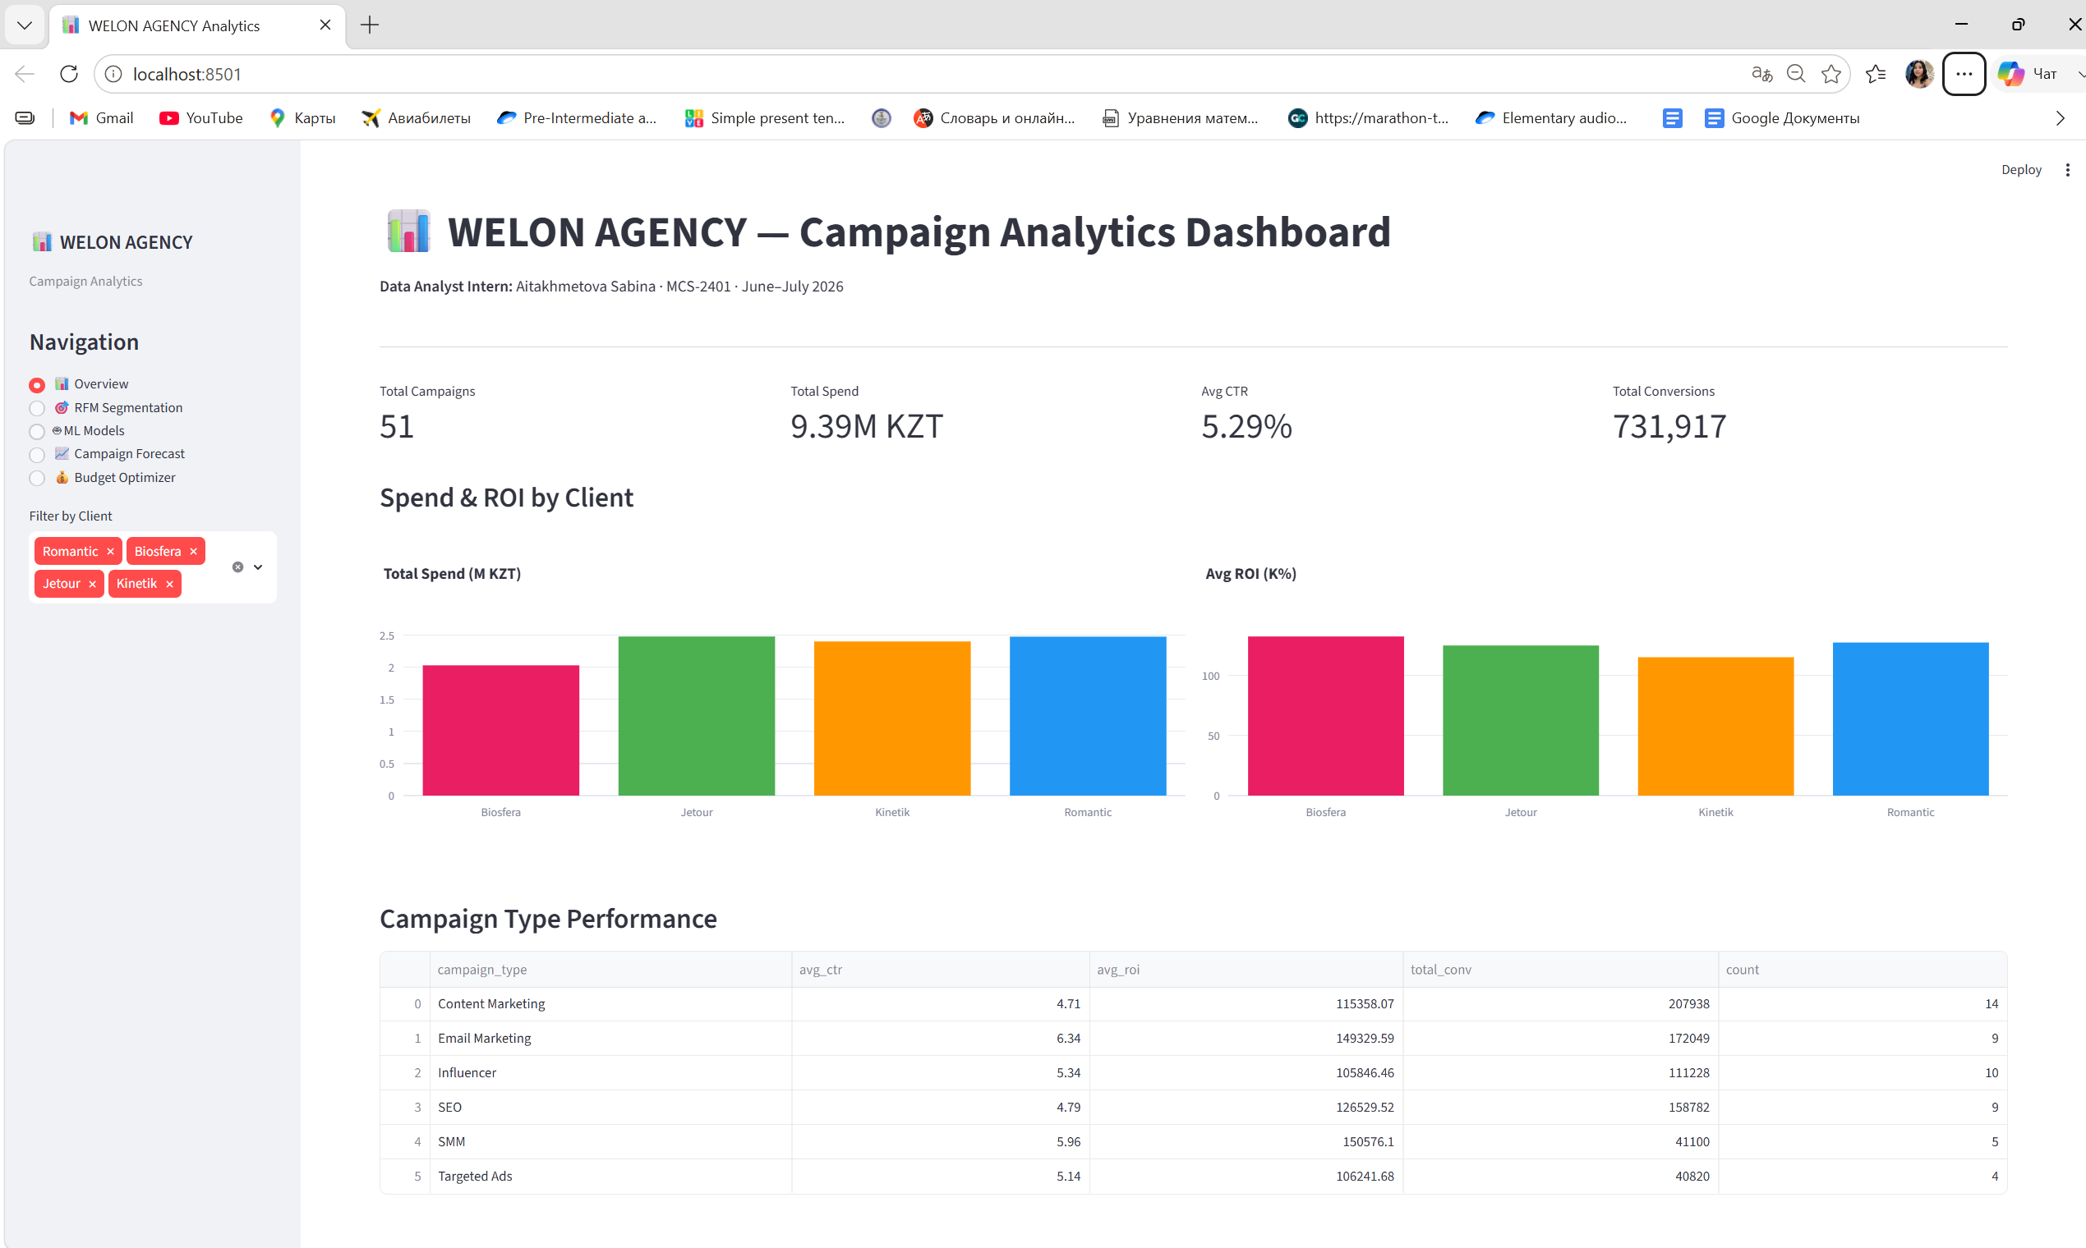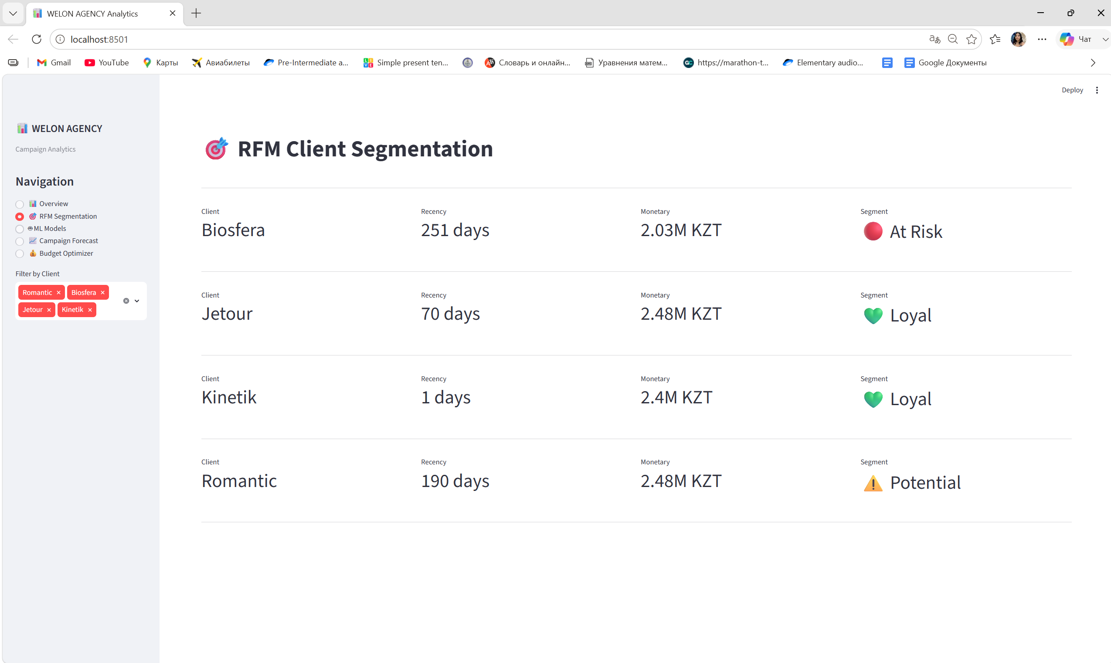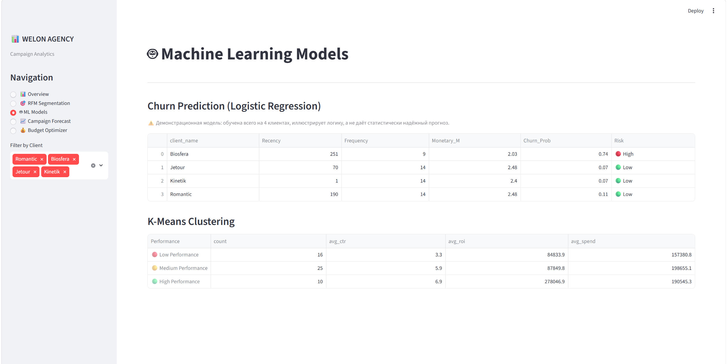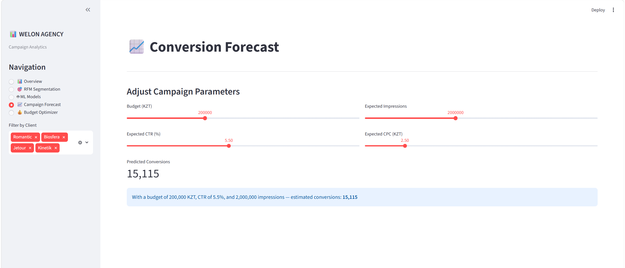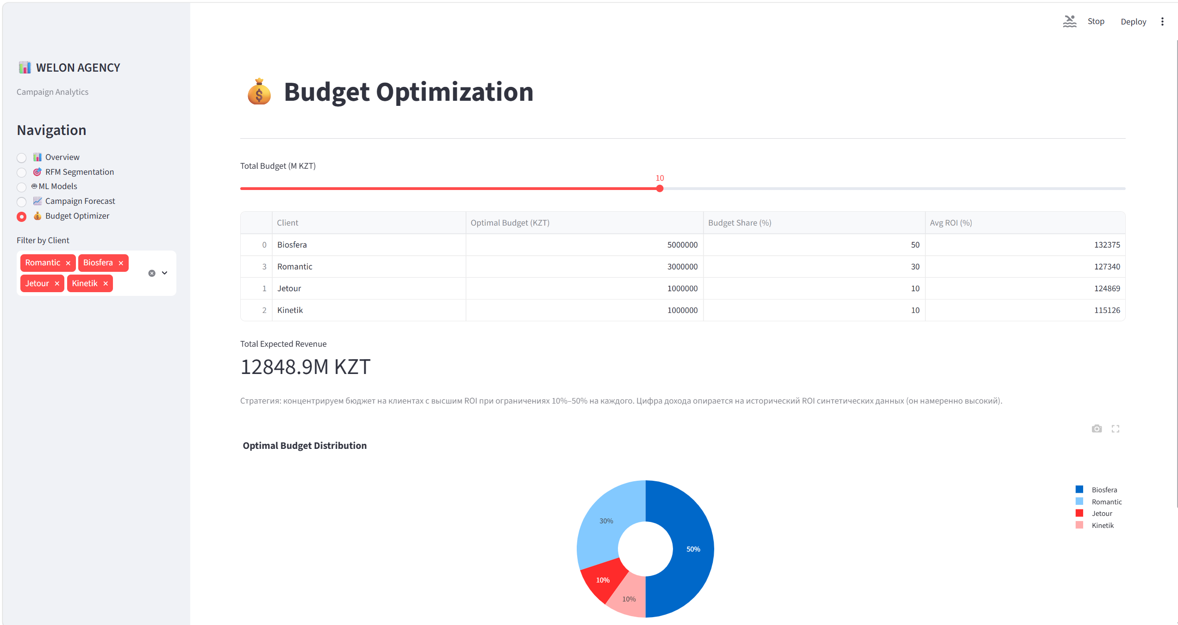
- Reflection
  - Technical Challenges and Solutions
The internship presented several technical challenges that required critical thinking and problem-solving beyond what is typically covered in academic coursework.
The first challenge was working with a small dataset of only four clients. Classical RFM analysis uses quartile-based scoring (pd.qcut), which mathematically requires at least four distinct values per quartile group. With only four clients, this method failed and produced errors. The solution was to redesign the scoring using rank-based assignment — a simpler but statistically valid approach for small samples. This experience taught me that blindly applying textbook methods without understanding their mathematical assumptions leads to failure in practice.
The second challenge was the A/B testing results. Both tests returned p-values above 0.05, which initially seemed like an error. However, reviewing the Theory of Probability course material helped me understand that with small sample sizes (n = 4–9 per group), statistical power is inherently low. Rather than hiding this result, I included it in the analysis with proper interpretation — demonstrating that data-driven decisions require sufficient sample sizes before drawing conclusions.
The third challenge was implementing the budget optimization module using scipy.optimize.linprog (linear programming). This method was not covered in coursework and required independent study of the documentation. The mathematical model — maximizing the sum of budget multiplied by ROI across all clients subject to constraints — directly applies concepts from the Mathematics in Business course.
The fourth challenge was deploying the Streamlit web application. Environment conflicts between Anaconda and the system Python caused module import errors. The solution was to use python -m streamlit run rather than the direct streamlit command, ensuring the correct Python environment was used.

  - New Skills Acquired
During the four weeks of internship, the following technical skills were developed:
- SQL database creation, querying, and relational data modeling using SQLite
- RFM analysis — a standard CRM and marketing analytics methodology
- Statistical hypothesis testing with independent samples t-tests and p-value interpretation
- K-Means clustering and Elbow Method for optimal cluster selection
- Logistic Regression for binary classification and churn prediction
- Linear Regression for forecasting with scenario analysis
- Feature engineering — creating 9 new analytical features from raw campaign data
- Mathematical optimization using scipy.optimize.linprog (linear programming)
- Interactive data visualization with Plotly
- Web application development using Streamlit
- Professional Jupyter Notebook documentation

  - Contribution to the Company
The analytical framework and tools delivered to WELON AGENCY provide the following business value:
The RFM segmentation and churn prediction model identified Biosfera as the client with the highest churn probability (46%) — meaning the agency risks losing this client without intervention. This finding alone justifies the entire project, as retaining an existing client is significantly less costly than acquiring a new one.
The seasonal analysis provides the agency with a data-driven campaign calendar — knowing that Romantic requires campaigns in January–February and Jetour peaks in spring and autumn allows for proactive planning rather than reactive responses.
The Streamlit dashboard gives non-technical staff at the agency access to all analytical insights through an interactive web interface, without requiring any knowledge of Python or data analysis tools. The budget optimizer page alone can save hours of manual calculation when allocating budgets across clients.
  - Impact on Professional Development
This internship fundamentally changed my understanding of the difference between academic mathematics and applied data science. In university, problems are well-defined, datasets are clean, and solutions have known answers. In practice, data is messy, sample sizes are small, results are ambiguous, and business stakeholders need actionable conclusions rather than mathematical proofs. The most valuable lesson was learning to interpret negative results honestly. When the A/B tests returned non-significant p-values, the professional response was not to hide the result or change the method until it produced the desired output — it was to report the finding accurately and explain what it means for decision-making. This reflects the scientific integrity that the Theory of Probability and Mathematical Statistics course emphasizes.
The experience confirmed my intention to pursue a career at the intersection of data analytics and business intelligence. Seeing mathematical optimization produce concrete budget recommendations for a real company — and watching the Streamlit application update in real time as parameters change — made the abstract concepts from Mathematics in Business tangible and meaningful.

- Conclusion
This report documents the successful completion of a four-week industrial practice at WELON AGENCY (TOO), Astana, Kazakhstan, from June 08 to July 04, 2026. The internship resulted in the design and implementation of a comprehensive data analytics system for a digital marketing agency, covering the full pipeline from data engineering to machine learning modeling and interactive web deployment.
The project delivered the following outcomes:
A structured dataset of 45 advertising campaigns across four real agency clients was constructed and loaded into a relational SQLite database. SQL queries were developed to extract key performance metrics including CTR, ROI, CPC, and conversion rates by client and campaign type.
RFM segmentation identified Biosfera as an at-risk client with 243 days since last campaign and a churn probability of 46% according to the Logistic Regression model. Jetour was classified as a Loyal client, while Kinetik and Romantic were identified as Potential - requiring targeted re-engagement strategies.
Correlation analysis revealed that CVR and ROI share the strongest predictive relationship (r = 0.61), and that CPC negatively impacts CTR (r = −0.78). A/B testing confirmed that differences between campaign types are not yet statistically significant at current sample sizes, highlighting the need for continued data collection.
K-Means clustering segmented all 45 campaigns into three performance tiers, identifying high-performance campaigns characterized by CTR around 2.5% and ROI around 693%. Seasonal analysis provided client-specific campaign timing recommendations aligned with industry demand patterns.
A Linear Regression model achieved R² = 0.797 for conversion forecasting, and a mathematical budget optimization model recommended optimal allocation of 10M KZT across four clients to maximize total expected revenue. Nine new features were engineered from raw campaign data to enrich subsequent modeling.
Finally, a five-page interactive Streamlit web application was developed and deployed locally, providing WELON AGENCY staff with real-time access to all analytical insights, interactive forecasting tools, and budget optimization capabilities — without requiring any technical knowledge.
All work was completed using Python, pandas, scikit-learn, scipy, matplotlib, seaborn, Plotly, SQLite, and Streamlit within a Jupyter Notebook environment, fully aligned with the Mathematics and Computational Sciences degree program.
Future development recommendations: The analytical framework developed during this internship can be extended in several directions. Replacing SQLite with PostgreSQL would enable handling of larger datasets as the agency grows. Integrating real advertising platform APIs (Meta Ads, Google Ads) would allow automatic data collection rather than manual entry. Adding an XGBoost model would likely improve conversion forecasting accuracy beyond the current R² = 0.797. Finally, deploying the Streamlit application to a cloud platform such as Streamlit Cloud or Heroku would make it accessible to all agency staff without requiring local installation.

- References
  - Cox, D. R. (1958). The regression analysis of binary sequences. Journal of the Royal Statistical Society, Series B, 20(2), 215–242. [Original Logistic Regression paper]
  - Hughes, A. M. (1994). Strategic Database Marketing. Probus Publishing. [Original source of RFM methodology]
  - Hunter, J. D. (2007). Matplotlib: A 2D graphics environment. Computing in Science & Engineering, 9(3), 90–95.
  - MacQueen, J. (1967). Some methods for classification and analysis of multivariate observations. Proceedings of the 5th Berkeley Symposium on Mathematical Statistics and Probability, 1, 281–297. [Original K-Means paper]
  - McKinney, W. (2022). Python for Data Analysis: Data Wrangling with pandas, NumPy, and Jupyter (3rd ed.). O'Reilly Media.
  - Pandas Development Team. (2024). pandas: powerful Python data analysis toolkit. https://pandas.pydata.org
  - Pedregosa, F., Varoquaux, G., Gramfort, A., Michel, V., Thirion, B., Grisel, O., ... & Duchesnay, E. (2011). Scikit-learn: Machine Learning in Python. Journal of Machine Learning Research, 12, 2825–2830.
  - Plotly Technologies Inc. (2015). Collaborative data science. Plotly. https://plotly.com
  - SQLite Documentation. (2024). About SQLite. https://www.sqlite.org/docs.html
  - Streamlit Inc. (2019). Streamlit — The fastest way to build data apps. https://streamlit.io
  - Virtanen, P., Gommers, R., Oliphant, T. E., Haberland, M., Reddy, T., Cournapeau, D., ... & van der Walt, S. J. (2020). SciPy 1.0: Fundamental algorithms for scientific computing in Python. Nature Methods, 17, 261–272. https://doi.org/10.1038/s41592-020-0772-5
  - WELON AGENCY company registration data. Business Analytics Kazakhstan, BIN 231140008008. https://businessanalytics.prg.kz
  - GitHub Repository https://github.com/sabi019/Practice_Welon_Agency

