**APJ Live Build Movement**

Login Server – **Prod-Nginx1** in AWS SG environment Go to – root user

change path to **/opt/nginx/conf**

Take back up of **nginx.conf** file

[root@ip-172-31-30-146 conf]# **cp nginx.conf /opt/backup/nginx_13082021.conf**

Go below path to set the maintenance page

[root@ip-172-31-30-146 backup]# **cd /opt/nginx/conf/ apjprod-nginx-Maintanance.conf** ---> Maintenance page Copy maintenance page with **nginx.conf**

[root@ip-172-31-30-146 conf]# **cp apjprod-nginx-Maintanance.conf nginx.conf**

cp: overwrite ‘nginx.conf’? Yes

Change path to sbin **cd../sbin #/opt/nginx/sbin**

then test the nginx.conf file which replaced [root@ip-172-31-30-146 sbin]#**./nginx -t**

you get below messages if test got successfull

nginx: the configuration file /opt/nginx/conf/nginx.conf syntax is ok nginx: configuration file /opt/nginx/conf/nginx.conf test is successful

now we can reload that **nginx.conf** by using below command [root@ip-172-31-30-146 sbin]# **./nginx -s reload**

Now you can check the website , we have updated the maintenance page <https://cloud.kpisoft.com/home/>

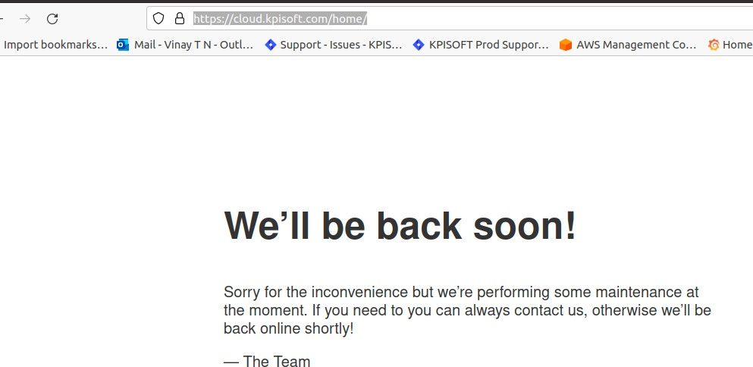

Login Jenkins <https://jenkins.kpisoft.com/> check the docker build

Copy **dockerbuild** and **UI** paths like below

dockerbuild--->

# Releaseskylarkskylark-7.0-18082021133120-9f0de6b3b1070161c11ddec72a843bb7228fdd7e- release_2021_S13_label_fix

ui--->

# skylark-7.0-18082021133219-9f0de6b3b1070161c11ddec72a843bb7228fdd7e- release_2021_S13_label_fix-prod

copy the path and deply in ctswarmpit <https://ctswarm.kpisoft.com/> then go to

# stacks-> apjlive

Please make sure to take snapshot of this page.

Copy path from jenkins **dockerbuild --> console output--> scp -r (copy path)**

# click on apj_bi --> edit--> remove existing build --> add copied path--> wait till it appears --> deploy

copy the path from build for release skylark , paste it hear

# Repeat same for apj_bi , apj_bi_insight, apj_epms, apj_epms_admin, apj_epms_admin_bulk

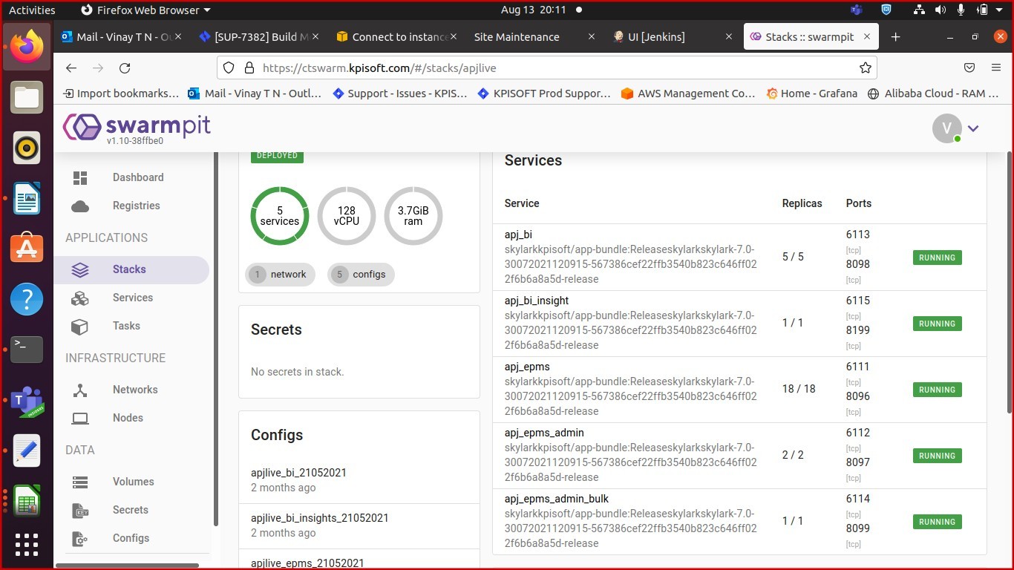

================================

For UI Build

go to path **/opt/SMM/**

**create a folder “13082021_backup” and move admin and home folders inside it,** take backup of admin and home folders , then go to SMM folder

[root@ip-172-31-30-146 SMM]# **scp -r kpisoft@ftp.kpisoft.com:/tmp/**skylark-7.0- 13082021135145-2c5401b4f14440b4c1c69508133ae8696bdf08f3-release-prod**/* .**

(add UI build details in the above path like {skylark-7.0-13082021135145- 2c5401b4f14440b4c1c69508133ae8696bdf08f3-release-prod})

Pasword is: **Passw0rd@54321**

Once it is successfull, copy the backup nginx file to the original [root@ip-172-31-30-146 conf]# **cd /opt/nginx/conf**

[root@ip-172-31-30-146 SMM]# **cp /opt/backup/nginx_13082021.conf nginx.conf**

change nginx in

then goto [root@ip-172-31-30-146 SMM]# **cd ../sbin**

test the nginx

[root@ip-172-31-30-146 sbin]# **./nginx -t**

wait for queries to execute, then load nginx and check the maintenance page. then reload the nginx

[root@ip-172-31-30-146 conf]# **./nginx -s reload**

Now check the maintenance page [https://cloud.kpisoft.com/home/#/signin](https://cloud.kpisoft.com/home/%23/signin) , below page should appear

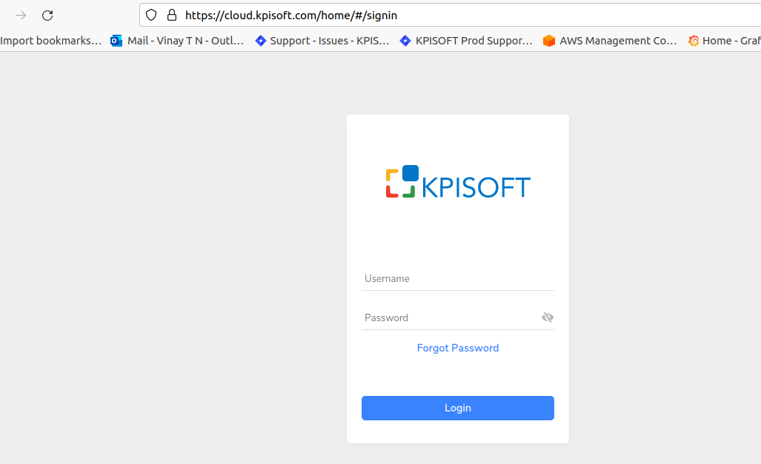

Make sure to clear the cache in Redis.

Build number UI:

skylark-7.0-13082021080021-2c5401b4f14440b4c1c69508133ae8696bdf08f3-release Build number Backend:

skylark-7.0-13082021080021-2c5401b4f14440b4c1c69508133ae8696bdf08f3-release

Update the build details in Live release team chat as build movement successfull.