Environment name: APJ Live

Maria Db name: smm_live

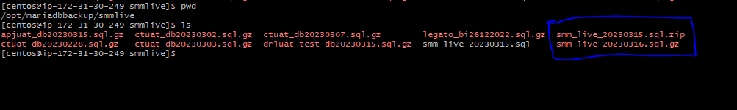

Mongo Db name: smm_live_mongo



Environment name: Legato Prod

Maria Db name: legato_db

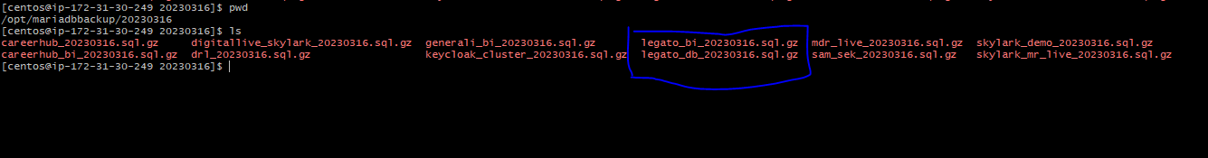

Mongo db name:

Environment name : Show

Maria db name: skylark_demo

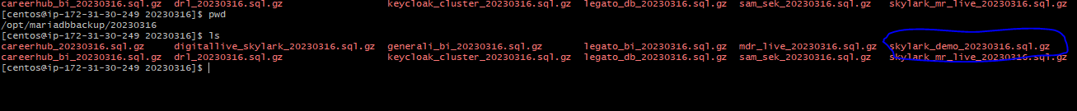

Mongo Db name: show

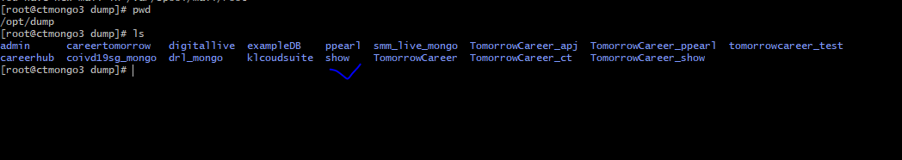

Environmant name: CAH

Maria db name: careerhub

Mongo db name: careerhub

Environment name: DRL Live

MariaDB name:

Mobgo Db name: drl_mongo

Environment name: JKLive

MariaDB name: jk_live

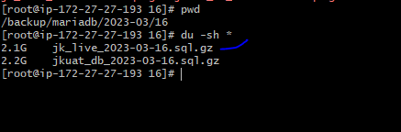

Mongo dB name: jklive_mongo



Environment name: MEA Live

MariaDB name: mea_live

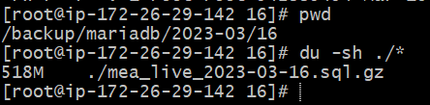

Mongo dB name: mealive_mongo

