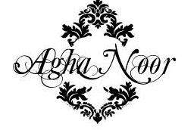
I like the design on the outside ….but not the writing.



I like the & because it stands out before the R’s at the back….perhaps on my Logo the V can stand out the same way before the purple Rose…..



basically if the writing layout could be similar to this concept the V in the middle and the words on the sides please if possible….Open to other ideas as well


I like how the crown sits on top of this number



I like the look of this crown but once again open to ideas…with out the letters in between.

 I like the element of a rose inserted as well…but once again open for ideas but would be great.

