

CONFIRMATION OF INITIAL ASSESSMENT

Thank you for your recent enquiry.

I’m pleased to be able to confirm our appointment on

DATE: Tuesday 8th January 2013
TIME: 11am
VENUE: St Mildred’s Centre Bingham Road,
Lower Addiscombe, CR0 7EB

DIRECTIONS: The centre is at the junction of Bingham Road and Sefton Road

It is few minutes walk from Addiscombe Tram Station which is itself located on Bingham Road

Please use the side entrance to the Centre
The fee (£10) is payable at the time of the appointment by cash/cheque
Use the ‘reception’ bell and wait until I am free to collect you
Please do not arrive more than 5 minutes prior to your appointment

Thank you.
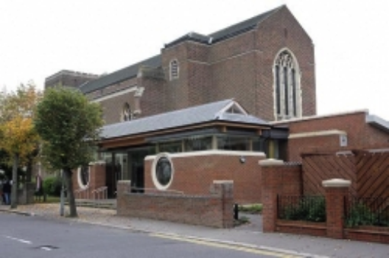

Eve Stephenson MBACP (Accred)
Service Director
Care To Listen
07985 343619
enquiries@caretolisten.co.uk

Please note that 24 hours notice is required for all cancellations otherwise the full fee will be payable

