LOGO DESIGN DRAFTS:
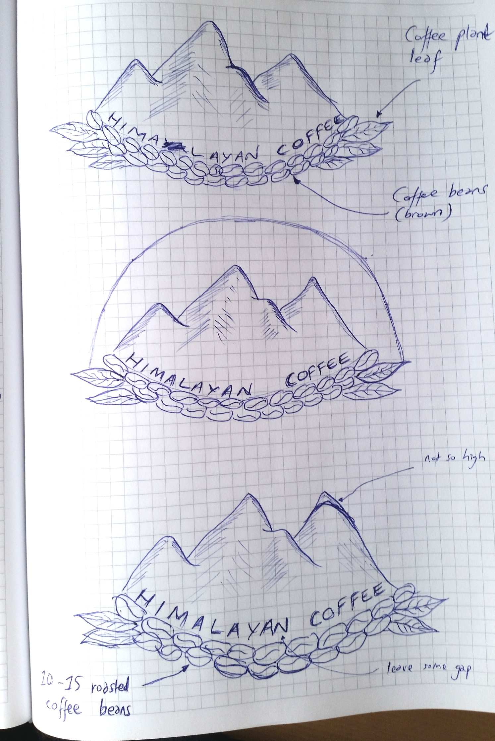

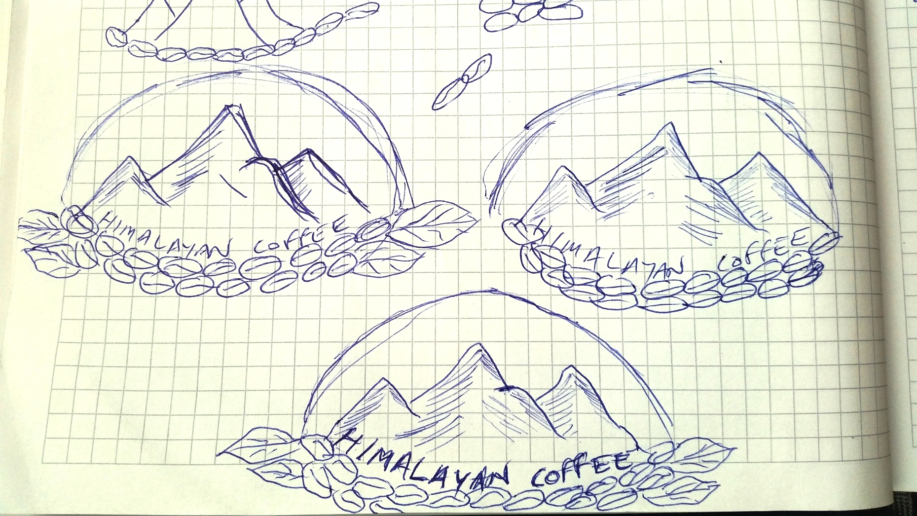

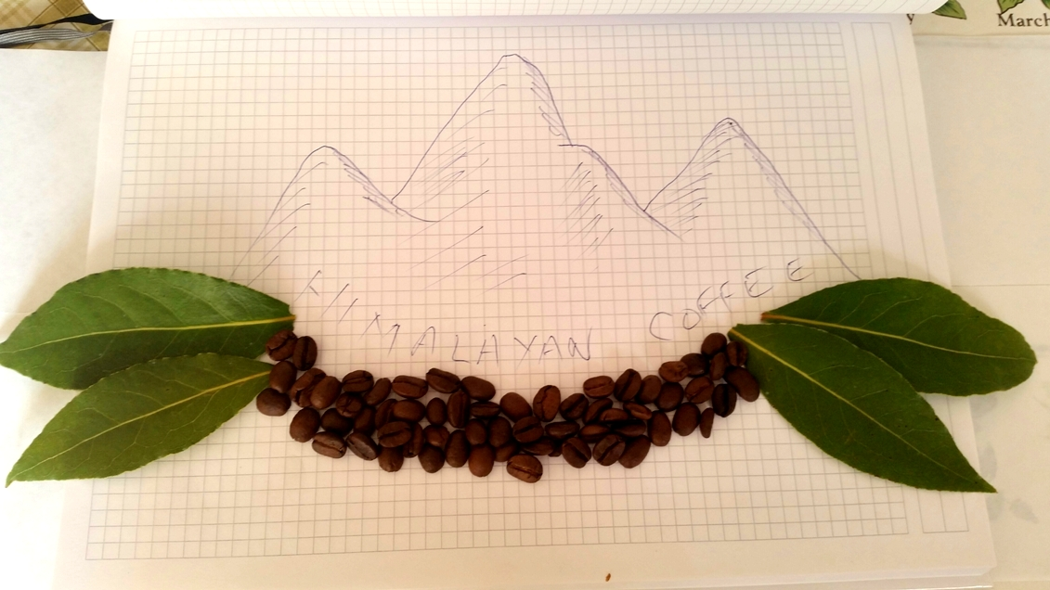

Please use pictures of real coffee beans and real coffee plant leaves like shown above…. Perhaps one with 2- leaves on each end or another with 3-leaves on each end (third leaf being smaller).

Please try to use the same type of Himalayas I have sketched on the above pictures.

