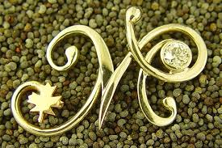

I do want kind of m written like this but no diamond in the middle and at the end just rounded part to keep it simple and no background just the letter. And as it says you will provide 6 custom made logos so any ideas which you think is good for my business is always welcomed because logos are a part of the face of the business so it is pretty important for me .

