Date: 28.1.2013

Reference: Equator Drilling logo

Company name: EQUATOR DRILLING

Background

We are looking to get a logo designed for an exploration drilling company. Just so you can envisage this, the industry serves the mining industry in that exploration drilling companies are contracted to drill various types of holes in order to produce rock samples for geological analysis. The company will be working solely in Africa.

Specifications

My preference is for something geographic rather than industry specific. The logo should therefore either give a global feel with the equator demarcated as in examples 2 or 3 below or a more African feel with the company name overlaid on a map of Africa similar to example 4, but using an outline such as 5 or 6. It might work to blend the two and have something similar to example 2, but substituting the globe for Africa with the equator marked on it and the company name laid out on the right as in 2.

1.

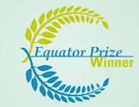

2.

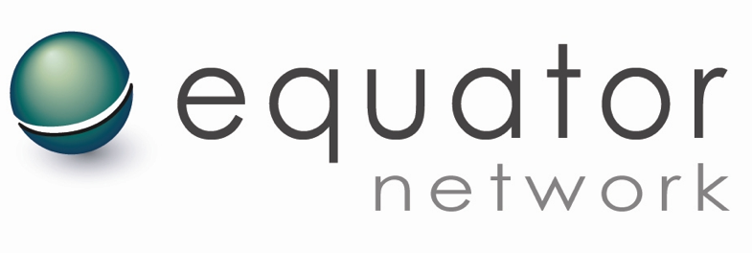

3.



4.



5.

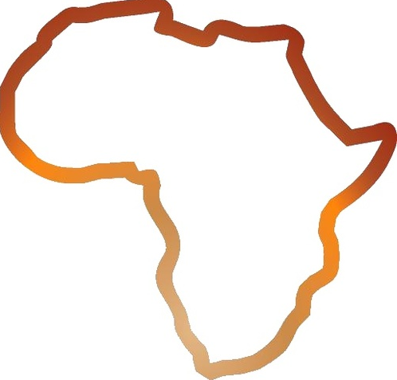

6.

