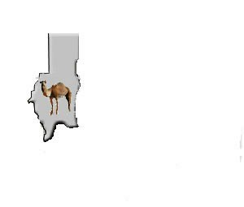

**Darfur Health and Education Concern**

Dear

The above shows the current organisational name and the logo. The current logo is the map of the Darfur region of Sudan and Camel in the map.

**Objectives:** DHEC aims to relieve poverty, give better opportunities in life its target population, provide and support to refugees who survived the ethnic conflict in Darfur and currently residing in the United Kingdom.

**Current Project**

The overall aim of this project is to help a refugees and asylum seekers from Darfur for them to be better integrated into the wider society here in the UK, the project will build the profile of Darfur Community in Derby and potentially improve the participation and community cohesion as it will raise the awareness of the Darfur community in Derby.

The project will facilitate that Darfur community in Derby to celebrate for their cultural traditions. The project will also conduct play activities for parents to entertain their children during the event.

Therefore, we would like you to develop a new Logo for us, the new logo may not have the map of Darfur, but it should reflect some sort of community support work.

If you think the map is ok please contact us so that we will provide you quality picture of the map.