<http://www.orkney.uhi.ac.uk/studying-at-oc/departments/department-images-1/maritime>



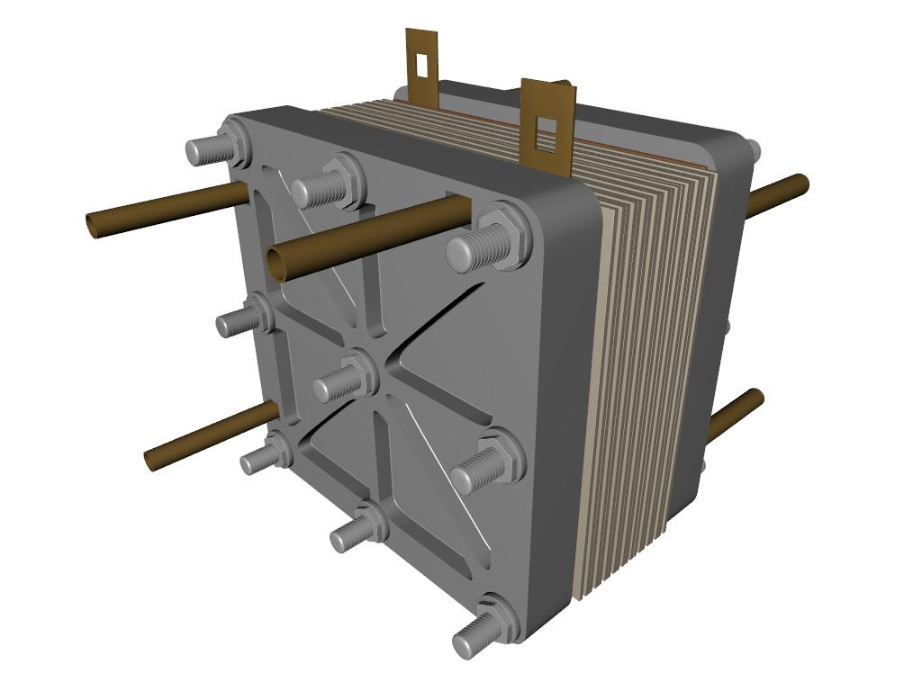

**HYDROGENIX**

PURE ENERGYTM