I like the idea of a logo contained within an app style square. I’d like to see at least one example such as this with the word fab in lower case written over the word people, similar to my crude attempt below.

**fab**

people

I like the effect of depth created by shading on these –



I like the colours used on this –

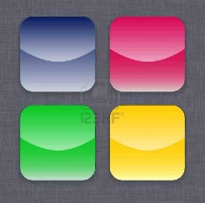

And I like the font and the fun element of this with the smile beneath the AB



and would like to see an example within a rectangle with fab people on the top line, a smile beneath the ab of fab followed by .co.uk, set out as below but not limited to the colours shown.

fab people

.co.uk