The word **UBER** should appear on the top red section between the two outer stars

**Option one -**

The winged detail centre should contain the initials **UM** side by side where the W sits.

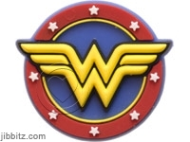

The words **MUMMA.COM** should appear on the lower red section between two outer stars

**Option two -**

The speech bubble should contain the words,

**Uber**

**Mumma**

**.com**

As on this example the words should all be the same width.



The bubble should be **blue (similar to this)**, the figure should be **pink (similar to this)**

**Option Three -**



The words should read be displayed with **Uber** set large with **mumma.com** off set to the right below in smaller text

The circle should be made more of a female shaped head as shown here giving the suggestion of bobbed hair.