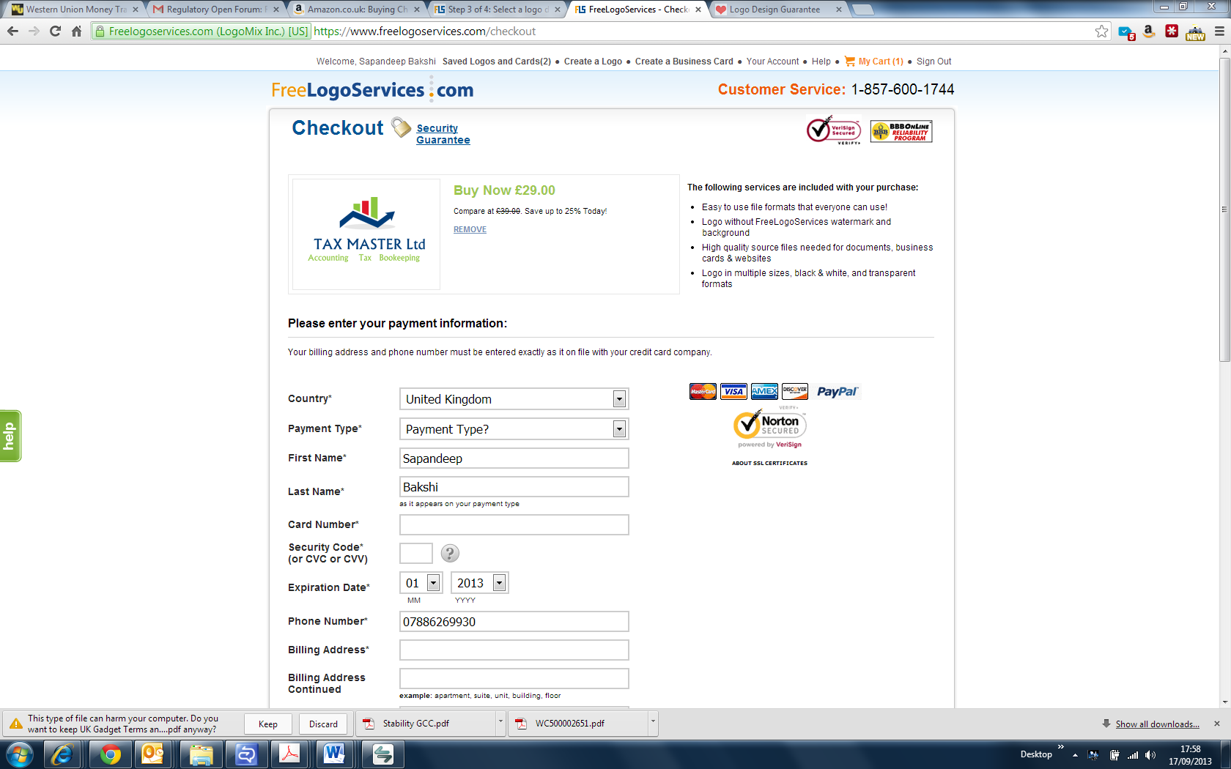

I want Tax to be red in tag line below.

I want some kind of creative spacer b/w Accounting TAX and Bookeeping like