[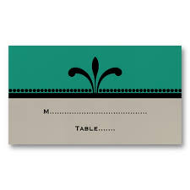](http://www.google.co.uk/imgres?sa=X&biw=1366&bih=651&tbm=isch&tbnid=8W-gfUMjj86c_M:&imgrefurl=http://www.zazzle.com/green_beige_fancy_art_deco_place_cards_business_card-240181714279224239&docid=r6wCtzKa8NJuUM&imgurl=http://rlv.zcache.com/green_beige_fancy_art_deco_place_cards_business_card-r9f288b82342e4a70ab62f2fded8fa974_xwjbk_8byvr_512.jpg&w=512&h=512&ei=gfxfUvnuFoi7hAfE9oCYAg&zoom=1&ved=1t:3588,r:63,s:0,i:280&iact=rc&page=3&tbnh=159&tbnw=198&start=44&ndsp=25&tx=88&ty=90)[](http://www.google.co.uk/imgres?sa=X&biw=1366&bih=651&tbm=isch&tbnid=47Dni8KTlOFTSM:&imgrefurl=http://msdesign1.hubpages.com/hub/Colors-Art-Deco-Interiors&docid=TEMPCyyZxUerlM&imgurl=http://s3.hubimg.com/u/5358238_f248.jpg&w=248&h=186&ei=gfxfUvnuFoi7hAfE9oCYAg&zoom=1&ved=1t:3588,r:81,s:0,i:334&iact=rc&page=4&tbnh=148&tbnw=184&start=69&ndsp=19&tx=115&ty=75)[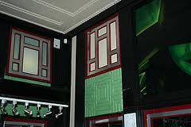](http://www.google.co.uk/imgres?sa=X&biw=1366&bih=651&tbm=isch&tbnid=e_8W77CIB8HbWM:&imgrefurl=http://www.the-silk-route.co.uk/engartdecolondon.htm&docid=A7LUj9PN36HaUM&imgurl=http://www.the-silk-route.co.uk/images-artdecolondon/apollo6.jpg&w=300&h=200&ei=gfxfUvnuFoi7hAfE9oCYAg&zoom=1&ved=1t:3588,r:43,s:0,i:220&iact=rc&page=2&tbnh=160&tbnw=187&start=20&ndsp=24&tx=94&ty=51)[](http://www.google.co.uk/imgres?sa=X&biw=1366&bih=651&tbm=isch&tbnid=AXyxVOeqcM8mTM:&imgrefurl=http://www.zazzle.co.uk/orange_green_fancy_art_deco_thank_you_card-137722757410678963&docid=h_IcDqAridGzBM&imgurl=http://rlv.zcache.co.uk/orange_green_fancy_art_deco_thank_you_card-rdb68adb23cb94033a2e4d70777f2a1b5_xvuai_8byvr_512.jpg&w=512&h=512&ei=gfxfUvnuFoi7hAfE9oCYAg&zoom=1&ved=1t:3588,r:45,s:0,i:226&iact=rc&page=3&tbnh=164&tbnw=121&start=44&ndsp=25&tx=77&ty=106)[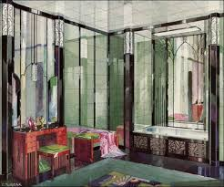](http://www.google.co.uk/imgres?sa=X&biw=1366&bih=651&tbm=isch&tbnid=nT74fJ-Wt7dMYM:&imgrefurl=http://www.art-deco-style.com/art-deco-bathrooms.html&docid=H8mKu8NA6_-8zM&imgurl=http://www.art-deco-style.com/image-files/1929_art_deco_vitrolite_bathroom.jpg&w=403&h=336&ei=gfxfUvnuFoi7hAfE9oCYAg&zoom=1&ved=1t:3588,r:29,s:0,i:178&iact=rc&page=2&tbnh=175&tbnw=198&start=20&ndsp=24&tx=122&ty=88)[](http://www.google.co.uk/url?sa=i&rct=j&q=&esrc=s&frm=1&source=images&cd=&cad=rja&docid=3V7BJPIAajaFTM&tbnid=Mc-j_zcYtpcSvM:&ved=0CAUQjRw&url=http://www.gentryconnects.com/2012_07_29_archive.html&ei=SP1fUuTiFMSohAfiqoEQ&bvm=bv.54176721,d.ZG4&psig=AFQjCNFoviuT1ZDjRo01Fl891cKXM9apZg&ust=1382108673927802)

[](http://www.google.co.uk/url?sa=i&rct=j&q=&esrc=s&frm=1&source=images&cd=&cad=rja&docid=U3KDPK3MpsDaQM&tbnid=rPisQ3rjy8ewnM:&ved=0CAUQjRw&url=http://www.jannaludlow.co.uk/Art_Deco/Index.html&ei=pgBgUsK2KMKthQeMvYGABQ&bvm=bv.54176721,d.ZG4&psig=AFQjCNEL036uCFHptnba5LdQcklcsPPyVw&ust=1382109583698294)

[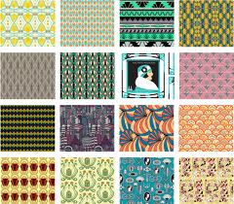](http://www.google.co.uk/imgres?sa=X&biw=1366&bih=651&tbm=isch&tbnid=gQTsIkdHFY8-7M:&imgrefurl=http://blog.spoonflower.com/2012/02/art-deco-collage-vote-for-your-favorite-art-deco-inspired-fabric-designs.html&docid=8-qOjh_BqcDKZM&imgurl=http://spoonflower.typepad.com/.a/6a00e5523f5f4d88340167618f9562970b-500wi&w=500&h=438&ei=DwBgUpJClJCFB7LLgdAD&zoom=1&ved=1t:3588,r:20,s:0,i:160&iact=rc&page=2&tbnh=202&tbnw=231&start=15&ndsp=26&tx=109&ty=109)

[](http://www.google.co.uk/url?sa=i&rct=j&q=&esrc=s&frm=1&source=images&cd=&cad=rja&docid=U3KDPK3MpsDaQM&tbnid=rPisQ3rjy8ewnM:&ved=0CAUQjRw&url=http://vintageprintable.com/wordpress/vintage-printable-art-and-design-2/design-textile-and-paper/design-textile-art-deco/&ei=vABgUvm3HoGBhAfttYGYCg&bvm=bv.54176721,d.ZG4&psig=AFQjCNEL036uCFHptnba5LdQcklcsPPyVw&ust=1382109583698294)