I’d like the Urban Lifestyle font in this style and in black:

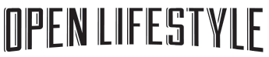

I’d like the Clothing and the EST ‘14 font in this style and in black:



And logo overall to look like this, but to be all symmetrical – I’d also like the lines surrounding the test to be almost a distressed sort of look (not a solid colour):

