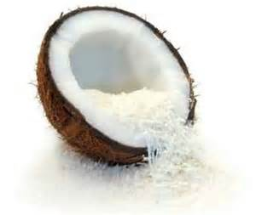

**L**

**C**

**C**

**ounge**

**eat * drink * relax**