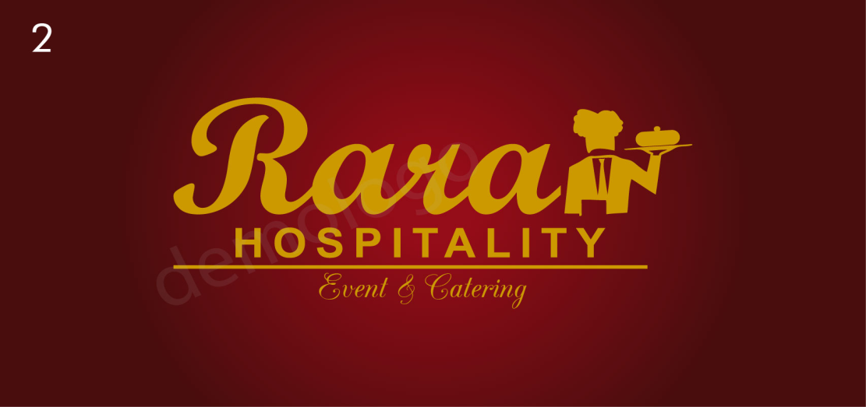

Sample no 2

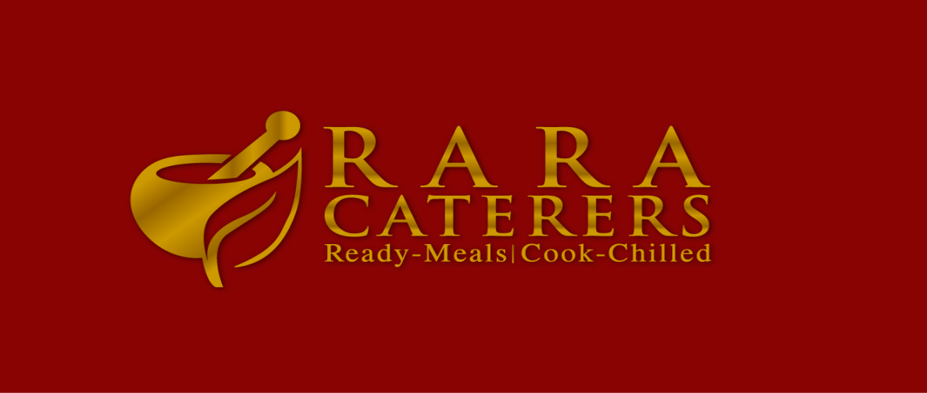

1. Please take the image of chefs and serving ( from the top one) one on the left and second on the right
2. Follow the style of sample no 2 (bottom)
3. Try to create third sample explore different images to rectify event staffing from your side too.

R A R A

Event Staff