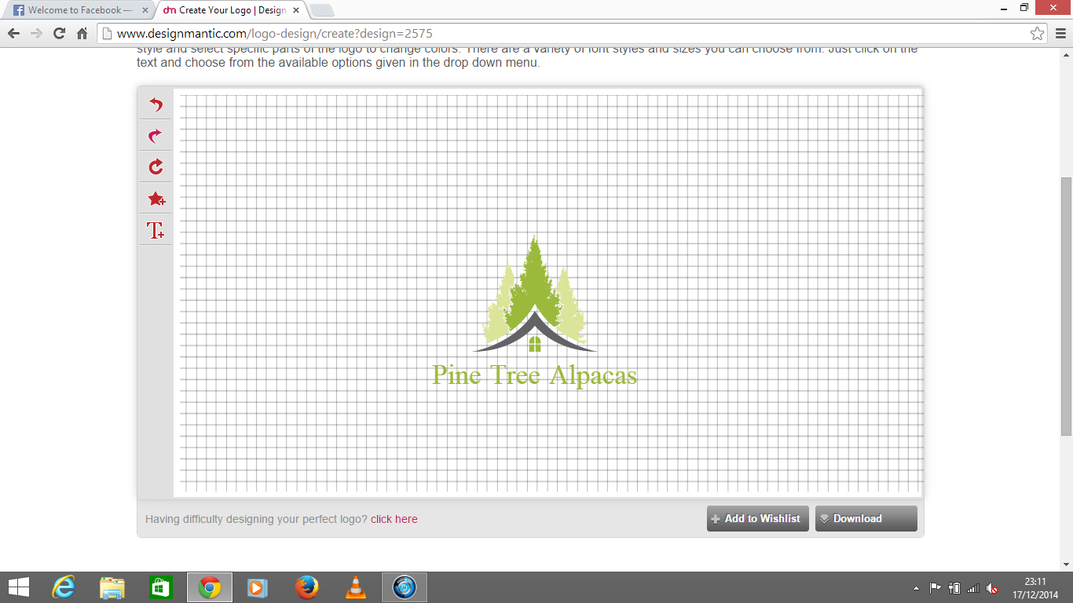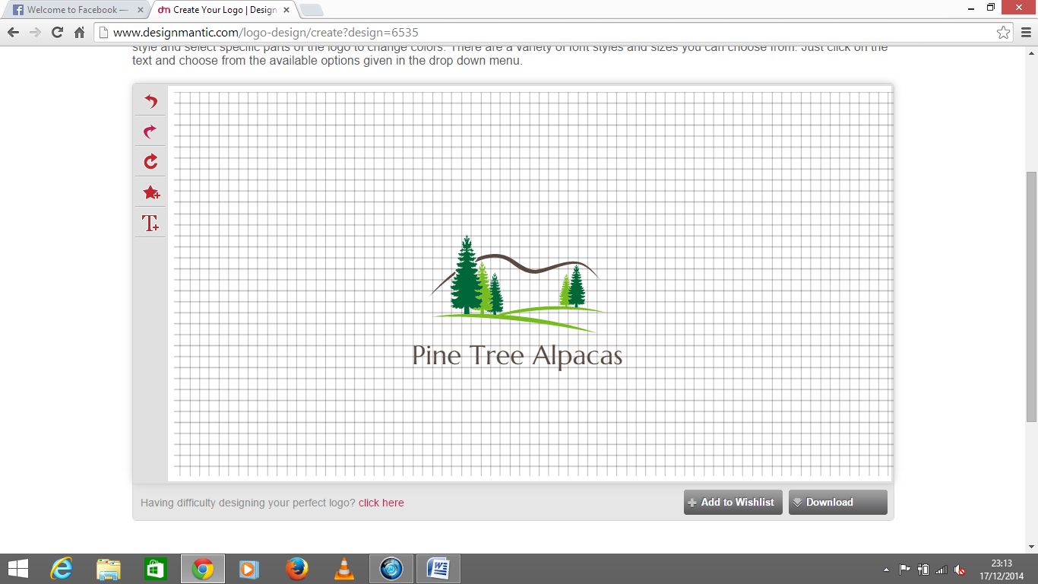

We would like to incorporate the house from the first one using the tree design from the second one as they are more like pine trees.

Can we get a close match to the font on the pic below? Lastly to include an outline of an alpaca either within the picture or as an add on. There are also some samples of others we’ve seen below. You can also see current branding at www.pinetrealpacas.co.uk

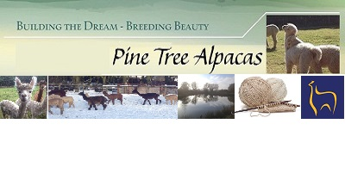

These are from the web so copyright

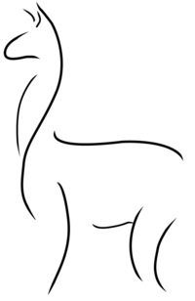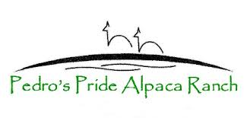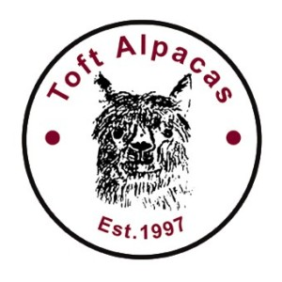like the button logo on this!

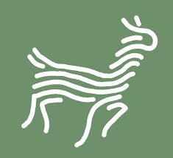 we like this image as it incorporates the yarn side, if we could do anything similar! Or the one below indicates a good fleece in the crimped pattern.

