**The Fitness People**

**Creative Brief**

|  |  |
| --- | --- |
| Required Project Elements: | * Logo Design With Unlimited Revisions |
| Required Format of Logo | * Original Source Files * EPS Vector Format **and** PhotoShop * High resolution JPEG * Should be suitable for print, product such as resistance bands, digital and electronic media and easy to modify at a later stage * The files will be provided to private label manufacturers in china for custom print work on custom products |
| Required Format | * Original Source Files |
| Project Price | * Includes ownership vested in The Fitness People and copyrights of logo and all designs |
| Project Owners | Mitesh Soni ([mitesh.soni@gmail.com](mailto:mitesh.soni@gmail.com))  Nilakshi Soni ([nilakshi0703@gmail.com](mailto:nilakshi0703@gmail.com)) |

|  |
| --- |
| **Logo Design** |
| This logo should incorporate the name of the company and include a suitable icon to make up the logo. Need to create an emotional connection with the community of gym and fitness people  Logo must work in black and white and other two tone formats |

|  |  |
| --- | --- |
| **Exact name on logo:** | **The Fitness People** |
| **Caption of your logo (if any):** | * Stay Fit, Live Well |

|  |
| --- |
| **Brief description of your business:** |
| * Online transaction business * Available 24/7 * Currently UK based * Selling of fitness and health related products on the Internet * Good quality, good value products |

|  |
| --- |
| **The overall feeling you would like to project with your new logo:** |
| * Health and fitness connotations * Shows wellbeing * Spring morning * Looking at beautiful scenery of mountains and lakes at sunrise * Fresh and Crisp * Modern * Clean * Simple |

|  |
| --- |
| **Unique features of your logo design:** |
| * We prefer a white font on a light blue background similar to the Twitter bird colour (but not exactly the same colour) * We also like orange / apple green as a secondary colour |

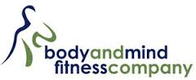

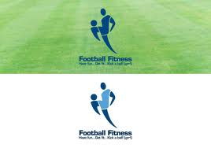

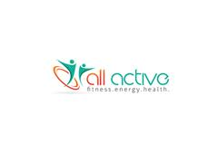



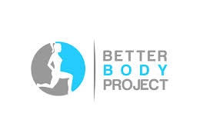This one is nice but would only appeal to women so a man and woman might be good

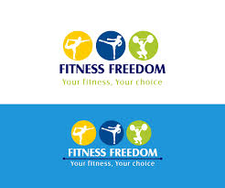 This one is a bit busy but appeals to different people going to a gym

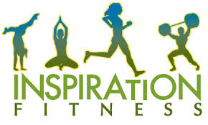

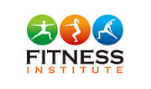too many colours