**Groomie’s Gardening Services** – Design Brief

Our client (title above) is starting a new UK based gardening business that will perform the following services. They are looking for a clean but basic logo with no strap line that just blends well with their work and business – the owner is very funny, down to earth and likes to chat to people so we are looking for a cartoon or characterture type of logo with the words “Groomie’s Gardening Services”.

Services:

1. Lawn mowing
2. Planting
3. Landscaping
4. Tree Surgeon
5. Odd jobs and handy man

Some of the sample logo’s we like are detailed below to give you a feel of the type of logo’s to create:

1. This is a nice icon which we found good – but a lot of people use this, however something similar would be good:

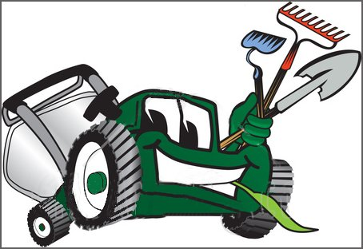

2. This was nice and clean but we do not like the watering can, the size of the logo is ok:

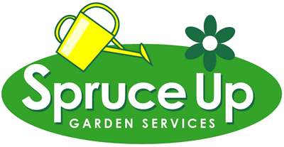

3. The below was one of our favorites, we liked the lawn mower, the flow of the logo and position of the name of the business:

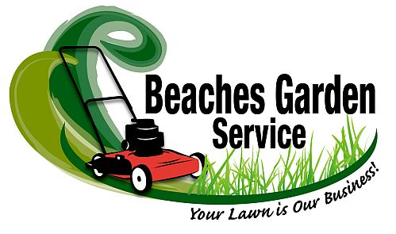

4. This logo was too tall but very nice, good colours. The best part was the man and lawn mower which could be incorporated within the logo design:

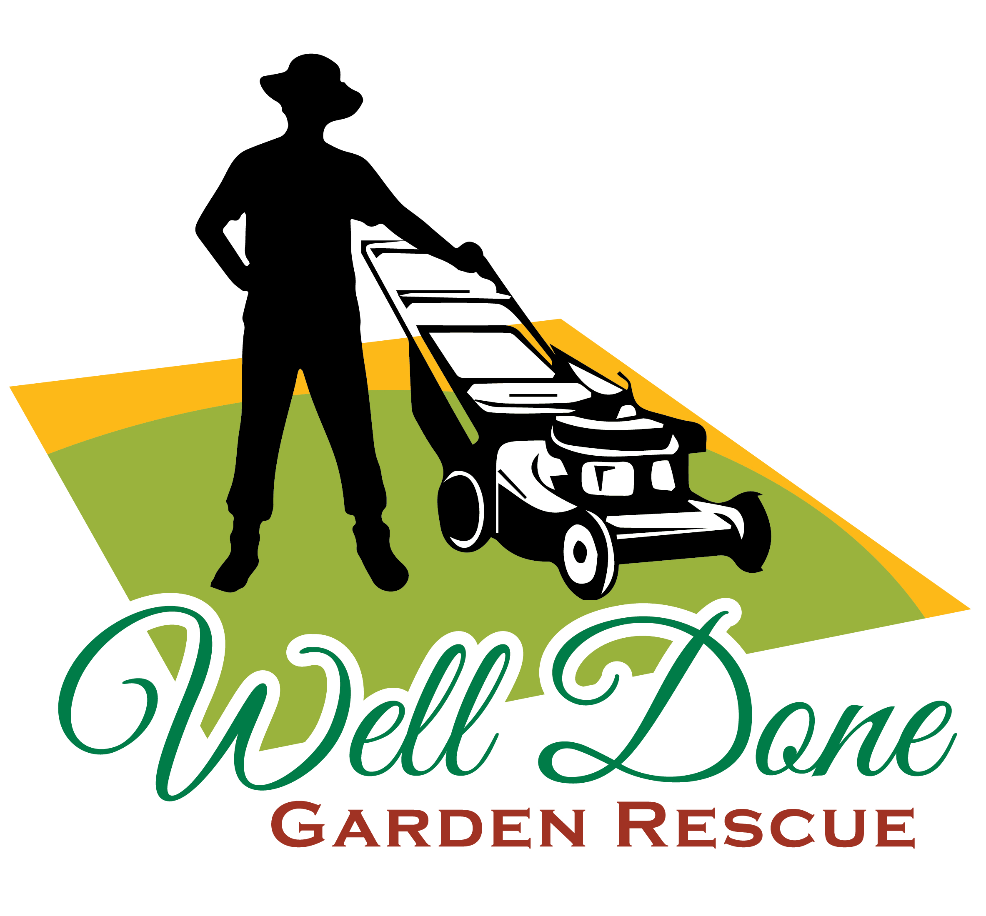

5. This is our favorite as we like the cartoon bee mowing the lawn if we could combine this with 1,3 and 4 some how it would give a really nice look and feel. The grass is a nice additional but the writing for the name of the business is a little too plain:

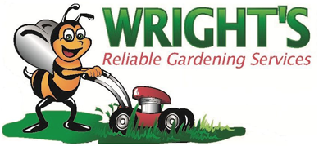

6. Nice writing on this but the logo is not very appealing: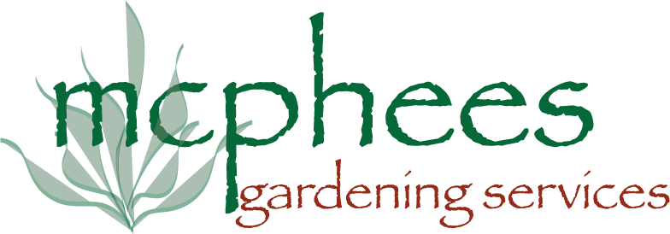

7. This is the type of character we would like to see mowing the lawn on number 5:

