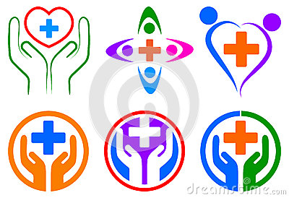

In place of the cross, have the archipelago map/within the cross have the archipelago map, as if through a window. ‘Saude Bijagos’ arching over the top.