Design brief

Client name: Mosu Natucare

Contact name: Utlwanang Rabodietso

Telephone number :72149742

Email address: u.seabe@gmail.com

Brief date: 24/08/2015

A design brief is a written explanation – given to a designer – outlining the aims, objectives and

milestones of a design project. A thorough and articulate design brief is a critical part of the design

process. Above all, the design brief ensures that important design issues are considered and questioned

before the designer starts work.

What does your organisation do?

Mosu Natucare is a start-up personal care product company intending to use locally sourced raw materials to produce high quality, world standard organic/natural cosmetics. The current situation is that it is very difficult to get natural or organic cosmetics locally even though most of the raw materials are exported to other countries from Botswana and Africa at large. The little products that are available are extremely expensive and therefore it is important to cater for clients who are in need of such products. Mosu Natucare will also cater to international clients in need of high quality, certified organic raw materials by sourcing the materials and supplying these clients.

What are your company mission and vision statements?

Mission: To provide the most innovative, environmentally friendly, global standard cosmetics and raw materials free from dangerous synthetic chemicals.

Vision: To be a leading cosmetics company in sub-saharan Africa

What is your tagline or slogan?

**Nurture By Nature**

Who is your target audience (age, sex, income, occupation, location, etc)

The target audience is women from ages 20 to 50, who are aware of ingredients of their cosmetic product and want to minimize the amount of synthetic chemicals that they are exposed to on a daily basis. The client knows the dangers associated with some ingredients that have previously been used and is on the lookout for anything that excludes those ingredients as they are a bit difficult to come across in Botswana and regionally. Location is primarily southern Africa, with the intent to spread globally in the next five years. Income is P3000+ and occupation will vary from formal environment (corporate) to those in creative environment such as photographers, models, actors and musicians.

Design examples (colour, imagery, quantity and quality of text, typography,

atmosphere, etc). Provide examples of what you consider to be effective or relevant

design. Make sure to include samples of your company’s current marketing materials

– even if their purpose is to explain what you don’t want. The more clues you give

about your design tastes, the more likely the designer will be able to produce

something close to your aims. Expecting your designer to second-guess what you

require rarely produces the best results and is costly.

The envisioned colour is black to reflect the mother continent origins, green to show environmental awareness, pink to represent women empowerment. The pink should be on the softer side, and the green a bit darker, almost a lime shade (I hope this makes sense and it does not restrict you too much. You let me know if it does.)

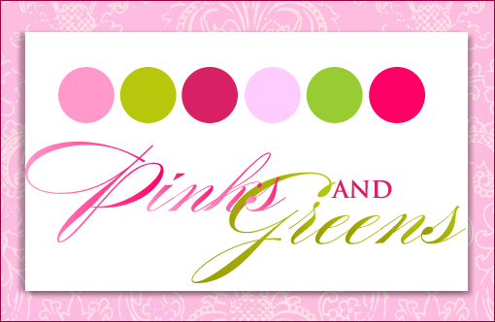

New or update of existing material: New Existing Material

(please provide physical sample)

Who is going to use this item?

Mosu Naturals Pty Ltd

What is the purpose of this item?

Business logo

What is the overall message you want to convey to your target audience?

Their needs are catered for in a very special manner in our product, in that we use organic raw materials to make cosmetics that are less harmful than most synthetic chemicals, and that we support those who wish to wear their hair in its natural state and help them realize you can sport natural African hair and still be classy, cultured and fashionable. We want to teach that beauty is variable and is defined by the wearer through our products.

Logo design:

Do you have specific images or icons that you wish to portray in your logo? (applicable to

logo design only)

A black woman’s head with an Afro in the shape of a rough sketch of the African map (mother continent roots); with hot pink lips and super-long eyelashes to show she pays particular attention to her looks (fashion), and is not afraid to wear her hair in its natural state(positive self image). There will be a hair accessory which will cover a minimum portion of the head so that the Africa shaped hair will not be hidden. The hair accessory will be in a ‘shweshwe’ design which will also be provided to showcase the origins of the founder, this will preferably in the original blue, white, turqouse and may stand out from the rest of the colours of the logo.

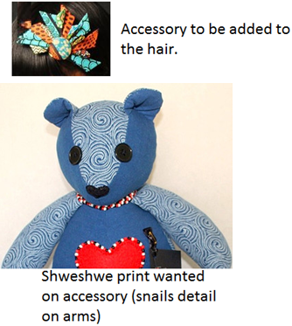

Figure 1; some elements for the logo 1

Instead of having the whole head, only facial features may be added to the Africa map hair, to make for a sophisticated image.

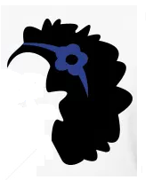

The image above depicts the type of finished product I’m aiming for; with the hair in the Africa map shape and facial features such as pink lips and superlong eyelash added. The rest of the face may be left without border as in the picture above.

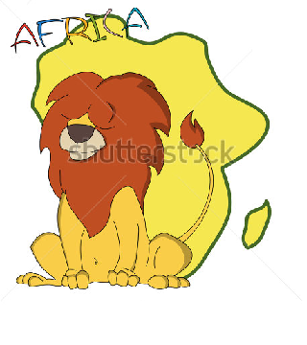

The image above is a lion in a rough or cartoonish Africa Map, this is the kind of shape I want instead of a very detailed map (exclude Madagascar hey). The facial features could be around the general area where the lion’s face is, see what you can do.

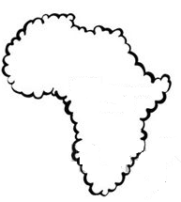

With the image above I was wondering what the whole image would look like if it had this for the borders, so you could just check it out and see what you come up with.

I hope you get the idea. Play around with the concept and colour me impressed!!!!

What attributes of your business would you like your logo to reflect? (applicable to logo

design only)

Beauty, fashion, positive self image, environmental awareness (green colour)

What are your thoughts of your main competitors logos and how do you want to

differ?

Most of the biggest brands in the business have grossly overlooked the needs of this particular client and I want this logo to relate to her. I want the logo to be bold and make a statement in a very unique manner, while also letting the client know her interests are placed ahead in our products. We are creating the product to meet these needs and not just to make sales.

Will you be requiring corporate stationery (business cards, letterhead design, etc)?

YES.

Website design:

Do you require animation, sound or video?

.........................................................................................................................................

Do you own images already or do you need them to be produced or sourced?

.........................................................................................................................................

Will you need help with writing the copy?

.........................................................................................................................................

Do you need to be able to update the website yourself?

.........................................................................................................................................

How many pages will you require and what information do you want those pages to

contain?

.........................................................................................................................................

Is being found by search engine users important to you?

.........................................................................................................................................

If so, what particular search phrases do you envisage targeting, on which particular

search engines?

.........................................................................................................................................

Suggested visuals: Please provide high resolution images (300dpi at maximum size)

on CD or DVD

Language: English Setswana Other

Colour:

.........................................................................................................................................

Add specific instructions if material being briefed requires variants in size, colour or

visual, etc

.........................................................................................................................................

Supply other restrictions on material with size, colour, mechanism, cost, etc

.........................................................................................................................................

Notes

Images to be in .png format with a colourless background, and the resolution of at least 300dpi.

Fonts should be freehand kind of style, to add a personal touch; kind of like the nandos font.