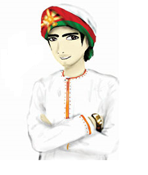

The road to Entrepreneurial Ecosystem in Oman.

The ecosystem has 9 components: You can use an image to express the components rather than wright

1. **Entrepreneurial Finance**. The availability of financial resources—equity and debt—for small and medium enterprises (SMEs) (including grants and subsidies).
2. **Government Policy**. The extent to which public policies support entrepreneurship. This EFC has two components: a) Entrepreneurship as a relevant economic issue and b) Taxes or regulations are either size-neutral or encourage new and SMEs.
3. **Government Entrepreneurship Programs**. The presence and quality of programs directly assisting SMEs at all levels of government (national, regional, municipal).
4. **Entrepreneurship Education**. The extent to which training in creating or managing SMEs is incorporated within the education and training system at all levels. This EFC has two components: a) Entrepreneurship Education at basic school (primary and secondary) and b) Entrepreneurship Education at post-secondary levels (higher education such as vocational, college, business schools, etc.).
5. **R&D Transfer**. The extent to which national research and development will lead to new commercial opportunities and is available to SMEs.
6. **Commercial and Legal Infrastructure**. The presence of property rights, commercial, accounting and other legal and assessment services and institutions that support or promote SMEs.
7. **Entry Regulation**. This EFC contains two components: a) Market Dynamics: the level of change in markets from year to year, and b) Market Openness: the extent to which new firms are free to enter existing markets.
8. **Physical Infrastructure**. Ease of access to physical resources—communication, utilities, transportation, land or space—at a price that does not discriminate against SMEs.
9. **Cultural and Social Norms**. The extent to which social and cultural norms encourage or allow actions leading to new business methods or activities that can potentially increase personal wealth and income

[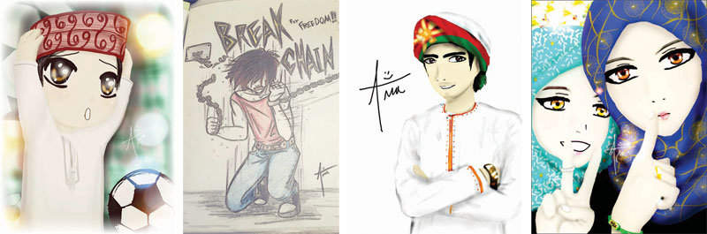](http://www.google.co.uk/url?sa=i&rct=j&q=&esrc=s&frm=1&source=images&cd=&cad=rja&uact=8&ved=0CAcQjRxqFQoTCMnev7TR0cgCFYPAFAodJR0P_A&url=http%3A%2F%2Fomanobserver.om%2F144240%2F&bvm=bv.105454873,d.d24&psig=AFQjCNHNtNJ1m-N4f3QMBudtEc90dbt1HQ&ust=1445450630576059) Omani character. There are many you can get from Google.

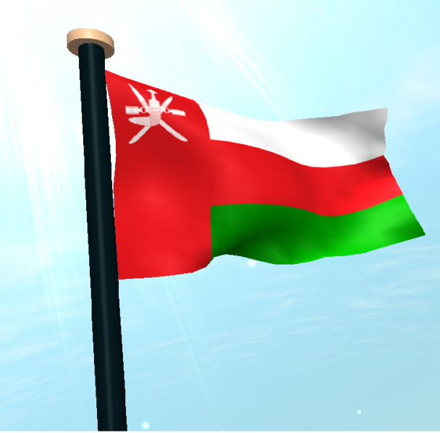 Please use any of the Omani Flags from Google