 Æmyriei

 æmyriei

[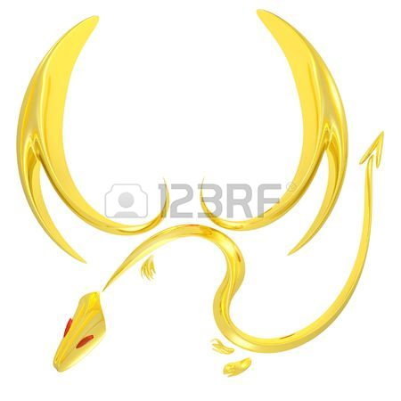](http://previews.123rf.com/images/knorre/knorre0902/knorre090200014/4305332-3d-rendered-gold-dragon-symbol--Stock-Photo-logo-dragon-wing.jpg) Æmyrie

[](http://previews.123rf.com/images/knorre/knorre0902/knorre090200014/4305332-3d-rendered-gold-dragon-symbol--Stock-Photo-logo-dragon-wing.jpg) æmyrie